Describing the scale and composition of calls for service in Detroit

Samuel Langton (Netherlands Institute for the Study of Crime and Law Enforcement)

In the spirit of a recent contribution by Ratcliffe (2021) published in *Crime Science* this short paper describes the scale and composition of public demand for police services in Detroit, United States, during 2019. Findings broadly confirm those by Ratcliffe, namely, that a considerable proportion of police time is spent resolving a diverse array of calls for service, including public health incidents. The temporal and spatial patterning of different types of public demand for police services are often distinct. The data and code to replicate analyses are made openly available.

Keywords: police, calls for service, 911, demand, reactive.

# Introduction

Amidst austerity measures, growing public expectation, and scrutiny, understanding the public demand for police services has become a priority among evidence-based policing researchers and practitioners (Boulton et al., 2017). Without a grasp on the scale (‘how much?’) and composition (‘what type?’) of police demand, we are likely to observe sub-optimal and inequitable outcomes for the public, the inappropriate distribution of public funds, and unnecessary strain on officers (Ellison et al., 2021; Lum et al., 2021). Understanding the characteristics of public demand for the police has become particularly pertinent following recent calls to rethink, and some cases, radically reform, the role and reach of contemporary police forces (Lum et al., 2021).

A study from Ratcliffe (2021) in *Crime Science* sought to describe the complexity and diversity of public demand for police services in Philadelphia, United States. The study was motivated by the recognition that police spend a considerable proportion of deployed resource resolving incidents which fall outside the traditional crime-fighting role of the police. Instead, the origins of public demand for the police can often be attributed to a lack of supply and/or accessibility failure in other organisations, such as those providing support for people requiring (mental) health assistance (Dijk & Crofts, 2017; Wood et al., 2021). The study’s findings provided data-driven evidence to suggest that the police indeed spend considerable amounts of time dealing with incidents that could be resolved by other – often more appropriate – agencies. Comparable findings were subsequently reported in the United States across multiple (anonymised) police jurisdictions (Lum et al., 2021). In advance of recent contributions, this short paper describes the public demand for police services in Detroit, United States, using open data and open code which can be used to reproduce the findings (see xxxxxxxxxxxxxxxxxxxxxxxxxxxx).

# Ratcliffe (2021)

Using computer aided dispatch (CAD) data from the Philadelphia Police Department (PPD) the Ratcliffe (2021) study provided a breakdown of calls for police service during 2019. CAD codes, discrete descriptions of the incident based on information available to the dispatcher, of which eighty unique descriptions originated from the public and required officer dispatch, were categorised into six broad classifications: community issues, crime, medical/public health, proactive policing, quality of life, and traffic duties. Recognising that frequency counts of calls for service do not necessarily reflect the amount of consumed police resource, raw counts were adjusted by the time committed by officers to deal with each incident type. Findings indicated that around 55% of officer shift activity time was spent on calls relating to crime, with the remainder of time allocated to incidents involving medical/public health (9%), the community (7%), proactive policing (5%), quality of life (14%) and traffic duties (11%). Focusing on medical/public health incidents, findings also indicated that calls concentrated in particular areas of the city and during particular hours of the day.

# Public demand in Detroit

The data used for this study covers the city of Detroit in Michigan, United States. The City of Detroit authority publish calls for service data through their open data portal.[1]. The raw data includes both citizen-initiated 911 calls to request police services and officer-initiated calls spanning back to September 2016. In alignment with Ratcliffe (2021), the data used here is subset for the year 2019 and excludes those calls initiated by an officer. For each incident, the response time and time on the scene are reported. In sum, these comprise the total deployed time officers spend on the incident. Incidents which had a total allocated time of zero minutes (or negative values) were excluded.

Each incident has a *calldescription* variable which describes the nature of the call. Call descriptions involving administrative duties (e.g., “start of shift information”), completely unknown problems, and non-deployment (e.g., “employee call in / time off”) were removed. This left 207 unique call description categories. In the interests of parsimony and ease of interpretation these categories were recoded into 101 broader call descriptions.[2] Each call description was then categorised into the six demand type classifications used in Ratcliffe (2021). 2.8% of incidents were deemed unclassifiable. For each of the six demand classifications an ‘other’ incident type was generated for those incidents which consumed less than 0.2% of police time during the year. This left a total of 48 categories for the reported breakdowns, capturing ~267,000 individual public calls for service in Detroit during 2019.

## Scale and composition

In alignment with Ratcliffe (2021), the frequency counts and proportional breakdowns for each demand type classifications are reported in Table 1. This tells a comparable story to Philadelphia: a considerable proportion of citizen calls for service, and in turn, time spent by officers, is committed to a diverse array of (often non-criminal) issues. In Detroit, just 46% of police time was spent dealing with calls for service relating to crime. The remainder of time was spent dealing with community issues (6%), public and mental health (7%), proactive activity (7%), quality of life incidents (19%) and traffic duties (13%). The proportional breakdown of time consumed for each incident type, grouped by the six demand classifications, are visualised in Figure 1.

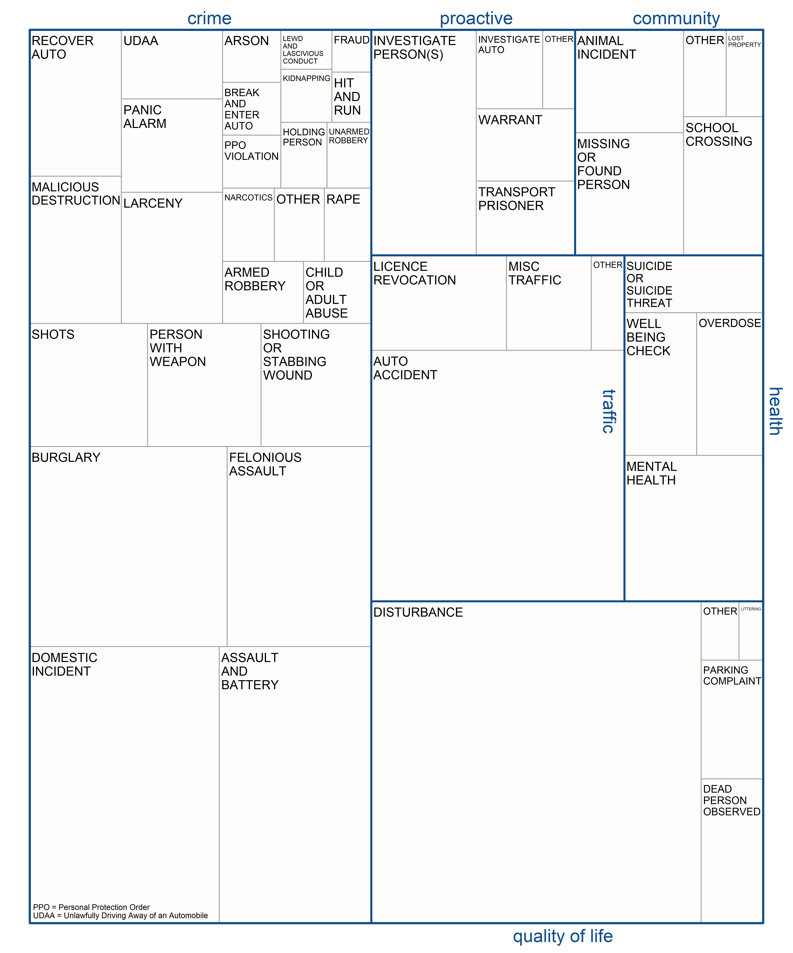

## Temporal patterning

The mean incident counts by day of the week and by hour, for each demand classification, are visualised in Figure 2. This demonstrates that the different sources of public demand for police services, as indicated by the six demand classifications, can have distinct temporal patterning. Community calls appear to concentrate on weekdays, around lunchtime. Crime and quality of life-related calls both appear to occur in the evening and early hours of the morning, although crime incidents are more impacted by weekend activity stretching into Saturday and Sunday mornings. Traffic incidents concentrate in the evenings, particularly on a Friday. Proactive policing does not have a distinct hourly patterning, but this could be attributed to the low hourly counts. Calls relating to health issues, the primary interest of Ratcliffe (2021), appear to largely take place in the evening and early morning, aligning with findings from Philadelphia.

## Spatial patterning

Individual incident location coordinates were aggregated to synthetic grid cells laid over the city to generate heatmaps of counts throughout the year.[3] These are visualised for each demand classification in Figure 3. While there is overlap, call hotspots and the degree of concentration differs between types of public demand. Calls about community issues concentrate overwhelmingly in and around the Wayne State University (WSU). Crime calls tend to cluster near hospitals, most notably, the Henry Ford Hospital in the city centre. Proactive call activity originates from the WSU area and Midtown, and quality of life around WSU and downtown. Health calls concentrate in downtown, but also around WSU and in the vicinity of the Detroit Rescue Mission Ministries, a large facility for the vulnerable, abused and homeless people in the city.

# Discussion

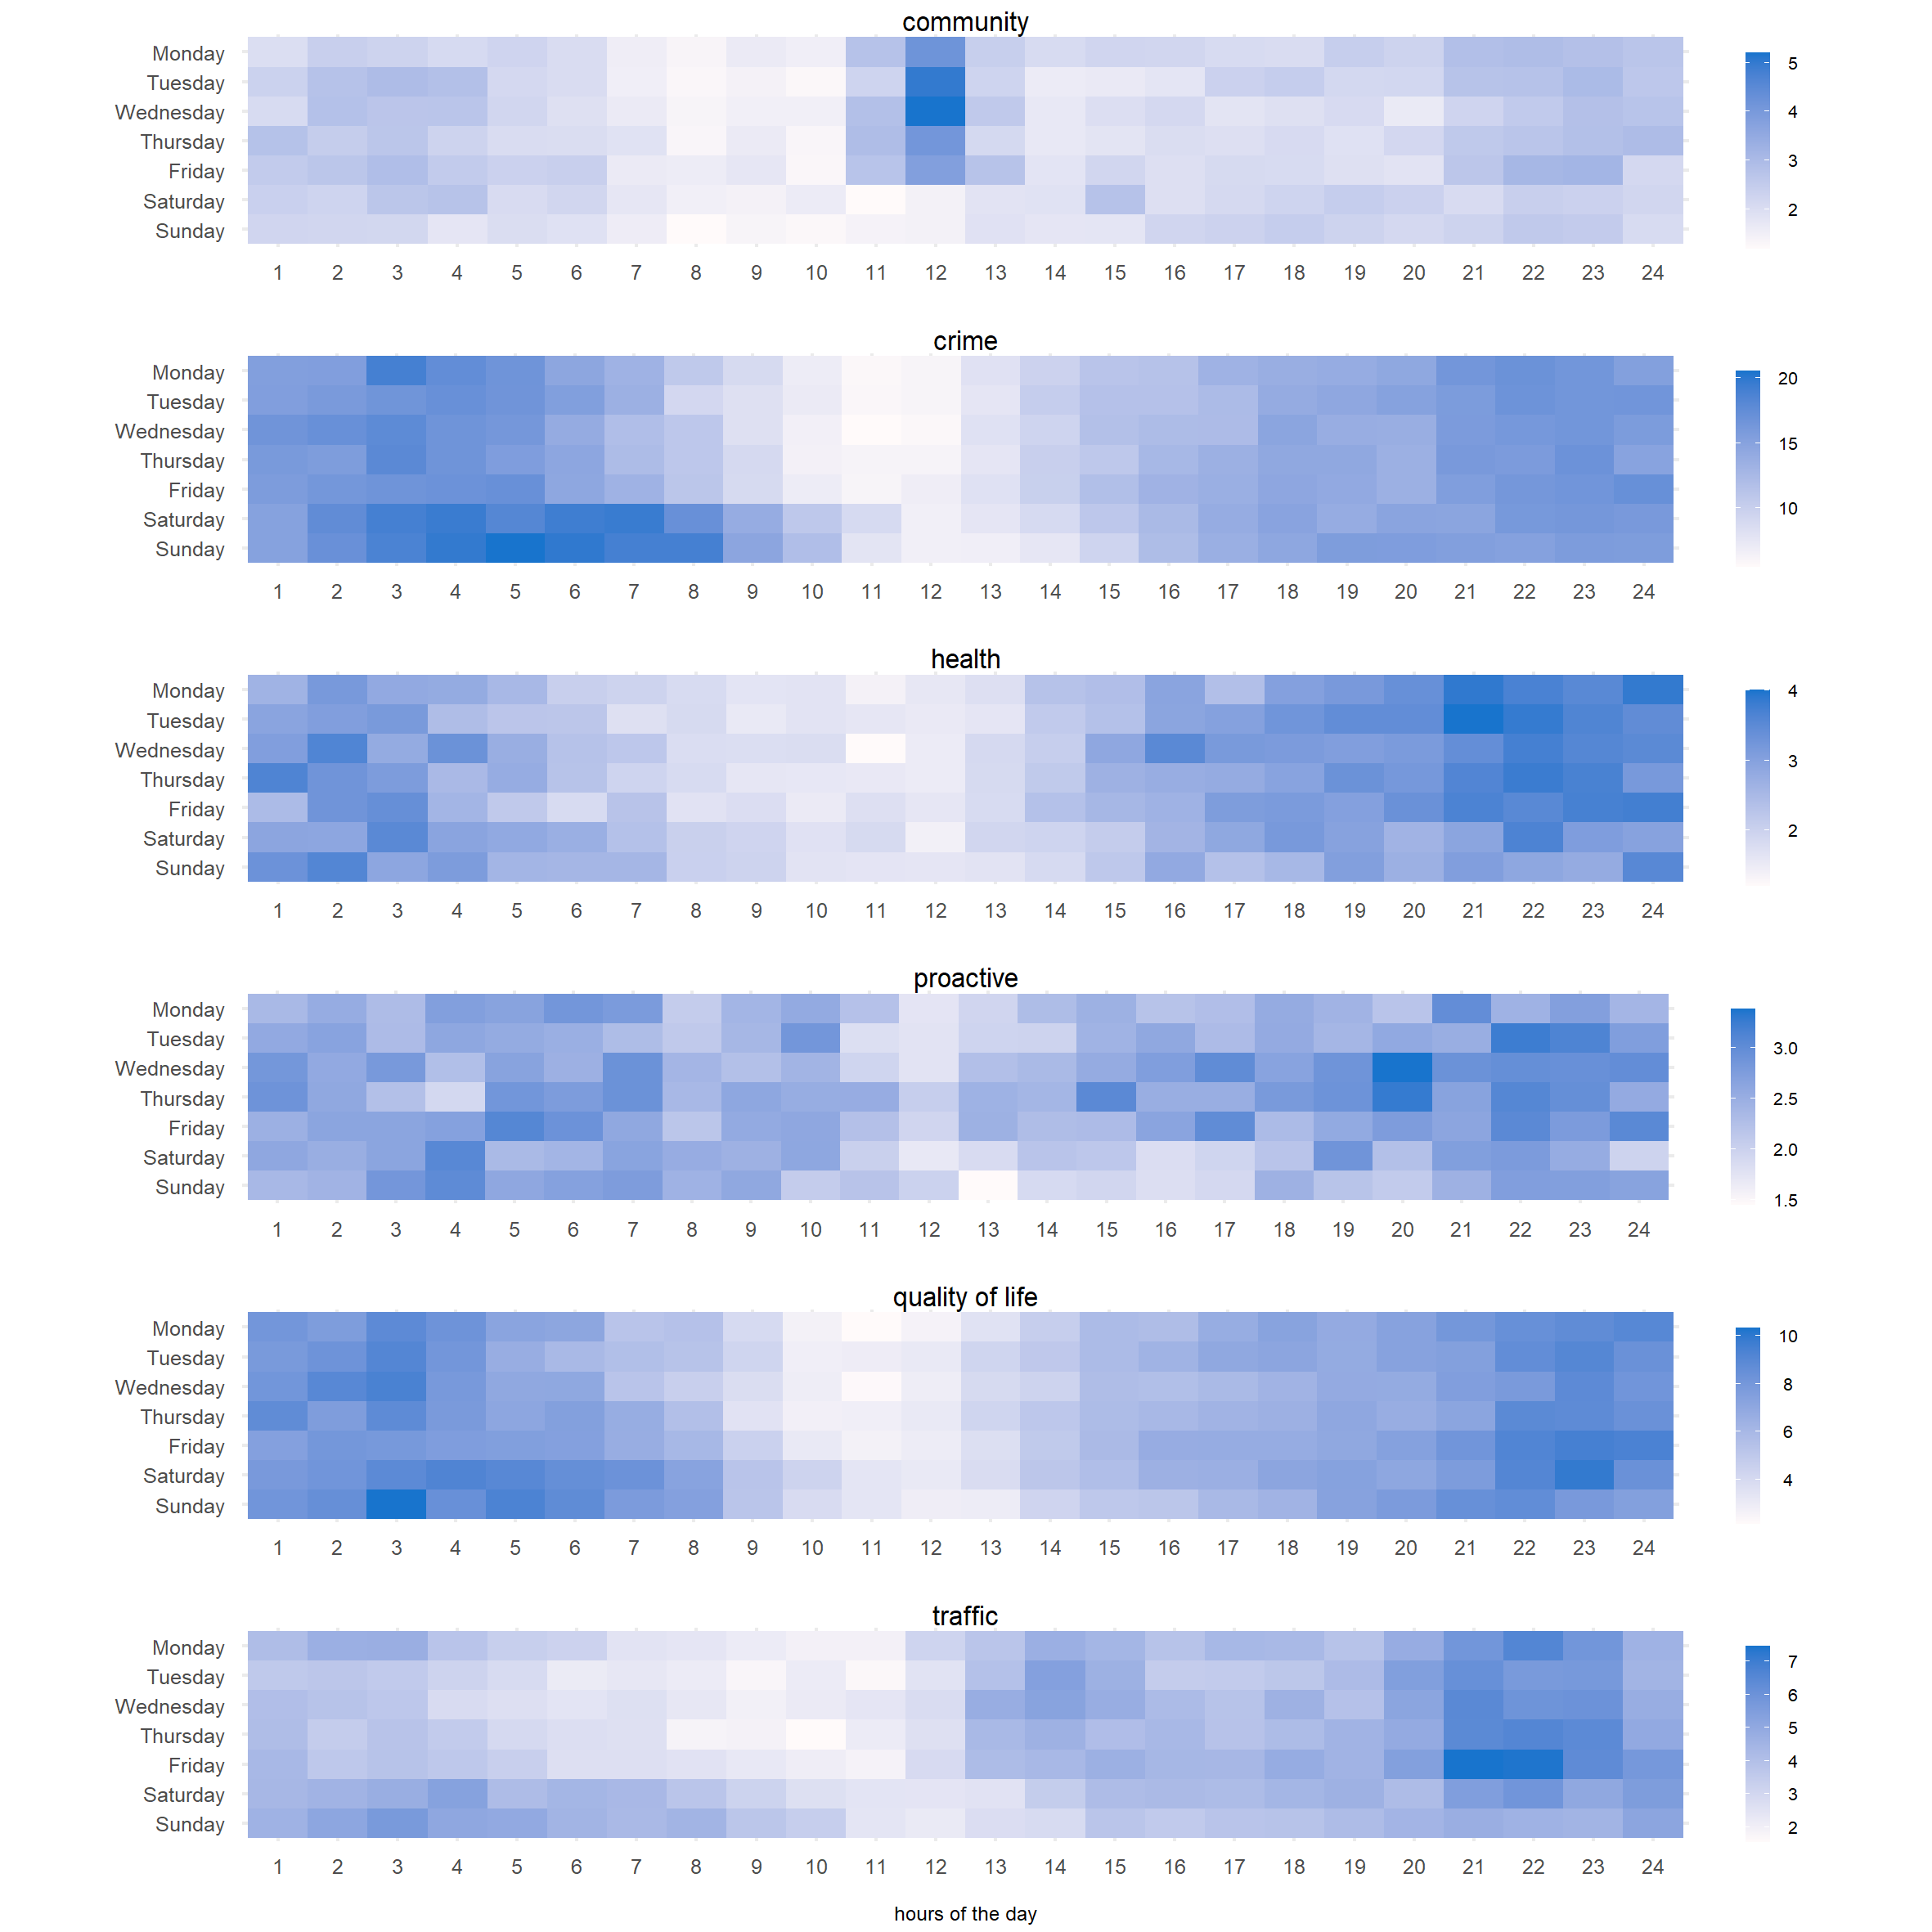

Mean incident counts by day and week, for each demand type.

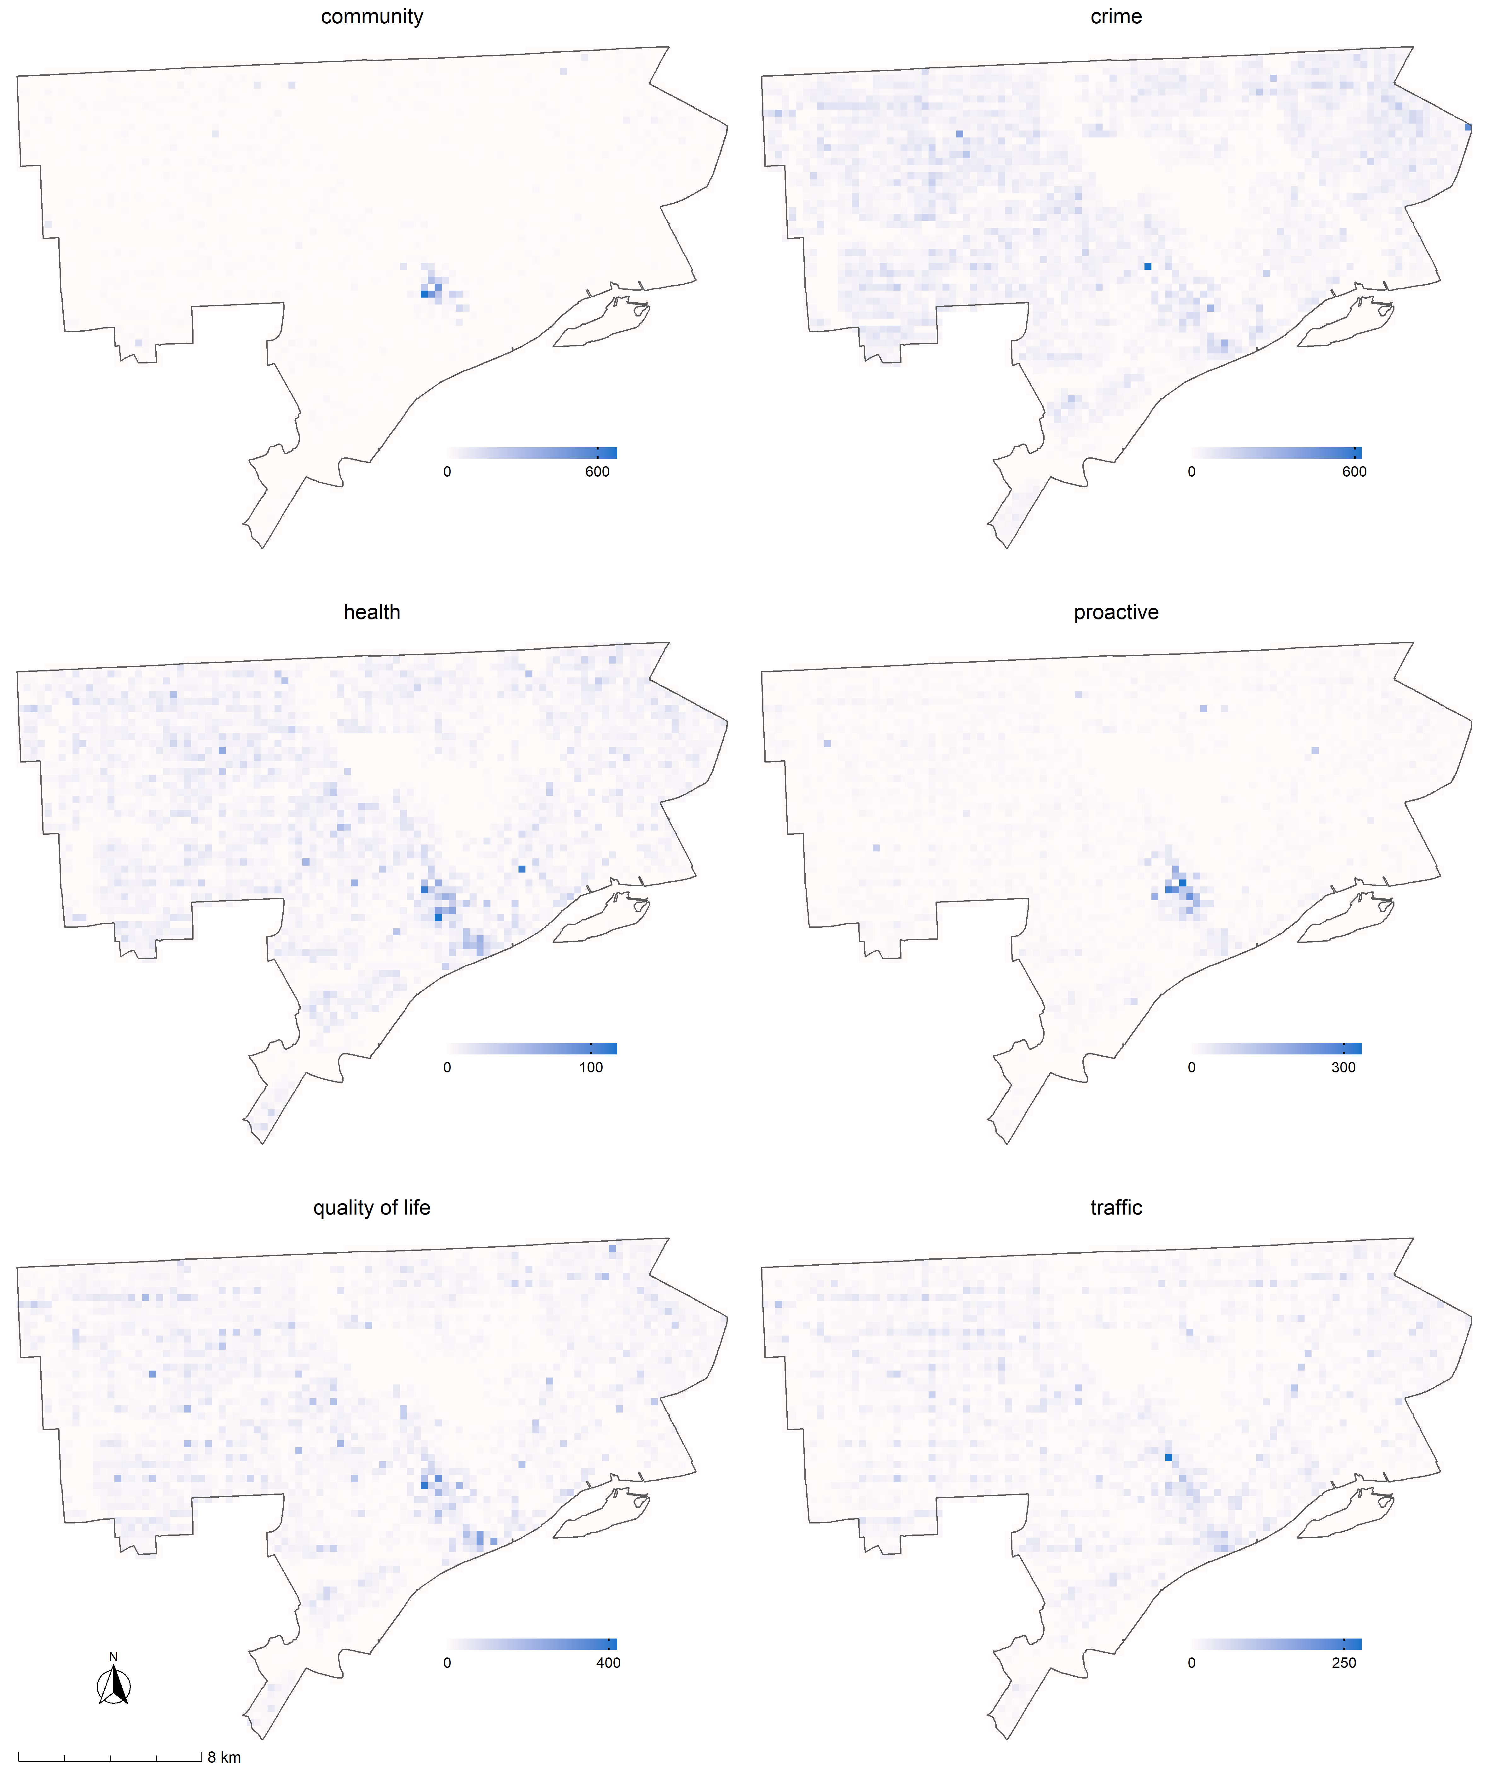

# References

Boulton, L., McManus, M., Metcalfe, L., Brian, D., & Dawson, I. (2017). Calls for police service: Understanding the demand profile and the UK police response. *The Police Journal*, *90*(1), 70–85.

Dijk, A. van, & Crofts, N. (2017). Law enforcement and public health as an emerging field. *Policing and Society*, *27*(3), 261–275.

Ellison, M., Bannister, J., Lee, W. D., & Haleem, M. S. (2021). Understanding policing demand and deployment through the lens of the city and with the application of big data. *Urban Studies*, 0042098020981007.

Lum, C., Koper, C. S., & Wu, X. (2021). Can we really defund the police? A nine-agency study of police response to calls for service. *Police Quarterly*, 10986111211035002.

Ratcliffe, J. H. (2021). Policing and public health calls for service in philadelphia. *Crime Science*, *10*(1), 1–6.

Wood, J. D., Watson, A. C., & Barber, C. (2021). What can we expect of police in the face of deficient mental health systems? Qualitative insights from chicago police officers. *Journal of Psychiatric and Mental Health Nursing*, *28*(1), 28–42.

1. Accessible via <https://data.detroitmi.gov/>
2. We refer readers to the corresponding GitHub repository for further details on how call descriptions were combined (xxxxxxxxxxxxxxxxxxxxxxxxxx). Readers unfamiliar with R code can review the reference table entitled ‘categorisation summary.’
3. Grid cells were defined as 1000 ft $​^{2}$ (305m $​^{2}$) – a size deemed appropriate based on a balance between capturing localised variation and interpretable visualisations. 2% of incidents were excluded from the spatial visualisations due to incomplete geographic information.