**GAME DESIGN DOCUMENT**

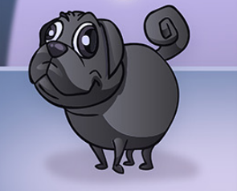

Ooonimals Turn-Based RPG

CM National Inc.

Designed by

Trevor Merel

Version # 1.00

September 6th, 2021

Table of Contents

High Concept 4

Mission Statement 4

Player Hook 4

Game Vision 4

Unique Selling Points 4

Audience 4

Genre 4

Rating 5

Platform 5

Software 5

Gameplay & Mechanics 5

Overview of Gameplay 5

Gameplay Guidelines 6

Player Experience 6

Core Player Actions 6

Goals 7

Rules 7

Control Scheme 13

Systems 15

Object Breakdown 16

Level Design 17

Setting Overview 17

Level Mockups 17

User Interface Design 18

Aesthetics 18

Flow Chart 19

Wireframes 20

Narrative Design 23

Plot Outline 23

Script 23

Storyboards 23

Asset List 23

Visual Assets 23

Auditory Assets 23

Wish List (Backlog) 24

Reference Images 24

# High Concept

This game is a top-down, turn-based RPG that allows players to explore the lands of the Oooniverse battling their Ooonimals against other Ooonimals. Collect more Ooonimals and transfer them to the game to battle with them and level them up. Earn all sixteen (16) Tokens, one (1) from each land, to gain access to a special area where Ooonimals roam free.

# Mission Statement

The purpose of creating this game is to create a world where owners of Ooonimals can use their collections in a fun and engaging way.

# Player Hook

You’ll love playing this game. The fun of a turn-based RPG turned up by a factor of 80 with all the awesome Ooonimals you could collect! Battle to your heart’s content, level up your Ooonimals, and trade them with your friends!

# Game Vision

## Unique Selling Points

This game stands out as it is the only one today that is fully cross-platform and also allows physical, collectible items to be used in-game and traded and transferred to other players with all stats from the game intact.

## Audience

This game is intended for children aged 6 and up. This game has simple combat, but the player needs to have a grasp of the choices they’re making in battles.

## Genre

The game fits into the turn-based RPG genre.

## Rating

The game aims to be rated E by the ESRB in order to reach the young target audience.

## Platform

The game will initially release on mobile (iOS, iPadOS, and Android). Ports to Windows, MacOS, PlayStation 4, PlayStation 5, Xbox One, Xbox Series X|S, and Switch will come later.

## Software

Engine: Unity 2D

Audio:

Art:

Organization:

Communication:

Version Control:

# Gameplay & Mechanics

## Overview of Gameplay

The gameplay begins with the player going through the starting town to learn the game’s mechanics. They then are either given Ooonimals or can scan their own and put them into the game. The main gameplay loop has the player battling their Ooonimals against other Ooonimals in turn-based combat.

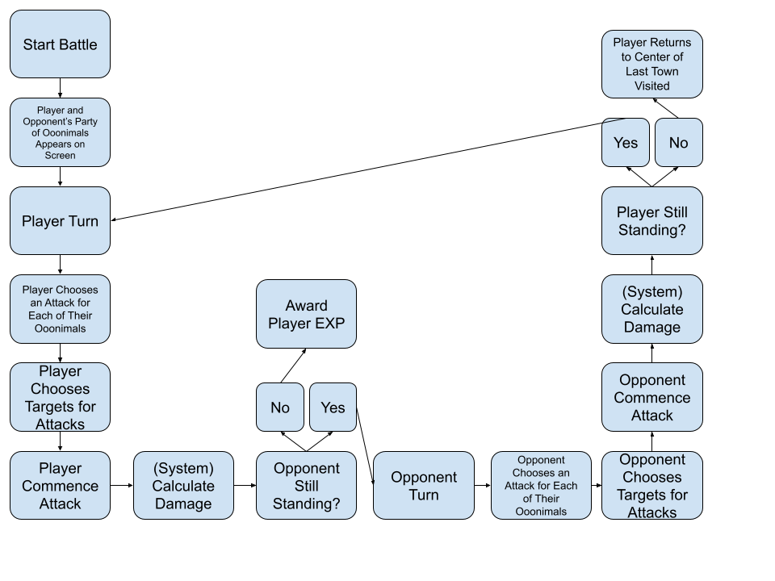

## Gameplay Guidelines

This game should be aiming to hit that sweet spot of simple enough to attract a younger audience while also being engaging enough to keep them interested. The game should not have any violence or graphic content of any kind as to maintain the target E rating from the ESRB. The game should always be forgiving and never punishing.

## Player Experience

The player should experience a fun adventure that isn’t frustrating to play. The player shouldn’t be surprised by anything except for the cool new Ooonimals they encounter. The player should be familiar with and attached to their Ooonimals and want to keep playing the game.

## Core Player Actions

In this game, the player can:

* Create a player avatar
* Walk around as a player avatar
* Talk to NPCs
* Battle Ooonimals
* Choose Ooonimals party
* Choose Attacks
* Choose Targets

## Goals

Main Goal: Collect all sixteen (16) Tokens and gain access to the “Free Roam Land”.

Sub Goal: Help each town with their quests.

Moment-to-Moment Goal: Win battles against other Ooonimals.

## Rules

**Getting Started:**

The player will first create an avatar when starting the game for the first time. They will have male, female, three (3) skin tones, three (3) hair styles, three (3) hair colors, and three (3) outfits to choose from.

The player is placed in the Starter Town (official name TBD). Here, they will get a quick introductory to the Oooniverse from an NPC.

The player will be given three (3) Ooonimals to start their adventure with. These Ooonimals are special and cannot level up beyond Level 10 out of 100. They also cannot be traded in any way.

The Ooonimals given will be three (3) of the Exotic Characters such as Boss, Blackie, Char, Loci, etc.

The player will participate in a practice battle with that NPC that will teach them the mechanics of battling Ooonimals. No EXP will be gained during this practice battle.

This practice battle can be done as many times as desired when speaking to that particular NPC. The NPC’s Ooonimals will always be the same levels as your own party.

**Player Avatar and the World:**

The player avatar will move on a grid. They can move Left, Right, Up, and Down along the X and Y axis from a top-down perspective.

As you can see in this diagram, you can move in four directions. Moving up as indicated by the diagram, would cause the player to activate a trigger using OnTriggerEnter. The trigger would LoadScene and place the PlayerPosition at the door on the inside of the building.

To exit, the player would move down and enter another trigger using OnTriggerEnter to LoadScene back into the outside. The PlayerPosition would be facing down and just outside the door of the building just exited exactly as the diagram above portrays it.

l

To speak to an NPC, the player avatar would have to walk up to them and activate them. OnTriggerEnter would be used here as well. The player would have to be inside the trigger in the spaces next to the NPC and the player would have to be facing that NPC and then Activate.

A dialogue box will pop up on the bottom of the screen and the player will be frozen in place using an If-Then Statement. An example would be something like:

If playerAvatar inDialogue = true;

Then FreezePosition;

The world around the player would not freeze though. This is an important distinction if multiplayer is planned later. Do not use time.deltaTime.

To progress in the conversation, the Activate button can be pressed. To exit the conversation without progressing through all the dialogue, the Back button can be pressed.

Using an Xbox controller as an example, Activate would be mapped to the ‘A’ button and Back would be mapped to the ‘B’ button.

To engage in a battle, the player would need to Activate an Ooonimal the same way they would Activate a human NPC. Battles can also be engaged from Activating or being approached by an NPC who has their own Ooonimals.

Battles will have the characters all presented horizontally so it will fill up a 16:9 screen perfectly. This means that for the mobile version, the game must be played in Landscape mode.

**Battling:**

The party of Ooonimals that the player will be taking into battle would be selected prior to battle in the Menu Screen. The Menu Screen is not to be confused with the Main Menu. The Menu Screen is not its own screen but an overlay.

Pressing the Menu button would enable a SetActive bool on the Menu Screen and it would also FreezePosition on the player like discussed earlier.

When the Menu Screen is SetActive, all controls go to the Menu Screen.

In the Menu Screen, the player will be able to adjust Options such as Music and SFX Audio, Quit (the game should be saved on the servers so there should be no need to manually Save), view a list of friends (when the game has multiplayer), view the Overworld, and swap Ooonimals to and from their Party (max size of 3) and their Storage (no max size). The player can view info on their Ooonimals from either the Party or Storage sections of the Menu Screen.

Once the player has a Party, Battles can commence.

Battles can be anywhere from one (1) Ooonimal on each side to three (3) or any combination. There is no benefit to not having a full party of three (3) so it is in the player’s best interest to fill it.

While the game remains single player, the player will always go first. When multiplayer is added, Speed stats will be introduced to mix it up.

The player will select an attack for each Ooonimal before any actions and animations start.

To maintain the E rating from the ESRB, all Attacks in the game are themed around a food fight.

Each Ooonimal will have three (3) attacks to choose from. A Basic attack, one that is specific to type (Birds, Cats, Dogs, etc) known as Special, and each Ooonimal will have an Ultimate attack.

The Ultimate attack is based on a food associated with the Ooonimal according to the style guide. There will be some examples in the next section.

Special and Ultimate attacks will have a limited number of uses per battle. Basic attacks will be unlimited.

Special attacks will be limited to five (5) uses per battle and will do 1.5x damage when used on an Ooonimal that is weak against the attacking Ooonimal. When used against an Ooonimal that is strong against the attacker, the attack does 0.5x damage. If the Ooonimal being attacked is neutral to the attacker, the attack does the standard 1.0x damage.

Ooonimals from each land share a Special attack. Ooonimals from certain lands are strong and weak against others. For example, Ooonimals from Aves City are strong against Ooonimals from Irk Garden but weak against Ooonimals from Middleville.

Ultimate attacks can only be used one time (1) per Ooonimal per battle. All Ultimate attacks have “splash damage”. When hit, the Ooonimal targeted is damaged 2.0x what a Basic attack would do and the surrounding opposing Ooonimals (if there are any) are hurt at a rate of 1.0x like a Basic attack.

Attacks have a chance to Miss. Ultimate attacks become more accurate the more turns that have taken place in the battle. This is to prevent players from using Ultimate attacks when they start every battle and abusing the system. More about this in *Stats and Probability.*

Every Attack will have an animation. (The specifics of that should be left up to the animator.) Throwing food, smashing food on each other’s heads, etc. are generally what we’re going for.

Combat itself will simply be done by selecting an Ooonimal (tapping them on mobile), selecting one of three attacks, and selecting a target. Do that for your entire party and watch the fight play out until the player loses, wins, or its their next turn.

An Ooonimal who hasn’t selected an Attack and Target yet will have a gold aura around them as feedback/indication.

Ooonimals heal and their attack limits are restored after each battle.

When an Ooonimal loses all of its HP (health), an animation will play and it will run off the screen. Use Play.Animation and Object.Destroy.

Every Ooonimal can land a Critical Hit when attacking. A Critical Hit will do 1.5x damage multiplied by the attack’s normal damage output. More details in *Stats and Probability.*

After each battle, the results will be displayed with the amount of EXP earned per Ooonimal. More on this in *Progression and Travel.*

**Examples and Power Structure:**

Each Ooonimal in the game will use a food from the style guide for their Ultimate attack. Here are some examples:

**Danish Steak Sushi Fried Egg Apple Heart**

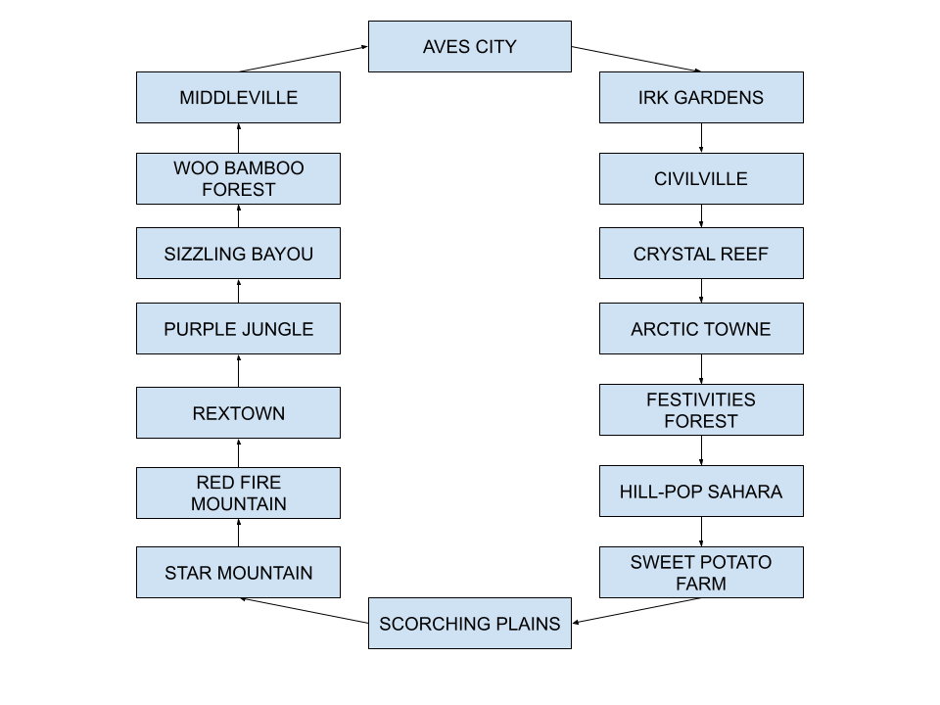

As you can see from the diagram above, Ooonimals are weak to and strong against Ooonimals from certain lands and neutral to each other and most other Ooonimals.

For example:

Ooonimals from Rextown are strong against those from Purple Jungle and weak to those from Red Fire Mountain. As for the others, they are neutral so the Special attack has a damage output of 1.0x against them while outputting 1.5x to Ooonimals from Purple Jungle and 0.5x to Ooonimals from Red Fire Mountain.

This mechanic will force players to experiment, use, and buy new Ooonimals.

**Stats and Probability:**

Critical Hits:

Basic – 1.0x

Special – 1.5x/0.5x/1.0x

Ultimate – 2.0x/1.0x

Basic Critical – 1.5x

Special Critical – 2.25x/0.75x/1.5x

Ultimate Critical – 3.0x/1.5x

Hits and Misses:

Basic – 90% accuracy

Special – 75% accuracy

Ultimate – 25% accuracy on first turn + 10% accuracy each user turn (clamped to max of 95%)

**Progression and Travel:**

EXP will be earned with each successful battle. An Ooonimal that flees (loses) will NOT gain EXP for that battle.

The level cap is 100 for every regular Ooonimal. The level cap for the special starter Ooonimals if the player doesn’t have their own is 9. This prevents the player playing for free for too long and also bars them from using any Ultimate attacks.

An Ooonimal can use Basic and Special attacks from the start but won’t learn their Ultimate attack until level 10.

Ooonimals earn EXP using this formula:

Traveling to new lands is done using a Bus Stop in a town. Lands are completed in a linear order. Once completing all the objectives in one land, a Token is awarded to the player and that Token may be used at a Bus Stop to travel back and forth to the new land you’ve unlocked.

Once all sixteen (16) Tokens are collected, the free roam area where Ooonimals from all lands exist is unlocked. The player may battle with them there freely.

## Control Scheme

PC/Mac – Mouse and Keyboard

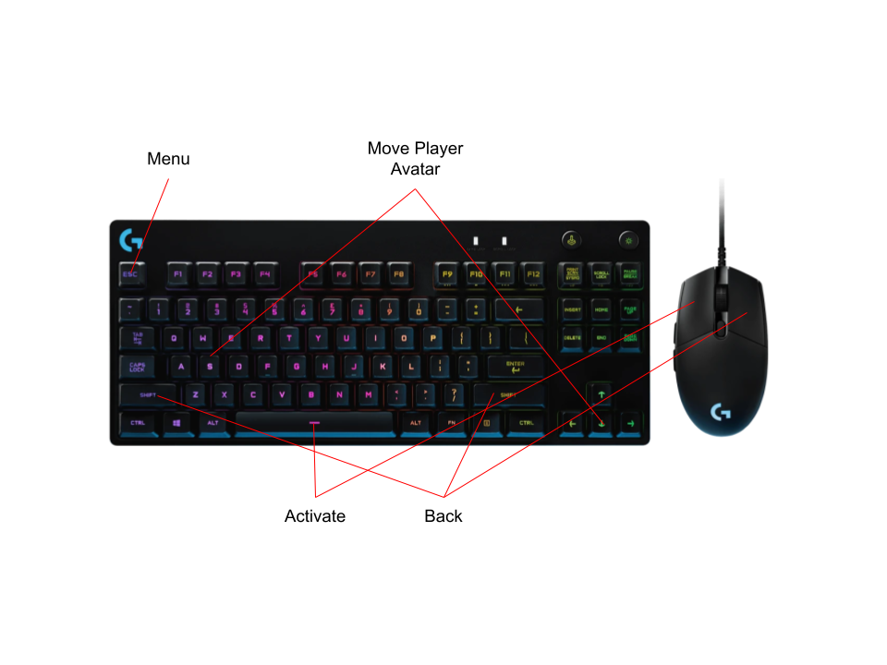

Xbox/PlayStation/Switch – Gamepad

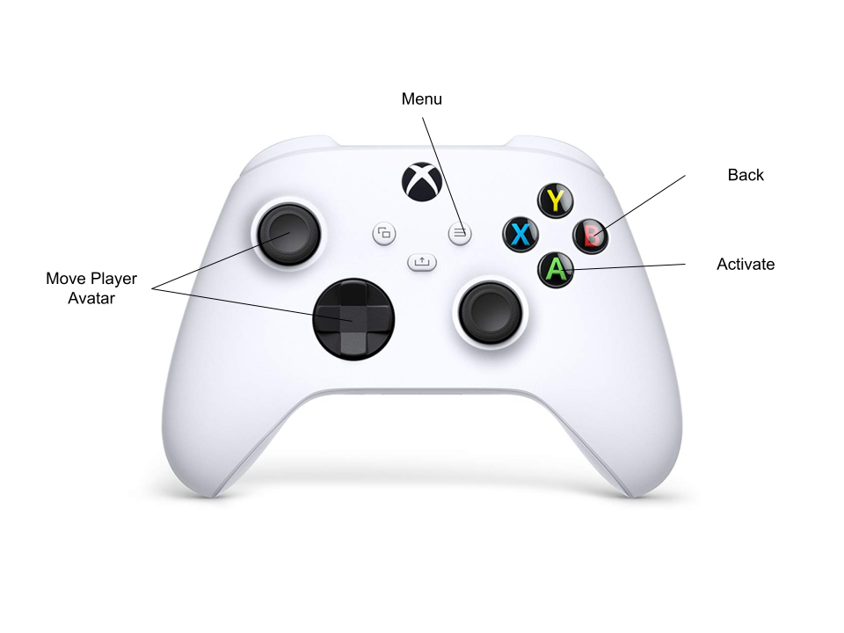

iPhone/iPad/Android – Touchscreen

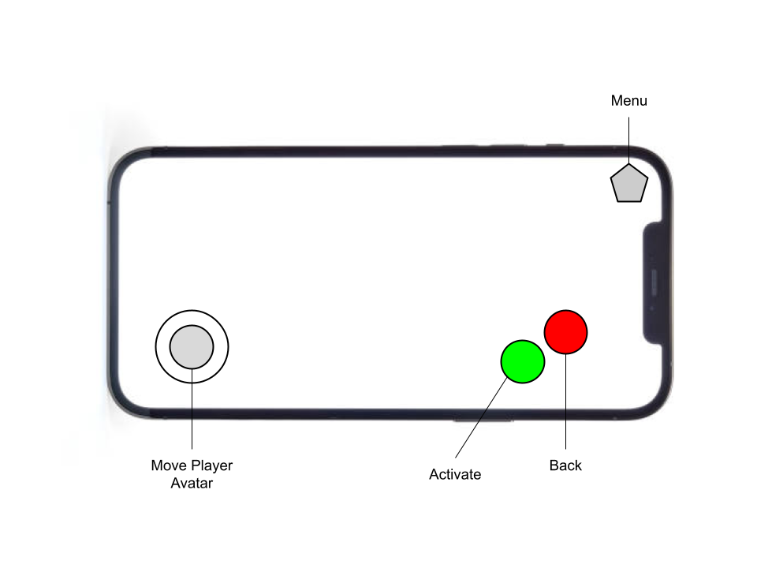

## Systems

This is a list of all the systems the game will need:

* Player avatar movement
* Entering and leaving buildings (LoadScene, SetPlayerPos)
* Speaking to NPCs
* “Speaking” to Ooonimals (Activating)
* Menu screen (SetActive)
* Volume settings (music & SFX)
* Store in menu
* Server saves
* Ooonimal storage
* Ooonimal party
* Initiate Ooonimal battles
* Play Ooonimal animations (Play.Animation)
* Script AI for NPCs and Ooonimals to walk around
* SFX playback
* Music playback
* Ooonimal leveling system
* Ooonimal battle damage calculation
* Ooonimal ultimate attack unlock
* Ooonimal ultimate attack accuracy
* Attack accuracy
* Attack limits
* HP tracking
* Ooonimal healing post battle
* Token awards
* Bus stop token tracking
* Quest/task tracking
* Ooonimal battle targeting
* Ooonimal battle ultimate splash damage
* Ooonimal glowing when turn active
* Display proper background terrain
* Trading Ooonimals between players
* Track the special Ooonimals gifted and make sure they don’t level past 9
* Camera

## Object Breakdown

Player Avatar

* Used for having a physical representation in the world

Ooonimals (80)

* Used to collect and battle

Human NPCs

* Used for advice/tips, quests/tasks, and battles

Tokens

* Earned from completing all tasks in a town and is used to traverse to the next land

Bus Stop

* Used to travel between lands with earned Tokens

Buildings/Houses/Structures

* Traveled in and out of
* Can contain NPC’s task objectives, etc

# Level Design

## Setting Overview

<Needs Input>

## Level Mockups

Town

Oooniverse Overworld

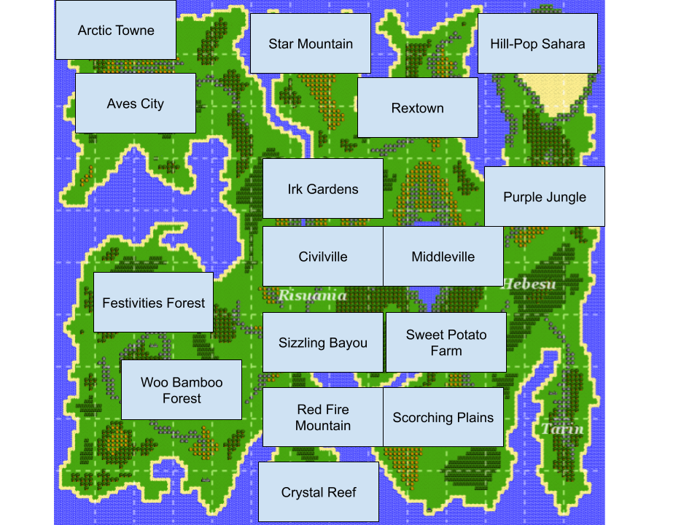

# User Interface Design

## Aesthetics

The aesthetics of the UI should be simple and easy for a young audience member to read and operate. It should be colorful and have some personality with some Ooonimals decorating the screen. The screenshot below gives a good idea of what we should strive for.

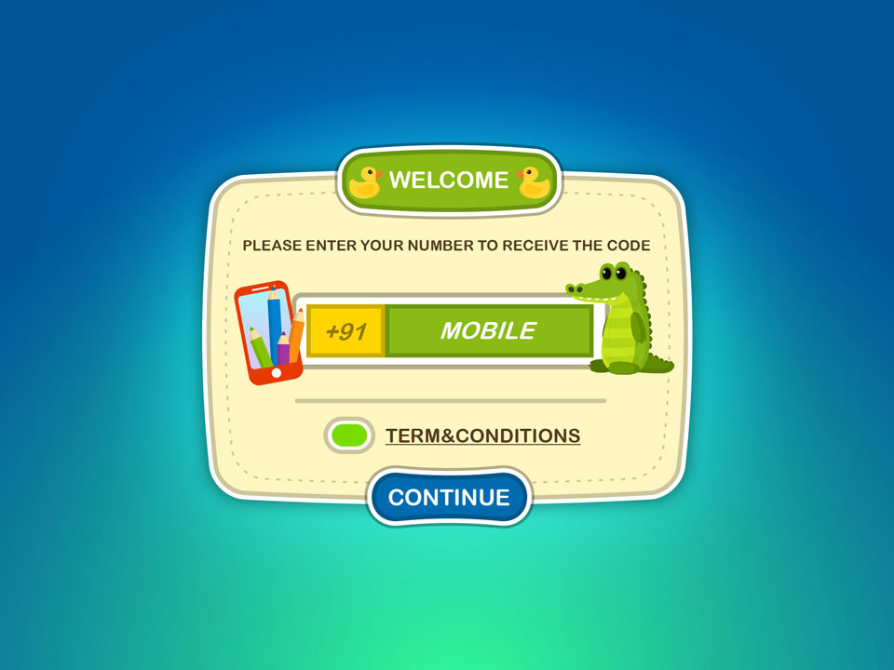

## Flow Chart

Main Menu

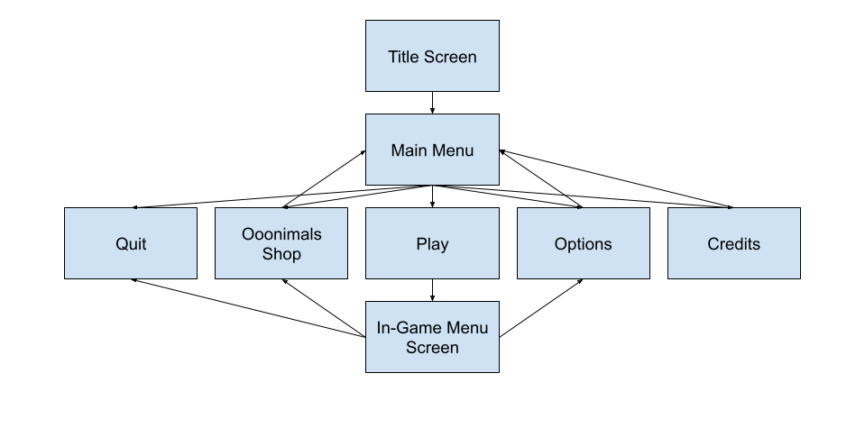

In-Game Menu Screen

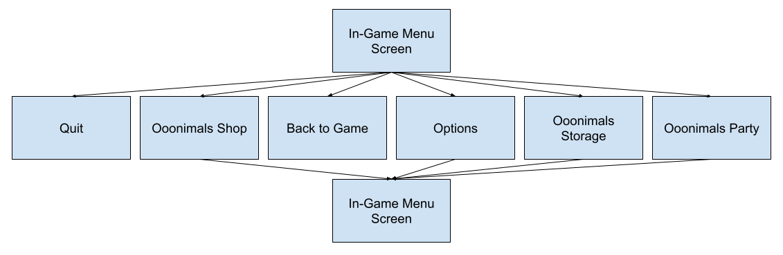

## Wireframes

Title Screen

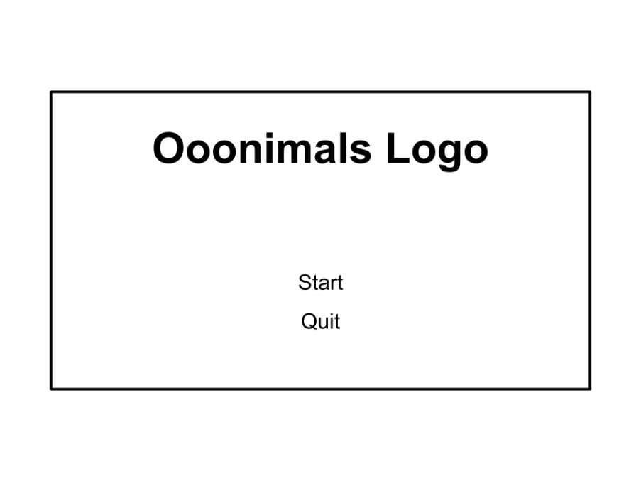

Main Menu

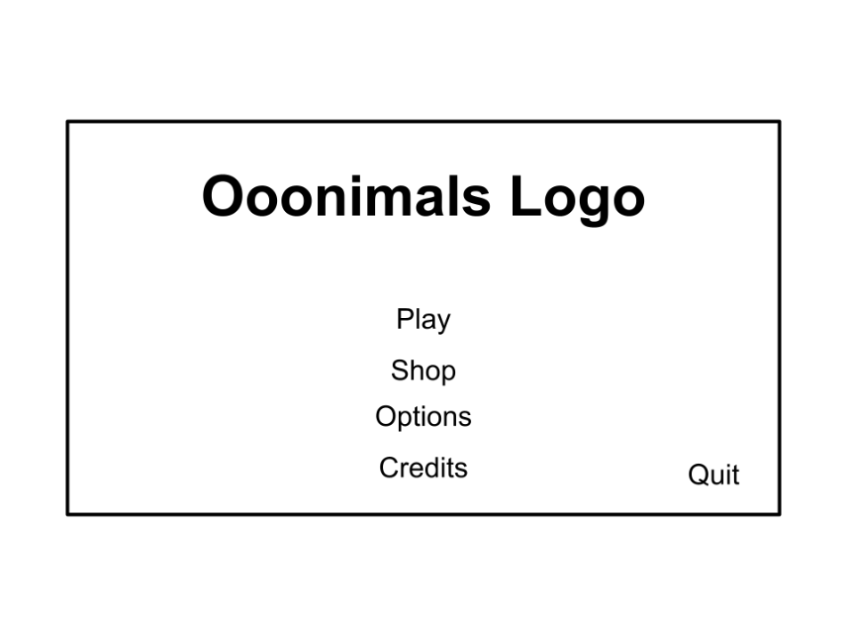

Options Menu

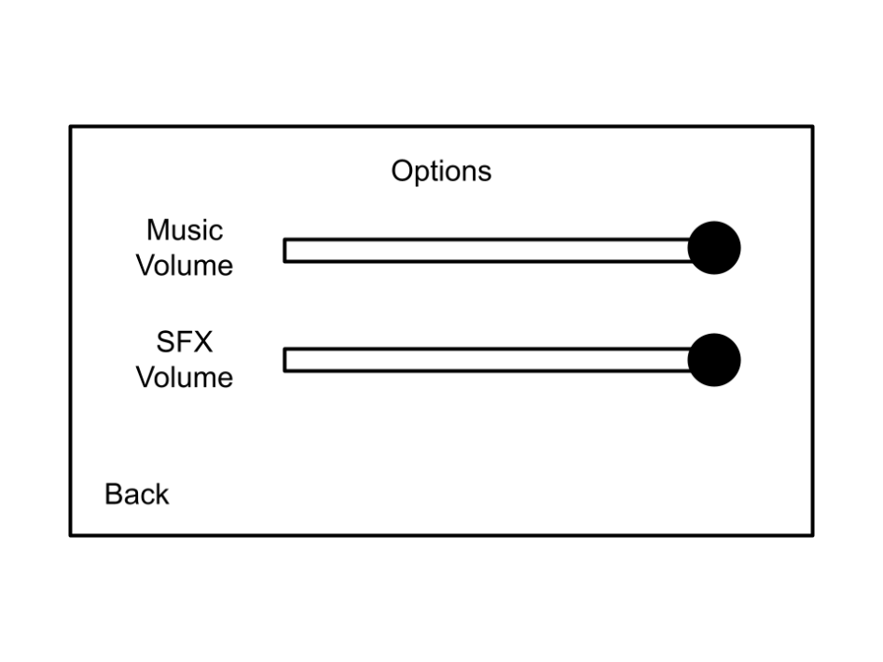

Shop Menu

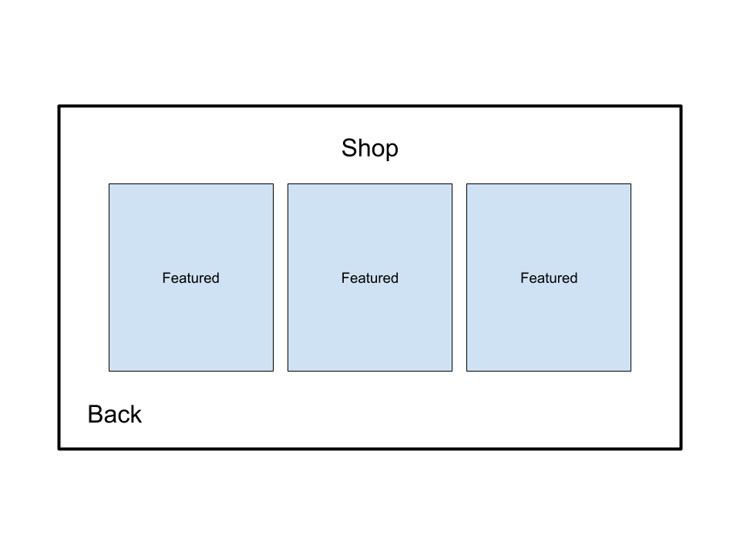

Credits Menu

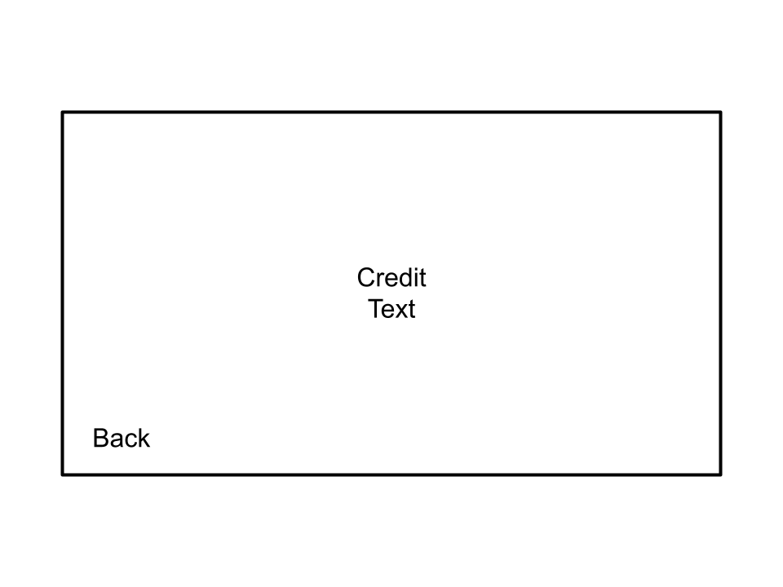

# Narrative Design

## Plot Outline

<Needs Input>

## Script

<Needs Input>

## Storyboards

<Needs Input>

# Asset List

## Visual Assets

* Player avatar
* Light avatar skin tone
* Medium avatar skin tone
* Dark avatar skin tone
* Male avatar
* Female avatar
* Various NPC’s (TBD)
* Avatar clothing set 1
* Avatar clothing set 2
* Avatar clothing set 3
* Hairstyle 1 (blonde, brunette, black)
* Hairstyle 2 (blonde, brunette, black)
* Hairstyle 3 (blonde, brunette, black)
* Ooonimals (80)
* Land terrain backgrounds (17)
* Buildings/Houses (TBD)

## Auditory Assets

* Town/Land theme (17)
* Title theme
* Starter town theme
* Activation SFX
* Back SFX
* Menu Screen SetActive SFX
* Basic attack SFX
* Special attack SFX (16)
* Ultimate attack SFX (80)
* Menu scroll SFX (main menu and in-game menu screen)
* Ooonimal roars (80)
* Results screen music
* EXP gain SFX

# Wish List (Backlog)

The stretch goals for this game will be adding all eighty (80) Ooonimals, adding online multiplayer with PVP, and getting the game on all current platforms.

# Reference Images

