

**Very Simple GIF**

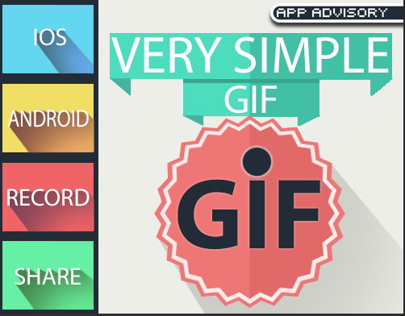

Thanks for the purchase.

VIDEO TUTORIAL : <https://youtu.be/D59ssrLHGc0>

**Third Party:**

Very Simple Gif uses giphy to allow gif sharing on Facebook and Twitter

<https://github.com/Giphy/GiphyAPI>

This service requires a key to upload gif. You have to go in the Giphy developer portal to create a new app.

**QUICK START:**

Add the Record.cs script to your main camera

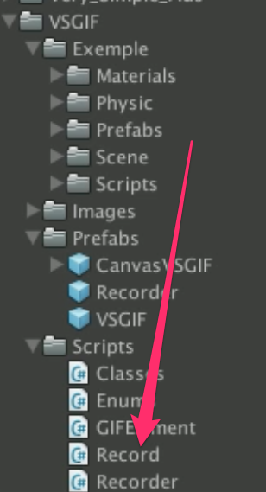

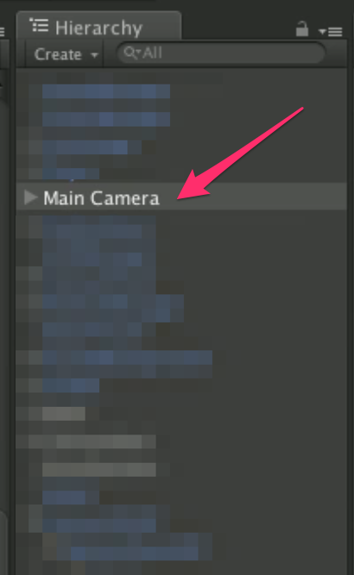

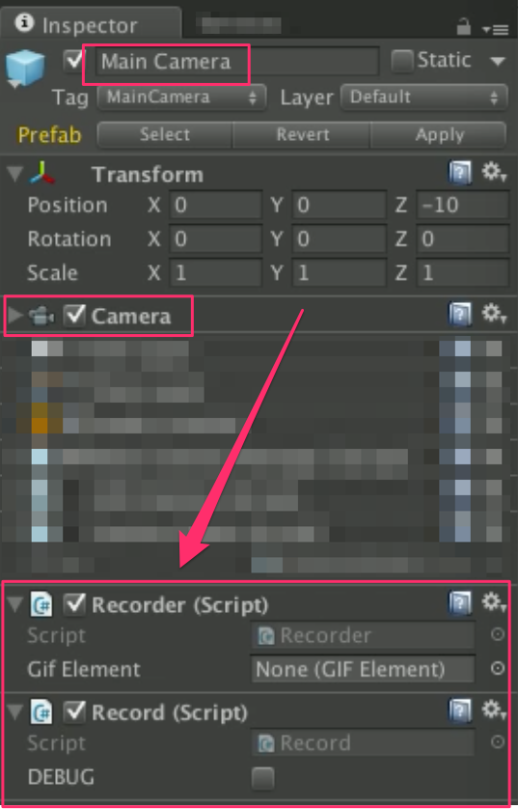

Drag and drop the VSGIF and the canvasVSGIF prefabs in the scene

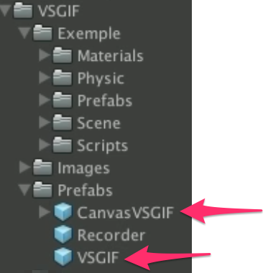

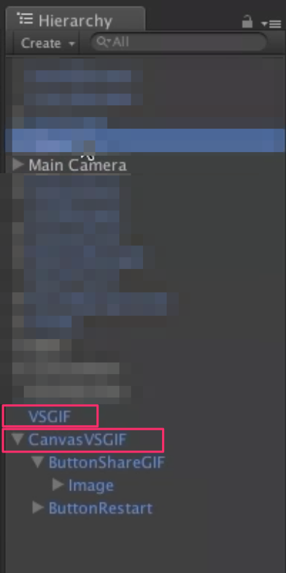

Link the prefabs together

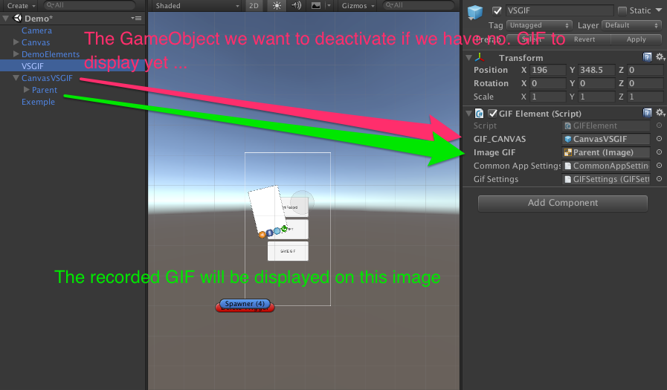

Your are now ready to use Very Simple GIF!

IMPORTANT : Always add at the top of the scripts you want to use VSGIF using AppAdvisory.VSGIF;

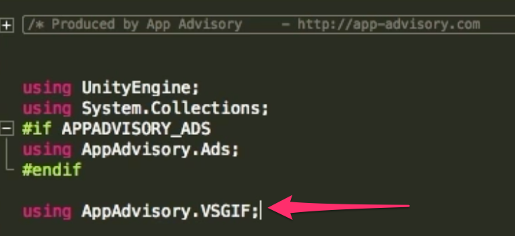

HOW TO START A RECORD?

https://lh5.googleusercontent.com/CXyHh8axQfO-itP9Ocyj8VtxMUu_HFWAAD97bXe76OZ8QEbUN73bkbGmcLo2qleEXezptZZuMcFam3dWdSkclK7MQ9inbNmVC6DdK_ZwCdvGtB-hX85rVkVrIi91Euev6mG5YKcn

(TIPS: I usually use this method when the game start)

HOW TO PAUSE THE RECORD?

https://lh5.googleusercontent.com/CXyHh8axQfO-itP9Ocyj8VtxMUu_HFWAAD97bXe76OZ8QEbUN73bkbGmcLo2qleEXezptZZuMcFam3dWdSkclK7MQ9inbNmVC6DdK_ZwCdvGtB-hX85rVkVrIi91Euev6mG5YKcn

(yes I know it’s the same method… so if the recorder is not in RECORDING state, this method will start the record. If the recorder is in RECORDING state, this method will pause the record)

HOW TO SAVE THE RECORD AND DISPLAY THE GIF?

https://lh4.googleusercontent.com/gXK2FtjIa5NzHI_xCL8EVoX5zW3EneobASZ-HEsXoXjuxEl2HfFzXkVI0_jY0hY6su2faT_rWQkPuhSWF6Wo_rN3ctYsIpUaX4uKb4tUf_rUgf5AYlFZlE-IuUWcb1m7Og04LK8t

(TIPS: I usually use this method at Game Over)

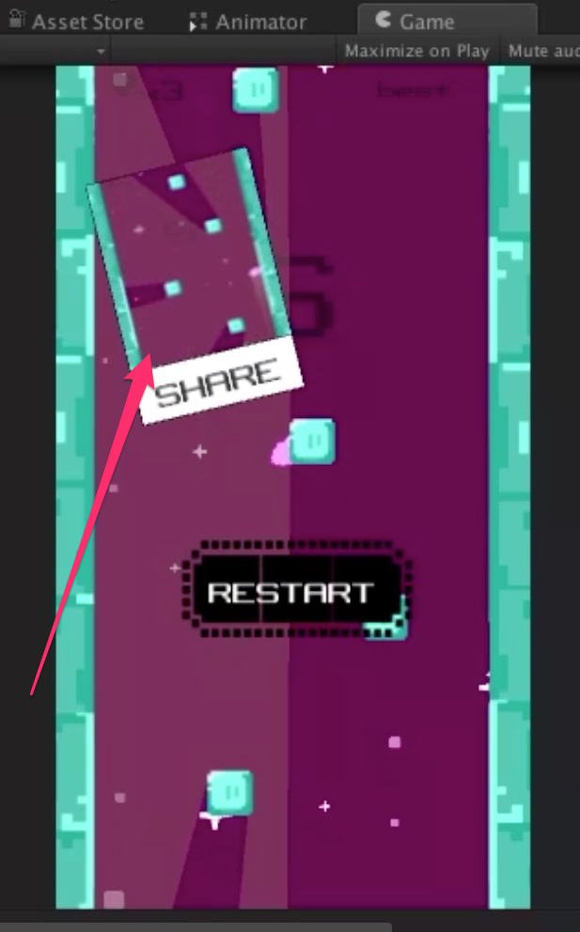

Click on it on mobile to share the GIF.

On editor, you will see the GIF saved in the Project view:

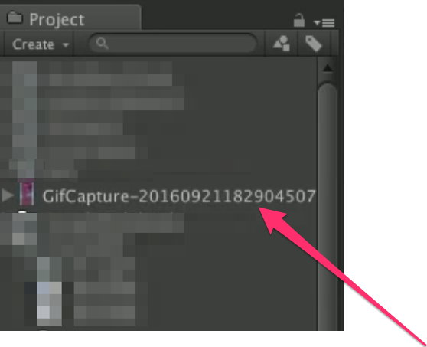

**METHODS**

Record.DORec() to start or pause the current record.

Record.DORec(Text text) to start or pause the current record, and display on a UI Text the current state of the recorder.

Record.HaveAGif() return true if a GIF is available, false if not.

Record.DOSave() to save the current record into a GIF.

Record.DOReset() to reset the current record.

Record.DOShare() to share the current record as a GIF.

**DELEGATES**

https://lh3.googleusercontent.com/fHI3V4ydzcXCm18x5lcGOT2ehqQqL1tDAXEJUCtsLBl7NwkX-cvccqoElkMLw4ggNpg2LFN62eoCH5wKUad0mOiJErkas9Rqlr-t9u7Xd3qtYMHF59CRaRcx7Eo8-SVjYSj63Fq3

Triggered when the record start (or restart) by using Record.DORec().

https://lh3.googleusercontent.com/kt4h5VGfgA7F_vapM1ecMDbnuzkA-VMcvHTwiP53SfwJpjeN_0zRgzI5DqnKiOHvucJd6MsZmgQeJZeQzrTlazsinqNNa9GnTc5GGnTCyjdKbk0mQV_v9ZFjOmMkYPLOCMBPI1WP

Triggered when the record turn from rec to pause by using Record.DORec().

https://lh5.googleusercontent.com/dlOaB3-KAGGKgrpLc5MAizJu2jqKU_qwjj03w8Uilj8CJYTvw7s5R7eYpec12_-3pu9U0wXpdyjC3PM80ZXE-ePyCCN7p0u6-iAK6h9ugKk9jVO5KV8hcvPvV-8IJbdrlUcdCCAJ

Triggered when the recorder is creating the GIF and when the GIF is created. The 2 states are:

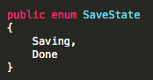

https://lh6.googleusercontent.com/f-dzO_67sY27msEFTpVxnjEoIj0WzPprUZskjArjNkV3hh-eU8BMcbScafmYACeO_T6aBsx4WY4FWnychv-ahiJY08m7t3drqrrY0h43om2PD4htSwtmxy72u_NzlLDHhyIxc4xj

Triggered when the recorder is reseted by using Record.DOReset().

https://lh5.googleusercontent.com/qpUCpNiTV87IT4fjZ8WrV98SmLXQJUspF-RJL0mrRqAc9aRA8gO1ynMWK1r-90sUymVft2j8C5VCELCt_qqSnj-ce38hB2p_szQztZd9P_NzyR0z_FWdx2lzosRdkL-1vVk6tZ9e

Triggered when the player is sharing the GIF by using Record.DOShare().

**VARIABLES**

Open the Settings Window

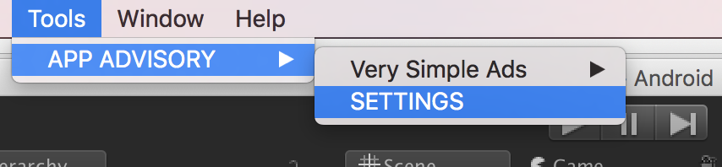

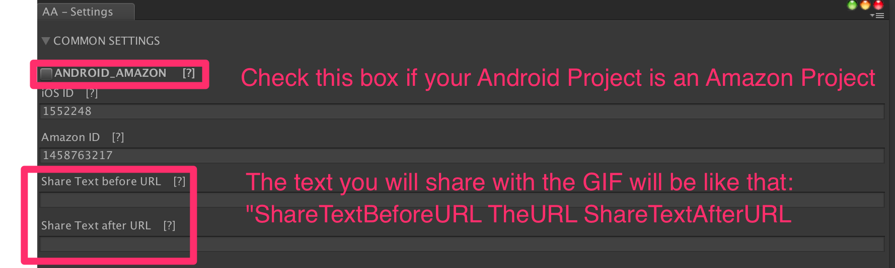

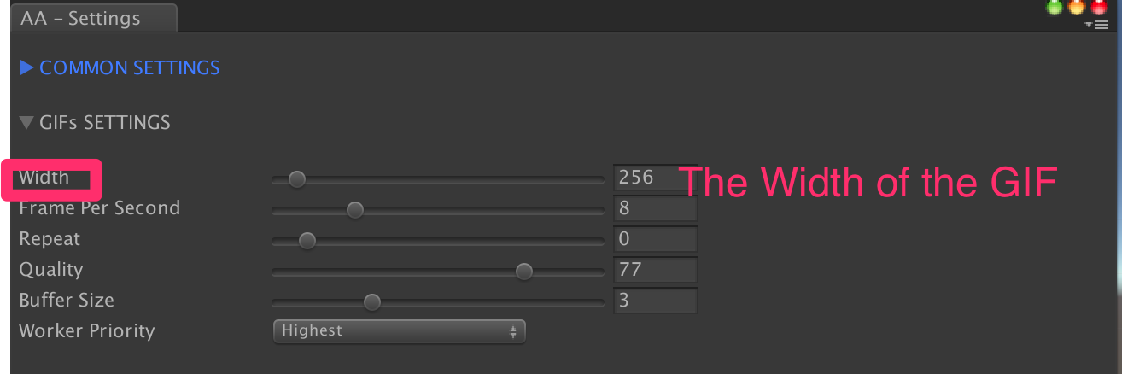

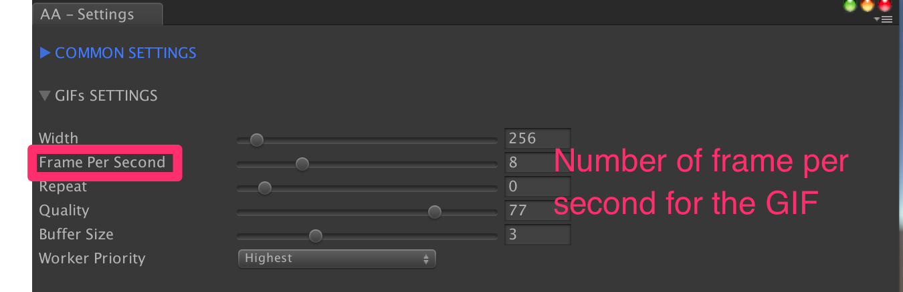

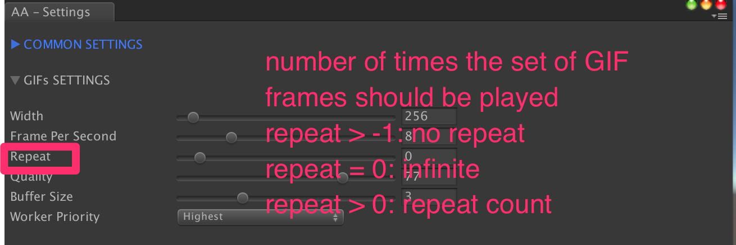

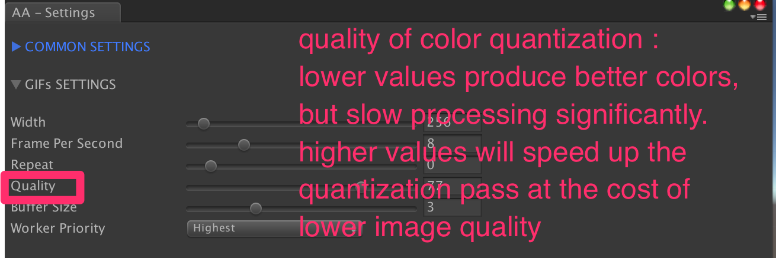

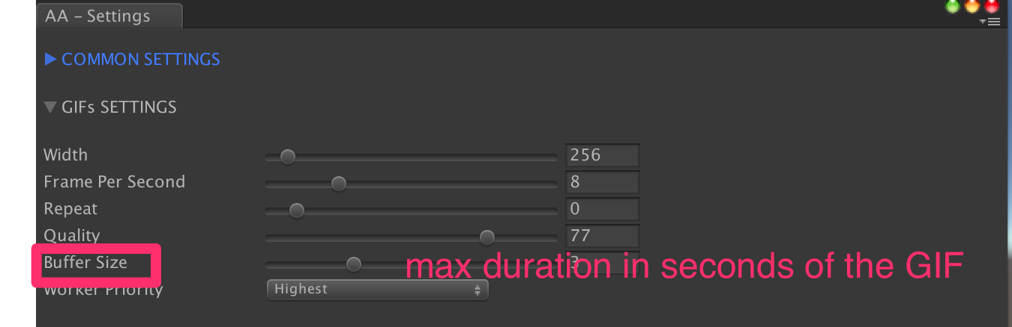

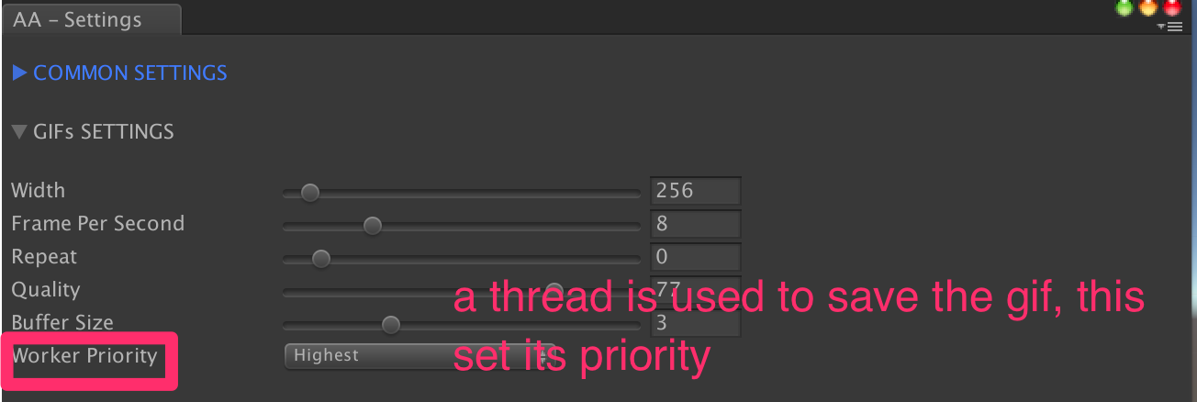

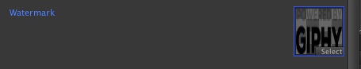

Drag and drop the texture you want to use as Watermark. Leave the field empty if none are needed. By default Very Simple Gif uses Giphy Watermark to allow private key obtention. This is not required if you use the public beta key (**dc6zaTOxFJmzC**at the moment**).**

**Implement Custom Sharing App**

If you want to use other sharing system :

* First get a reference to the gif element, if you don’t have one simply use :

../../../../../../dev/Desktop/Capture%20d’écran%202017-06-09%

* Then call the UploadGifToGiphy Method giving it the callback you want to execture once the gif is uploaded :

../../../../../../dev/Desktop/Capture%20d’écran%202017-06-09%

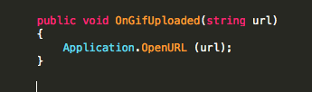

you can use URL Scheme to open app directly :

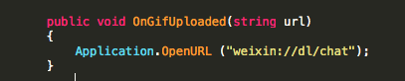

an then use the giphy url

Thanks!

Please rate my file, I’d appreciate it! <http://u3d.as/ACQ>

Produced by App Advisory - <http://app-advisory.com>

Facebook: <https://facebook.com/appadvisory>

Contact us: <https://appadvisory.zendesk.com/hc/en-us/requests/new>

App Advisory Unity Asset Store catalog: <http://u3d.as/9cs>

Developed by Gilbert Anthony Barouch - <https://www.linkedin.com/in/ganbarouch>

Inquiries: <https://appadvisory.zendesk.com/>

**Very Simple Combo Pack:**

Everything is done for you: « Very Simple Combo Pack » is already implemented.

Get it here:  <http://u3d.as/yex>

**Very Simple Ads:**

Everything is done for you: « Very Simple Ad » is already implemented.

Get it here:<http://u3d.as/oWD>

**Very Simple Rate:**

Everything is done for you: « Very Simple Rate » is already implemented.

Get it here: <http://u3d.as/Dt2>

**Very Simple Leaderboard:**

Everything is done for you: « Very Simple Leaderboard » is already implemented.

Get it here:<http://u3d.as/qxf>

**Very Simple Share:**

Everything is done for you: « Very Simple Share » is already implemented.

Get it here:<http://u3d.as/u3N>

