**DOCUMENTATION**

Warning! We would recommend you to make a reskin to prevent  
problems with Google Play and App Store (game can be banned).  
  
You Can require Our Reskin Services as well from Staying away from the red zone of the playconsole And App Store Policies

Integration of side plugins is your own responsibility.

Support Can be given you In Current Issues.

All rights of the source code belong reserved by Markhor Studio Games. After purchase you will have the right to use it to create your own games and publish it on stores. Resale of the source code is prohibited.

**How to Start**

**1.**Download and Install the recommended Unity Version – **Download**  
**2.** Create a new Unity project.  
**3.** Import unitypackage to the project.  
**4.** Add all scenes (from Scenes folder) in the right order to “Scenes In Build”.  
**5.** Change Ads ids(Check Below How to do)  
**6.** Reskin the Game(Check Below the Steps)  
**7.**Adding More Bottles(Add new Levels using Bottle editor)  
**8.**Add More Levels(Add new Levels using editor)  
**9.**Add Scenes In Build Setting And Build the abb file

**How to Integrate Your Own Ads ids**

**1.**Open Main Menu Scene(Assets/Resources/Scenes/MainMenu)  
**2.**Click on AdManager And Paste your New Ids

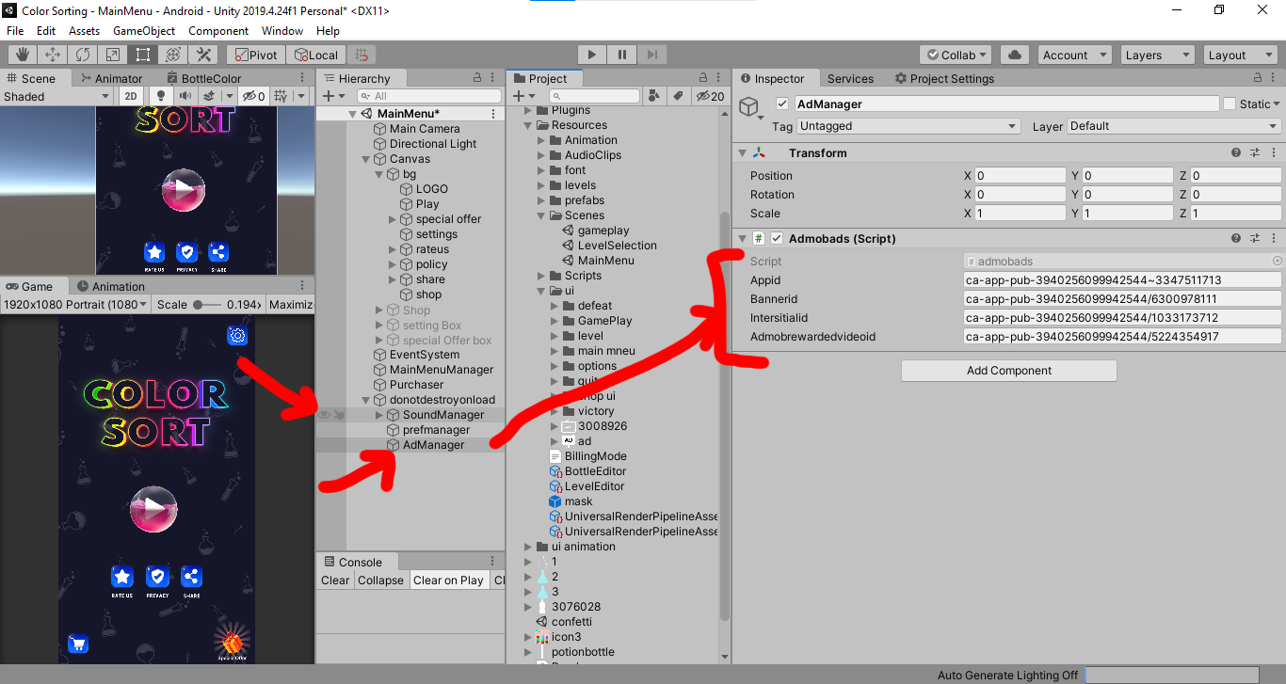

**3.**Must Replace your App id here as well

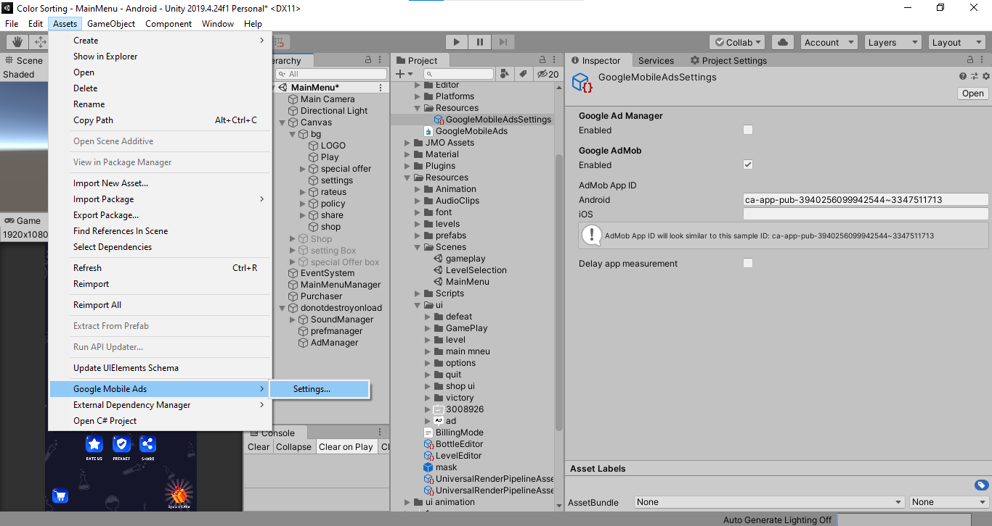

**How to Reskin the Game  
1.**Open UI folder And replace All the design files with your new design files

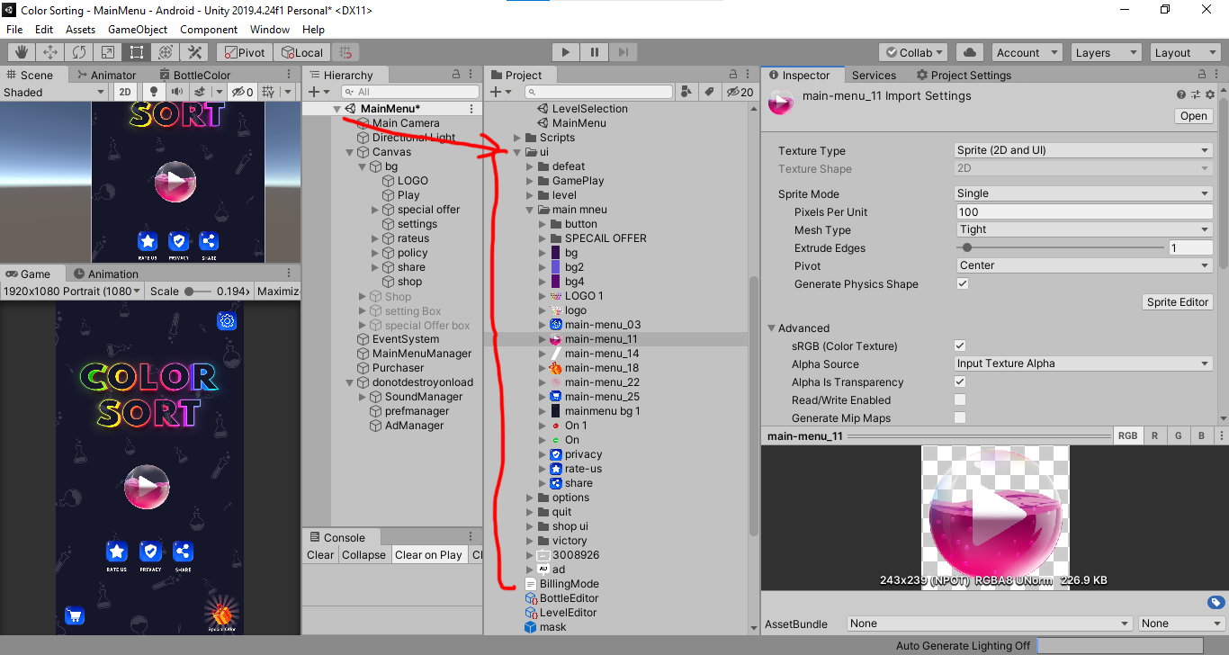

**How to Add New Bottles**

**1.**Open Level Editor Click On prefab and duplicate And design your bottle with same Size using One Mask image And assign the New Bottle again In the Editor.

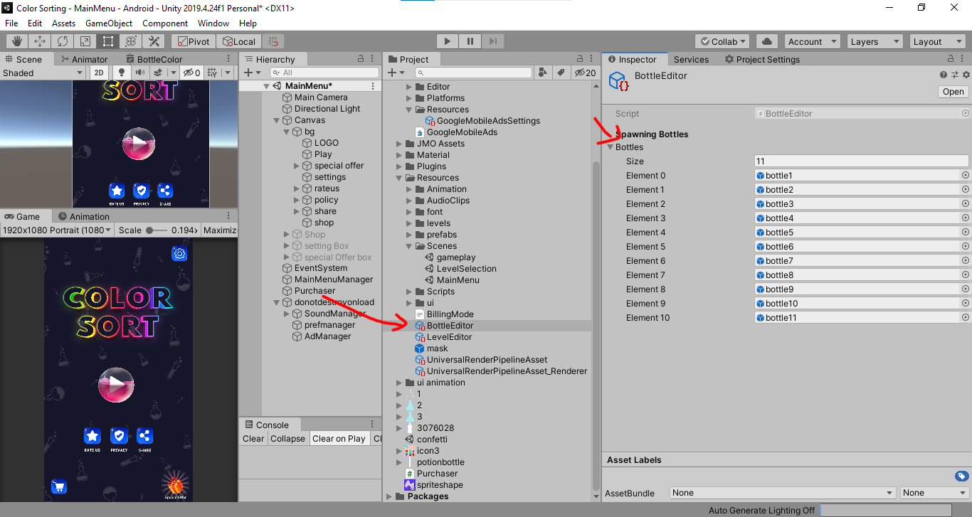

**How to Create New Levels**

**1.**Open Resources folder  
**2.**Click On Level Editor **3.**Give Level Name  
**4.**Give Total filling bottles value Which needed to be filled  
**5.**Create Number of Bottle And Assign per Bottle Number of Colors

