LanguageTool Test Document
This document shows if your LanguageTool (http://languagetool.org) installation works correctly. First, make sure that auto spell-checking is enabled. For that, activate this button in the toolbar (if it cannot be activated, make sure this document is opened in read/write mode, not in read-only mode):


Now here are two example sentences with errors:
This is an test.
Feel tree to do so.
- If both “an” and “tree” are underlined in blue, LanguageTool is working fine. You can then use the context menu on those errors to get a short explanation of the problem.
- If “an” is underlined, but “tree” is not that means the integrated Lightproof checker is running instead of LanguageTool. Disable Lightproof like this:
  - Go to Tools → Options in the menu.
  - Select Writing Aids
  - Uncheck the item Lightproof grammar checker (English)
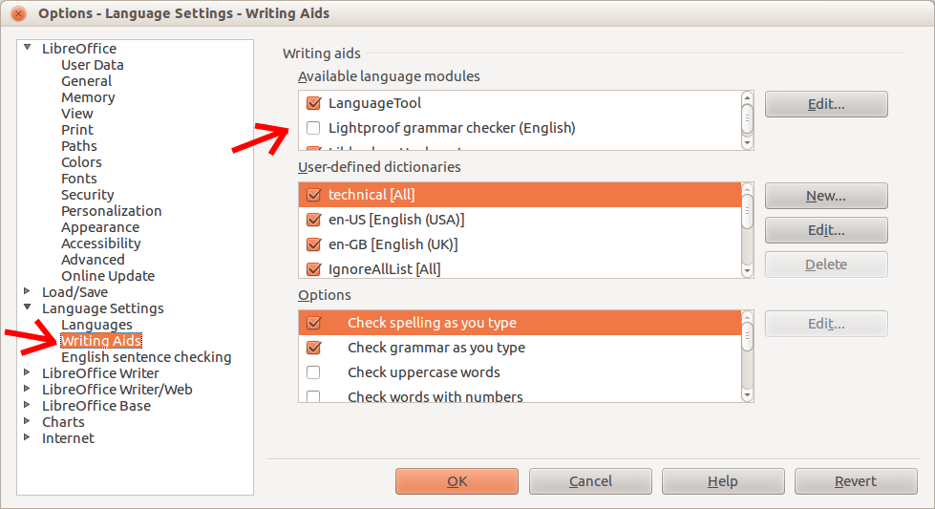
- If neither is underlined, or if you have other issues, please see http://languagetool.org/issues/

