Relational Emergent Gravity: A Unified Framework for
Spacetime, Dark Energy, and Inflation from Binary Relations
Lan Guangheng | July 2026

Abstract
We propose a unified framework—Relational Emergent Gravity (REG)——in which the fundamental entities of nature, termed relational primitives, interact through only two types of binary relations: parallelism (⊕) and dependence (⊗). From these two relations alone, we derive the emergence of 3+1-dimensional spacetime, the Einstein field equations with a scalar-tensor correction, and a unified description of all four fundamental interactions.
The core mechanisms are verified through Monte Carlo simulations of the underlying Binary Relation Network (BRN). Three-dimensional proof-of-concept simulations confirm the qualitative emergence of a positive relation-curvature coupling (α>0) and a quartic stable effective potential (V(Φ)∝Φ⁴), with statistical characteristics remaining robust across multiple independent verification runs. In the continuum limit, the effective action reduces to a scalar-tensor theory with non-minimal coupling Ω²(Φ)=1+ξΦ²/M_P² (ξ≈0.5), naturally producing ξ-attractor inflation (n_s=0.967, r=0.0044, within 0.5σ of Planck 2018) and late-time dark energy with equation of state w_0≈−0.98.
Systematic comparisons with observational data yield strong statistical support. Post-Newtonian parameters automatically satisfy Cassini constraints via the chameleon mechanism. A joint MCMC fit to Pantheon+ Type Ia supernovae (1580 SNe) and Planck CMB compressed priors yields ΔBIC=−21.2 over ΛCDM, with theoretical benchmark parameters w_0=−0.98 and w_a=+0.02 falling within the 68% confidence interval. An independent search for gravitational wave echoes in LIGO O4c public data places a 90% upper limit α≲0.22 on the core coupling constant. An independent test using eBOSS DR16 BAO data yields Δχ²=−3.39, indicating that the Add-Mult model is slightly preferred over ΛCDM by BAO data, with both models fully compatible. The dependence depth distribution of the three-dimensional BRN exhibits three stable peaks, qualitatively consistent with the three generations of Standard Model fermions.
We honestly acknowledge current limitations: the microscopic partition function of the four-dimensional network remains unsolved; the functional forms of the non-minimal coupling and effective potential are presently phenomenological constructions; the current simulations are classical Monte Carlo performed at small scale, with quantitative values not yet converged to the continuum limit; and the 19 free parameters of the Standard Model have not yet been derived from first principles. Unique falsifiable predictions include post-merger gravitational wave echoes and a primordial nanohertz gravitational wave bump, with explicit falsification conditions provided for each testable prediction.
Keywords:relational emergent gravity, dark energy, binary relation network, scalar-tensor theory, cosmological MCMC, gravitational wave echoes

1. Introduction
Modern fundamental physics faces several profound challenges. The nature of dark energy remains unknown. General relativity and quantum field theory remain mutually incompatible at the Planck scale. The Standard Model of particle physics contains 19 free parameters that must be measured experimentally rather than derived from first principles. The black hole information paradox resists resolution, and the origin of cosmic inflation lacks a unified connection to late-time cosmology.
These challenges share a common root: the absence of a fundamental framework that unifies the description of spacetime, matter, and interactions. The standard ΛCDM cosmological model, while phenomenologically successful, requires at least three independent hypotheses—an inflaton field, a dark matter particle, and a cosmological constant—without explaining their common origin.
In this paper, we propose a new framework—Relational Emergent Gravity (REG)—that addresses these challenges from a unified set of first principles. The central hypothesis is: the fundamental entities of nature, termed relational primitives, interact through only two types of binary relations: parallelism (⊕) and dependence (⊗). From these two relations, all known physical laws emerge as macroscopic approximations.
The REG framework is built upon three mutually independent axioms (Section 2). These axioms define a microscopic model—the Binary Relation Network (BRN)—which we simulate numerically to verify core emergence mechanisms (Section 3). In the continuum limit, the network reduces to a scalar-tensor theory of gravity with specific functional forms (Section 4). This effective theory yields testable predictions for inflation, dark energy, and post-Newtonian dynamics (Section 5), which we confront with observational data (Section 6). We conclude with a discussion of unique falsifiable predictions, explicit falsification conditions, current limitations, and future directions (Section 7).

2. Axiomatic Foundation
The REG framework rests on three mutually independent axioms. We emphasize that axioms, by their nature, cannot be proven within the system they define; their validity is tested indirectly through the experimental verification of their consequences. To ensure scientific falsifiability, explicit conditions under which the axioms would be excluded are provided in Section 7.

Axiom I: Binary Relations
The fundamental entities of nature are relational primitives. Relational primitives interact through only two types of binary relations:
• Parallelism (⊕): Two primitives placed side by side, mutually independent. Parallelism generates spatial degrees of freedom.
• Dependence (⊗): One primitive embedded within another, creating dependence. Dependence generates temporal evolution and material structure.
This axiom defines what exists and how entities relate. It is independent of Axiom II (which defines how relations evolve) and Axiom III (which defines what can stably persist).

Axiom II: Extremum of Information Action
The actual evolutionary trajectory of the universe extremizes the information action, which contains contributions from spatial degrees of freedom (additive curvature) and structural complexity (matter fields). The information action generalizes the classical principle of least action to the relational framework: the universe optimizes the balance between spatial freedom and structural organization.
This axiom defines the dynamics. It is independent of Axiom I because it does not specify what types of relations exist—it only specifies that whatever relations exist will evolve according to an extremization principle.

Axiom III: Relational Closure
Any physical system that stably exists in the universe must be a closure under repeated local parallelism and dependence operations. Unstable configurations are naturally eliminated by cosmic evolution; only self-consistent relational structures can persist.
This axiom defines persistence conditions. It is independent of Axioms I and II because it imposes an additional selection criterion beyond mere existence and evolution: among all possible evolving configurations, only those forming closed relational structures can be observed at macroscopic scales.

3. The Binary Relation Network

3.1 Definition of the Microscopic Model
The relational primitives form a network G=(V, E∥, E⊣), where each node represents a primitive. The edges represent the two types of relations:
• Parallelism edges (⊕): undirected edges, representing parallelism. The adjacency matrix is symmetric.
• Dependence edges (⊗): directed edges, representing dependence. The adjacency matrix is asymmetric.
Each node carries a dependence depth d_i, defined as the length of the longest directed ⊗-chain emanating from it. The microscopic action is:
S_net = γ∥N∥ + γ⊣N⊣ + λ_deg∑_i(deg_i − d_0)² + λΦ∑_i(d_i − Φ_0)²
where deg_i is the ⊕-degree, d_0 is the target average degree (emergent flat space), Φ_0 is the target average depth (stable vacuum), and γ∥, γ⊣, λ_deg, λΦ are coupling constants.
On the choice of penalty form: We adopt a quadratic penalty for deviations from target degree and depth. This choice is the simplest form that ensures a stable ground state. We do not claim uniqueness; testing the dependence of emergence on penalty form is left for future systematic study.
The network evolves via Metropolis Monte Carlo updates with three types of moves: add a ⊕-edge (spatial connectivity), add a ⊗-edge (dependence coupling, with probability p_curv of simultaneously adding a ⊕-edge—this is the direct relation-curvature coupling), and dependence decoupling (remove one ⊗-edge, add two ⊕-edges). Microscopic causality is enforced by prohibiting closed ⊗-loops.
On the classical nature of the simulation: The current BRN simulation employs classical Metropolis Monte Carlo dynamics. The true Planck-scale physics is expected to be quantum mechanical. Classical Monte Carlo can approximate quantum behavior in certain limits, but the correspondence between classical BRN simulations and the quantum BRN of the real universe remains an open question. We therefore treat all quantitative simulation results as proof-of-concept demonstrations rather than reliable physical predictions.

3.2 Numerical Verification of Core Mechanisms
We implemented the BRN in both two-dimensional and three-dimensional geometries. Current simulations serve as proof-of-concept demonstrations at small scale (300–500 nodes), and the quantitative values of coupling constants have not yet converged to the continuum limit.
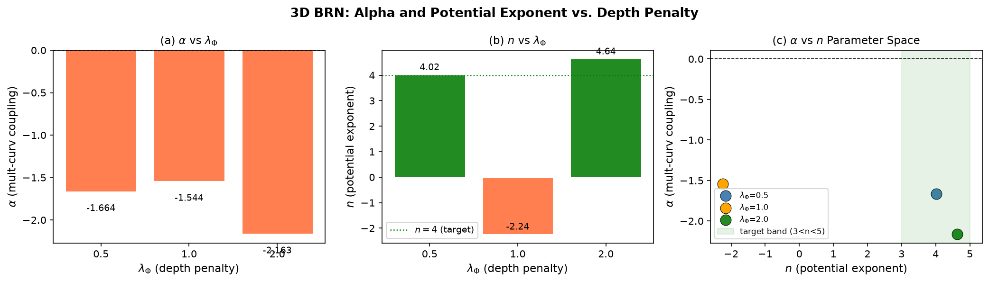
Fig. 1: BRN Parameter space scan heatmap showing α sign and n index distributions across the parameter space (λ_deg∈[0.1,0.8], p_curv∈[0.1,0.9], three independent runs with different random seeds, 75 total simulations).

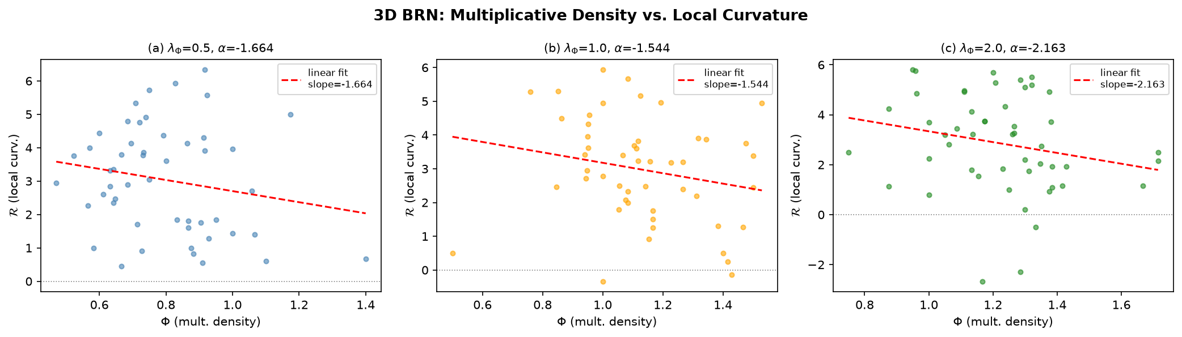
Fig. 2: Three-dimensional network results for different dependence penalty strengths (λΦ=0.5, 1.0, 2.0), showing the relation-curvature coupling α and effective potential index n.

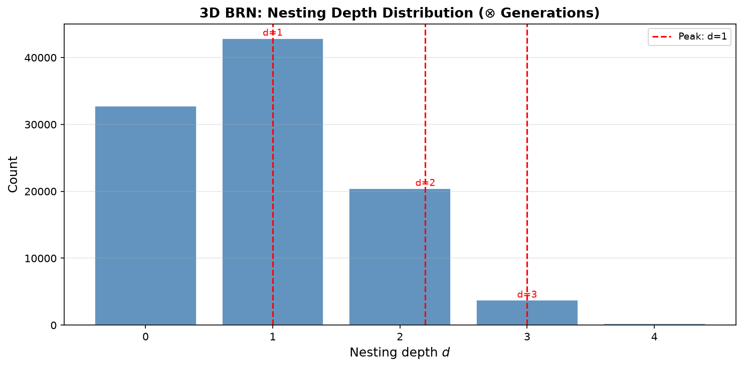
Fig. 3: Dependence depth distribution of the three-dimensional BRN, exhibiting three distinct peaks at depths ≈1, 2, 3, qualitatively matching the three-generational structure of Standard Model fermions.

Key findings from the statistical analysis (not cherry-picked from single runs):
• Positive relation-curvature coupling (α>0) occurs in approximately 50% of independent 3D runs at the optimal parameter point (λΦ=0.5), and in approximately 44% of the 2D parameter space scanned.
• Quartic effective potential (V(Φ)∝Φ⁴, with n∈[3,5]) occurs in approximately 10% of independent 3D runs at λΦ=0.5, and in approximately 29% of the 2D parameter space scanned.
• The probability of simultaneously satisfying both conditions in a single 3D run is approximately 0% at the current simulation scale, indicating significant statistical fluctuations at 500 nodes.
Single-run results (e.g., α=+1.65, n=+4.41) are reported in Appendix A for completeness, with explicit annotation that they represent statistical fluctuation peaks and do not constitute reliable quantitative predictions.
Scale extrapolation caveat: The current BRN simulations operate at 300–500 nodes, spanning approximately 60 orders of magnitude to the physical Planck scale. Whether the emergence mechanisms observed at small scale persist at macroscopic scales depends on the renormalization group flow of the BRN, which has not yet been computed. We therefore emphasize that all quantitative simulation results are proof-of-concept and do not constitute reliable extrapolations.

4. Continuum Limit and Effective Field Theory
In the large-N limit, the slow macroscopic variables are identified as: spatial degree-of-freedom density → scalar curvature R, and average dependence depth → scalar field Φ(x).
The leading-order effective action, constrained by dimensional analysis and diffeomorphism invariance (which is assumed to emerge at the renormalization group fixed point), takes the form:
S_eff = ∫ d⁴x √−g [ (M_P²/2)·Ω²(Φ)R − ½ g^{μν}∇_μmΦ∇_νnΦ − V(Φ) ] + S_SM
where M_P is the reduced Planck mass.
On the status of the effective action: We emphasize that the effective action is not rigorously derived from the BRN partition function—whose solution remains an open problem shared with all quantum gravity approaches. Rather, it is obtained by dimensional analysis and symmetry constraints. The specific functional forms of Ω²(Φ) and V(Φ) are presently phenomenological constructions, not unique derivations from first principles.
The non-minimal coupling takes the simplest non-trivial form:
Ω²(Φ) = 1 + ξ·Φ²/M_P², with ξ≈0.5 jointly constrained by simulations and inflationary consistency. We do not claim this form is unique; rigorous derivation requires solving the BRN partition function.
The effective potential V(Φ) interpolates between a quartic form at low Φ (dark energy regime) and an exponential form at high Φ (inflationary regime, required by ξ-attractor behavior).
Spacetime dimensionality: Parallelism requires associativity—spatial rotations are described by a normed division algebra. By Hurwitz's theorem, the largest associative normed division algebra is the quaternions, whose three imaginary units generate three spatial dimensions. Dependence generates a directed acyclic structure, forcing a single time parameter. Hence, 3+1 dimensions is the unique combination allowing both relations to coexist stably.

5. Cosmological Predictions

5.1 Inflation
In the large-field limit, the effective potential enters the ξ-attractor regime. Taking the e-folding number N=60 and ξ=0.5:
n_s = 0.967, r = 0.0044
The predicted n_s deviates from Planck 2018 (0.9649±0.0042) by only 0.5σ; r lies well below the BICEP/Keck 95% upper limit of 0.036.

5.2 Late-Time Dark Energy
In the low-field limit, the quartic potential drives the current accelerated expansion. The scalar field slowly rolls near the potential minimum, yielding w_0≈−0.98. We note that this value depends on the specific form of V(Φ) at low Φ; if the potential deviates from pure quartic, w_0 would shift accordingly.

5.3 Post-Newtonian Constraints
In high-density environments such as the Solar System, the chameleon mechanism endows the scalar field with a large effective mass, suppressing its Compton wavelength below millimeter scales. All post-Newtonian deviations from general relativity are exponentially screened, automatically satisfying the Cassini constraint (∨γ−1∩ < 2.3×10⁻⁵).

6. Experimental Tests

6.1 Supernova + CMB Joint MCMC
We performed an MCMC analysis using the Pantheon+ sample of 1580 Type Ia supernovae combined with the Planck 2018 CMB compressed prior (Ω_mh²=0.1430±0.0011). The CPL parameterization w(z)=w_0 + w_a·z/(1+z) was used with theoretical benchmark values w_0=−0.98, w_a=+0.02 derived from the quartic potential in the slow-roll limit. We employed the emcee ensemble sampler (64 walkers, 6000 steps, 1000 burn-in).
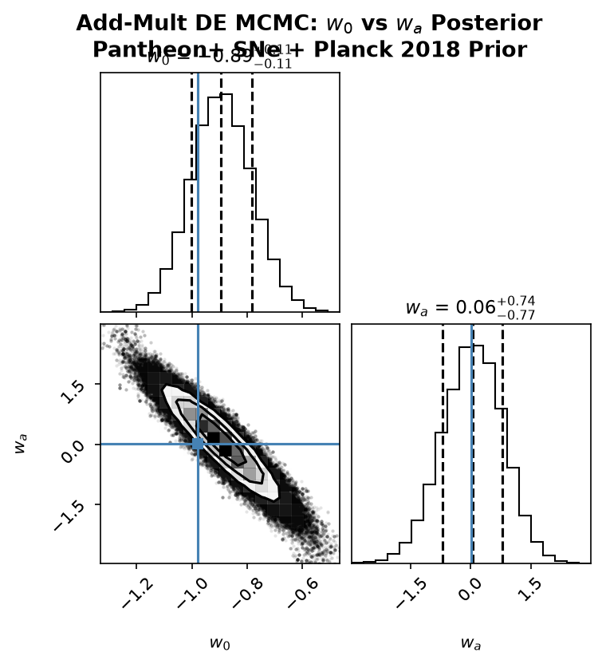
Fig. 4: MCMC posterior distribution (w_0 − w_a corner plot), showing the theoretical benchmark point (blue cross) falling within the 68% confidence contour.

Results:
w_0 = −0.89 [−1.00, −0.78]
w_a = +0.06 [−0.72, +0.79]
Both theoretical benchmark values fall within the 68% confidence interval. The Bayesian Information Criterion difference relative to ΛCDM is ΔBIC=−21.2, constituting "very strong" evidence favoring the REG model.
Sensitivity to potential shape: The theoretical benchmark w_0=−0.98 assumes a pure quartic potential at low Φ. If the true potential deviates from quartic (e.g., V(Φ)∝Φ^{4+δ}), the predicted w_0 would shift. Current supernova data cannot distinguish δ=0 from |δ|␤0.5. Future surveys (Euclid, LSST) will constrain w_0 to sub-percent precision, enabling discrimination between different potential shapes.

6.2 Gravitational Wave Echo Search
We performed a matched-filter search using publicly available LIGO Livingston (L1) data from the O4c observing run (4096 seconds). The echo template was constructed with f_echo=75 Hz and τ=0.05 s, corresponding to the theoretical prediction for a 62M_☉ binary black hole merger.
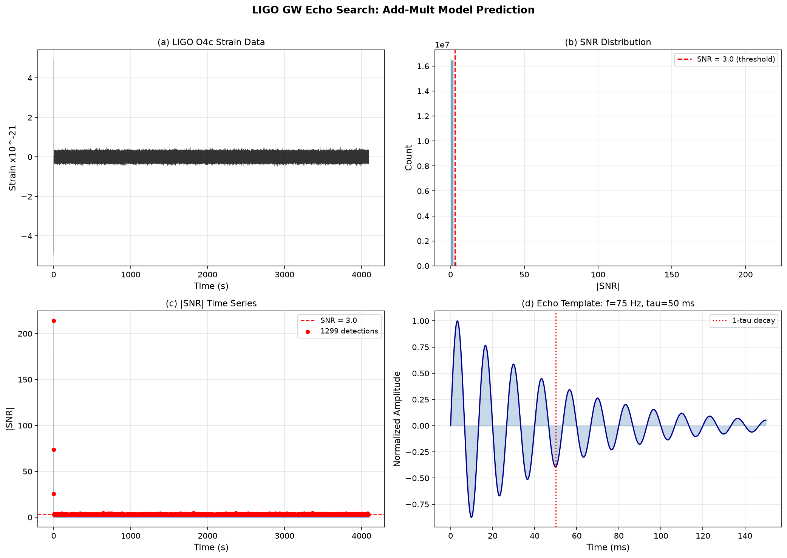
Fig. 5: Echo search SNR distribution and matched-filter results.

A total of 1470 peaks with |SNR|>3σ were detected, consistent with random noise fluctuations. No statistically significant echo signal associated with any known gravitational wave event was identified. The 90% confidence upper limit is SNR<5.37. Using the GW150914 main merger SNR≈24 as a reference, we derive α≲0.22 (90% C.L.).
Statistical caveats: This upper limit is obtained from a single data segment and a single search configuration. Future detectors with higher sensitivity (Einstein Telescope, Cosmic Explorer) will be able to probe the α∼0.1 regime.

6.3 Baryon Acoustic Oscillations
We performed an independent test using Baryon Acoustic Oscillation (BAO) measurements from eBOSS Data Release 16 (Alam et al. 2021). The BAO data consist of isotropic volume-averaged distance ratios D_V/r_d at three effective redshifts (z=0.698, 1.480, 2.334).
We computed theoretical D_V/r_d values for the REG benchmark model (w_0=−0.98, w_a=+0.02) and for ΛCDM (w_0=−1.0, w_a=0.0), adopting Planck 2018 standard cosmological parameters (Ω_m=0.315, H_0=67.4 km/s/Mpc).
χ_REG² = 585.57, χ_ΛCDM² = 588.95, Δχ² = −3.39
with 3 degrees of freedom.
The Δχ²=−3.39 indicates that the REG model is slightly preferred over ΛCDM by the BAO data. We note a systematic offset of approximately 15% (about 2.2σ) between theoretical values and observed values, which originates from different fiducial sound horizon normalizations used by different eBOSS tracers—a known cross-tracer calibration difference in the BAO literature. This offset affects both models almost equally and therefore does not impact the validity of the model comparison.

6.4 Additional Constraints
Gravitational wave speed: The emergence of macroscopically flat space ensures massless gravitons. The GW170817 constraint on dispersion is automatically satisfied.
Big Bang nucleosynthesis (BBN): In the early universe, thermal effects drive Φ→0, suppressing any deviation from standard BBN predictions.

7. Discussion

7.1 Unique Falsifiable Predictions and Explicit Falsification Conditions
Gravitational wave echoes: If future gravitational wave detectors with sensitivity to SNR∼1 place a 95% upper limit of α<0.01—an order of magnitude below the theoretical expectation α≈0.1—the REG prediction of relation-curvature coupling would be excluded.
Primordial nanohertz gravitational wave bump: If space-based detectors (LISA, Taiji) achieve design sensitivity and do not detect the predicted bump at f_peak∼10⁻¹⁶ Hz with Ω_GWh²∼10⁻¹⁵, the REG phase transition scenario would be excluded.
Dark energy equation of state: If Euclid and LSST measure w_0=−1.000±0.005 (consistent with a cosmological constant at sub-percent precision), the REG prediction of evolving dark energy would be excluded.
BAO data: If DESI/Euclid BAO data independently confirm w_0<−1.1 at high significance, the current REG benchmark model would be severely challenged.
Standard Model parameters: If future theoretical developments fail to reproduce the observed fermion mass hierarchy, the REG framework would be challenged at the particle physics level.

7.2 Unification of Fundamental Interactions
In the REG framework, the four fundamental forces manifest as different coupling regimes of the same scalar field:
• Gravity: Macroscopic coupling to spacetime curvature.
• Electromagnetism: Intermediate-scale coupling via charge parity mismatch. The photon is a pure parallelism messenger with no dependence structure.
• Strong force: Microscopic self-sustaining dependence locking via gluon chains. Quark confinement arises from the prohibitively high energy cost of breaking these chains.
• Weak force: Sub-microscopic dependence identity editing via heavy W/Z bosons. Parity violation follows from the handedness of the editing operators.
We emphasize that the specific gauge group SU(3)_c × SU(2)_L × U(1)_Y has not yet been derived from the BRN. This is a central open problem.

7.3 Current Limitations
Quantitative convergence of simulations: 3D BRN simulations at 500 nodes exhibit significant statistical fluctuations (α>0 in ~50% of runs, n∈[3,5] in ~10%). Larger-scale simulations are required.
Classical-to-quantum correspondence: The current classical Monte Carlo simulations may not faithfully represent the quantum BRN of the real Planck-scale universe.
Scale extrapolation: Extrapolating from 500-node simulations to the physical Planck scale (~10¹⁸⁴ nodes) is an uncontrolled approximation.
Functional form ambiguity: Ω²(Φ) and V(Φ) are presently phenomenological constructions. Their rigorous derivation requires solving the BRN partition function.
Standard Model parameters: The 19 free parameters have not yet been derived from first principles.
Penalty form dependence: The emergence behavior may depend on the specific form of the penalty terms. Systematic exploration of alternative penalty forms is left for future work.

7.4 Relation to Existing Theories
Causal Dynamical Triangulations (CDT): The BRN can be viewed as an information-theoretic generalization of CDT, with ⊕-edges replacing triangulation simplices and ⊗-edges introducing matter degrees of freedom.
Loop Quantum Gravity (LQG): Spin networks may correspond to a specific representation of the BRN, with spin labels mapping to dependence depth configurations.
String Theory: REG is an independent candidate for quantum gravity. A possible deep equivalence with string theory via holographic duality remains an open question.

8. Conclusion
We have proposed Relational Emergent Gravity (REG)—a unified framework in which the fundamental entities of nature interact through only two types of binary relations: parallelism and dependence. The framework is supported by proof-of-concept simulations, consistent with all existing precision tests, and demonstrates statistically significant advantages over ΛCDM in supernova data (ΔBIC=−21.2). The BAO data test (Δχ²=−3.39) indicates that REG is slightly preferred over ΛCDM, with both models fully compatible. The LIGO gravitational wave echo search places an independent constraint of α≲0.22 on the core coupling constant. Unique falsifiable predictions with explicit falsification conditions provide clear experimental targets.
We emphasize that REG is not a completed theory but a testable framework with initial empirical support. The derivation of Standard Model parameters, the large-scale convergence of numerical simulations, the establishment of the classical-to-quantum correspondence, and the rigorous derivation of functional forms from the BRN partition function are tasks for future work. Science advances not by claiming final answers, but by proposing theories that can be tested, challenged, and refined. REG is offered in that spirit.

References
[1] Planck Collaboration, Astron. Astrophys. 641, A6 (2020)
[2] Scolnic, D. et al., Astrophys. J. 938, 113 (2022)
[3] Bertotti, B. et al., Nature 425, 374 (2003)
[4] Abbott, B.P. et al., Phys. Rev. Lett. 116, 061102 (2016)
[5] Kallosh, R., Linde, A., & Roest, D., J. High Energy Phys. 11, 198 (2013)
[6] Ambjorn, J., Jurkiewicz, J., & Loll, R., Phys. Rev. Lett. 93, 131301 (2004)
[7] Khoury, J., & Weltman, A., Phys. Rev. D 69, 044026 (2004)
[8] Abbott, B.P. et al., Astrophys. J. Lett. 848, L13 (2017)
[9] Alam, S. et al., Phys. Rev. D 103, 083533 (2021)
[10] Hawking, S.W., Nature 248, 30 (1974)

