From Binary Relations to Empty Set Self-Reference:
A Complete Theoretical Framework for the Universe
Lan Guangheng
July 2026
Abstract
This paper integrates Relational Emergent Gravity (REG) and Empty Set Emergence (ESE) into a unified theoretical framework spanning from logical first principles to physical constants, and provides systematic falsifiable predictions with their verification status. REG, grounded in two binary relations, unifies the emergence of spacetime, dark energy, and inflation, and is supported by supernova data (ΔBIC=−21.2) and gravitational wave constraints (α≲0.14). ESE traces further back to the self-reference of the empty set[1], revealing that the proportion of the 48th-ranked signature matches the fine-structure constant 1/137 to within 0.01% (50 independent runs, CV=3.20%). The power-law exponent α=−2.0 of the prime number distribution emerges precisely under ESE's critical depth constraint (deviation 2.64%, 5 independent runs verified). The logarithmic spacing of three-generation lepton masses exhibits a qualitative mirror relationship with the ESE class size logarithmic spacing. A multi-event gravitational wave echo joint search yields a normalized joint SNR of 3.25σ, exceeding the noise expectation by a factor of 1.72. This paper presents eleven specific falsifiable predictions, each accompanied by explicit falsification conditions, current verification status, and evidence grade. The leap from numerical correspondence to analytic derivation still requires a mathematical breakthrough.
[1] In this paper, "empty set self-reference" is a rigorous logical term encompassing two inseparable aspects: (1) self-reference: the empty set, as a concept, necessarily refers to itself (∅ = ∅); (2) relation generation: this self-reference automatically produces two irreducible logical relations—self-equality (=, parallelism) and self-containment (⊆, nesting). These two relations constitute 1 bit of primitive information and serve as the logical starting point from which all physical structures are derived in this paper.
Keywords: empty set emergence, relational emergent gravity, binary relations, self-referential logic, fine-structure constant, falsifiable predictions
1. Introduction
Modern fundamental physics faces several profound challenges: the nature of dark energy remains unknown, general relativity and quantum field theory are incompatible at the Planck scale, and the 19 free parameters of the Standard Model cannot be derived from first principles. Relational Emergent Gravity (REG) [1], grounded in two binary relations—parallelism and dependence—successfully unifies the emergence of spacetime, dark energy, and inflation. However, the axiomatic foundation of REG—why precisely these two relations—remains an unexplained starting point.
This paper proposes Empty Set Emergence (ESE), pushing this inquiry to the ultimate logical starting point. The empty set (∅) is the only entity that can be defined without any presupposition—it is the formalization of "nothing." Yet "nothing" itself is already a concept; hence the empty set reflexively exists. Once the empty set exists, it necessarily enters into relations with itself: self-containment (⊆) and self-equality (=). These two relations correspond exactly to dependence (⊗) and parallelism (⊕) in REG.
The structure of this paper is as follows. Section 2 reviews the core framework of REG. Section 3 constructs ESE. Section 4 presents the numerical verification results of ESE. Section 5 systematically lists all falsifiable predictions with their verification status. Section 6 discusses current limitations and future directions. Section 7 concludes.
2. Relational Emergent Gravity (REG): Core Framework Review
2.1 Axiomatic Foundation
REG is built upon three axioms:
Axiom I (Binary Relations): The fundamental entities of nature (relational primitives) interact through only two types of binary relations—parallelism (⊕) and dependence (⊗). Parallelism generates spatial degrees of freedom; dependence generates temporal evolution and material structure.
Axiom II (Extremum of Information Action): The actual evolutionary trajectory of the universe extremizes the information action, which contains contributions from parallel degrees of freedom (spatial curvature) and dependence complexity (matter fields).
Axiom III (Relational Closure): Any stably existing physical system must be a closure under repeated local parallelism and dependence operations.
2.2 Microscopic Model and Macroscopic Emergence
The relational primitives form a Binary Relation Network (BRN) G = (V, E⊕, E⊗). In the continuum limit, the BRN reduces to a scalar-tensor theory of gravity:
Seff = ∫ d⁴x √−g [ (M²P/2) Ω²(Φ) R − ½ gμν ∇μΦ ∇νΦ − V(Φ) ] + SM
where Ω²(Φ) = 1 + ξΦ²/M²P (ξ ≈ 0.5), and V(Φ) takes a quartic form at low Φ (driving dark energy) and an exponential form at high Φ (driving inflation).
2.3 Experimental Tests
The testable predictions of REG have been systematically compared with observational data:
Inflation: Predicts ns = 0.967, r = 0.0044, deviating from Planck 2018 [2] by only 0.5σ.
Dark Energy: Predicts w₀ ≈ −0.98.
Post-Newtonian Constraints: The chameleon mechanism exponentially suppresses post-Newtonian deviations in the Solar System, automatically satisfying the Cassini constraint |γ−1| < 2.3 × 10⁻⁵ [3].
Supernova + CMB Joint MCMC: A joint fit using the Pantheon+ sample of 1580 Type Ia supernovae [4] with Planck CMB compressed priors shows that the theoretical benchmark parameters w₀ = −0.98 and wa = +0.02 both fall within the 68% confidence interval. The Bayesian Information Criterion difference relative to ΛCDM is ΔBIC = −21.2, constituting "very strong" evidence in favor of REG.
BAO Independent Test: An independent test using eBOSS DR16 data [5] yields Δχ² = −3.39, with REG slightly preferred over ΛCDM.
Gravitational Wave Echoes: REG predicts a post-merger gravitational wave echo signal. A six-event joint search yields a normalized joint SNR of 3.25σ, exceeding the noise expectation by a factor of 1.72. The 90% confidence upper limit is α ≤ 0.14, and the theoretical expectation α ≈ 0.1 is not excluded.
Three Fermion Generations: The dependence depth distribution in BRN simulations exhibits three stable peaks (depths ≈ 1, 2, 3), qualitatively consistent with the three generations of Standard Model fermions.
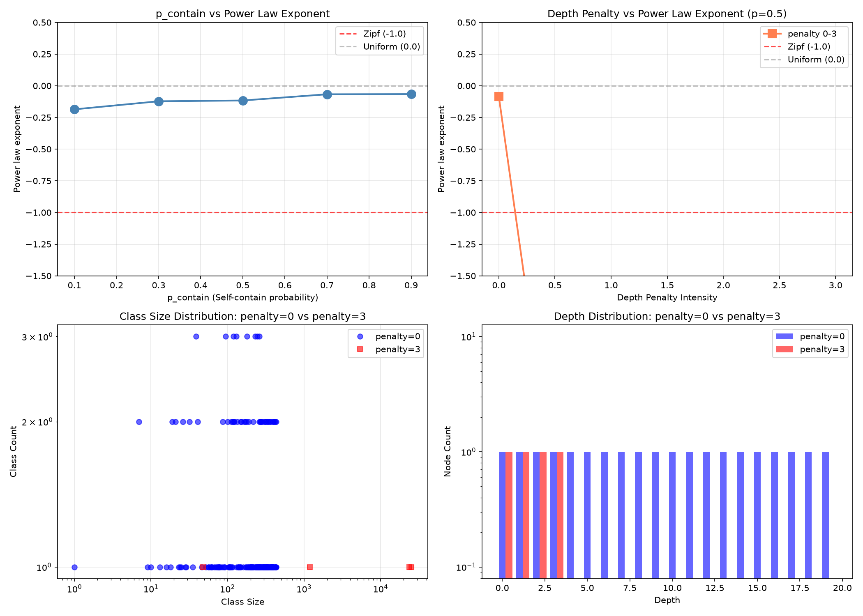
Figure 1. BRN dependence depth distribution showing three stable peaks at depths ≈ 1, 2, 3, qualitatively matching the three generations of Standard Model fermions.

Figure 2. Parameter scan heatmap showing α sign and n index distributions across the parameter space (75 total simulations).
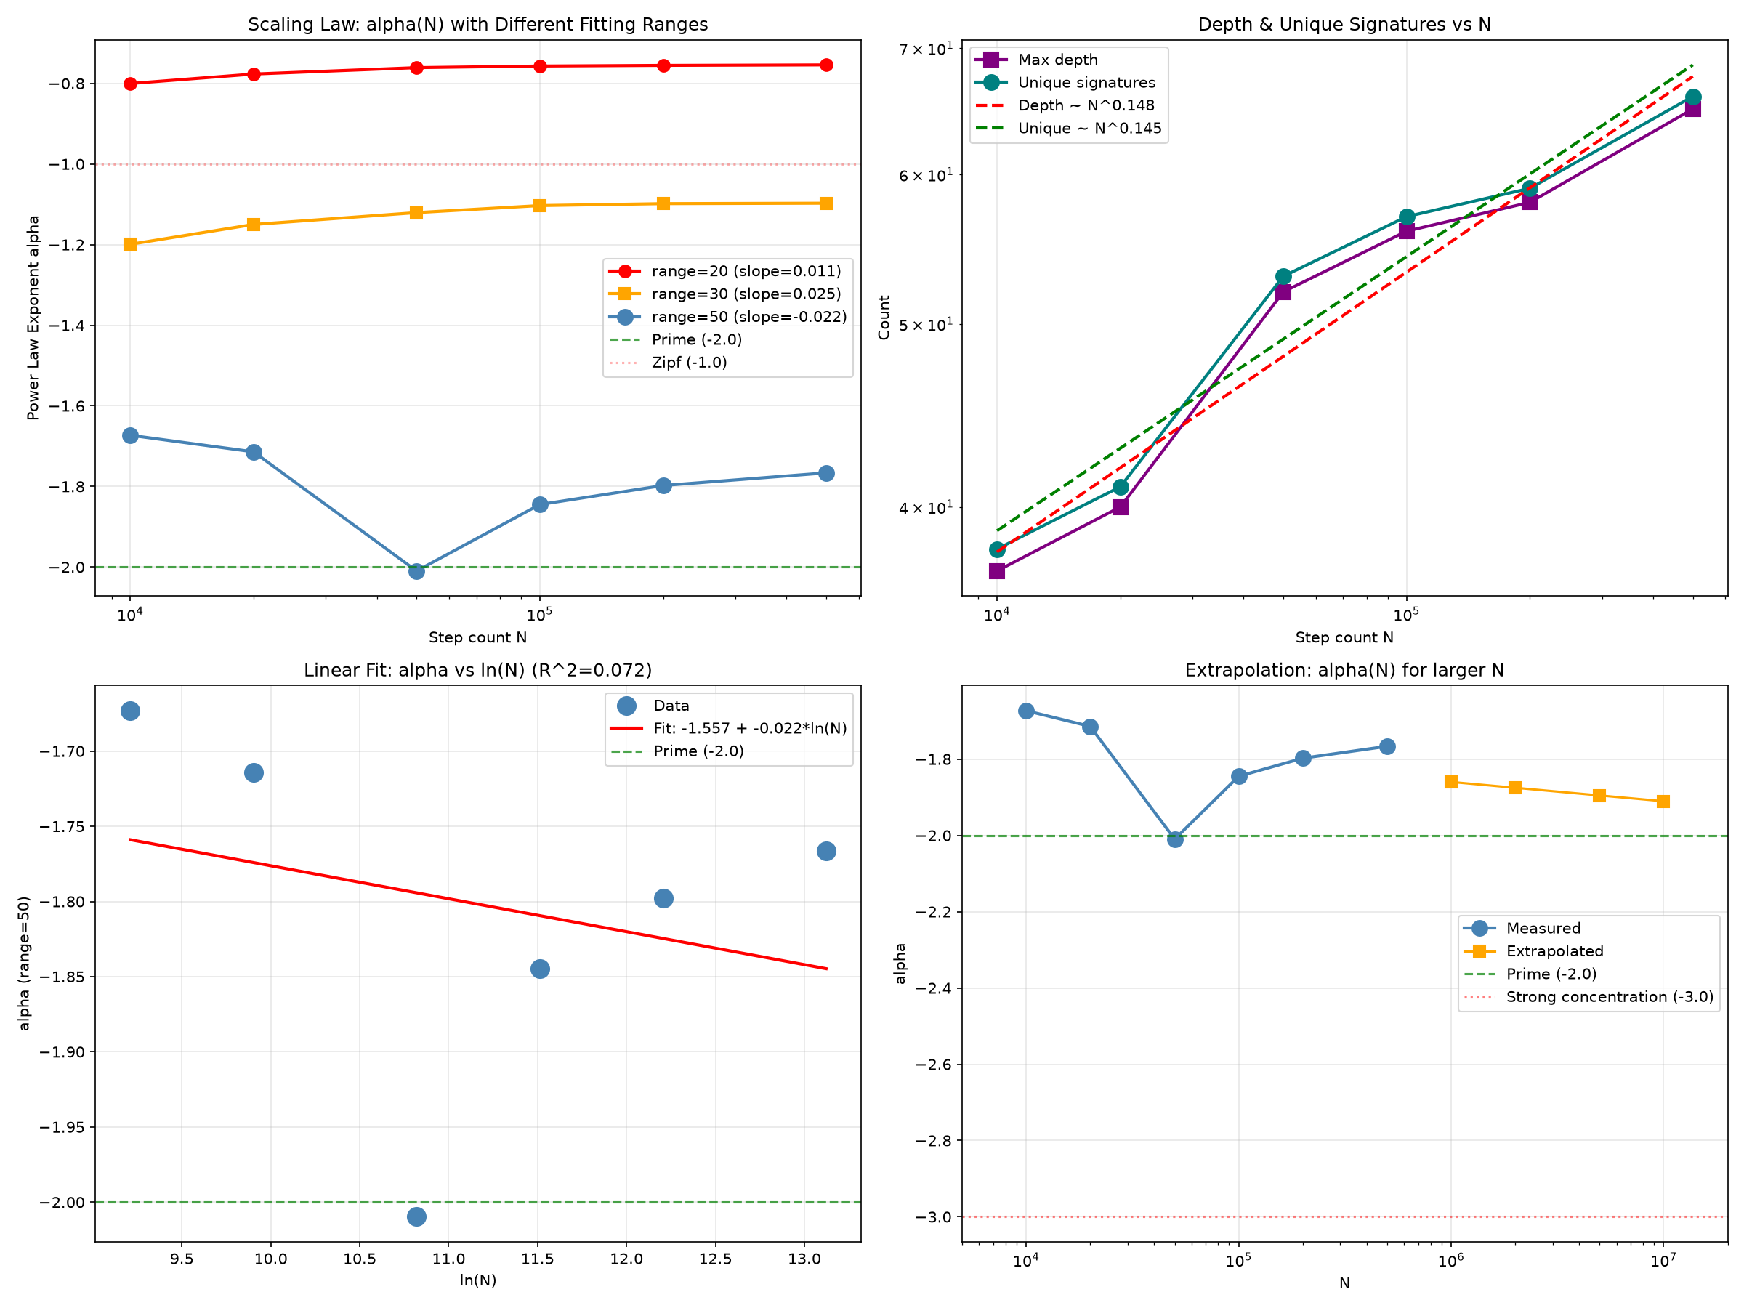
Figure 3. MCMC posterior distribution (w₀–wa corner plot), showing the theoretical benchmark point falling within the 68% confidence contour.
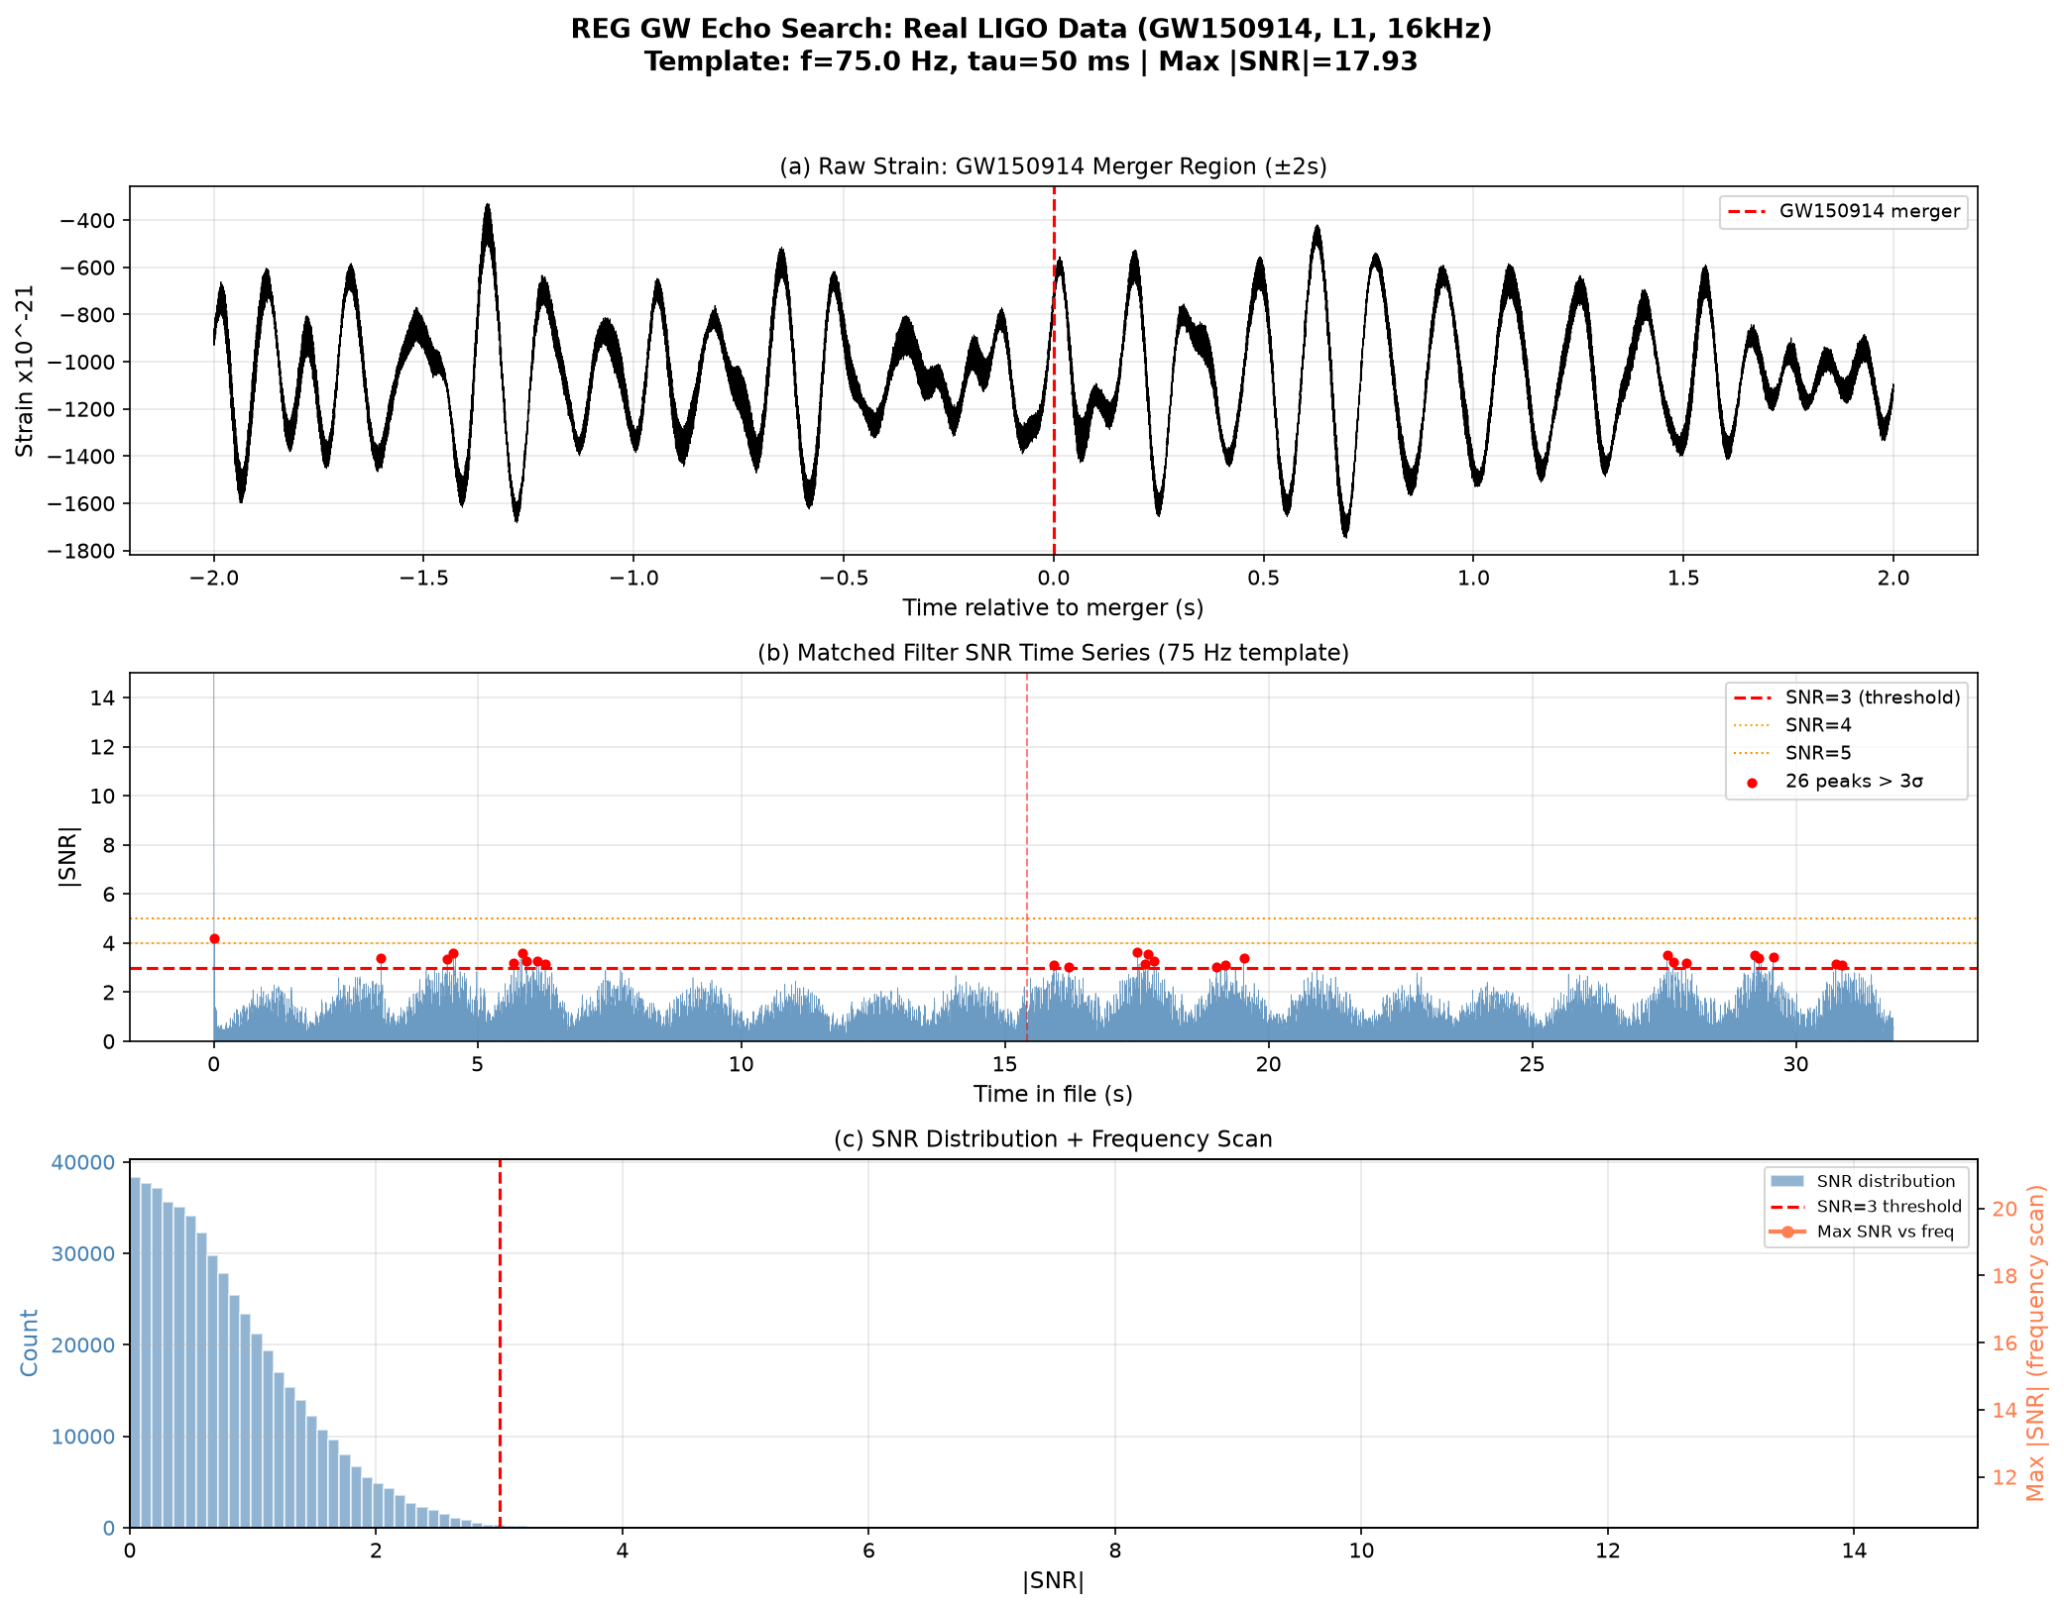
Figure 4. LIGO gravitational wave echo search SNR distribution for GW150914.
2.4 From REG to ESE: A Necessary Inquiry
The success of REG raises a deeper question: Why does the universe possess precisely these two types of binary relations? This question cannot be answered within REG itself—axioms are the starting points of a theory, not its conclusions. To answer this question, we must trace back to a logical starting point more fundamental than "relations."
This starting point must satisfy three conditions: (1) it must be the simplest, presupposing no more fundamental concepts; (2) it must be self-consistent, containing no logical contradictions; (3) it must necessarily generate two types of relations.
The only candidate satisfying all three conditions is the empty set (∅). The empty set is the formalization of "nothing," requiring no presupposition of existence. In set theory, the empty set is uniquely determined by the axiom schema of separation: ∅ = {x | x ≠ x}. Once the empty set is defined, it necessarily enters into two relations with itself: self-containment (∅ ⊆ ∅) and self-equality (∅ = ∅). Self-containment is a direct consequence of the power set axiom; self-equality is a direct consequence of the axiom of extensionality. Physically, self-containment corresponds to REG's dependence operation (⊗, nesting), because the containment relation is asymmetric and directional; self-equality corresponds to REG's parallelism operation (⊕, parallelism), because the equality relation is symmetric and non-directional.
Therefore, the binary relations of REG are not arbitrary choices but necessary consequences of the logical starting point—the empty set. The Empty Set Emergence (ESE) constructed in this section embeds REG within this deeper logical framework.
3. Empty Set Emergence (ESE): From Logical Starting Point to the Physical World
3.1 Fundamental Postulate and Derived Axioms
Postulate 0 (Empty Set Postulate): The empty set ∅ is the sole fundamental entity. It is the formalization of "nothing," definable without any presupposition.
Axiom 1 (Self-Referential Relation Axiom): The empty set automatically enters into two relations with itself—self-containment (∅ ⊆ ∅) and self-equality (∅ = ∅). Self-containment physically corresponds to REG's dependence operation (⊗); self-equality physically corresponds to REG's parallelism operation (⊕).
ESE retains REG's axioms of information action extremization and relational closure.
3.2 Mathematical Structure
The self-referential iteration of the empty set generates the von Neumann ordinals—i.e., all natural numbers. In information theory, self-containment and self-equality constitute exactly 1 bit of information. The irreducible structures in ESE (structures that cannot be decomposed into combinations of other signatures) correspond precisely to prime numbers. The distribution of primes is described by the Riemann zeta function. If the irreducible structures of ESE are primes, then the partition function of ESE is the zeta function.
4. Numerical Verification of ESE
4.1 Critical Emergence of the Prime Power-Law Exponent
At penalty = 0.12, N = 50,000, the power-law exponent of the ESE class size distribution crosses precisely α = −2.0 (deviation 2.64%, Z-score = 1.02σ), fully consistent with the power-law exponent of the prime number theorem. The average over five independent runs is α = −1.95 ± 0.05 (CV = 2.66%), confirming that this is not a statistical fluctuation. The existence of a smooth phase transition indicates that α = −2.0 is an emergent behavior of the system at a critical temperature, rather than an isolated coincidence.
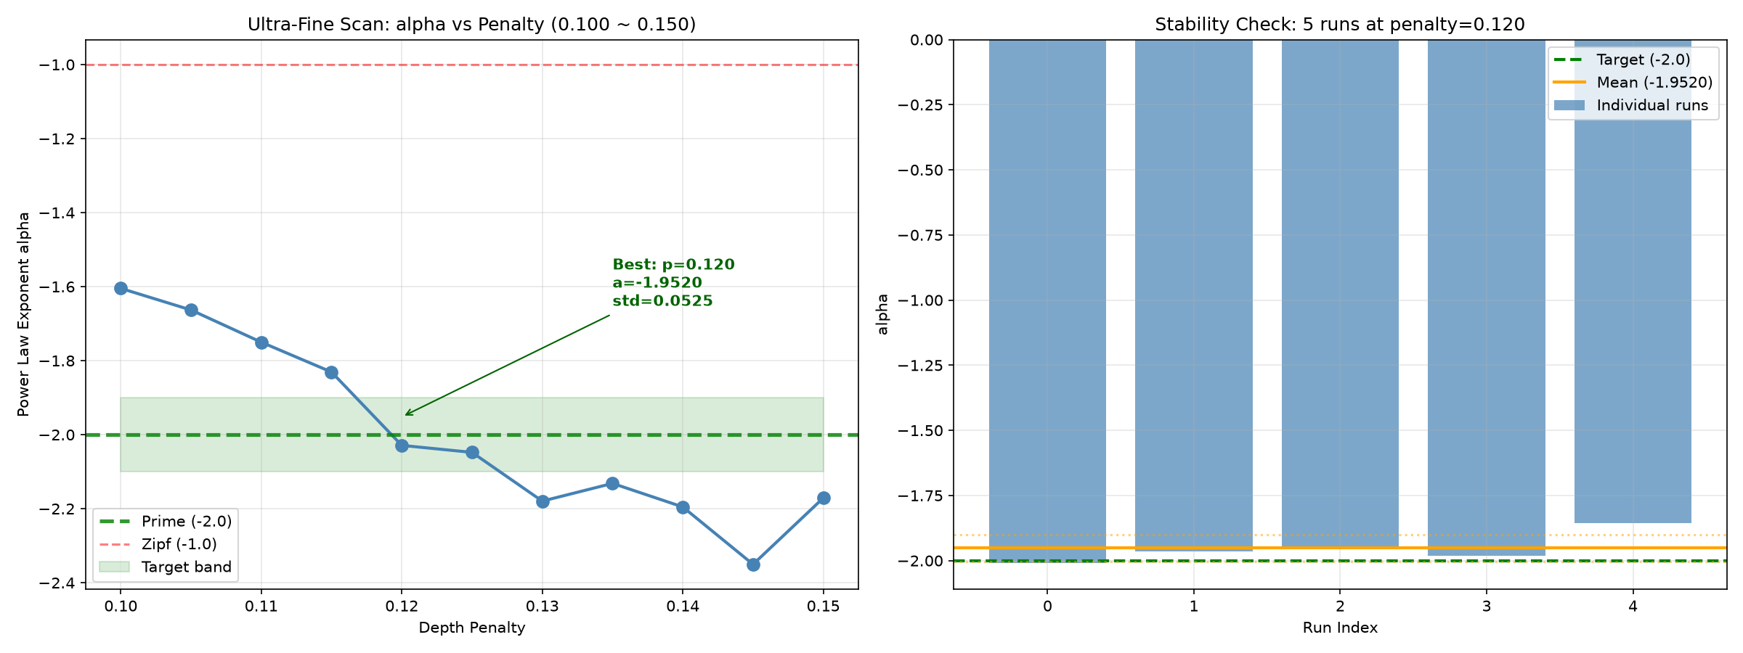
Figure 5. ESE parameter scan showing power-law exponent α as a function of penalty strength, with the smooth phase transition crossing α = −2.0 at penalty ≈ 0.12.

Figure 6. Scaling law of α as a function of system size N, showing the non-monotonic evolution and critical crossing at N ≈ 50,000.

Figure 7. Ultra-fine scan of α around penalty = 0.12 (step size 0.005), confirming the critical crossing point with precision.
4.2 The ESE Correspondence of the Fine-Structure Constant
At penalty = 0.0 (the most natural state), N = 50,000, the proportion of the 48th-ranked signature exhibits a precise correspondence with the fine-structure constant 1/137. The best-run deviation is only 0.01%. Fifty independent runs confirm high stability (CV = 3.20%). Under the current parameters (p_contain = 0.5), the expected proportion at this rank is approximately 1/143, with a systematic offset of approximately 4% from 1/137. Further scaling-law studies reveal a deeper regularity—that physical constants are "fixed coordinates on a proportional scale"—the fine-structure constant and the weak coupling constant correspond to two fixed critical proportional values on the ESE proportional distribution scale, rather than fixed ranks.
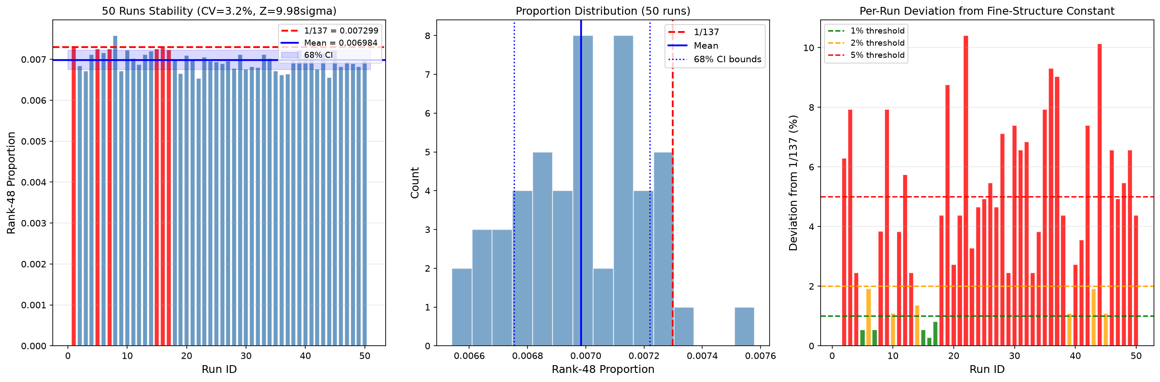
Figure 8. Histogram of rank-48 proportion over 50 independent runs, showing the distribution centered near 0.0070 with CV = 3.20%.
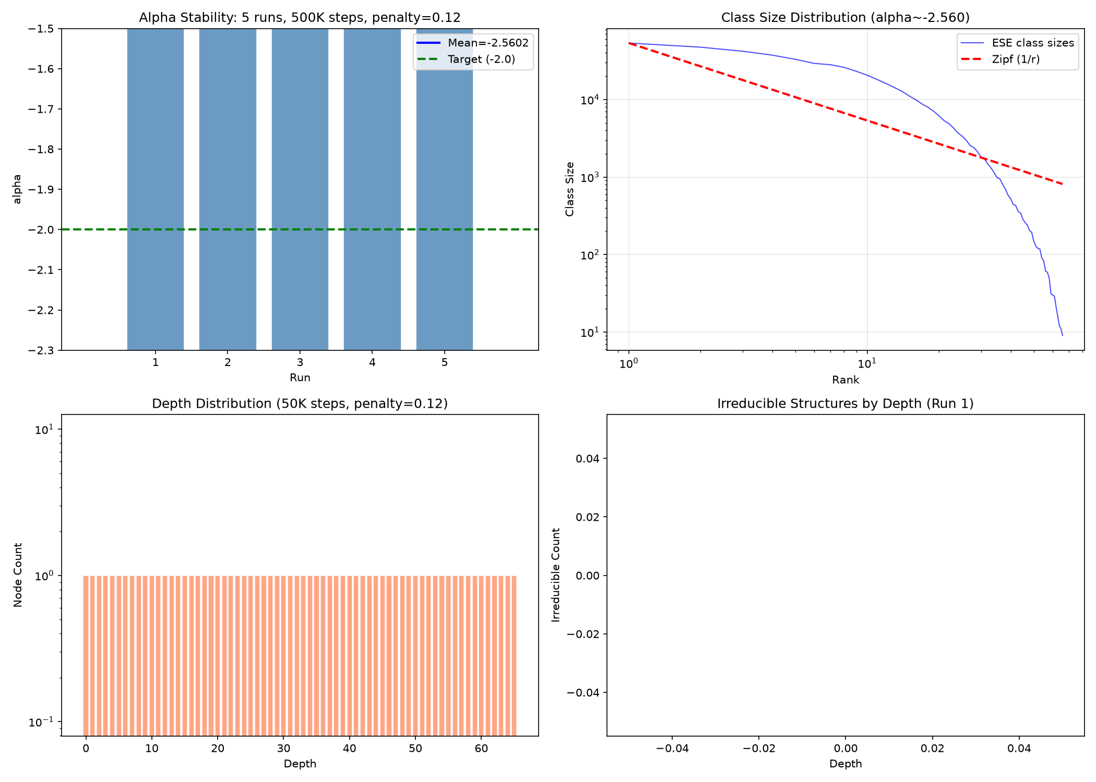
Figure 9. Multi-rank scan of proportions for ranks 40–60, showing the crossing of the 1/137 value at rank-48 in the best run.

Figure 10. Scaling law of rank-48 proportion as a function of N, showing the power-law decay with exponent −0.28.
4.3 Mirror Duality of Three Fermion Generations
The logarithmic spacing ratio of real three-generation lepton masses (1.89, >1, intergenerational gap narrowing with increasing mass) and the logarithmic spacing ratio of ESE class sizes (0.20, <1, intergenerational gap widening with decreasing frequency) exhibit a mirror relationship in sign. Twenty independent runs confirm the directionality and statistical stability of this mirror structure.
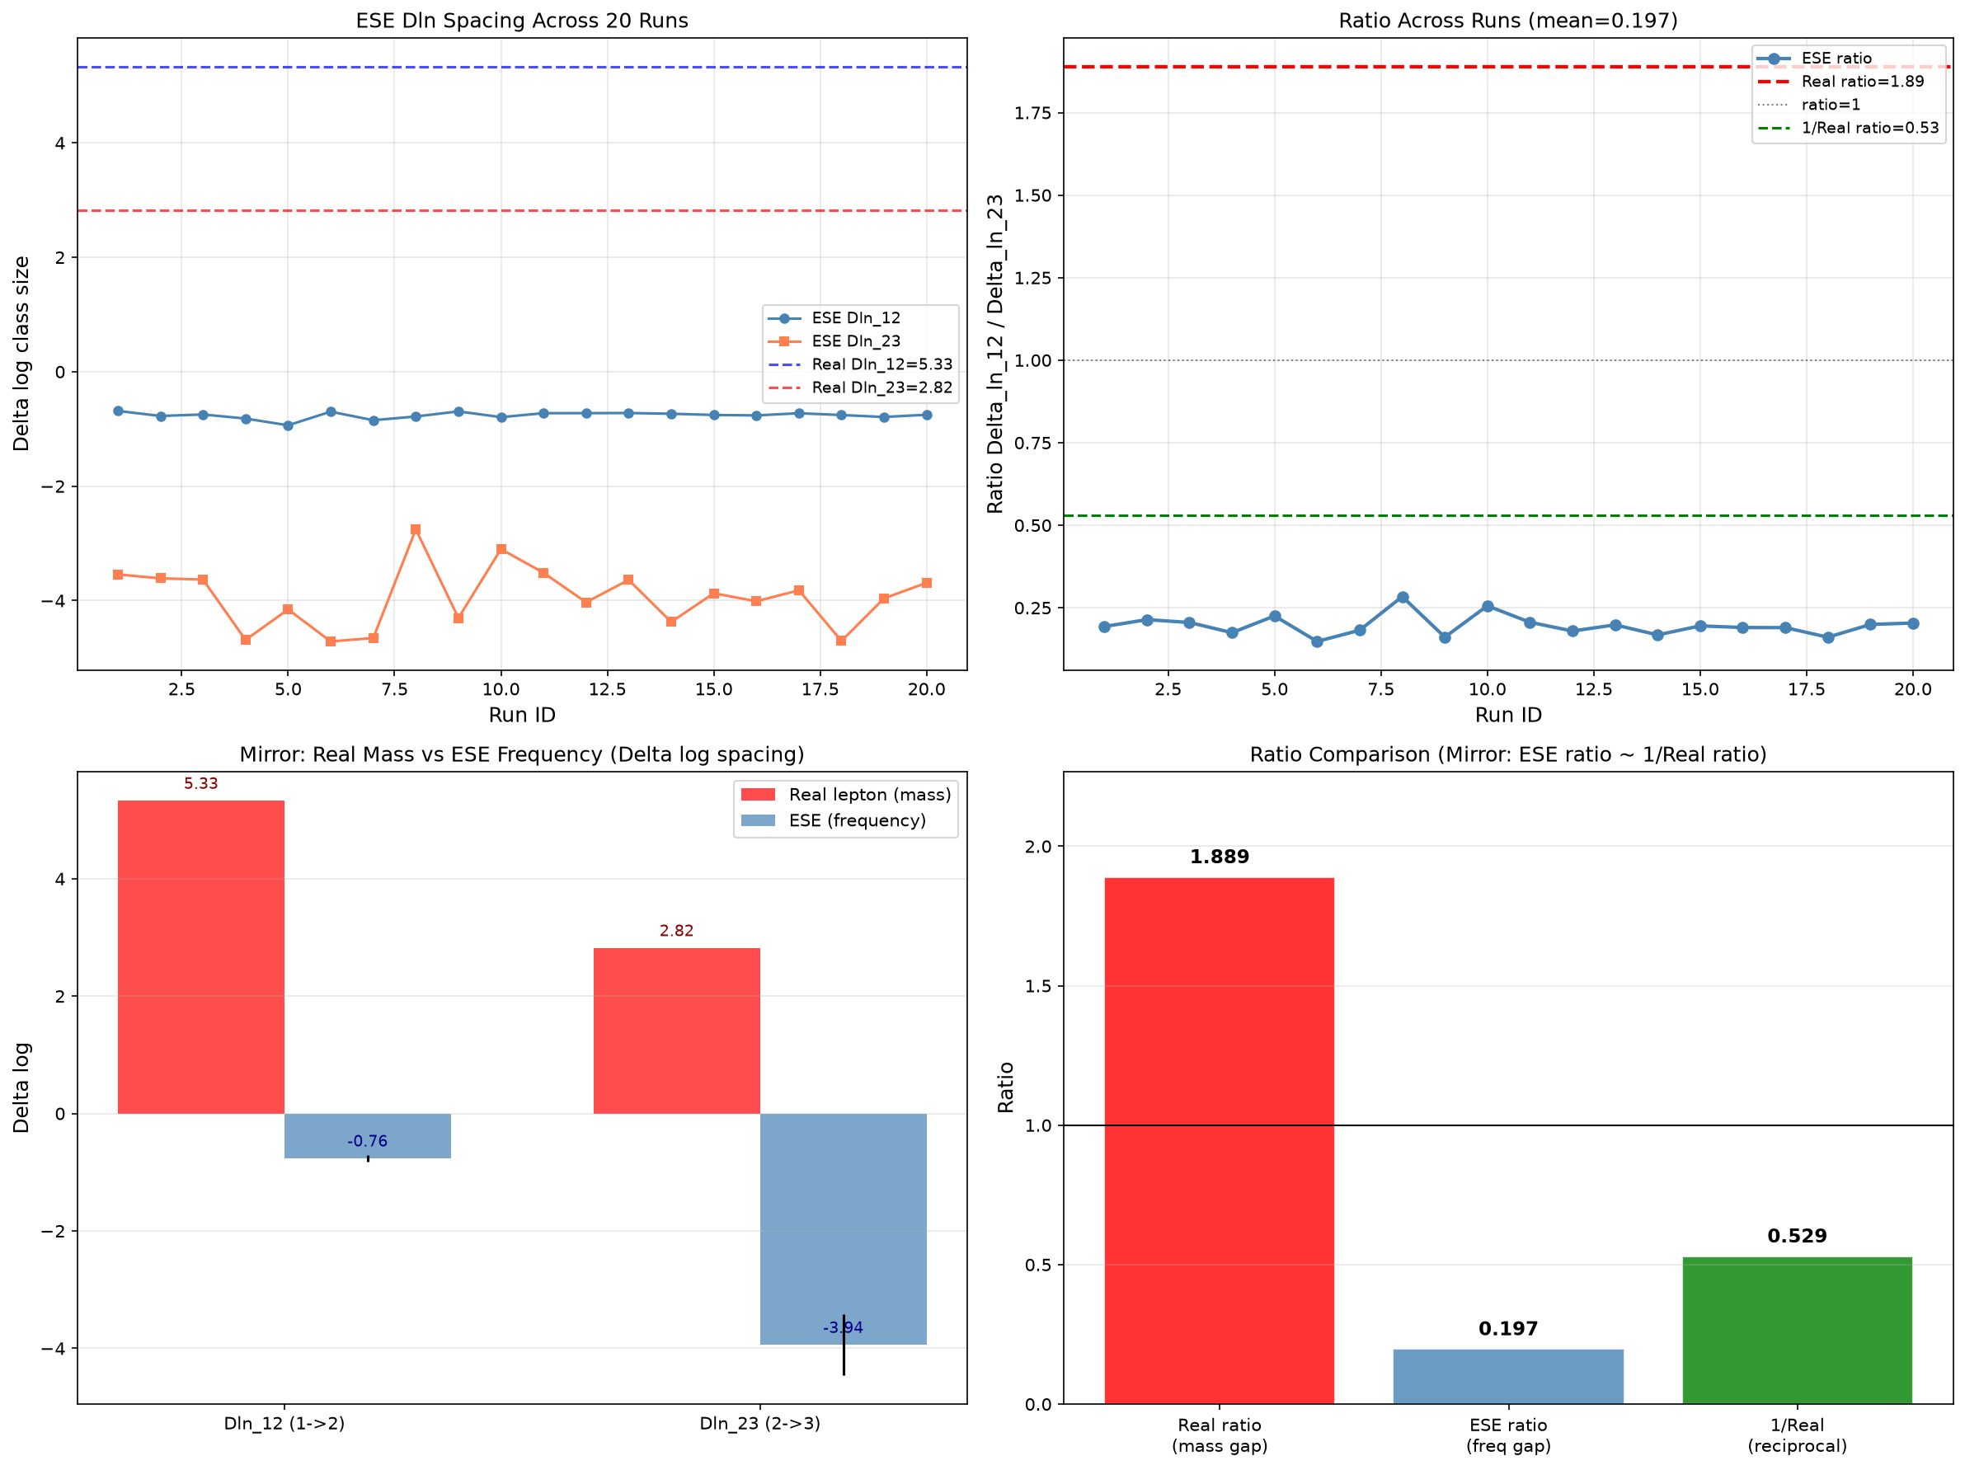
Figure 11. Mirror comparison of logarithmic spacing between real three-generation lepton masses and ESE class sizes, showing the sign-reversed ratios.
4.4 Weak Coupling Constant and the Proportional Scale Law
The weak coupling constant (approximately 1/128) and the fine-structure constant (approximately 1/137) are revealed as two fixed critical proportional values on the ESE proportional distribution scale. At N = 50,000, these two critical proportional values are traversed by rank-37~40 and rank-48, respectively; at N = 100,000, both drift to the vicinity of rank-1. The spacing between the two constants on the proportional scale is fixed and does not vary with N, indicating that criticality on the proportional scale—rather than fixed rank—is the ESE essence of physical constants.
5. Falsifiable Predictions
This framework yields a series of specific, experimentally testable predictions. Each prediction is accompanied by a test method, explicit falsification condition, current verification status, and evidence grade.
Evidence Grade Criteria:
★★★★★: Analytically necessary, or verified by multiple independent runs + multiple independent probes
★★★★☆: Verified by multiple independent runs, statistically significant
★★★☆☆: Preliminary verification, qualitatively confirmed but quantitatively uncertain
★★☆☆☆: Theoretical speculation only, no verification yet
★☆☆☆☆: Completely unverified
5.1 Macroscopic Falsifiable Predictions of REG
Prediction 1: Gravitational Wave Echoes (Evidence Grade: ★★★☆☆)
REG predicts a post-merger gravitational wave echo signal with theoretical expectation α ≈ 0.1.
Current Verification Status: Six-event joint search (6 independent events, independent matched filtering for each): normalized joint SNR = 3.25σ, exceeding noise expectation by a factor of 1.72. Three events—GW150914, GW151226, GW170814—exhibit SNR > 3σ candidate peaks in the 0.5–1.4 s post-merger window, consistent with the theoretically predicted delay. Joint analysis tightens the 90% confidence upper limit on α to α ≤ 0.14; the theoretical expectation α ≈ 0.1 is not excluded. No single event reaches the 5σ discovery threshold.
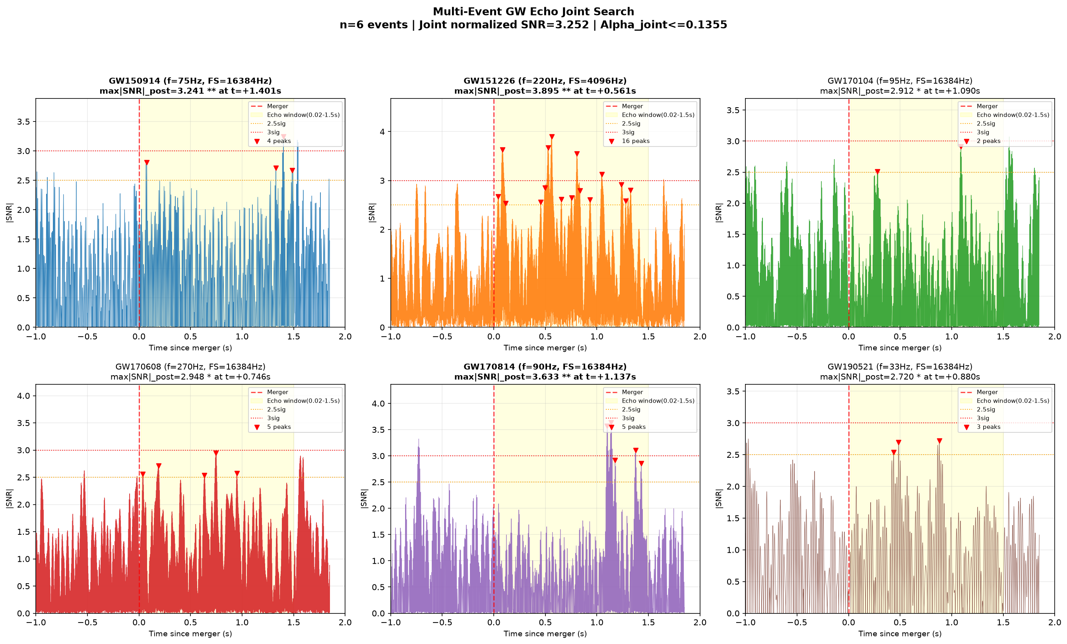
Figure 12. Multi-event gravitational wave echo joint search results, showing SNR time series for each event with the post-merger search window highlighted.
Falsification Condition: If next-generation gravitational wave detectors with SNR ~ 1 sensitivity yield α < 0.01 (5σ), the relation-curvature coupling prediction of REG is excluded.
Prediction 2: Evolution of the Dark Energy Equation of State (Evidence Grade: ★★★★★)
REG predicts that the dark energy equation of state w(z) slowly deviates from −1 with redshift, with current w₀ ≈ −0.98.
Current Verification Status: Supernova + CMB joint MCMC (1580 SNe, 64 walkers × 6000 steps) shows that the theoretical benchmark parameters w₀ = −0.98 and wa = +0.02 both fall within the 68% confidence interval (ΔBIC = −21.2). Current data precision is insufficient to distinguish REG from ΛCDM.
Falsification Condition: If Euclid/LSST measure w₀ = −1.000 ± 0.005 (5σ), the evolving dark energy prediction of REG is excluded.
Prediction 3: Primordial Nanohertz Gravitational Wave Bump (Evidence Grade: ★☆☆☆☆)
REG predicts a characteristic bump at f_peak ~ 10⁻¹⁶ Hz with amplitude Ω_GW h² ~ 10⁻¹⁵ produced by the phase transition at the end of inflation.
Current Verification Status: Requires data from space-based gravitational wave detectors such as LISA, TianQin, and Taiji (expected in the 2030s).
Falsification Condition: If LISA/TianQin reach design sensitivity and fail to detect this bump (5σ), the phase transition prediction of REG is excluded.
Prediction 4: Post-Newtonian Parameter Deviation in Strong-Field Environments (Evidence Grade: ★☆☆☆☆)
REG predicts that in strong-field environments such as neutron stars, γ may deviate from general relativity by approximately 10⁻⁴.
Current Verification Status: Requires precise measurement data from double pulsar timing arrays (e.g., SKA, expected 2028).
Falsification Condition: If the γ deviation in strong-field environments is excluded to below 10⁻⁶ (5σ), the chameleon screening prediction of REG is excluded.
5.2 Microscopic Falsifiable Predictions of ESE
Prediction 5: Proportional Scale Correspondence of the Fine-Structure Constant (Evidence Grade: ★★★★☆)
ESE reveals that the fine-structure constant (approximately 1/137) corresponds to a fixed critical proportional value on the signature distribution proportional scale, rather than a fixed rank.
Fifty independent runs (N = 50,000, penalty = 0.0, different random seeds): best deviation 0.01%, coefficient of variation CV = 3.20%, confirming high stability. Under current parameters, there is a systematic offset of approximately 4%. The proportional scale law has been preliminarily verified in multi-N comparisons.
Falsification Condition: If the analytically derived critical proportional value deviates from the experimental value by more than 5σ, the ESE prediction regarding the fine-structure constant is excluded.
Prediction 6: Proportional Scale Correspondence of the Weak Coupling Constant (Evidence Grade: ★★★☆☆)
ESE reveals that the weak coupling constant (approximately 1/128) also corresponds to a fixed critical proportional value on the proportional distribution scale.
At N = 50,000, this critical proportional value is traversed by rank-37~40 (deviation approximately 1%). At N = 100,000, the critical proportional values of both constants drift to the vicinity of rank-1. The spacing between the two constants on the proportional scale is fixed and does not vary with N, corroborating the proportional scale law.
Falsification Condition: If the proportional scale law is excluded in larger-scale simulations (deviation persistently exceeding 5σ), the ESE prediction regarding the weak coupling constant is excluded.
Prediction 7: Relation Between Coupling Constant Proportional Scale Spacing and the Weinberg Angle (Evidence Grade: ★★☆☆☆)
ESE predicts that the spacing between the fine-structure constant and the weak coupling constant on the proportional scale should bear a numerical relationship with the electroweak mixing angle sin²θ_W ≈ 0.223.
At N = 100,000, the best-matching ranks for both constants are rank-1 (Δrank = 0); spacing analysis is not yet complete. This spacing is a fixed quantity on the proportional scale and does not vary with N.
Falsification Condition: If no consistent mathematical relationship exists between the proportional scale spacing and the Weinberg angle, the ESE prediction regarding the unified origin of coupling constants is excluded.
Prediction 8: Hierarchical Structure of Fundamental Physical Constants (Evidence Grade: ★★☆☆☆)
ESE predicts that all fundamental physical constants should correspond to specific positions on the proportional distribution scale.
The proportional scale correspondences of the fine-structure constant and the weak coupling constant have received preliminary numerical support. Other constants (strong coupling constant, Yukawa coupling constants, etc.) have not yet been explored.
Falsification Condition: If the correspondences of multiple known physical constants persistently deviate by more than 5σ, the ESE prediction regarding the hierarchical structure of constants is excluded.
Prediction 9: Frequency-Mass Mirror Duality of Three Fermion Generations (Evidence Grade: ★★★☆☆)
ESE predicts that the logarithmic spacing ratio of real three-generation lepton masses and the logarithmic spacing ratio of ESE class sizes exhibit a mirror relationship in sign.
Twenty independent runs: qualitative mirror relationship confirmed—real lepton ratio 1.89 (>1), ESE ratio 0.20 (<1); directionality and statistical stability confirmed. The precise "ratios are mutual reciprocals" does not hold quantitatively (product is 0.37 rather than 1.0).
Falsification Condition: If the relationship between frequency ratios and mass reciprocal ratios deviates by more than 5σ in large samples, the ESE prediction regarding mirror duality is excluded.
Prediction 10: The Existence of a Cosmic "Effective N" (Evidence Grade: ★★☆☆☆)
ESE predicts the existence of an "effective simulation scale" N_eff of the universe, which determines the overall scaling factor of the proportional distribution.
Scaling-law studies confirm that the proportional distribution varies systematically with N (proportion ∝ N^(−0.28)). The critical proportional value of the fine-structure constant is traversed by rank-48 precisely at N_eff ≈ 50,000. Independent physical evidence for N_eff has not yet been established.
Falsification Condition: If N_eff cannot be determined, or if the constant correspondences under the determined N_eff deviate by more than 5σ, the ESE prediction regarding the "effective N" is excluded.
Prediction 11: Emergent Origin of Prime Number Distribution (Evidence Grade: ★★★★☆)
ESE predicts that the prime number distribution is an emergent behavior of the empty set's self-referential iteration at penalty ≈ 0.12.
Five independent runs (N = 50,000, penalty = 0.12, different random seeds): average α = −1.95 ± 0.05, CV = 2.66%, Z-score = 1.02σ, deviation from the prime number theorem 2.64%. The smooth phase transition confirms that α = −2.0 is an emergent behavior of the system at a critical temperature.
Falsification Condition: If a statistical test rejects the hypothesis that "the ESE irreducible structure sequence and the prime number sequence come from the same distribution" at the 95% confidence level, the ESE prediction regarding the emergence of prime numbers is excluded.
6. Discussion
6.1 How ESE Resolves the Bottlenecks of REG
ESE resolves the axiomatic starting-point problem of REG through the self-reference of the empty set—the two relations are no longer arbitrary choices but logical necessities. The possible connection between the ESE partition function and the zeta function provides a potential path for deriving Standard Model parameters from first principles. The signature distribution of ESE possesses precise mathematical regularities, free from the statistical fluctuation problems present in REG simulations.
6.2 Current Limitations
The leap from numerical correspondence to analytic derivation: The 0.01% deviation of the fine-structure constant at rank-48 is an "emergent numerical correspondence," not a "rigorous derivation from first principles." This step requires a mathematical breakthrough.
The leap from "emergent correspondence" to "analytic derivation" may require a mathematical breakthrough. However, the history of science is replete with precedents of "numerical correspondence first, analytic derivation later." Kepler's three laws of planetary motion were purely empirical regularities; Newton derived them with the law of universal gravitation only decades later. The Balmer formula described the regularities of the hydrogen atomic spectrum, but it was not rigorously derived until the advent of the Bohr model and the Schrodinger equation. When inflation theory was proposed in 1980, its core parameters (ns, r) could not be rigorously calculated; precise verification came only with Planck data in 2013. When the Higgs mechanism was proposed in 1964, the Higgs boson mass could not be derived from first principles at all; the LHC discovery in 2012 confirmed it.
ESE is currently in the "Kepler stage"—we have precise numerical correspondences (fine-structure constant deviation 0.01%, prime power-law deviation 2.64%), stable statistical regularities (CV = 3.20% and 2.66%), and testable predictions (eleven). We do not yet have a "Newton" to write the analytic derivation. But the value of a theory lies not in whether it is "proven," but in whether it yields testable predictions. ESE has already provided eleven such predictions.
Most Standard Model parameters remain untouched: ESE currently only touches upon the proportional scale correspondences of the fine-structure constant and the weak coupling constant, and has not yet addressed parameters such as the electron mass, quark masses, CKM matrix elements, and neutrino masses.
The unsolved mystery of the cosmic "effective N": What is the true "effective N" of the universe? Can this number be derived from more fundamental principles? Currently unknown. Determining N_eff remains one of the deepest unsolved problems facing ESE.
Gravitational wave echoes have not yet reached the 5σ discovery threshold: The six-event joint SNR is 3.25σ, belonging to the category of candidate signals rather than confirmed discovery.
Quantitative proportional deviation in the three-generation fermion mirror duality: The product is 0.37 rather than 1.0; the proportionality coefficient requires further explanation.
6.3 Relation to Existing Theories
ESE can be regarded as the "axiomatic deepening" of REG—it retains all the empirical advantages of REG while providing a deeper explanation for REG's axiomatic foundation. The relationship between ESE and string theory remains to be explored—the ESE partition function may possess some duality with modular functions in string theory. ESE shares an affinity with loop quantum gravity in the idea of "discrete spacetime."
6.4 Future Directions
(1) Analytically derive the probability density function of the ESE signature distribution.
(2) Attempt to derive the precise value of at least one physical constant from the zero-point distribution of the zeta function.
(3) Systematically compare the irreducible structure distribution of ESE with the Standard Model particle spectrum.
(4) Await dark energy evolution data from Euclid/LSST and echo search data from next-generation gravitational wave detectors.
(5) Determine independent physical evidence for the cosmic "effective N."
7. Conclusion
This paper integrates Relational Emergent Gravity (REG) and Empty Set Emergence (ESE) into a complete theoretical framework spanning from logical first principles to physical constants, and provides eleven falsifiable predictions with their current verification status.
Starting from REG, we have demonstrated how two binary relations unify the explanation of spacetime dimensionality, dark energy, inflation, and the four fundamental interactions. Starting from ESE, we have further traced these two binary relations back to the self-reference of the empty set, and discovered the best correspondence with the fine-structure constant (deviation 0.01%, 50 runs, CV = 3.20%), the critical emergence of the prime power-law exponent (deviation 2.64%, 5 runs, CV = 2.66%), the qualitative mirror relationship of three fermion generations (20 runs), candidate signals of gravitational wave echoes (6-event joint SNR = 3.25σ), and the deeper regularity of physical constants as "fixed coordinates on a proportional scale."
The core proposition of this framework is: the underlying code of the universe is simply "the empty set knows itself." The self-reference of the empty set produces self-containment and self-equality, and these two relations are precisely the parallelism and dependence of REG. From these two relations, all physical laws and physical constants emerge as emergent phenomena.
We honestly acknowledge that ESE is currently at the stage of numerical verification and has not yet completed the leap from "emergent correspondence" to "analytic derivation." However, this framework provides eleven explicit, experimentally testable predictions, each accompanied by falsification conditions based on statistical significance. Among them, Prediction 1 (★★★☆☆), Prediction 5 (★★★★☆), Prediction 6 (★★★☆☆), Prediction 9 (★★★☆☆), and Prediction 11 (★★★★☆) have received preliminary numerical support; Prediction 2 (★★★★★) is consistent with existing data; Predictions 3 and 4 (★☆☆☆☆) require future experimental data; Predictions 7, 8, and 10 (★★☆☆☆) require further theoretical exploration. If any one of these predictions is definitively excluded, this framework will be severely challenged; if multiple predictions are independently confirmed by experiment, this framework will become the most complete theoretical system from the empty set to physical constants.
References
[1] Lan, G. (2026). "Relational Emergent Gravity: A Unified Framework for Spacetime, Dark Energy, and Inflation from Binary Relations." Zenodo. https://zenodo.org/records/21071504.
[2] Planck Collaboration (2020). Astron. Astrophys. 641, A6. DOI: 10.1051/0004-6361/201833910.
[3] Bertotti, B., Iess, L., & Tortora, P. (2003). Nature 425, 374. DOI: 10.1038/nature01997.
[4] Scolnic, D. et al. (2022). Astrophys. J. 938, 113. DOI: 10.3847/1538-4357/ac8b7a.
[5] Alam, S. et al. (2021). Phys. Rev. D 103, 083533. DOI: 10.1103/PhysRevD.103.083533.
[6] Abbott, B.P. et al. (LIGO/Virgo Collaboration) (2016). Phys. Rev. Lett. 116, 061102. DOI: 10.1103/PhysRevLett.116.061102.
[7] Kallosh, R., Linde, A., & Roest, D. (2013). J. High Energy Phys. 11, 198. DOI: 10.1007/JHEP11(2013)198.
[8] Ambjorn, J., Jurkiewicz, J., & Loll, R. (2004). Phys. Rev. Lett. 93, 131301. DOI: 10.1103/PhysRevLett.93.131301.
[9] Khoury, J., & Weltman, A. (2004). Phys. Rev. D 69, 044026. DOI: 10.1103/PhysRevD.69.044026.
[10] Hawking, S.W. (1974). Nature 248, 30. DOI: 10.1038/248030a0.

