标准测试问题优化实验

## G01

Fmincon终止条件设置为步长小于1e-6和函数值变化小于1e-6,使用默认的内点法;罚函数外点法收敛条件为步长小于1e-6和函数值变化小于1e-6，惩罚因子设为1000，增长倍数设为5，无约束优化选择fmincon。测试点结果如下。

测试点为[1, 1, 1, 1, 1, 1, 1, 1, 1, 1, 1, 1, 1]

|  |  |  |
| --- | --- | --- |
| Method | Test_point | [1,1,1,1,1,1,1,1,1,1,1,1,1] |
| Penalty_fun | Min_point | [0.3750,1,1,1,1,1,1,0.993,1,3,3,2.9984,1] |
| Min_value | -14.9999 |
| Call_count | 3147 |
| fmincon | Min_point | [1,1,1,1,1,1,1,1,1,3,3,3,1] |
|  | Min_value | -15.00 |
|  | Call_count | 182 |

测试点[0.5,0.5,0.5,0.5,0.5,0.5,0.5,0.5,0.5,0.5,0.5,0.5,0.5]

|  |  |  |
| --- | --- | --- |
| Method | Test_point | [0.5,0.5,0.5,0.5,0.5,0.5,0.5,0.5,0.5,0.5,0.5,0.5,0.5] |
| Penalty_fun | Min_point | [1,1,3.16e-6,1.2e-6,1,1,1,1,1,1,3,3,1] |
| Min_value | -14.9999 |
| Call_count | 3819 |
| fmincon | Min_point | [1,1,0 ,1,1,1,1,1,1,2.9999,2.9999,2.9999,1] |
|  | Min_value | -14.9994 |
|  | Call_count | 182 |

测试点[0.1,0.2,0.3,0.4,0.5,0.6,0.7,0.8,0.9,1,2,3,0.5]

|  |  |  |
| --- | --- | --- |
| Method | Test_point | [1,1,1,1,1,1,1,1,1,1,1,1,1] |
| Penalty_fun | Min_point | [1,1,1,1,1,1,1,1,1,3,3,3,1] |
| Min_value | -12.9999 |
| Call_count | 4571 |
| fmincon | Min_point | [0.125,1,3.0,0 ,1,1,1,1,1,3,3,1] |
|  | Min_value | -12.4531 |
|  | Call_count | 299 |

## G06

Fmincon终止条件设置为步长小于1e-6和函数值变化小于1e-6,使用sqp算法;罚函数外点法收敛条件为步长小于1e-6和函数值变化小于1e-6，惩罚因子设为1e6，增长倍数设为5，无约束优化选择fminsearch。测试点结果如下。

测试点为[15,15]

|  |  |  |
| --- | --- | --- |
| Method | Test_point | [15,15] |
| Penalty_fun | Min_point | [14.0950,0.8430] |
| Min_value | -6962.8045 |
| Call_count | 1718 |
| fmincon | Min_point | [14.0950,0.8430] |
|  | Min_value | -15.00 |
|  | Call_count | 24 |

测试点[25,50]

|  |  |  |
| --- | --- | --- |
| Method | Test_point | [25,50] |
| Penalty_fun | Min_point | [14.0950,0.8430] |
| Min_value | -6961.8052 |
| Call_count | 2025 |
| fmincon | Min_point | [14.0950,0.8430] |
|  | Min_value | -14.9994 |
|  | Call_count | 43 |

测试点[30,24]

|  |  |  |
| --- | --- | --- |
| Method | Test_point | [30,24] |
| Penalty_fun | Min_point | [14.0950,0.8430] |
| Min_value | -6961.8032 |
| Call_count | 4571 |
| fmincon | Min_point | [14.0950,0.8430] |
|  | Min_value | -12.4531 |
|  | Call_count | 33 |

## PVD

Fmincon终止条件设置为步长小于1e-6和函数值变化小于1e-6,使用sqp算法;罚函数外点法收敛条件为步长小于1e-6和函数值变化小于1e-6，惩罚因子设为1e4，增长倍数设为5，无约束优化选择fminsearch。测试点结果如下。

测试点为[1.3,0.8,50.0,100]

|  |  |  |
| --- | --- | --- |
| Method | Test_point | [1.3,0.8,50.0,100] |
| Penalty_fun | Min_point | [1.2991,0.6422,67.3126,25.0] |
| Min_value | 8926.2046 |
| Call_count | 6366 |
| fmincon | Min_point | [1.2991,0.6422,67.3119,25.0] |
|  | Min_value | -8925.9458 |
|  | Call_count | 113 |

测试点[1.0,0.7,60.0,200.0]

|  |  |  |
| --- | --- | --- |
| Method | Test_point | [1.0,0.7,60.0,200.0] |
| Penalty_fun | Min_point | [1.2991,0.6423,67.3119,25.0] |
| Min_value | 8926.8289 |
| Call_count | 3988 |
| fmincon | Min_point | [1.2991,0.6422,67.3119,25.0] |
|  | Min_value | 8925.9458 |
|  | Call_count | 67 |

测试点[1.0,0.9,120.0,50.0]

|  |  |  |
| --- | --- | --- |
| Method | Test_point | [1.0,0.9,120.0,50.0] |
| Penalty_fun | Min_point | [1.2992,0.6423,67.3145,25.0] |
| Min_value | 8926.9461 |
| Call_count | 4376 |
| fmincon | Min_point | [1.2991,0.6422,67.3119,25.0] |
|  | Min_value | 8925.9458 |
|  | Call_count | 70 |

## 总结

TABEL1.optimation result

|  |  |  |  |  |
| --- | --- | --- | --- | --- |
|  |  | G01 | G06 | PVD |
| Penalty_method | Best | -15 | -6961.8063 | 8926.0978 |
| Mean | -14.2481 | -6961.8038 | 8926.5989 |
| Worst | -12.6562 | -6961.8015 | 8927.3705 |
| Median | -14.9986 | -6961.8035 | 8926.6575 |
| FeasiNUM | 10 | 10 | 10 |
| Fmincon | Best | -15 | -6961.8139 | 8925.9458 |
| Mean | -14.1389 | -6961.8138 | 8925.9547 |
| Worst | -11.2811 | -6961.8104 | 8925.0254 |
| Median | -14.4997 | -6961.8139 | 8925.9458 |
| FeasiNUM | 10 | 10 | 9 |

TABEL2.model call count

|  |  |  |  |  |
| --- | --- | --- | --- | --- |
|  |  | G01 | G06 | PVD |
| Penalty_method | Min | 3147 | 1427 | 3812 |
| Mean | 5485 | 1703 | 4628 |
| Max | 7008 | 2112 | 6366 |
| Median | 5828 | 1645 | 4422 |
| FeasiNUM | 10 | 10 | 10 |
| Fmincon | Min | 182 | 21 | 50 |
| Mean | 312 | 35 | 83. |
| Max | 508 | 45 | 127 |
| Median | 296 | 37 | 80 |
| FeasiNUM | 10 | 10 | 9 |

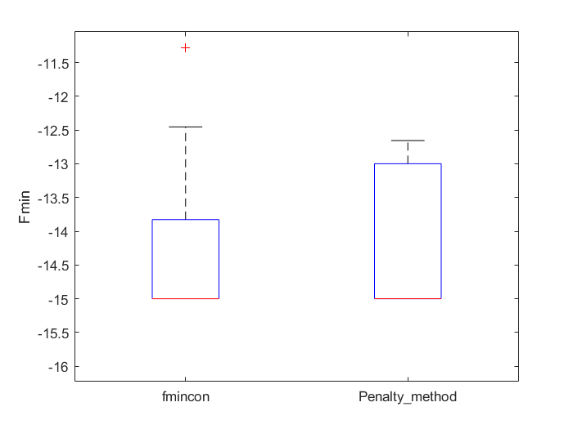 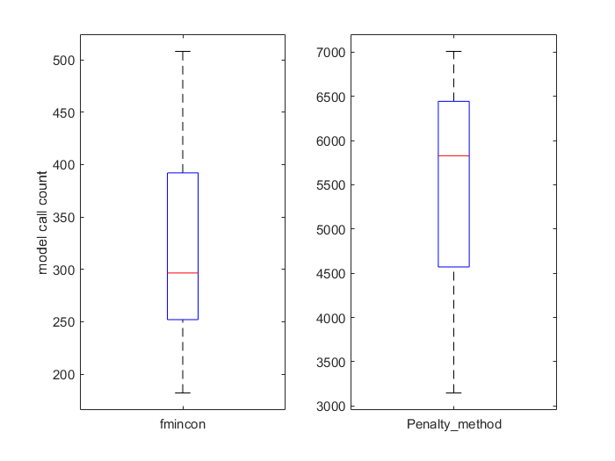

图 1 G01最优结果

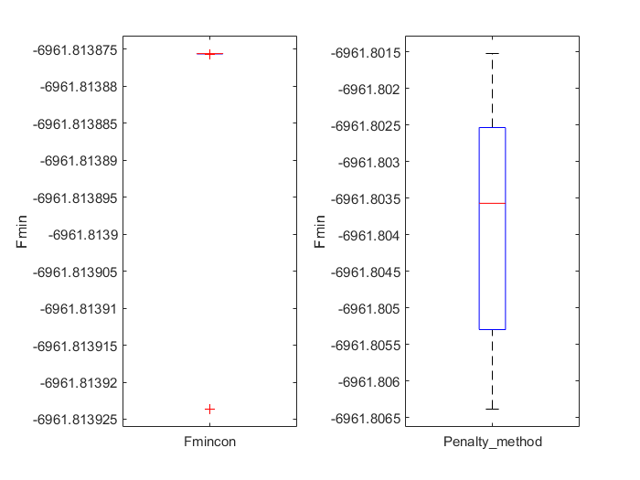

图3 G06最优结果

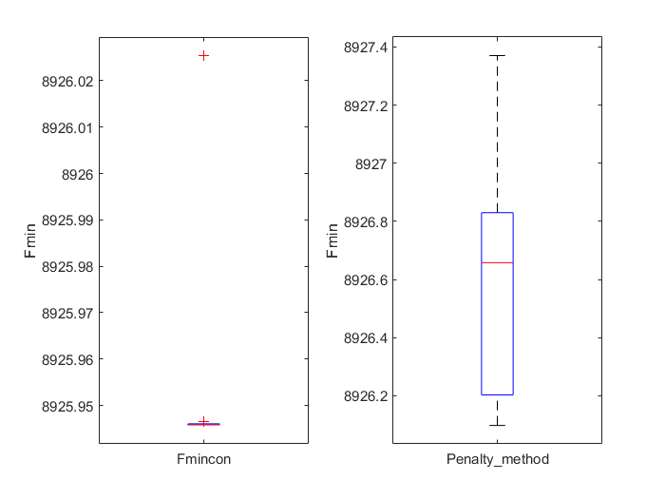

图5 PVD 最优结果

图2 G01计算成本

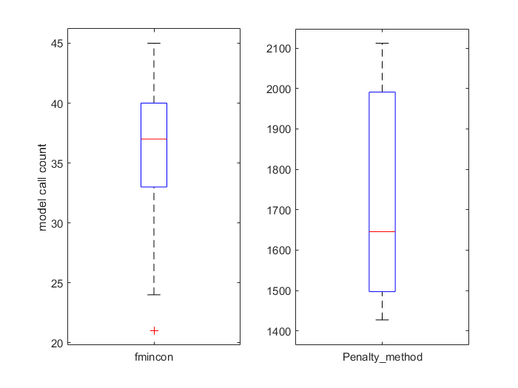

图4 G06计算成本

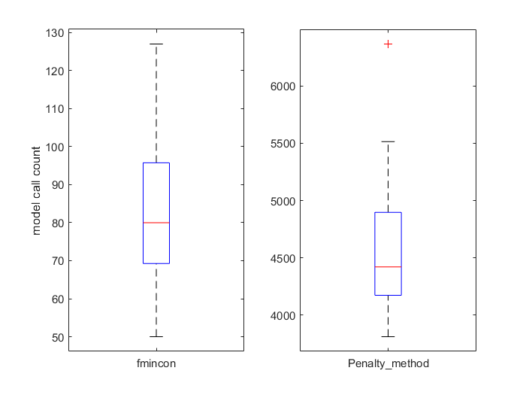

图6 PVD计算成本

罚函数外点法实现简单，但求解效率不如fmincon，即便是简单的线性约束问题G01在求解精度1e-6下模型调用次数基本在fmincon(Interior-Point)的1000倍以上，同时罚函数参数的设置也极大影响罚函数求解。初始罚因子小，有利于向外寻找最优点，减小初始点的影响，但同时也会增加迭代次数。当罚因子增长到足够大时，采用拟牛顿法的无约束优化方法会存在数值求解困难。

Fmincon求解效率高，但对初始点和参数设置敏感，某些情况求不到可行解，需合理选择算法。