1、获取所有运动项目：

[http://159.226.110.64/movementapp/rest/events](http://159.226.110.64/movementapp/rest/events/all)

2、获取某项目(id=1)的新闻：

<http://159.226.110.64/movementapp/rest/events/1/news>

3、获取某项目(id=1)的活动：

<http://159.226.110.64/movementapp/rest/events/1/activities>

4、获取某项目(id=1)的比赛：

<http://159.226.110.64/movementapp/rest/events/1/competitions>

5、获取某项目(id=1)的教程：

<http://159.226.110.64/movementapp/rest/events/1/courses>

6、获取某比赛(id=1)的所有参赛队：

<http://159.226.110.64/movementapp/rest/events/1/competitions/1/competitionteams>

7、创建活动服务:

(POST):<http://159.226.110.64/movementapp/rest/events/3/activities>

参数如图：

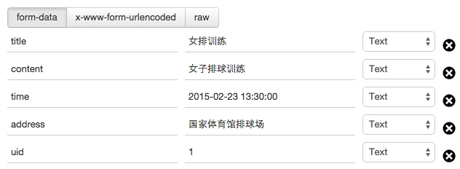

8、参见活动服务:

(POST):<http://159.226.110.64/movementapp/rest/events/1/activities/1/join>

参数如图：

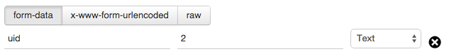

9、获取报名参加活动的人：

(GET):<http://159.226.110.64/movementapp/rest/events/3/activities/1/peoples>

10、获取某项目的所有战队：

(GET):<http://159.226.110.64/movementapp/rest/events/2/teams>

11、创建某项目的战队：(POST):<http://159.226.110.64/movementapp/rest/events/3/teams>

参数如图：

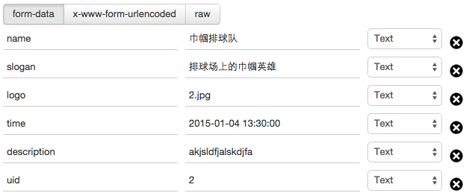

12、申请加入某战队：(POST):<http://159.226.110.64/movementapp/rest/events/3/teams/7/join>

参数如图：

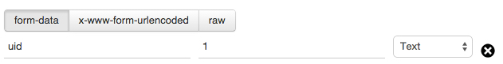

13、获取某战队的所有成员（包括未审核）:

(GET):<http://159.226.110.64/movementapp/rest/events/3/teams/7/members>

14、获取某战队的所有队员：

(GET):<http://159.226.110.64/movementapp/rest/events/3/teams/7/>checkedmembers

15、批准加入战队申请：

(PUT):<http://159.226.110.64/movementapp/rest/events/3/teams/7/members/5/check>

16、拒绝加入战队申请：

(PUT):<http://159.226.110.64/movementapp/rest/events/3/teams/7/members/6/uncheck>

17、获取所有单位:

(GET):<http://159.226.110.64/movementapp/rest/units>

18、获取所有比赛场馆:

(GET):<http://159.226.110.64/movementapp/rest/sites>

19、获取某个单位举办的所有比赛:

(GET):<http://159.226.110.64/movementapp/rest/units/1/competitions>

20、获取某个赛场举办的所有比赛:

(GET):<http://159.226.110.64/movementapp/rest/sites/3/competitions>

21、某个战队请求参加某项比赛:

(POST):<http://159.226.110.64/movementapp/rest/events/1/competitions/1/join>

参数如图：

