- Phần 1: Các lệnh cơ bản thao tác với Docker
- docker –version
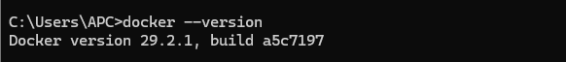
- docker run hello-world
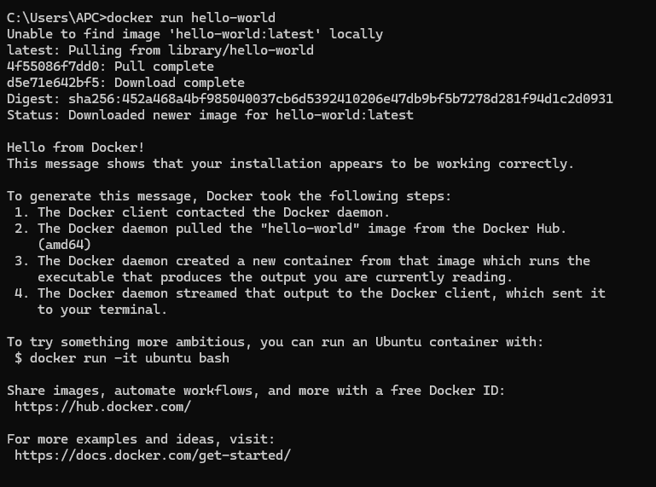
- docker pull nginx
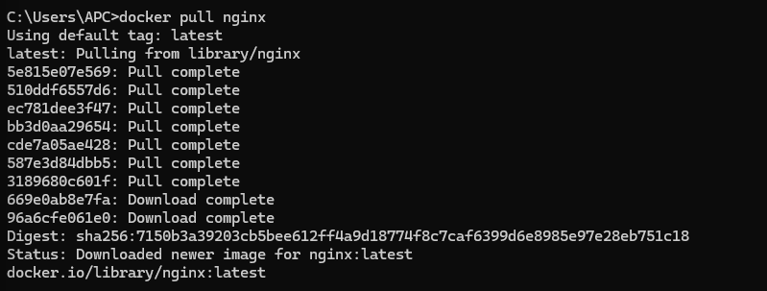
- docker images
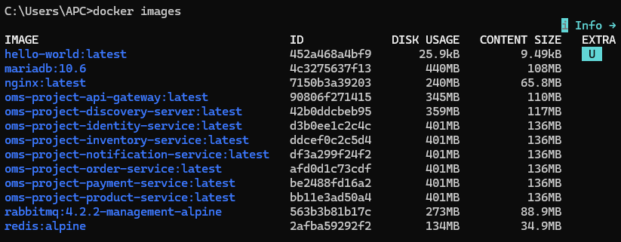
- docker run –d nginx
- docker ps
- docker ps –a
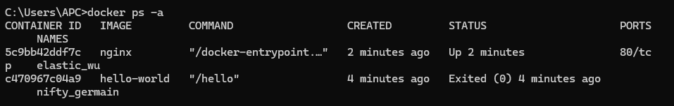
- docker logs <container_id>
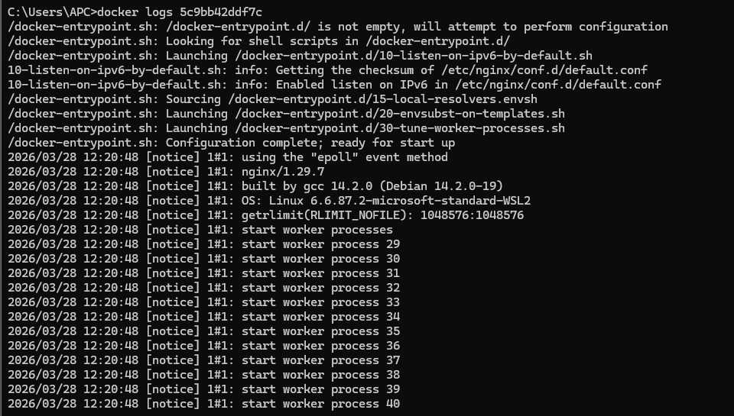
- docker exec –it <container_id> /bin/sh
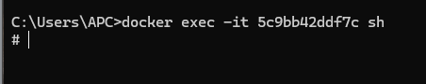
- docker stop <container_id>
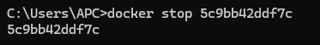
- docker restart <container_id>
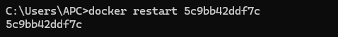
- docker rm <container_id>
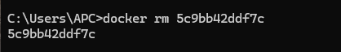
- docker container prune
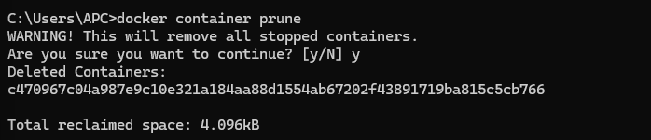
- docker rmi <image_id>
- docker image prune –a
- docker run –d –v

