**FINAL Exam: DATABASE**

**WEP 2022**

**{3h 00}**

15 Mar 2022

* All documents allowed
* Chatting and talking to other students are forbidden
* You are allowed to use PhpMyAdmin or VSCode or any other software
  + *But it is not required*

|  |  |
| --- | --- |
| EXERCICES | POINTS |
| EXERCICE 1 | 50 |
| EXERCICE 2 | 50 |
| **TOTAL** | **100** |

# Exercise 1 – BUS TRAVELS

Before start:

* Open PHPMyAdmin and import the database database/pnc_bus_station.sql

We want to manage the bus trips in Cambodia

# 

**Q1 – (10 POINTS)** Write a query to display the first name and last name of the customers who are in **bus number 2**.

|  |
| --- |
| Select first_name, last_name from Customers where bus_number = 2; |

**Expected result:**

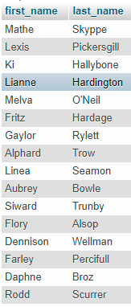

**Q2 – (10 POINTS)** Write a query to **create a view** to display data like expected result of the travels managed by the driver named *“HIM HEY”*.

|  |
| --- |
|  |

**Expected result:**

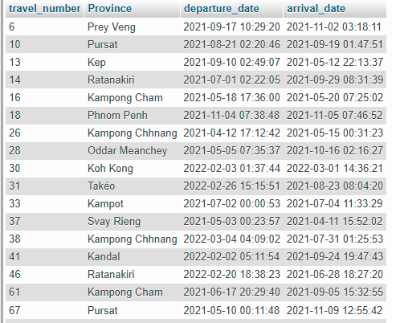

**Q3 – (10 POINTS)** Use the view above to display only the travels of driver *“HIM HEY”* on departure date: **2021-09-17**

*Note: you need to use date function to format datetime in MYSQL.*

*Ex: DATE (“*2021-09-17 10:29:20”) = ”2021-09-17”.

|  |
| --- |
|  |

**Expected result:**



**Q4 – (10 POINTS)** Write the query to display **the number of buses** for each bus model

|  |
| --- |
|  |

**Expected result:**

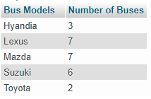

**Q5 – (10 POINTS)** Write query to display the **bus model** include the **first name** and **last name** of the customers who have traveled with bus **number 1**.

|  |
| --- |
|  |

**Expected result:**

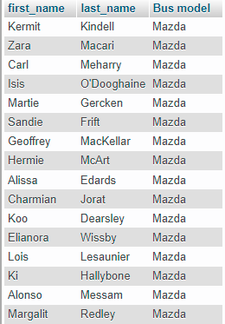

# Exercise 2 – PNC Facebook

We want to create a new **Facebook application** for PNC’s students. Please read the requirements and description of database for this application.

* **Users** are described by their full name, gender, email and password.
* **Posts** are described by their title, description and image (the name of the image file).
* **Comments** are described by their content.
* **Likes** contain user and post information.

Additional information about the relations between entities:

* A user can share many posts.
* A post is created by one user.
* A post can be commented by many users.
* A comment is created by one user.
* A post can have many likes from many users, and one like is related to one post.

**Q1 – (20 POINTS)** Design the ERD Physical Model related to this problem

* Create your ERD in the file EXERCICE-2-ERD.PPTX
* include the keys, types, and all necessary tables

**Q2 – (10 POINTS)** Insert fake data in the database: at least 5 rows in each table.

|  |
| --- |
|  |

**Q3 – (5 POINTS) -** Write a query to display **the user who have posted the most** on PNC Facebook.

|  |
| --- |
|  |

**Q4 – (5 POINTS)** - Create a **view** to show the **title of the post** with the **highest number of likes**

|  |
| --- |
|  |

**Q5 – (10 POINTS) -** Write the query to display, for each comment **on the post of ID 1**, the username of the comment’s author and the comment’s content.

|  |
| --- |
|  |