# Social Media and Civic Engagement

Lani M'cleod

( Irm238 )

[Python Notebooks on GitHub](https://github.com/lanimc/NYCAgencyTwitterData)

Problem

*New forms of social connectivity are presenting new opportunities for government to engage with the public. Agencies are exploring possibilities for new, more transparent, more direct, and more responsive operations. Proponents of the use of social media point to apps and services that increase exchange of information to make agencies more effective. Others challenge the notion that communication through social media is more than just new but transformative. The aim of this paper is to contribute to the debate by looking at what agencies have been communicating and the resulting response from constituents. By looking at tweets of 8 top active agencies on Twitter, I hope to identify shared topics for which agencies are tweeting from their accounts and investigate if these topics are a good prediction for retweets – as a proxy for civic engagement. While any study of social media platforms are subject to critique due to questions of adoption, usage and access, looking at what has been tried and its response among citizens may help agencies proactively navigate in the debate by knowing what topics hold their active constituents attention and what areas need other forms of outreach or engagement.*

Social media has provided government institutions, offices, and officials a new way to engage with citizens. Agencies are providing customer service, public advisories, calendar reminders, service provision, and service assistance. The literature is replete with investigations into the transformative nature of the interactions or the operational impact of those interactions.

Some are bullish about the possibilities on how social media can influence government-citizen interactions. Proponents point to apps and services that increase exchange of information to make agencies more effective, like [nextdoorc.com](http://nextdoorc.com/), a social network that ‘allows for an information exchange between residents and local police.[1]’ IE social media provides new opportunities to interact more transparently at a granular level.

## 

## Others are not as enthusiastic. Dr. Lori Brainard, (associate professor of public policy and public administration, George Washington university) focuses on how “government agencies use the Internet to activate and mobilize for change and to disseminate information, conduct transactions and engage in community building and collaboration.[2]” She does not see social media as transformative in relation to problem solving.

## 

## Conclusions are hard to draw and generalize. Twitter is an entirely different medium that Facebook or Instagram. The popularity of these platforms vary across socio-economic groups and usage can change overnight.  In addition, it’s hard for agencies to innovate in the arena. As James Toscano (vice president fo public affairs and communications at tidewater community college notes, there is ‘organizational bias’ to engage with citizens in more traditional ways like town meetings, notices in newspapers, mail paper notices – local ordinances, agency rules and regulations still mandate communication in person or by mail and aren’t updated to require or include more modern modes of communication.

## 

## This paper contributes to the debate by examining the types of interactions agencies are attempting and the corresponding response by citizens and constituents.  Using NYC agency Twitter data, this study examines what topics are tweeted by 8 operationally cross-sectional NYC city agencies.   It uses the Latent Dirichlet allocation model (LDA), a bayesian inference model to identify topics across all tweets. Then uses these topics to predict the number retweets.

## 

## This study is useful to the debate because it delves into the particular areas agencies can use social media to engage with citizens, who may not be engaged on more traditional platforms. It also illuminates areas that policy makers can work toward transforming for greater engagement. It can act as a tool for agencies to act proactively on these topics in order to engage citizens.

## 

Data Analysis Methods

We first took a cursory look at the the NYCOpenData dataset ‘NYC Social Media Usage’ provided by the Mayor's Office of Media And Entertainment (MOME) at <https://data.cityofnewyork.us/Recreation/NYC-Social-Media-Us>. This data set listed the likes, tweets, posts, downloads and followers of NYC agencies from 2011-2012 that had a social media presence across several platforms such as Twitter, Facebook, Instagram and LinkedIn. I used this data to gage social media usage across city agencies. The top eight agencies were pulled that represented operational, administrative, emergency and service constituency specific missions. This ‘stratified sample’ was done in order to get the most diversity in types of tweets issued. The Twitter API was then used to pull back the twitter profiles.

The data in the table below was pulled through the twitter api, last updated on 12/12. It represents the current twitter follower and status counts for the selected agencies.

|  |  |  |  |  |  |
| --- | --- | --- | --- | --- | --- |
| name | followers_count | statuses_count | description | expanded_url | created_at |
| NYC Mayor's Office | 575,432 | 16,867 | Live from City Hall, in the greatest city on e... | http://www.NYC.gov | Thu Jul 09 |
| City of New York | 708,426 | 18,537 | Official New York City government Twitter. Kee... | http://nyc.gov | Sat Feb 12 |
| NYPD NEWS | 267,340 | 13,499 | The official Twitter of the New York City Poli... | http://www.nyc.gov/nypd | Fri Nov 14 |
| FDNY | 180,236 | 26,392 | The official New York City Fire Department fee... | http://www.nyc.gov/fdny | Mon Apr 19 |
| NYC Public Schools | 97,282 | 10,640 | NYC Department of Education, serving 1.1 milli... | http://schools.nyc.gov | Thu Feb 26 |
| NYC Parks | 167,703 | 11,628 | New York City Department of Parks & Recreation... | http://nyc.gov/parks | Thu Apr 09 |
| NYCEM | 37,752 | 6,641 | The official Twitter feed of NYC Emergency Man... | http://www.nyc.gov/oem | Tue Dec 14 |
| NYCHA | 19,110 | 15,548 | With over 400,000 residents living in 177,666 ... | http://www.nyc.gov/nycha | Fri Mar 26 |
| New York City 311 | 191,278 | 24,034 | 311 is your source for New York City non-emerg... | http://www.nyc.gov/311 | Mon May 04 |

## The most recent 3200 tweets were pulled from Twelt.com (there were nagging timeout issues with my python code when attempting to pull back the tweets through python). The LDA method, a model that treats a topic as a discrete distribution of words with a probability with concentration and base measure, was used to identify groups of words that formed a topic across all tweets.

## Determining the right number of topics was through trial and error. The LDA model was run several times over a test set of the data at varying alpha and number of topics and number of passes as shown below. Cross validation against training data was attempted but not successful due to the size of the dataset (again timeout and kernel stopping issues occurred). From the trial and error, the higher number of passes led to a greater accuracy in results. Number of topics were tried from 40 down to 5. A final number of 7 was chosen. Each tweet has it’s own distribution over topics given by probabilities from the model.

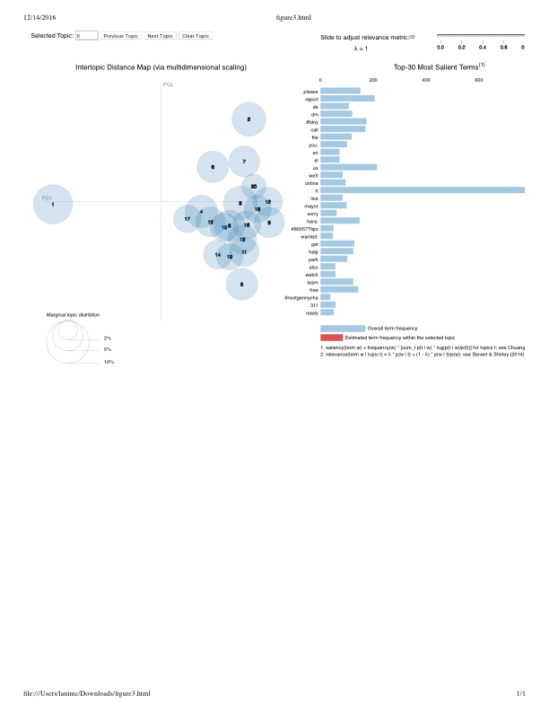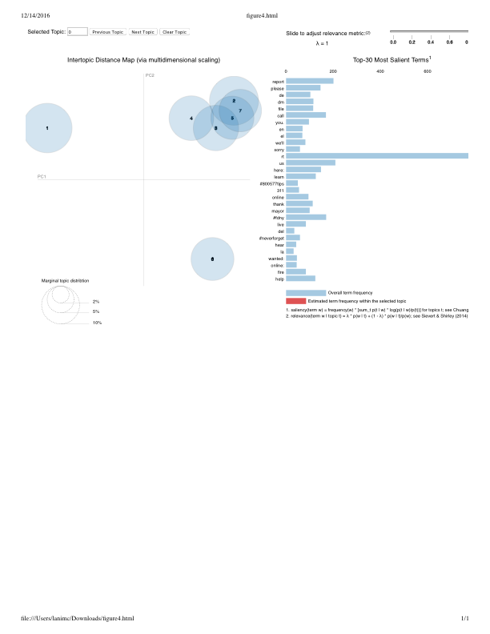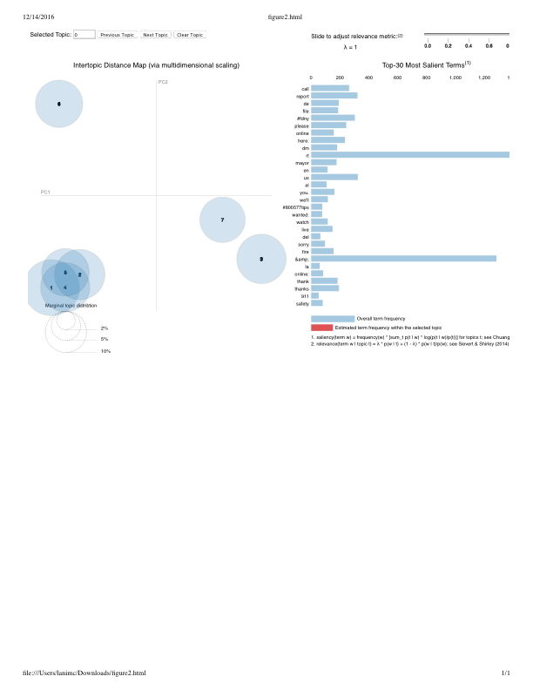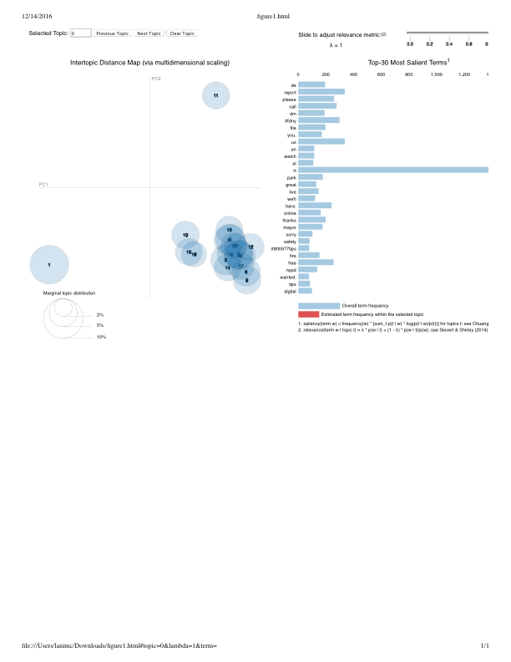

A numpy matrix was extracted from the LDA model listing each tweets probability of belonging to the final list of 7 topics. The probability distributions were treated as features against the number of retweets[3]. An ordinary least squares regression was run, checked for dimensionality reduction using principal component analysis and reran the regression with significant features.

## Findings

The table below shows the final 7 topics nd their probabilities

|  |  |  |
| --- | --- | --- |
|  | topicnum | wordprob |
| 0 | 0 | 0.026*"&amp;" + 0.019*"rt" + 0.016*"learn" + 0.013*"call" + 0.010*"#800577tips" + 0.009*"visit" + 0.008*"wanted:" + 0.008*"great" + 0.008*"find" + 0.007*"happy" |
| 1 | 1 | 0.033*"&amp;" + 0.031*"report" + 0.026*"please" + 0.023*"us" + 0.021*"dm" + 0.021*"file" + 0.019*"call" + 0.017*"you." + 0.014*"here:" + 0.014*"we'll" |
| 2 | 2 | 0.046*"rt" + 0.016*"&amp;" + 0.011*"mayor" + 0.010*"#fdny" + 0.009*"#neverforget" + 0.008*"live" + 0.008*"thank" + 0.006*"members" + 0.006*"today" + 0.006*"watch" |
| 3 | 3 | 0.020*"&amp;" + 0.016*"rt" + 0.011*"#fdny" + 0.011*"help" + 0.007*"park" + 0.007*"w/" + 0.007*"fire" + 0.006*"sign" + 0.006*"#nextgennycha" + 0.005*"day" |
| 4 | 4 | 0.032*"rt" + 0.024*"&amp;" + 0.009*"free" + 0.009*"here:" + 0.007*"also" + 0.007*"we're" + 0.006*"digital" + 0.006*"park" + 0.006*"report" + 0.006*"nypd" |
| 5 | 5 | 0.031*"rt" + 0.012*"get" + 0.010*"&amp;" + 0.009*"#fdny" + 0.009*"free" + 0.007*"help" + 0.007*"live" + 0.007*"today" + 0.006*"see" + 0.006*"find" |
| 6 | 6 | 0.036*"rt" + 0.027*"&amp;" + 0.024*"de" + 0.017*"en" + 0.016*"el" + 0.008*"find" + 0.008*"del" + 0.008*"la" + 0.006*"info" + 0.006*"free" |

It is difficult to determine the topics from the words provided. Further clean up of words or different tokenization could clean up the issue.

Topic 0: Get help here – customer service notice

Topic 1: Call to action

Topic 2: 911 rememberance?

Topic 3: Tweets notifying constituents of the agencies presence on twitter

Topic 4: another customer service type

Topic 5: Event notification

Topic 6: How to

## Further review could include the same type of analysis on many of the other social media platforms from which agencies are engaging their constituents. In addition, further analysis into agency followers or retweet-ers, in particular, could provide additional insights. Are ordinary citizens engaging with agencies over social media or do organized entities, like journalists, non-profit organizations, or academics, make up most of an agencies followers? And if so, how does this affect the retweet rate by topic?

## Annotated Bibliography

Mossberger, Karen, Yonghong Wu, and Jared Crawford. "Connecting citizens and local governments? Social media and interactivity in major US cities." Government Information Quarterly 30.4 (2013): 351-358.

This paper looks at the use of social networks and other interactive tools in 75 large cities between 2009 and 2011.

Bonsón, Enrique, et al. "Local e-government 2.0: Social media and corporate transparency in municipalities." Government information quarterly 29.2 (2012): 123-132.

This paper looks at the use of ‘Web 2.0 tools in EU local governments to determine whether local governments are using the web to increase transparency and participation.

Mainka, Agnes, et al. "Government and social media: A case study of 31 informational world cities." 2014 47th Hawaii International Conference on System Sciences. IEEE, 2014.

This paper looks at 31 cities around the world and describes how they are using social media.

Qualman, Erik. *Socialnomics: How social media transforms the way we live and do business*. John Wiley & Sons, 2010.

This book looks at the way social media affects the way people behave.

Tufekci, Zeynep, and Christopher Wilson. "Social media and the decision to participate in political protest: Observations from Tahrir Square." *Journal of Communication* 62.2 (2012): 363-379.

This paper looks at social media and the Tahrir Square protests in Cairo.

Juris, Jeffrey S. "Reflections on# Occupy Everywhere: Social media, public space, and emerging logics of aggregation." *American Ethnologist* 39.2 (2012): 259-279.

This article looks at social media and the occupy movement.

Virtual Government–Citizen Relations Informational, Transactional, or Collaborative?

Brainard, Lori A., and John G. McNutt. "Virtual Government–Citizen Relations Informational, Transactional, or Collaborative?." *Administration & society* 42.7 (2010): 836-858.

## Data sources

[www.twelt.com](http://www.twelt.com) - tweets

[www.twitter.com](http://www.twitter.com) - agency handles and profile summary data

[www.opendatanyc.gov](http://www.opendatanyc.gov) - 2011-2012 social media platform counts of city agencies

1. http://www.govtech.com/social/Does-Social-Media-Help-the-Government-Citizen-Relationship-Depends-Who-You-Ask-.html
2. Virtual Government–Citizen Relations Informational, Transactional, or Collaborative?

   Brainard, Lori A., and John G. McNutt. "Virtual Government–Citizen Relations Informational, Transactional, or Collaborative?." *Administration & society* 42.7 (2010): 836-858.
3. The list of tweets was truncated due to memory issues. Kernel kept dying.