1. Title Page
Coffee Sales Analytics and Forecasting System

Submitted by
Jyoti Ramesh Lanjewar

Submitted To
Unified Mentor Pvt. Ltd.

Master of Computer Applications (MCA)

Submission Year: 2026

2. Abstract

This project focuses on analyzing and forecasting coffee shop sales using data analytics and machine learning techniques. The system stores coffee sales data in a MySQL database and processes it using Python and the Pandas library. An interactive dashboard built with Streamlit visualizes historical sales trends and key performance metrics such as total revenue and number of orders. A machine learning model based on Linear Regression is implemented to predict future sales for the upcoming days. The project demonstrates how data collection, processing, visualization, and predictive modeling can be integrated to provide meaningful insights. This system helps businesses understand sales patterns and supports better data-driven decision-making.
3.Introduction
Data analytics plays an important role in helping businesses understand their sales trends and customer behavior. Coffee shops generate large amounts of sales data every day, and analyzing this data can help business owners make better decisions regarding inventory, marketing, and future planning.
The Coffee Sales Analytics and Forecasting System is a data analytics project developed using Python, MySQL, and Streamlit. The system collects coffee sales data, stores it in a structured database, performs analysis on the data, and visualizes the results through an interactive dashboard. In addition to analyzing historical data, the system also uses a machine learning model to predict future sales trends.
This project demonstrates how data engineering, data analysis, visualization, and machine learning can work together to build a complete analytics solution.

4. Objectives of the Project
The main objectives of this project are:
• To store coffee shop sales data in a structured database
• To analyze sales data using Python
• To visualize historical sales using interactive charts
• To build a machine learning model to forecast future sales
• To present results using a dashboard interface
• To manage the project using Git and GitHub

5. Technologies Used
The following technologies were used in the development of this project:
Python
Python is the primary programming language used for data processing, analysis, and machine learning.
MySQL
MySQL is used to store coffee sales data in a structured relational database.
Pandas
The Pandas library is used for data manipulation and analysis.
Streamlit
Streamlit is used to build an interactive web dashboard for data visualization.
Scikit-learn
Scikit-learn is used to build the machine learning model that predicts future coffee sales.
Git and GitHub
Git is used for version control and GitHub is used to store and share the project repository.

6. Database Design
The project uses a MySQL database called:
coffee_sales_db
Inside this database, a table named sales stores all the coffee sales records.
The table contains the following columns:
Column Name | Description
id | Unique identifier for each sale
sale_date | Date when the coffee was sold
sale_datetime | Exact date and time of the sale
coffee_name | Type of coffee sold
cash_type | Payment method (Cash or Card)
money | Amount of money received for the sale
This table structure allows efficient storage and retrieval of sales information.
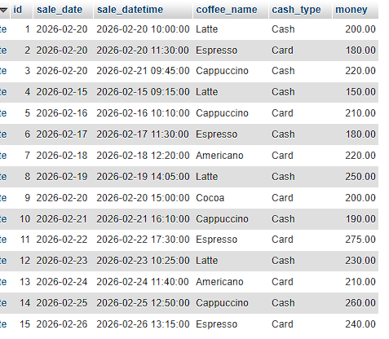

7. Project Architecture
The project is organized into multiple folders to maintain a clean and structured codebase.
Project Folder Structure
coffee-sales-analytics
│
├── dashboard
│ └── app.py
│
├── src
│ ├── analytics.py
│ ├── db_connection.py
│ ├── etl.py
│ ├── ml_model.py
│ └── report_generator.py
│
├── database
│ ├── schema.sql
│ └── sample_data.sql
│
├── data
│ └── coffee_sales.xlsx
│
├── reports
│
├── screenshots
│
├── requirements.txt
├── README.md
└── LICENSE
Each folder serves a specific purpose:
• src contains the main Python scripts for data processing and machine learning
• dashboard contains the Streamlit dashboard application
• database contains SQL files for database structure
• data contains the Excel dataset
• reports contains generated reports
• screenshots stores project screenshots

8. Data Processing
The sales data is processed using Python scripts. The system reads sales data from the MySQL database and converts it into a Pandas DataFrame for analysis.
Key steps in data processing include:
- Connecting to the MySQL database
- Retrieving sales data from the sales table
- Cleaning and formatting the data
- Preparing the dataset for visualization and machine learning
Pandas is used to perform calculations such as total revenue, total orders, and grouping sales by coffee type.
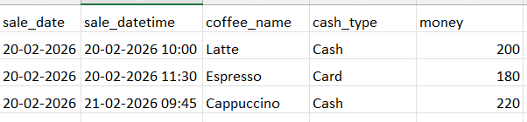

9. Dashboard Visualization
An interactive dashboard was built using Streamlit to visualize the sales data.
The dashboard provides several features including:
• Displaying total revenue
• Showing the number of orders
• Identifying the most popular coffee type
• Visualizing historical sales trends using line charts
These visualizations help users quickly understand sales patterns.
Historical Sales Chart:
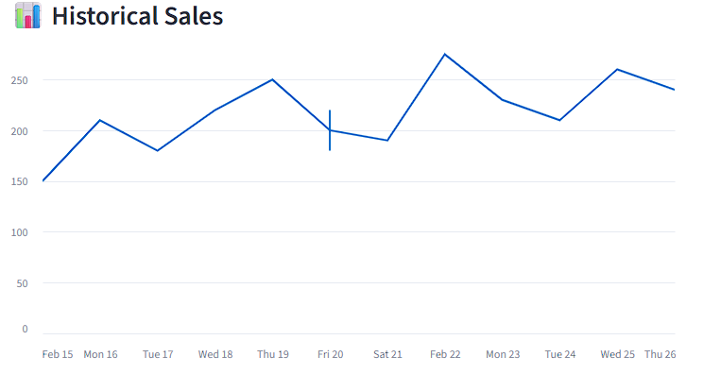

10. Machine Learning Sales Forecast
To predict future sales, a machine learning model was implemented using the Linear Regression algorithm from the Scikit-learn library.
The model uses historical sales data to learn patterns and generate predictions.
Steps in the Forecasting Process
- Extract sales dates from the database
- Convert dates into numerical format
- Train the linear regression model using historical data
- Generate predictions for the next 7 days
The trained model is saved as a file named:
sales_model.pkl
This allows the model to be reused without retraining every time the dashboard runs.
The dashboard displays predicted sales for the upcoming week.
Forecast Chart:
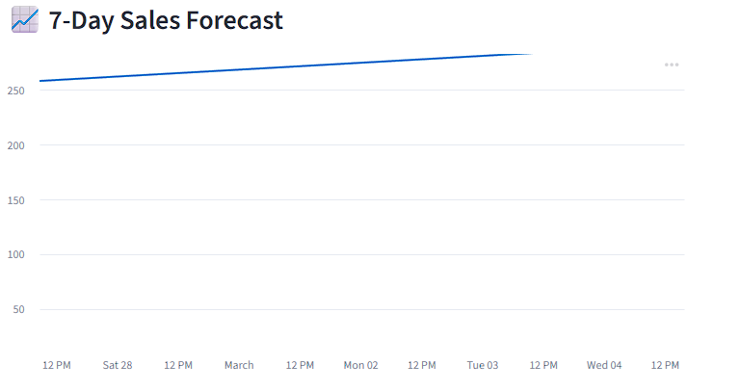

11. GitHub Repository
The entire project is stored in a GitHub repository using Git for version control.
GitHub allows the project to be shared, tracked, and maintained efficiently.
Key benefits include:
• Version tracking
• Easy collaboration
• Public project sharing
• Professional portfolio development
The repository contains all project files including code, documentation, and datasets.

12. Results
The project successfully achieved the following outcomes:
• Created a structured MySQL database for coffee sales
• Built Python scripts for data analysis
• Developed an interactive dashboard using Streamlit
• Implemented a machine learning model for sales forecasting
• Hosted the project on GitHub
The dashboard allows users to analyze historical sales and view predicted sales trends.

11. Conclusion
The Coffee Sales Analytics project demonstrates how data analytics and machine learning can be applied to real-world business scenarios. By combining database management, data processing, visualization, and predictive modeling, the system provides valuable insights into coffee sales patterns.
The project also highlights the importance of modern tools such as Python, MySQL, Streamlit, and GitHub in building complete data analytics solutions.
This system can be further enhanced by adding more advanced forecasting models, real-time data integration, and more detailed business analytics.

12. Future Improvements
The following improvements can be made in the future:
• Integration of real-time sales data
• Advanced machine learning models such as ARIMA or Prophet
• Customer analytics and behavior analysis
• Inventory prediction based on sales trends
• Deployment of the dashboard to a cloud platform
These improvements would make the system more powerful and useful for real business applications.

