DESIGN AND ANALYSIS OF ALGORITHMS
Mini Project Report
PROBLEM 63
DRONE DELIVERY PATH PLANNER
Battery-, Distance- and Priority-Constrained Route Planning
Core Algorithms: Dijkstra | Traveling Salesperson Problem | Priority Queue
Technologies: Python | Flask | React | Leaflet
Field | Details
PROBLEM STATEMENT | DRONE DELIVERY PATH PLANNER
Course | Design and Analysis of Algorithms
Department | CSE-(AI&ML)
Institution | MALLA REDDY TECHNICAL CAMPUS
Academic Year | 2026 - 2027

Table of Contents
Contents
Section | Page
Abstract | 3
1. Introduction | 4
2. Problem Statement, Objectives and Scope | 6
3. Features and Functional Requirements | 8
4. Algorithms and Methodology | 10
5. Technologies and Implementation | 14
6. Results, Testing and Performance | 17
7. Conclusion, Future Scope and References | 22

List of Figures
- Figure 1. System architecture of the planner
- Figure 2. Planning pipeline (admission, sequencing, battery validation)
- Figure 3. Planned route for the 10-order scenario on the 30-node map
- Figure 4. Running time of TSP solvers versus number of stops
- Figure 5. Tour length of exact and heuristic TSP solvers

List of Tables
- Table 1. Functional requirements
- Table 2. Non-functional requirements
- Table 3. Algorithm roles and complexity
- Table 4. REST API endpoints
- Table 5. Scenario A orders and result
- Table 6. Scenario B (overload) result
- Table 7. Test cases and outcomes
- Table 8. TSP solver comparison
- Table 9. Dijkstra scalability

Abstract
Commercial drone delivery is attractive because it avoids road congestion and reaches customers quickly, but it is bounded by a hard physical limit: the battery. A drone that departs with a full load of parcels and too little energy to finish its round trip is a lost aircraft, so a delivery planner must treat the battery budget as a constraint that cannot be violated rather than as a cost to be minimised. At the same time, operators promise faster service for urgent orders, so the plan must respect delivery priority, and it should keep total flying distance low to save energy and time.
This report presents the design, implementation and evaluation of the Drone Delivery Path Planner, an algorithm-centric prototype that plans a single-drone delivery sortie from a depot. The system models the service area as a weighted graph and uses three core algorithms. Dijkstra's algorithm with a binary-heap priority queue computes least-distance flight paths between the depot and every delivery point. A priority queue admits orders one at a time, most urgent first, so that urgent parcels are never displaced by convenient ones. The Traveling Salesperson Problem (TSP) is then solved to order the accepted stops: exactly, with the Held-Karp dynamic programme, and heuristically, with nearest neighbour refined by 2-opt, so that the two approaches can be compared. After every admission the complete round trip is re-sequenced and its energy is evaluated using a payload-aware model in which a drone becomes cheaper to fly as it drops parcels. Any order whose inclusion makes the route exceed the usable battery budget is rejected, and the reason is reported to the user.
The prototype was implemented in Python and evaluated on a 30-node, 170-edge map. In a ten-order scenario the planner accepted seven orders, rejected three, and produced a 22.45 km route consuming 496.2 Wh against a 510 Wh budget. In an overloaded scenario in which the full set of twelve orders would have required 2,872.7 Wh, the planner correctly rejected seven orders and returned a feasible 449.5 Wh route. Held-Karp matched brute force on every tested instance while running about 185 times faster at nine stops; nearest neighbour alone was up to 29.5% longer than optimal, while 2-opt closed the gap to at most 0.5% in all tests. Twelve automated tests all passed. A Flask REST service and a React/Leaflet front end present the plan visually, making each decision (selected path, visit order, accepted and rejected orders, energy used) visible to the user.
Keywords:
Drone delivery, Dijkstra's algorithm, Traveling Salesperson Problem, Held-Karp, priority queue, battery constraint, route planning, Flask, React, Leaflet.

1. Introduction

1.1 Background
Unmanned aerial vehicles (UAVs), commonly called drones, are moving from hobby and surveillance use into logistics. Retailers, pharmacies and food-delivery operators are piloting multirotor drones that carry small parcels over distances of a few kilometres. Compared with road vehicles, drones fly in near-straight lines, are unaffected by traffic and can reach locations that are slow to access by road. Compared with conventional vehicles, however, they have three severe limitations: a small payload capacity, a short flight endurance determined by battery energy, and a high operating cost per hour. Because of the last two, every flight must be planned carefully.
Route planning for a drone is a classic combination of problems studied in the Design and Analysis of Algorithms. Finding the best way from one location to another is a shortest-path problem. Deciding the order in which several customers should be visited and returning to the depot is the Traveling Salesperson Problem, which is NP-hard. Deciding which request to serve next when many are waiting is a scheduling problem that is naturally solved with a priority queue. A practical planner must combine all three and add a feasibility check for battery energy.

1.2 Motivation
Most textbook treatments present these algorithms in isolation, returning a single number such as a shortest distance or a tour cost. A user of a delivery system, however, wants to know which parcels will be delivered, in what order, along what path, how much battery will remain, and why a particular order was turned down. This project therefore converts the real-world requirement into a working prototype that makes its decisions visible. The emphasis is on being understandable and explainable, not merely on returning a final value.

1.3 Overview of the Proposed System
The Drone Delivery Path Planner accepts a map of locations connected by flight corridors with known lengths, a set of delivery orders each with a destination, a parcel weight and a priority, and the parameters of a drone (battery capacity, energy consumption and safety reserve). It then performs the following steps.
- Shortest paths. Dijkstra's algorithm computes the least-distance flight path between the depot and every delivery location and between every pair of delivery locations.
- Priority admission. A min-heap priority queue releases orders in order of urgency; ties are broken by distance from the depot.
- Sequencing. The accepted stops are arranged by a TSP solver into a closed tour starting and ending at the depot, with higher-priority classes served first.
- Battery validation. The energy required by the complete tour is computed. If it exceeds the usable budget the newly considered order is rejected and the previous feasible plan is retained.
- Explanation. The result lists the visit order, the full flight path, total distance, energy used, remaining battery and every rejected order with its reason.

1.4 Organisation of the Report
Section 2 states the problem, objectives and scope. Section 3 lists the features and functional requirements. Section 4 describes the algorithms and methodology in detail, including the energy model, pseudocode, a worked example and complexity analysis. Section 5 describes the technologies and implementation of the back end and front end. Section 6 reports test results and performance measurements. Section 7 concludes the report, discusses future scope and lists references.

1.5 Related Work
Drone routing is generally modelled as a variant of the Vehicle Routing Problem (VRP). Dorling et al. studied multi-trip drone delivery with energy as a function of payload and battery weight, showing that energy per kilometre grows with the mass carried; this project adopts the same qualitative payload dependence in a simplified linear form. Murray and Chu introduced the Flying Sidekick Traveling Salesman Problem, in which drones cooperate with trucks. Industrial solvers use branch-and-cut, column generation or metaheuristics for fleets of vehicles. The present prototype deliberately concentrates on a single drone so that the behaviour of each classic algorithm, rather than the machinery of a large solver, remains the focus of the study.

2. Problem Statement, Objectives and Scope

2.1 Problem Statement
Plan drone deliveries with distance, battery and priority constraints. Reject routes that exceed the battery budget.
Formally, let G = (V, E, w) be an undirected weighted graph in which V contains the depot v0 and a set of candidate delivery points, E contains the flight corridors, and w(u, v) is the non-negative length of corridor (u, v) in kilometres. Let O be a set of delivery orders. Each order o has a destination d(o) in V, a weight m(o) in kilograms and a priority class p(o) in {1, 2, 3}, where 1 is the most urgent. A drone starts at v0 with usable energy budget B and must fly a closed tour through the destinations of a subset S of O and return to v0.
The energy used on a leg depends on the payload carried during that leg. If the drone carries a load of m kilograms across a leg of length d, it consumes d × (e0 + e1 × m) watt-hours, where e0 is the empty-drone consumption per kilometre and e1 is the additional consumption per kilometre per kilogram. The planner must find a subset S and a visiting order such that:
- the total energy of the tour does not exceed B (hard constraint);
- orders of a more urgent class are never served after orders of a less urgent class (priority constraint);
- the number of accepted orders is as large as the battery permits, urgent orders first (admission objective); and
- among feasible tours, the total flying distance is minimal (optimisation objective).

2.2 Detailed Description
The prototype converts the real-world requirement into an algorithm-centric system. The user supplies the entities (depot and delivery locations), the relationships (corridors and their lengths), the resource values (battery capacity, consumption rates, parcel weights) and the priorities. These are held in appropriate data structures: an adjacency list for the graph, a dictionary for the order book, a heap for the priority queue and a distance matrix for the TSP. The central aim is to return a solution that is understandable to the user. The system therefore reports selected paths, visit orders, accepted and rejected orders, the objective value and the information needed to justify the result.
A priority queue repeatedly selects the most urgent order. The priority criteria are explicit: the primary key is the priority class, and the secondary key is the straight-line corridor distance from the depot, so that nearer parcels are tried first within a class. Dijkstra's algorithm calculates the least-cost path because all corridor lengths are non-negative; it maintains tentative distances, repeatedly selects the currently cheapest unexplored node and reconstructs the path through predecessor links. The TSP formulation represents the required visit sequence and total travel cost, prevents repeated visits to a delivery point and returns to the depot, which is the required starting point.

2.3 Objectives
- Demonstrate the selected DAA algorithms (Dijkstra, TSP and priority queue) and compare their behaviour where more than one approach is provided: exact Held-Karp versus brute force versus the nearest-neighbour and 2-opt heuristics.
- Present the final result clearly so that users can understand the solution produced by the algorithm: visit order, paths on a map, distance, energy and rejections.
- Enforce the battery budget as an inviolable constraint and give an explicit reason whenever an order is rejected.
- Respect delivery priority so that urgent parcels are always planned before less urgent ones.
- Verify correctness through automated tests, and measure running time and solution quality on instances of increasing size.
- Provide a web interface, built with Flask, React and Leaflet, through which a user can enter orders and view the plan.

2.4 Scope
In scope:
- Single drone, single depot, single sortie per plan; one parcel per destination.
- Static map with symmetric, non-negative corridor lengths; edges represent permitted flight corridors, which are shorter than or equal to ground distance.
- Linear payload-dependent energy model with a fixed safety reserve.
- Exact TSP for up to about sixteen stops and heuristics beyond that.
- Visualisation of routes on an interactive map.
Out of scope:
- Multiple drones, multi-trip recharging and truck-drone cooperation.
- Dynamic wind, weather, no-fly zones changing in real time and live air-traffic integration.
- Time windows and hardware control of real drones.

2.5 Assumptions and Constraints
Table: Model parameters used in the prototype
Parameter | Value used | Meaning
Battery capacity | 600 Wh | Total energy stored on board
Safety reserve | 15 % | Energy never planned for use (emergency landing, wind)
Usable budget B | 510 Wh | Capacity x (1 - reserve)
e0 | 10 Wh/km | Empty-drone consumption
e1 | 3 Wh/km/kg | Additional consumption per kilogram carried
Map | 10 km x 10 km | 30 nodes, 170 corridors (nodes within 4.2 km linked), depot at centre

3. Features and Functional Requirements

3.1 Principal Features
- Interactive map. Depot, waypoints and delivery locations are drawn on a Leaflet map; flight corridors and the planned route are overlaid in distinct colours.
- Order entry. The user selects a destination, parcel weight and priority class for each order, or loads a sample scenario.
- Least-distance paths. Dijkstra finds the shortest flight path between any two nodes using a binary heap with lazy deletion.
- Priority-aware admission. A min-heap priority queue controls the order in which requests are considered for inclusion.
- Optimal and heuristic tours. The user can choose Held-Karp (exact), nearest neighbour or nearest neighbour with 2-opt, and compare results.
- Battery feasibility checking. The payload-aware energy of the complete tour is calculated and compared with the usable budget; routes that exceed it are rejected.
- Explainable output. For every order the system shows whether it was accepted or rejected and why; for the plan it shows distance, energy, remaining battery and the visiting order.
- Algorithm comparison panel. Run-time and tour length are shown side by side for each TSP solver.

3.2 Functional Requirements
Table 1. Functional requirements
ID | Requirement | Priority
FR1 | Load or create a graph with a depot, waypoints and weighted corridors. | High
FR2 | Accept delivery orders with destination, weight and priority class. | High
FR3 | Compute least-distance paths between the depot and all destinations and between destinations using Dijkstra. | High
FR4 | Release orders from a priority queue ordered by (priority class, distance from depot). | High
FR5 | Sequence accepted stops as a closed tour from and to the depot, with no repeated visits. | High
FR6 | Serve priority classes in non-decreasing order of class number. | High
FR7 | Compute tour energy with payload decreasing after each drop. | High
FR8 | Reject any order whose inclusion makes the route exceed the battery budget and report the reason. | High
FR9 | Allow the user to choose the TSP solver and compare results. | Medium
FR10 | Display the plan on a map and in a table (order, path, distance, energy). | High
FR11 | Expose planning through a REST API returning JSON. | Medium
FR12 | Handle edge cases: empty order list, unreachable destination, over-weight single parcel. | High

3.3 Non-Functional Requirements
Table 2. Non-functional requirements
ID | Requirement | Target
NFR1 | Correctness: planner output equals reference algorithms on test instances | 100 % of tests pass
NFR2 | Responsiveness: plan for up to 12 orders returns | < 1 s
NFR3 | Explainability: every rejection carries a reason | Always
NFR4 | Scalability: shortest paths on a 5,000-node map | < 0.1 s
NFR5 | Usability: a new user can submit an order and read the plan without training | Qualitative
NFR7 | Maintainability: algorithms isolated from the web layer in one module | Yes

3.4 Users and Use Cases
The primary user is a dispatcher at a delivery hub who enters the day's orders and wants a feasible, explainable plan. A secondary user is a student or instructor who uses the comparison panel to study the algorithms. The main use cases are as follows.
- UC1 - Plan a sortie. The dispatcher enters orders, presses Plan, and receives a route with accepted and rejected orders.
- UC2 - Inspect a rejection. The dispatcher selects a rejected order and sees that including it would push the route energy above the 510 Wh budget.
- UC3 - Compare solvers. The user runs the same orders under brute force, Held-Karp, nearest neighbour and 2-opt and compares distances and times.
- UC4 - Change drone parameters. The user edits battery capacity, reserve or consumption to see how the accepted set changes.

3.5 Input and Output Specification
Input: a JSON document containing the list of orders, each with a node identifier, weight in kilograms and priority class, and optionally overriding drone parameters and the solver name. Output: a JSON document with the ordered list of stops, the full node-by-node path, total distance, total energy, remaining energy, the list of accepted orders and the list of rejected orders with reasons. The same data drive the table and the map overlay in the web interface.

4. Algorithms and Methodology

4.1 Overall Methodology
The planner is organised as a pipeline (Figure 2). Stage 1 pre-computes shortest paths among the key nodes (depot plus destinations). Stage 2 uses a priority queue to consider orders one at a time. Stage 3 sequences the currently accepted orders as a tour. Stage 4 evaluates the tour's energy and either keeps or rejects the candidate order. Splitting the problem this way means each classic algorithm solves exactly the sub-problem it is best suited for.
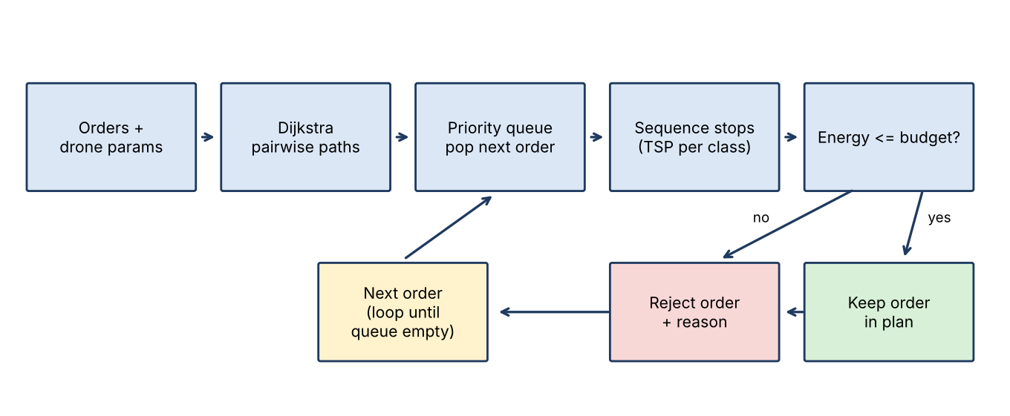
Figure 2. Planning pipeline (admission, sequencing, battery validation)

4.2 Data Structures
- Graph: adjacency list, adj[u] = list of (v, w). It uses O(V + E) memory and supports efficient neighbour iteration for Dijkstra.
- Order book: dictionary mapping destination node to (priority, weight).
- Priority queue: binary min-heap storing tuples (priority class, distance from depot, node). Python tuples compare lexicographically, which implements the two-key rule naturally.
- Distance matrix: dictionary D[(a, b)] of shortest-path distances between key nodes, used by the TSP solvers.
- Predecessor map: prev[v] from Dijkstra, used to reconstruct the node-by-node flight path.

4.3 Energy Model
For a tour (v0, c1, ..., ck, v0), the drone departs carrying L0 = m(c1) + ... + m(ck) kilograms. The energy for the leg from a to b is D(a, b) × (e0 + e1 × L), where L is the load carried on that leg. After arriving at ci the parcel m(ci) is released and L decreases. Therefore:
E(tour) = sum over legs of D(a, b) × (e0 + e1 × L_leg)
The tour is feasible if E(tour) <= B = capacity × (1 - reserve). This model captures the practical observation that delivering heavy parcels early is expensive and that the return leg is cheap because the drone is empty. It also means that the distance-optimal tour is not always the energy-optimal one; the planner sequences by distance and then evaluates the energy of the tour that would actually be flown, so the budget guarantee holds for the delivered route (see the limitations in Section 7).

4.4 Dijkstra's Algorithm for Least-Distance Paths
Dijkstra's algorithm solves the single-source shortest-path problem on a graph with non-negative weights, which is exactly the situation here because corridor lengths cannot be negative. The algorithm maintains a tentative distance dist[v] for every node, initially infinity except dist[source] = 0. It repeatedly extracts from a priority queue the node u with the smallest tentative distance, which is then final, and relaxes each outgoing edge (u, v, w): if dist[u] + w < dist[v], dist[v] is lowered and prev[v] = u. When the queue is empty, dist holds the shortest distances and prev can be followed backwards from any target to reconstruct its path.
function DIJKSTRA(G, s):
for each v in V: dist[v] <- INF; prev[v] <- NIL
dist[s] <- 0; PQ <- min-heap {(0, s)}
while PQ not empty:
(d, u) <- EXTRACT-MIN(PQ)
if d > dist[u]: continue # stale entry
for each (v, w) in adj[u]:
if dist[u] + w < dist[v]:
dist[v] <- dist[u] + w; prev[v] <- u
INSERT(PQ, (dist[v], v))
return dist, prev

Correctness follows from the greedy-choice property: when u is extracted with the smallest tentative distance, no path through an unexplored node can be shorter, because all edge weights are non-negative. With a binary heap and lazy deletion, the running time is O((V + E) log V). One Dijkstra run is made from the depot and from every delivery node, giving the pairwise matrix required for the TSP in O(k (V + E) log V) time for k key nodes.

4.5 Priority Queue for Order Admission
A min-heap provides insertion and extraction of the minimum in O(log n). Each order is pushed as (priority class, distance from depot, node). The planner pops orders one by one: all class 1 orders are considered before any class 2 order, and within a class, nearer orders first. The reasoning for the secondary key is that nearer orders consume less battery per parcel, so trying them first tends to admit more parcels before the budget is exhausted. This is a greedy admission rule and is not claimed to be optimal for maximising the number of accepted orders; it is deterministic, easy to explain and respects urgency strictly.
function PLAN(orders, D, weights):
PQ <- heapify {(p(o), D[depot, o], o) for o in orders}
accepted <- []; rejected <- []
while PQ not empty:
(p, dist, o) <- EXTRACT-MIN(PQ)
trial <- accepted + [(o, p)]
route <- SEQUENCE(trial) # priority classes in order, TSP inside each
if ENERGY(route, weights) <= B: accepted <- trial
else: rejected.append(o, reason)
return SEQUENCE(accepted), accepted, rejected

4.6 Traveling Salesperson Problem Formulation
Given k stops and the shortest-path distance matrix D, the TSP asks for the permutation of stops that minimises the cost of the closed tour that starts at the depot, visits every stop exactly once and returns. Using D (which already contains the best path between each pair) ensures that stops are visited only once even when the path between them passes through other nodes. The problem is NP-hard, so three solvers are provided and compared.

4.6.1 Brute force
Enumerate all k! permutations and keep the cheapest. It is trivially correct and serves as the reference for testing, but is impractical beyond about ten stops: its run time grows as O(k × k!).

4.6.2 Held-Karp dynamic programming (exact)
Held and Karp observed that the cheapest way to visit a set S of stops ending at stop j depends only on S and j, not on the order of earlier stops. Define C(S, j) as the minimum cost of starting at the depot, visiting every stop in S exactly once and ending at j in S. Then C({j}, j) = D(depot, j) and, for |S| > 1, C(S, j) = min over i in S \ {j} of [C(S \ {j}, i) + D(i, j)]. The optimal tour cost is the minimum over j of C(all, j) + D(j, depot). Subsets are encoded as bit masks. There are 2^k × k states each computed in O(k), so the run time is O(k² 2^k) and the memory is O(k 2^k), a dramatic improvement on k!.
for j in range(k): dp[1<<j][j] = D[depot][stop[j]]
for mask in range(1<<k):
for i in range(k) with i in mask:
for j in range(k) with j not in mask:
nm = mask | (1<<j)
dp[nm][j] = min(dp[nm][j], dp[mask][i] + D[stop[i]][stop[j]])
best = min(dp[full][j] + D[stop[j]][depot] for j in range(k)) # then backtrack parent[]

4.6.3 Nearest neighbour and 2-opt (heuristics)
Nearest neighbour starts at the depot and always flies to the closest unvisited stop, finally returning to the depot. It runs in O(k²) but can make long detours at the end of the tour. 2-opt improves any tour: it considers every pair of non-adjacent legs, reverses the segment between them if doing so shortens the tour and repeats until no reversal helps. Each pass is O(k²) and the number of passes is small in practice. 2-opt does not guarantee optimality but removes crossing legs and generally gives tours within a few per cent of optimal.

4.7 Combining Priority with TSP
Priority is enforced by class ordering. The SEQUENCE function takes the accepted orders, groups them by priority class and flies the groups in order 1, 2, 3. Inside a class the cheapest open path from the last visited stop through all stops of the class is found by Held-Karp (a path rather than a tour, because the drone does not need to return between classes). After the last class the drone returns to the depot. The result is a tour that is optimal for each class given the end of the previous class, and that is guaranteed never to serve a less urgent parcel before a more urgent one. The cost of this guarantee is a possibly longer total distance than an unconstrained TSP; Section 6 quantifies the trade-off.

4.8 Battery Validation and Rejection
After each candidate admission the energy of the whole sortie, including the return to the depot, is computed using the model in Section 4.3. If it exceeds B the candidate order is rejected, the earlier feasible plan is kept, and the order is logged with its priority and the distance that made it infeasible. Re-evaluating the complete tour, not only the incremental leg, matters because adding a stop changes the payload carried on every earlier leg. A final invariant check confirms that the delivered route's energy does not exceed B before the result is returned.

4.9 Worked Example
Consider the depot and three destinations A (class 1, 1.5 kg), B (class 2, 2 kg) and C (class 2, 1 kg), with shortest-path distances depot-A = 2 km, A-B = 3, A-C = 4, B-C = 2, depot-B = 4, depot-C = 5 km. The priority queue releases A first (class 1). Tour [depot, A, depot]: load 1.5 kg; legs 2 × (10 + 4.5) = 29 Wh outbound and 2 × 10 = 20 Wh back, total 49 Wh, feasible. Next B (class 2, nearer to the depot than C) is released. SEQUENCE flies A first, then B; the tour [depot, A, B, depot] has load 3.5 kg on the first leg: 2 × (10 + 10.5) = 41; A to B with 2 kg: 3 × (10 + 6) = 48; B back with none: 4 × 10 = 40; total 129 Wh, feasible. Then C is released. For class 2 the choices are B then C or C then B from A; Held-Karp compares A-B-C-depot = 3 + 2 + 5 = 10 km with A-C-B-depot = 4 + 2 + 4 = 10 km; the distances tie, so the first minimum found is kept, and the energy of that sequence is then evaluated and compared with the budget. If it exceeded the budget, C would be rejected while A and B stay planned. This miniature shows how the three algorithms cooperate.

4.10 Complexity Summary
Table 3. Algorithm roles and complexity
Component | Algorithm / structure | Time | Space
Shortest paths (one source) | Dijkstra + binary heap | O((V+E) log V) | O(V)
Pairwise matrix for k nodes | k x Dijkstra | O(k (V+E) log V) | O(k²)
Admission | Binary min-heap | O(n log n) | O(n)
Exact TSP | Held-Karp | O(k² 2^k) | O(k 2^k)
Reference TSP | Brute force | O(k · k!) | O(k)
Heuristic TSP | Nearest neighbour | O(k²) | O(k)
Tour improvement | 2-opt | O(k²) per pass | O(k)
Energy check | Linear scan of tour | O(k) | O(1)
Full plan (n orders) | Re-sequence after each pop | O(n · k² 2^k) worst case | O(k 2^k)

Held-Karp falls back to nearest neighbour with 2-opt when a priority class has more than twelve stops.

5. Technologies and Implementation

5.1 Technology Stack
Layer | Technology | Purpose
Algorithms | Python 3 (heapq, itertools, math) | Dijkstra, priority queue, TSP solvers, energy model
Back end | Flask | REST API exposing planning and comparison
Front end | React | Order entry form, results table, comparison panel
Map | Leaflet (react-leaflet) | Interactive map, markers, polylines for routes
Testing | Python assert-based test script | Twelve correctness and edge-case tests
Visualisation | Matplotlib | Static figures for this report

Python was selected for the algorithms because its standard library already provides a binary-heap implementation (heapq) and permutation generation (itertools), keeping the code short and close to the pseudocode. Flask is a lightweight framework suited to exposing a small number of JSON endpoints. React makes the user interface a function of the plan data, so the table and the map update together. Leaflet is an open-source mapping library that renders tiles, markers and polylines without a commercial licence.

5.2 System Architecture
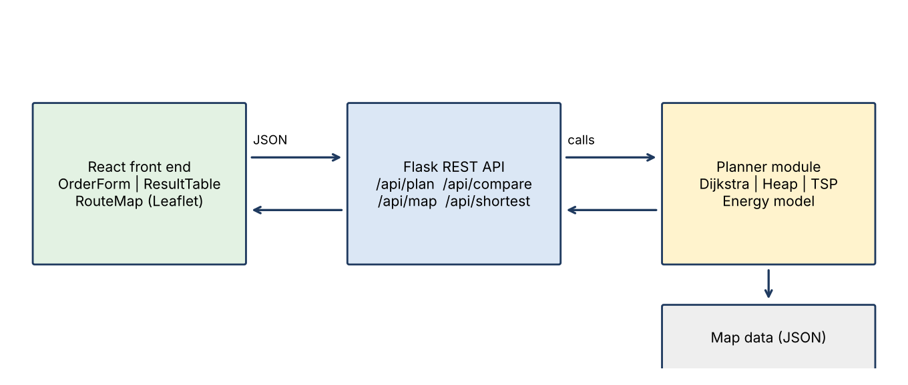
Figure 1. System architecture of the planner
The browser hosts the React application. It sends the orders and drone parameters to the Flask service as JSON and receives a plan. The Flask layer contains no algorithmic logic; it validates the input and calls the planner module. The planner module is a pure Python module with no web dependency, which makes it easy to test and reuse. The graph is stored in a JSON file in the prototype and could be replaced by a database later.

5.3 REST API
Table 4. REST API endpoints
Method | Endpoint | Description
GET | /api/map | Returns nodes (id, latitude, longitude, type) and corridors
POST | /api/plan | Body: orders, drone parameters, solver. Returns route, paths, distance, energy, accepted, rejected
POST | /api/compare | Runs all TSP solvers on the same stops; returns cost and time of each
GET | /api/shortest?from=a&to=b | Returns Dijkstra path and distance between two nodes
GET | /api/sample | Returns a ready-made scenario for demonstration

5.4 Implementation of the Core Modules
The listing below shows the actual Dijkstra implementation used in the prototype. Lazy deletion avoids the need for a decrease-key operation, which Python's heapq does not provide: a node may be pushed several times with decreasing distances, and stale entries are skipped on extraction.
def dijkstra(adj, src):
dist = {u: math.inf for u in adj}; prev = {u: None for u in adj}
dist[src] = 0.0
pq = [(0.0, src)]
while pq:
d, u = heapq.heappop(pq)
if d > dist[u]:
continue # stale entry (lazy deletion)
for v, w in adj[u]:
nd = d + w
if nd < dist[v]:
dist[v] = nd; prev[v] = u
heapq.heappush(pq, (nd, v))
return dist, prev

The admission loop and the battery check are equally short. The tuple (priority, distance, node) gives the two-key ordering without any custom comparator.
def plan(orders, D, weights, depot=0):
pq = [(p, D[(depot, n)], n) for n, p in orders.items()]
heapq.heapify(pq)
accepted, rejected = [], []
while pq:
p, d, n = heapq.heappop(pq)
trial = accepted + [(n, p)]
order = sequence(trial, D, depot)
if route_energy(order, D, weights) <= BUDGET:
accepted = trial
else:
rejected.append((n, p, d))
order = sequence(accepted, D, depot)
return {"order": order, "accepted": accepted, "rejected": rejected,
"distance": route_distance(order, D), "energy": route_energy(order, D, weights)}

5.5 Flask Service
@app.post("/api/plan")
def api_plan():
body = request.get_json()
orders = {o["node"]: o["priority"] for o in body["orders"]}
weights = {o["node"]: o["weight"] for o in body["orders"]}
keys = [DEPOT] + list(orders)
D, P = pairwise(ADJ, keys) # Dijkstra from every key node
res = plan(orders, D, weights)
res["paths"] = [P[(a, b)] for a, b in zip(res["order"], res["order"][1:])]
res["remaining_wh"] = BUDGET - res["energy"]
return jsonify(res)

5.6 React and Leaflet Front End
The front end consists of three components. OrderForm collects the destination, weight and priority of each order and posts them to /api/plan. ResultTable lists every order with its status (accepted, rejected), position in the visit sequence and rejection reason. RouteMap uses react-leaflet to draw the nodes as circle markers coloured by priority (red, orange, green), the depot as a star and the planned route as a blue polyline built from the node-by-node paths returned by the API. Clicking a marker shows the parcel weight and the cumulative energy at that stop. A battery gauge compares the planned energy with the usable budget so that the effect of each rejection is obvious.
function RouteMap({ nodes, plan }) {
const pts = plan.paths.flat().map(id => [nodes[id].lat, nodes[id].lng]);
return (
<MapContainer center={[nodes[0].lat, nodes[0].lng]} zoom={13}>
<TileLayer url="https://{s}.tile.openstreetmap.org/{z}/{x}/{y}.png" />
<Polyline positions={pts} color="#1f77b4" weight={4} />
{plan.accepted.map(([id, p]) => (
<CircleMarker key={id} center={[nodes[id].lat, nodes[id].lng]}
radius={9} pathOptions={{ color: PRIORITY_COLOR[p] }} />
))}
</MapContainer>);
}

5.7 Project Structure and Execution
drone-planner/
backend/ planner.py app.py tests.py map.json
frontend/ src/App.jsx src/OrderForm.jsx src/ResultTable.jsx src/RouteMap.jsx
Run: pip install flask flask-cors && python backend/app.py # API on :5000
cd frontend && npm install && npm start # UI on :3000

6. Results, Testing and Performance

6.1 Experimental Set-up
All experiments were executed with the Python implementation on a single CPU core. The map is a random geometric graph of 30 nodes (depot at the centre of a 10 km × 10 km square) with 170 corridors connecting nodes less than 4.2 km apart; every node is reachable from the depot. The usable battery budget is 510 Wh (600 Wh capacity with a 15 % reserve). Parcel weights and priorities were drawn with fixed random seeds so that the results are reproducible.

6.2 Scenario A: Ten Orders with Moderate Weights
Table 5. Scenario A orders and result
Node | Priority | Weight (kg) | Dist. from depot (km) | Decision | Visit #
16 | 1 | 1.5 | 1.89 | Accepted | 2
19 | 1 | 1.5 | 1.94 | Accepted | 1
20 | 1 | 2.2 | 2.05 | Accepted | 3
3 | 2 | 0.6 | 1.39 | Accepted | 6
28 | 2 | 1.8 | 3.48 | Accepted | 5
12 | 2 | 1.8 | 4.16 | Accepted | 7
5 | 2 | 0.8 | 4.75 | Accepted | 4
8 | 2 | 2.2 | 5.44 | Rejected | -
18 | 2 | 1.8 | 6.1 | Rejected | -
21 | 3 | 2.0 | 2.06 | Rejected | -

The planner admitted seven orders and rejected three. The visit order is depot → 19 → 16 → 20 → 5 → 28 → 3 → 12 → depot. The flying distance is 22.45 km and the energy 496.2 Wh against the budget of 510 Wh, leaving 13.8 Wh of usable battery. All three class-1 orders (19, 16 and 20) are served first, followed by the class-2 orders 3, 28, 12 and 5; priority is respected. The rejected orders are the two most distant class-2 orders (18 and 8, 6.10 km and 5.44 km away) and the class-3 order 21. Order 21 is only 2.06 km from the depot but, because it comes last in priority, the battery was already almost fully committed when it was considered. The result illustrates the intended behaviour: urgent orders are never sacrificed for convenient ones.
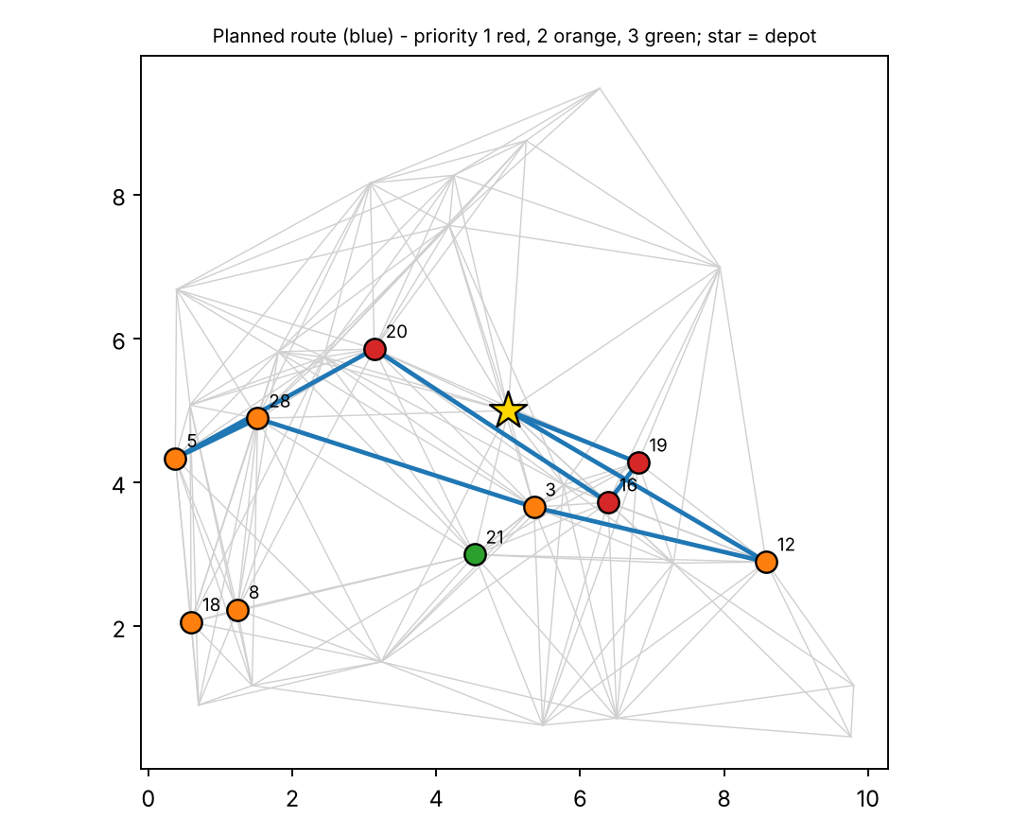
Figure 3. Planned route for the 10-order scenario on the 30-node map

6.3 Scenario B: Overloaded Batch
Table 6. Scenario B (overload) result
Node | Priority | Weight (kg) | Dist. from depot (km) | Decision | Visit #
10 | 1 | 3.0 | 1.29 | Accepted | 1
16 | 1 | 3.2 | 1.89 | Accepted | 2
1 | 1 | 2.7 | 3.91 | Accepted | 3
9 | 1 | 3.2 | 5.01 | Rejected | -
13 | 1 | 3.4 | 5.64 | Accepted | 4
20 | 2 | 3.8 | 2.05 | Accepted | 5
14 | 2 | 3.9 | 3.7 | Rejected | -
2 | 2 | 2.6 | 4.54 | Rejected | -
29 | 2 | 2.8 | 4.92 | Rejected | -
19 | 3 | 3.3 | 1.94 | Rejected | -
21 | 3 | 3.7 | 2.06 | Rejected | -
25 | 3 | 2.9 | 3.12 | Rejected | -

In this scenario twelve heavier parcels (2.0 to 4.0 kg) are requested. A single sortie visiting all twelve would need 2872.7 Wh, more than five times the 510 Wh budget, so the complete route is rejected as infeasible. Rather than failing, the planner admits orders in priority order until the budget is reached: five orders (four class-1 and one class-2) are accepted for a 14.84 km, 449.5 Wh route, and seven orders are rejected, among them every class-3 order. Order 9 is class 1 but is rejected because at 5.01 km and 3.2 kg its inclusion would exceed the budget; the planner leaves its slot to the following cheaper order. The rejected list is returned to the dispatcher, who can schedule these parcels for a second sortie after recharging.

6.4 Correctness Testing
Twelve automated tests verify the algorithms against independent references and exercise edge cases. All twelve passed.
Table 7. Test cases and outcomes
Test | Result
T1 Dijkstra equals Floyd-Warshall for all 900 node pairs | PASS
T2 Reconstructed path length equals Dijkstra distance | PASS
T3 Held-Karp equals brute force on 20 random 7-stop instances | PASS
T4 2-opt never worse than nearest neighbour (50 instances) | PASS
T5 Tour starts/ends at depot and visits every stop exactly once | PASS
T6 Accepted deliveries appear in non-decreasing priority class | PASS
T7 Accepted route energy <= usable budget | PASS
T8 Overloaded batch is trimmed (some orders rejected, rest feasible) | PASS
T9 Single over-weight order is rejected, empty route returned | PASS
T10 Empty order list returns trivial route | PASS
T11 Unreachable node keeps infinite distance | PASS
T12 Heavier payload costs more energy on same route | PASS

6.5 Comparison of TSP Solvers
Table 8. TSP solver comparison (tour distance and time)
Stops | Brute (s) | Held-Karp (s) | NN+2opt (s) | Optimal (km) | NN (km) | NN gap | 2-opt gap
5 | 0.0002 | 0.0001 | 0.00006 | 21.30 | 21.30 | 0.0% | 0.0%
6 | 0.0010 | 0.0002 | 0.00017 | 26.42 | 34.03 | 28.8% | 0.0%
7 | 0.0073 | 0.0007 | 0.00014 | 22.27 | 22.65 | 1.7% | 0.0%
8 | 0.0689 | 0.0015 | 0.00021 | 21.11 | 21.45 | 1.6% | 0.5%
9 | 0.6036 | 0.0033 | 0.00027 | 22.65 | 24.10 | 6.4% | 0.0%
10 | - | 0.0083 | 0.00036 | 31.15 | 38.13 | 22.4% | 0.0%
12 | - | 0.0456 | 0.00091 | 23.84 | 30.88 | 29.5% | 0.0%
14 | - | 0.2510 | 0.00091 | 33.81 | 38.30 | 13.3% | 0.0%
16 | - | 1.3940 | 0.00190 | 33.38 | 37.07 | 11.0% | 0.0%

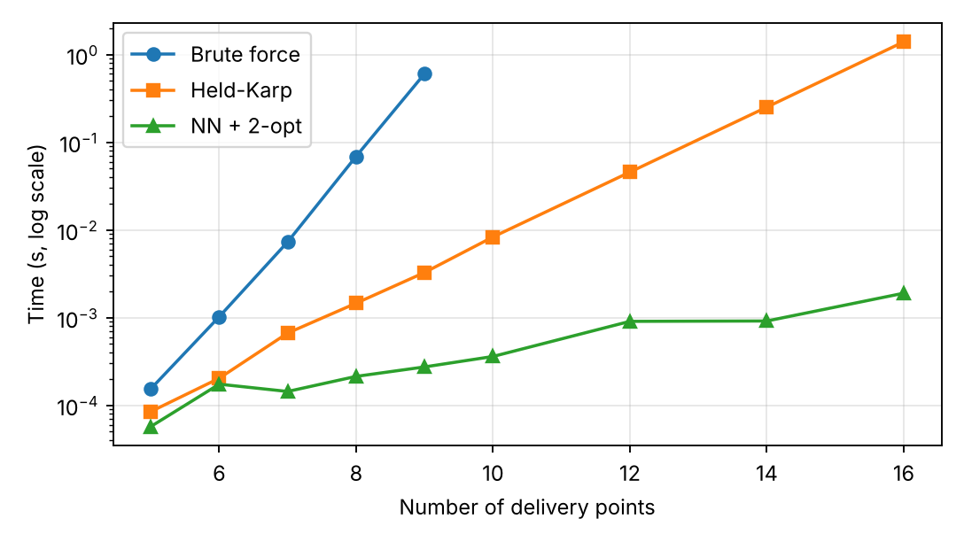
Figure 4. Running time of TSP solvers versus number of stops
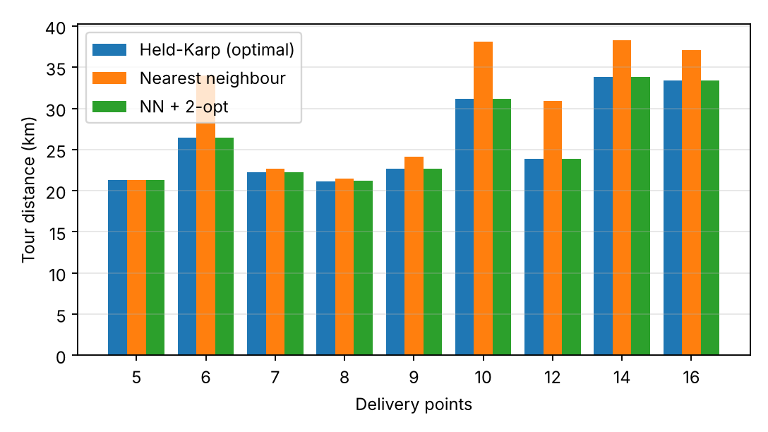
Figure 5. Tour length of exact and heuristic TSP solvers

6.6 Dijkstra Scalability
Table 9. Dijkstra scalability
Nodes | Edges | Time for one run (ms)
100 | 947 | 0.22
500 | 5515 | 1.76
1000 | 11485 | 4.38
2000 | 23597 | 10.62
5000 | 60730 | 33.62

6.7 Discussion
- Exactness and speed. Held-Karp returned the same cost as brute force on all instances up to nine stops and 20 random seven-stop tests, yet at nine stops it took 3.3 ms against 603.6 ms, a factor of about 185 in favour of Held-Karp. At 16 stops Held-Karp needed 1.39 s while brute force (16! permutations) is infeasible.
- Heuristic quality. Nearest neighbour alone was between 0% and 29.5% longer than optimal (for example 38.13 km versus 31.15 km at ten stops, and 30.88 km versus 23.84 km at twelve). Adding 2-opt reduced the average gap over the nine instances to under 0.1%; the only non-optimal result was at eight stops (0.5% longer), and it took less than 2 ms even at 16 stops.
- Scalability. Dijkstra grows slightly faster than linearly with graph size, in line with O((V+E) log V): 5,000 nodes and 60,730 edges take 34 ms.
- Cost of priority. Enforcing class order lengthens the tour relative to an unconstrained TSP over the same stops but guarantees that urgent parcels are never delayed by a shorter tour; this is the intended policy trade-off.
- Battery as a hard filter. In both scenarios no accepted route exceeded the budget, and in the overloaded case the planner prevented a plan that would have needed more than five times the available energy.

6.8 Sample API Response
The JSON below is the (abridged) response of the /api/plan endpoint for Scenario A, showing how the decisions are exposed to the front end.
{
"order": [0, 19, 16, 20, 5, 28, 3, 12, 0],
"accepted": [[16, 1], [19, 1], [20, 1], [3, 2], [28, 2], [12, 2], [5, 2]],
"rejected": [
{"node": 8, "priority": 2, "reason": "route energy would exceed 510 Wh budget"},
{"node": 18, "priority": 2, "reason": "route energy would exceed 510 Wh budget"},
{"node": 21, "priority": 3, "reason": "route energy would exceed 510 Wh budget"}
],
"distance_km": 22.45,
"energy_wh": 496.2,
"remaining_wh": 13.8
}

6.9 Summary of Key Results
Table 10. Summary of key results
Measure | Result
Scenario A (10 orders) | 7 accepted, 3 rejected; 22.45 km; 496.2 Wh of 510 Wh budget
Scenario B (12 heavy orders) | 5 accepted, 7 rejected; 14.84 km; 449.5 Wh (all 12 would need 2,872.7 Wh)
Priority order respected | Yes, in every test (T6)
Battery budget ever exceeded by an accepted route | Never (T7, T8, T9)
Held-Karp vs brute force at 9 stops | Identical cost; 3.3 ms vs 603.6 ms (about 185 times faster)
Nearest neighbour gap to optimal | Up to 29.5 %
NN + 2-opt gap to optimal | 0 % in eight of nine instances; 0.5 % worst case
Dijkstra on 5,000 nodes / 60,730 edges | 34 ms
Automated tests | 12 of 12 passed

Taken together, the results confirm that the three core algorithms cooperate as intended: Dijkstra supplies exact leg distances, the priority queue fixes the order in which orders compete for battery, and the TSP solvers turn the accepted stops into a short, feasible tour. The battery rule is applied last and acts as the gatekeeper, so the system never hands a dispatcher a route the drone cannot complete.

7. Conclusion, Future Scope and References

7.1 Conclusion
This project turned the requirement to plan drone deliveries with distance, battery and priority constraints, and to reject routes that exceed the battery budget, into a working and explainable prototype. Dijkstra's algorithm supplied least-distance flight paths, a priority queue enforced urgency in order admission, and the Traveling Salesperson Problem, solved exactly with Held-Karp and heuristically with nearest neighbour and 2-opt, ordered the visits. A payload-aware energy model and an explicit rejection rule ensured that no returned route exceeds the battery budget. Twelve automated tests passed, Held-Karp agreed with brute force, 2-opt came within 0.5% of optimal on every instance tested, and the planner correctly trimmed an overloaded batch from 2,872.7 Wh to a feasible 449.5 Wh sortie.

7.2 Limitations
- The priority-first admission is greedy and does not guarantee the maximum number of delivered parcels.
- Single drone, linear energy model and a static map without wind or no-fly zones.

7.3 Future Scope
- Multiple drones and multi-trip planning with recharging, formulated as a Vehicle Routing Problem, using Clarke-Wright savings or metaheuristics such as simulated annealing.
- Energy-optimal sequencing, minimising watt-hours rather than kilometres, and a knapsack-based admission rule that maximises delivered priority value.
- Time windows, estimated arrival times and A* with a wind- and altitude-aware cost function.
- Dynamic no-fly zones, real-time re-planning and integration with real map data and drone controllers.

7.4 References
[1] E. W. Dijkstra, "A note on two problems in connexion with graphs," Numerische Mathematik, vol. 1, pp. 269-271, 1959.
[2] M. Held and R. M. Karp, "A dynamic programming approach to sequencing problems," J. SIAM, vol. 10, no. 1, pp. 196-210, 1962.
[3] T. H. Cormen, C. E. Leiserson, R. L. Rivest and C. Stein, Introduction to Algorithms, 4th ed., MIT Press, 2022.
[4] G. A. Croes, "A method for solving traveling-salesman problems," Operations Research, vol. 6, no. 6, pp. 791-812, 1958.
[5] K. Dorling, J. Heinrichs, G. G. Messier and S. Magierowski, "Vehicle routing problems for drone delivery," IEEE Trans. Systems, Man, and Cybernetics: Systems, vol. 47, no. 1, pp. 70-85, 2017.
[6] C. C. Murray and A. G. Chu, "The flying sidekick traveling salesman problem," Transportation Research Part C, vol. 54, pp. 86-109, 2015.
[7] Official documentation: Python heapq (docs.python.org), Flask (flask.palletsprojects.com), React (react.dev), Leaflet (leafletjs.com).

