Final Group Project:
Retail Financial Dashboard with ML Insights on Azure

Group: 12
Team Members: Sai Gopal Lanka, Pawan Teja Bolla, Varsha Reddy Madhireddy
Team Contribution: All Team Members contributed equally.

Write up on ML-models:
Linear Regression
Linear Regression is an example of supervised learning where the goal is to predict the value of a dependent variable given one or more independent variables. It assumes that the relationship between the dependent and independent variables is linear. The goal is to minimize the distance between actual and predicted variables in order to produce accurate continuous value predictions. In retail analysis, Linear Regression can be employed in order to predict customers’ expenses according to the input characteristics like the frequency of purchase, customers’ income and household size. Though its easy to interpret, its performance may not be suitable for non-linear patterns in data.

Random Forest
Random Forest is an ensemble learning method. During the training stage, it generates a number of decision trees and then merges their predictions to increase the accuracy. This combination by taking the average of predictions from each tree removes the dependency to a single tree, thereby preventing over-fitting. Random Forest is excellent in processing large volumes of data, learning complex relationships and thus can be used for classification (predicting churn risk or categorizing customers into groups based on purchasing behavior).

Gradient Boosting
Gradient Boosting is a more sophisticated ensemble method where new models are built sequentially to address the errors of previous models. The prediction accuracy is increased in this method by stepwise reduction of the loss function. This is very effective in dealing with datasets that exhibit non-linearities and have a complex structure. This method can be easily overfitted if parameters are not properly chosen. The customer lifetime value (CLV) analysis is an area in retail analytics for which this method would be a perfect fit as there are often complex nonlinearities in customer purchase behavior and engagement.

Customer Lifetime Value (CLV) Model Selection
For customer lifetime value prediction, it is felt that Gradient Boosting is the best suited of the three models. Retail data typically exhibits non-linear relationships and so Gradient Boosting is well suited as it is an iterative algorithm which is able to identify the non-linear associations within such data and increase the accuracy of the predictions. By utilizing this model it allows a business to identify the most valuable customers, and therefore spend more resources targeting and retaining them.
Project Overview
This project presents an end-to-end retail analytics solution built using Azure Cloud and Streamlit. This system is designed to analyze customer spending, engagement and churn risk with actual retail data. It comprises data ingestion, preprocessing, visualization, and machine learning, all of which are brought together within an interactive web application to help in taking decisions on data.

Technologies Used
Cloud Platform: Microsoft Azure (Virtual Machine)
Web Framework: Streamlit
Programming Language: Python
Libraries: pandas, matplotlib, scikit-learn
Data Source: Retail datasets (Transactions, Households, Products)

Web Server Setup
The application is deployed on an Azure Virtual Machine and accessed via a public URL. A login system is implemented with username, password, and email authentication to restrict access, (but for the convenience, we have provided the login details in the login page itself). The server runs continuously when the VM is active. But, since we using a student version of azure, we have limitations on run time of the virtual machine. So, the website can be live and running as long as the virtual machines are active.
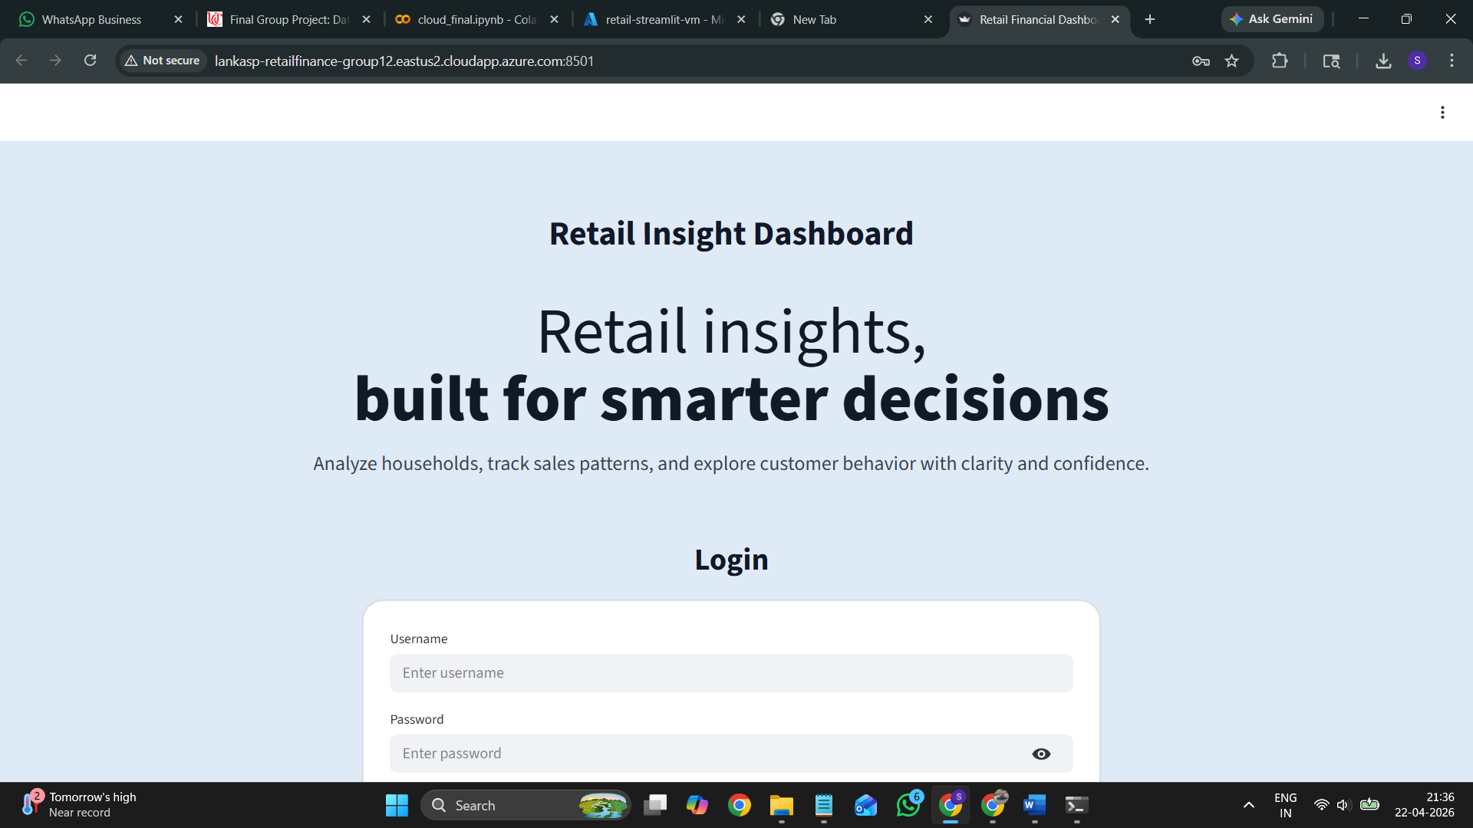
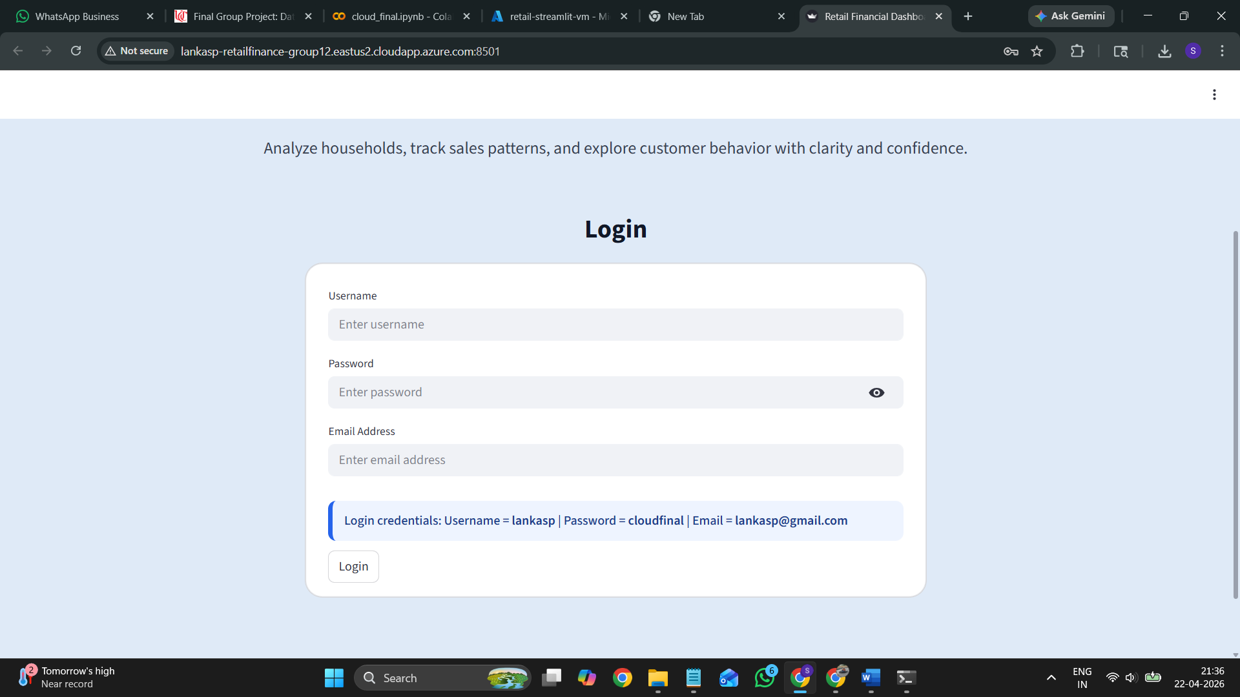
Datastore and Data Loading
The application is designed to load and process datasets dynamically using Python and the pandas library. The system reads updated datasets for Transactions, Households, and Products directly from the data source during runtime.
Whenever the datasets are updated at the backend, the application reloads the data and reflects the changes across all components of the dashboard, including the Household Search and Sample Data Pull features. This ensures that the system remains consistent and up-to-date without requiring manual intervention.
The integration between data loading and the interactive web pages was tested to confirm that updated data is correctly reflected in search results and visualizations. This demonstrates the ability of the system to handle dynamic data updates efficiently and maintain accurate analysis.
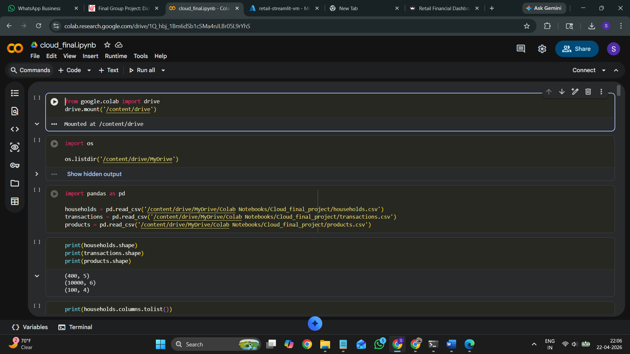
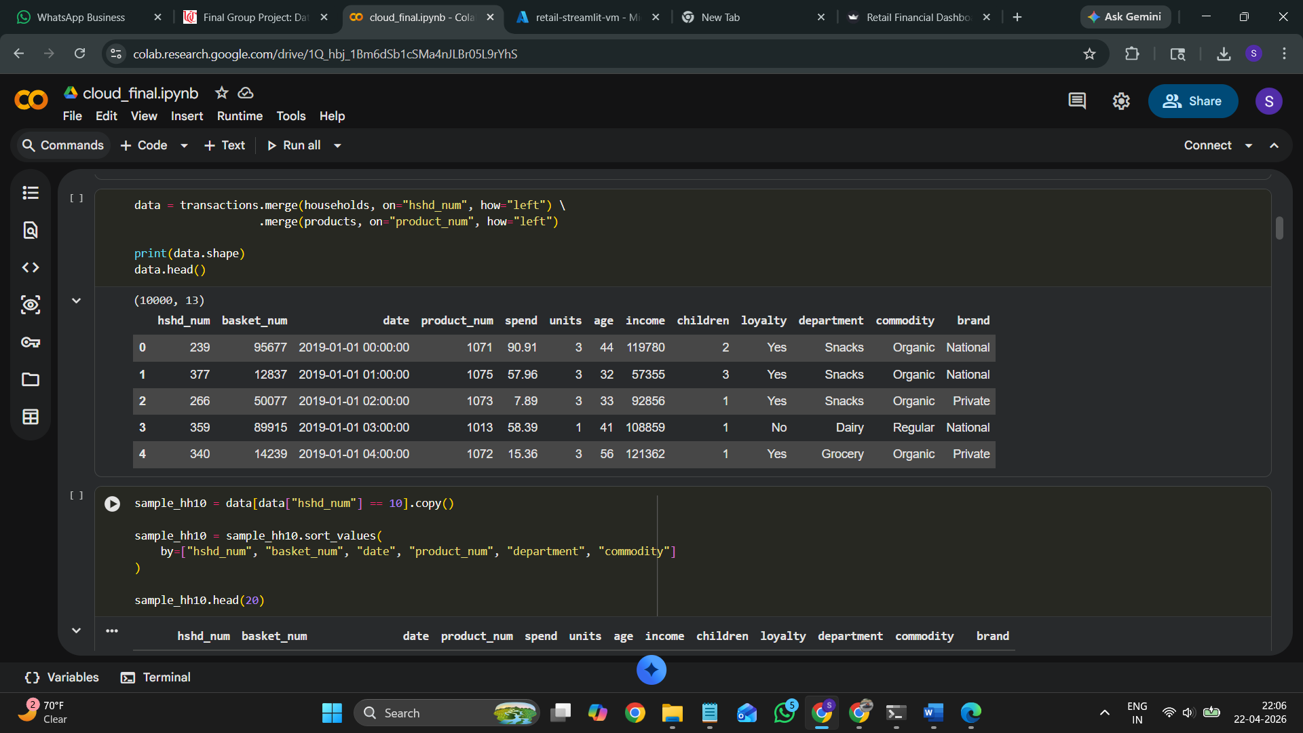
Fig 3&4: Data store and loading in google colab in the initial phase

Interactive Web Page
The Retail Financial Dashboard gives an intuitive and friendly interface for business users to discover how customers behave and how they perform in the market, as well as the tendency in the whole retail industry. The dashboard gives an overall picture on how is the business performing with some metrics including total sales, total units sold, total households and total products.
The system intends for business users to get the insights with chart and metrics and use those to explore more details. By integrating various data sets, the dashboard provides users a full view about the transaction behaviors of customers, product category and their loyalty behaviors to have business insights to make better decisions.
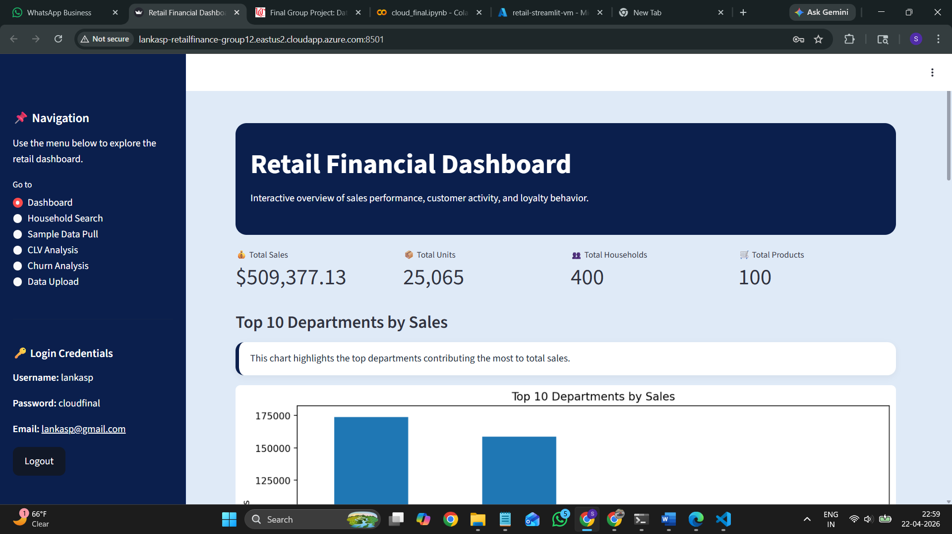
Fig 5: Website First page
Data Loading Web App
A feature has been implemented for loading data into the web application. This allows users to utilize the most recent Transaction, Household and Product datasets. When a new file containing updated datasets is loaded into the application, the analytical view also gets refreshed to enable dashboard and search pages to be presented using the newest available data.
The data loading is achieved through using Streamlit and Pandas to dynamically read the files and process them during application run time. All data preprocessing, such as normalization of columns, conversion of dates, merging datasets and others, are done automatically in order to guarantee consistent data presentation on every page. Caching is used when data loading to improve speed of load; once data are loaded, the cache is refreshed to make the application present updated data on every new load.
The process described above has been tested using the web application interactive pages, particularly the Household Search page and the Sample Data Pull page. Once data were loaded, the application still shows correct linkage records and the results are shown as sorted as it should be. Hence, it proves that web application could handle refreshing the data, and keep analysis of data accurate through retail dashboard page.
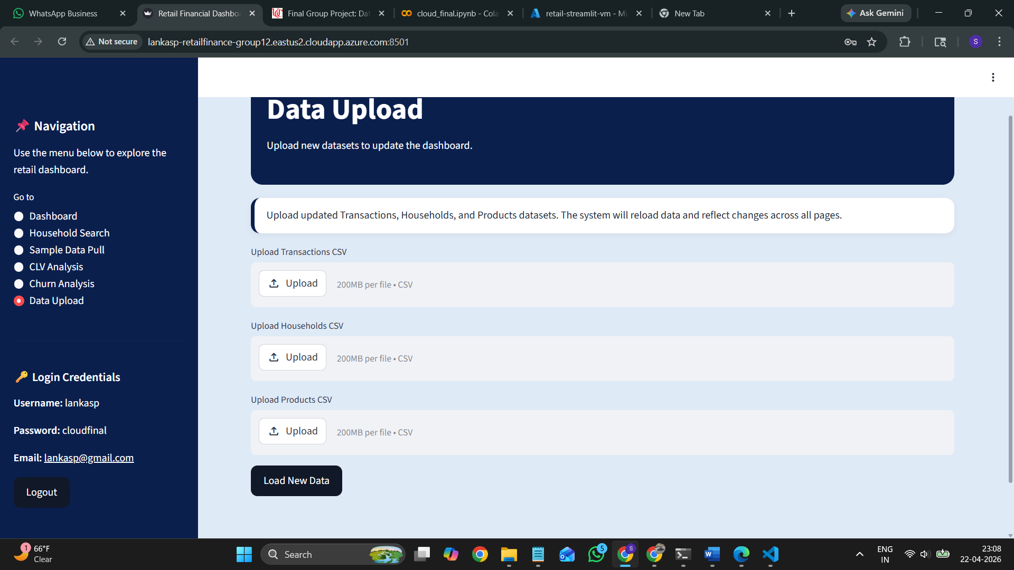
Fig 6: Website showing the data upload section

Dashboard Implementation
The dashboard provides key KPIs such as total sales, total units, households, and products. It includes visualizations such as department-wise sales, monthly trends, and loyalty-based analysis.
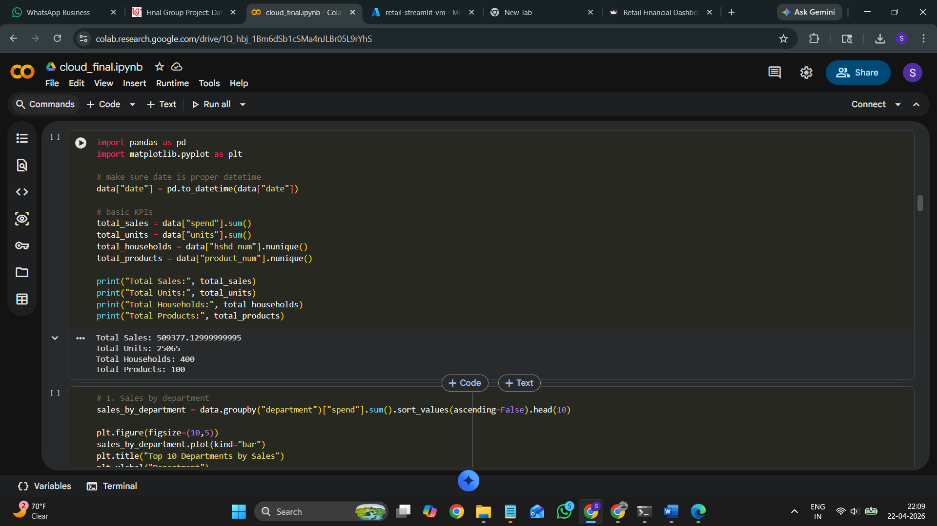
Fig 7: Initial implementation of KPI’s in google colab

Top Departments by Sales
This chart depicts the top departments that account for the greatest total sales. It presents the ability to make a quick comparison between departments regarding revenue produced across various product categories. From observing the visualization it can clearly be seen that Dairy and Grocery as departments have significantly greater sales volumes.
This data can be used to show the areas in which the retailer can maximize inventory levels, promotion and price changes accordingly. Also it could lead the retailers to decision of allocation of resources according to department performance.
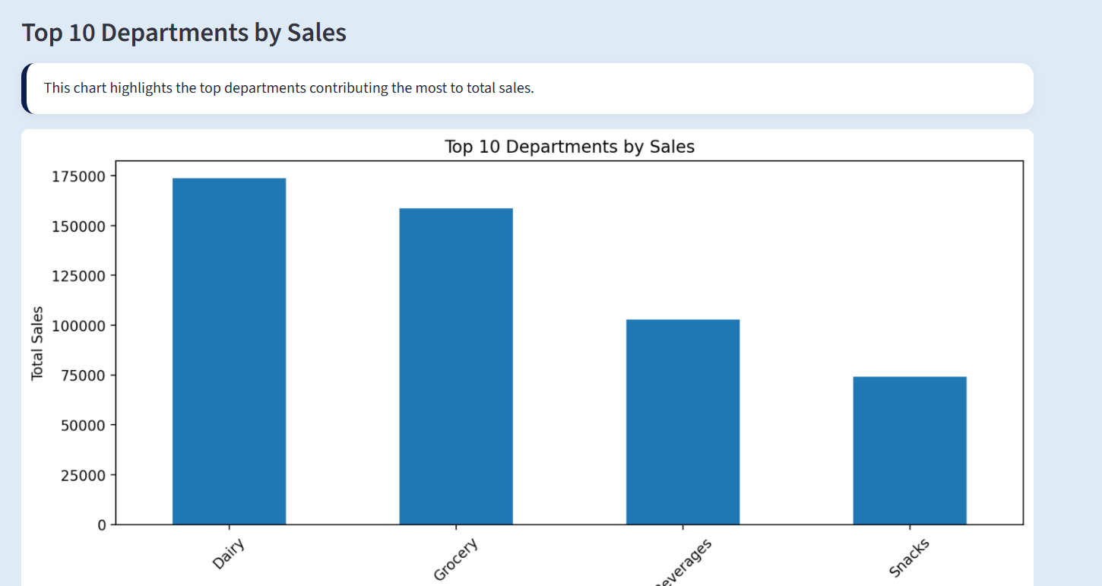
Fig 8: Screenshot of website showing the top departmental sales
Monthly Sales Trend
The Monthly Sales Trend chart reflects variations of retail spending over a course of time across different months. It can be helpful to distinguish seasonal variations, peaks and troughs, and overall increase and decrease of sales trends. From the trend chart, we can tell that there is a significant fluctuation among months, perhaps there is a seasonal effect on buying behavior and sales, hence it helps business to manage inventory, supply chain effectively and design some specific promotions during the month with high sales
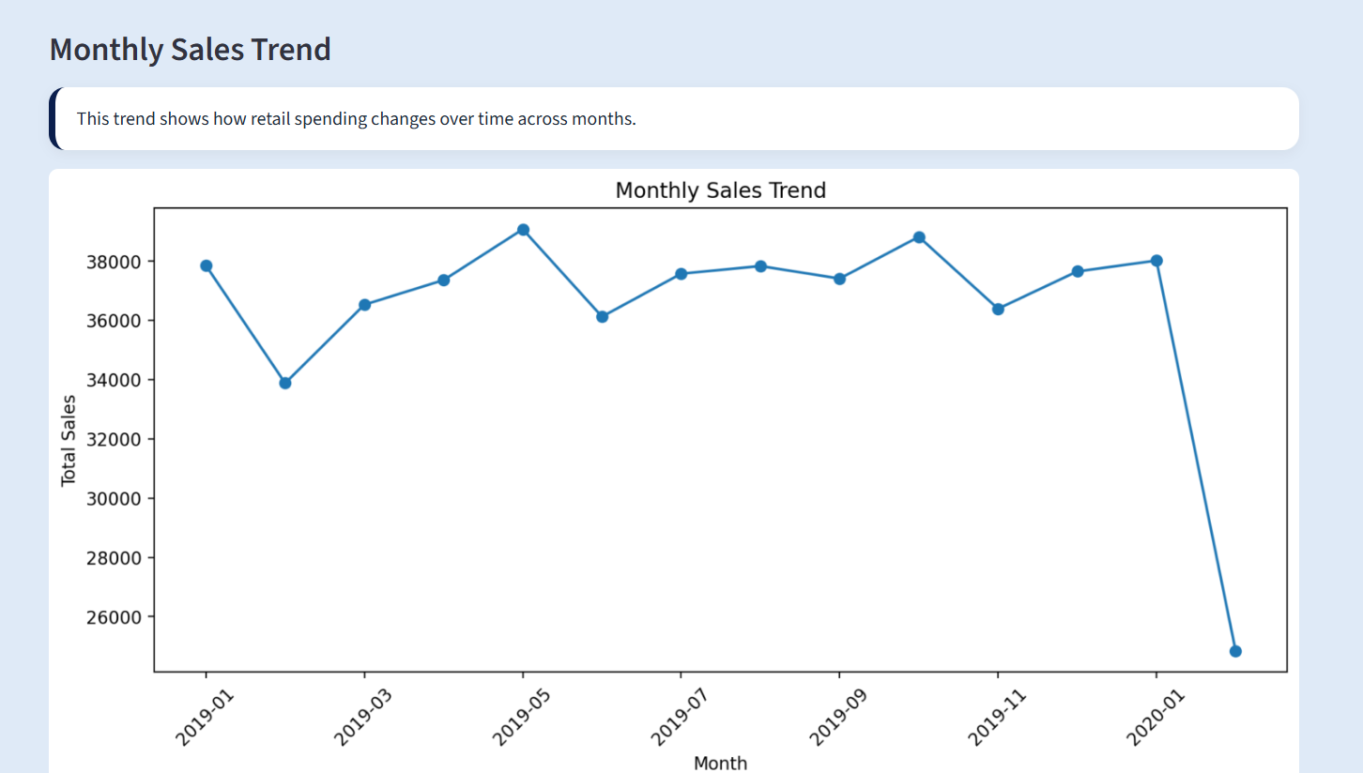
Fig 9: Screenshot of website showing monthly sales trends

Spending by Loyalty Flag
This graph demonstrates the comparison of spending between different customers according to their loyalty status. This aids us in studying the effect of loyalty programs on consumer purchase behavior. From the visual representation it is apparent that loyal customers are responsible for a good portion of the entire sales revenue when compared to non-loyal customers, and that loyalty programs do play a crucial part in the retention and purchasing pattern of the customers. Using this information, a company can try to develop stronger loyalty programs and personalize offers in order to increase the lifetime customer value.

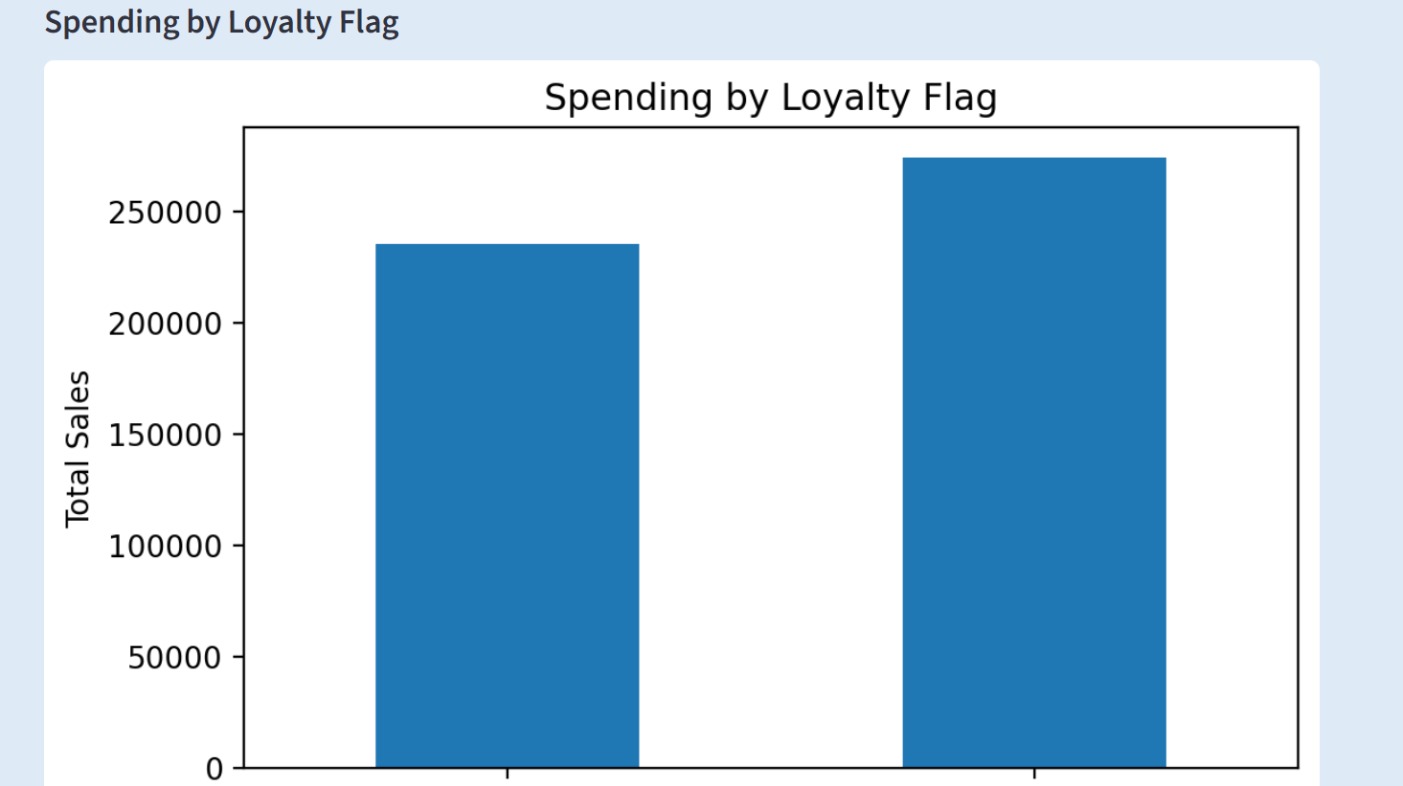
Fig 10: Screenshot of website showing spending by loyalty

Household Search
This feature allows you to extract transactional purchasing data based on the household number entered by the user. You enter the household number, and then the related transactions are filtered and presented in the form of a table.
Some of the extracted fields include: basket number, transaction date, product number, department, commodity, amount spent, quantity purchased, age, income level, number of children in household, loyalty status etc. All the purchase related information and the demographic information are provided to make a complete analysis of customer's purchasing behaviour possible.
The table is sorted on: Household number, basket number, date, product number, department, commodity.

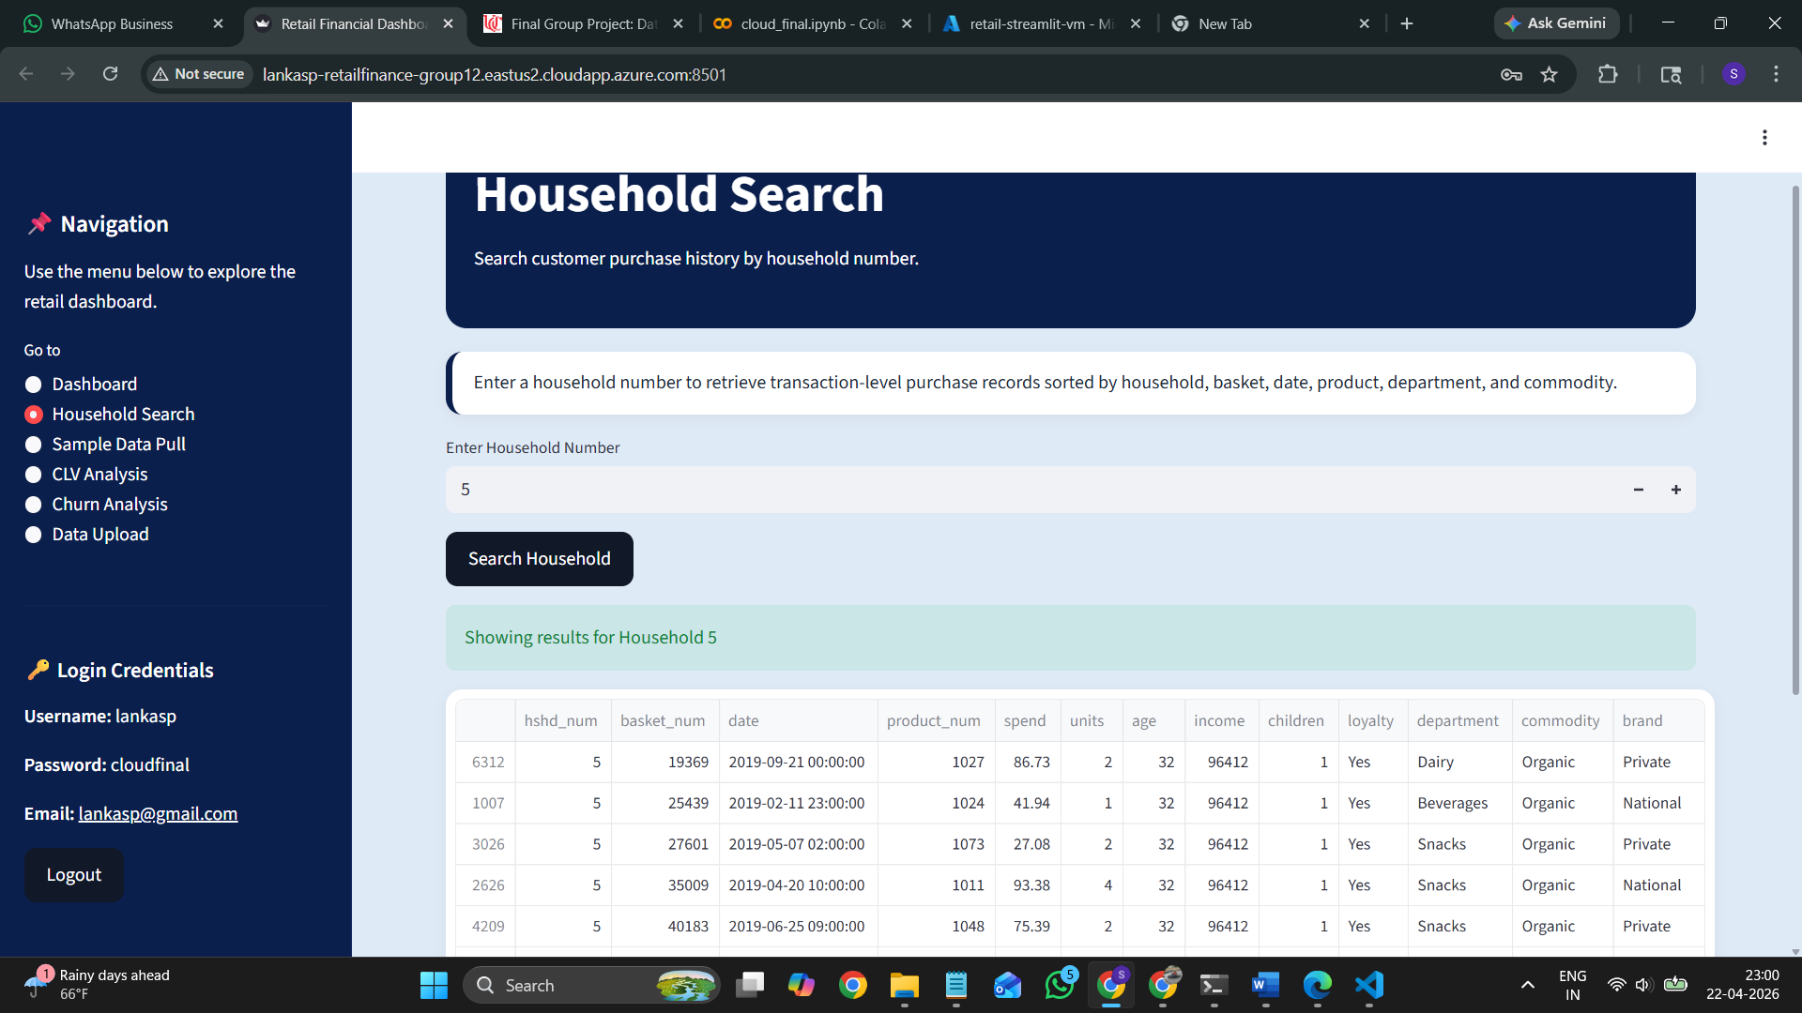
Fig 11: Screenshot of website showing spending by household search

Sample Data Pull
Sample Data Pull function shows an example how to join more then one dataset (Household, Transactions, and Products) together. This function shows data for one pre-selected household (Household #10), as required by the project scope.
This display shows the full joined data, displaying information about individual transactions and demographic data so the user is able to compare how these different datasets are joined and give useful information. Data are sorted by Household number, Basket number, Date, Product number, Department and commodity.
These functions show how the join and data transformation process worked, in order to identify if all the data sets have been joining properly.

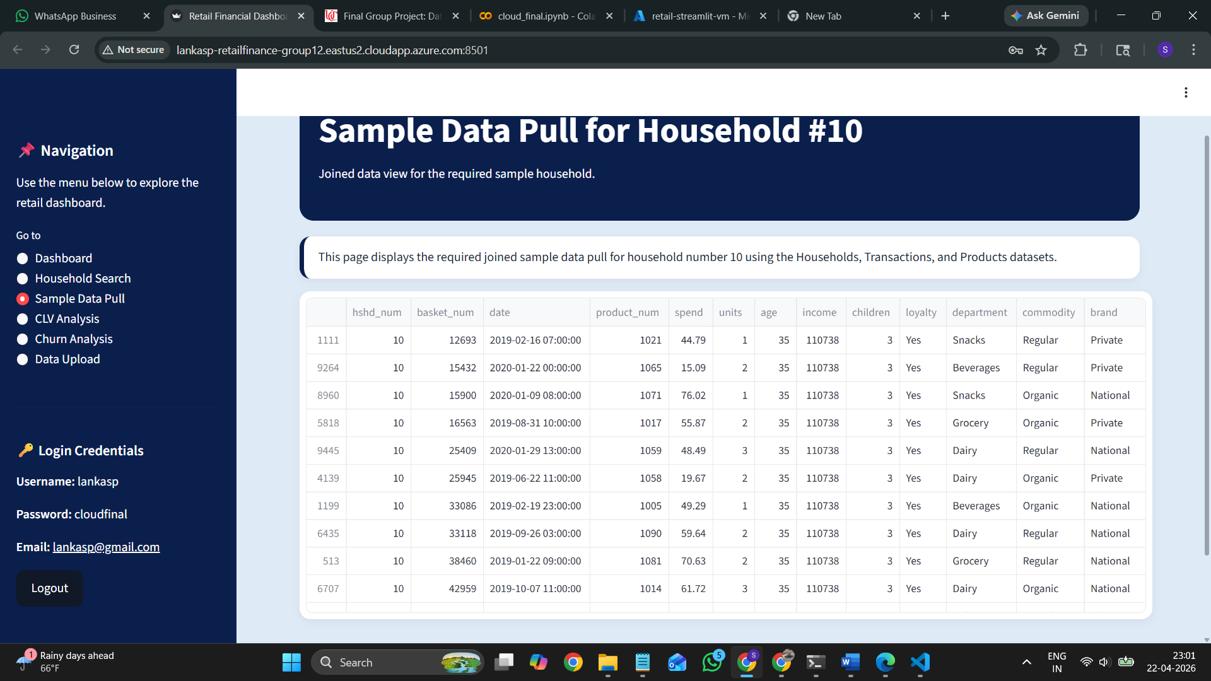
Fig 12: Screenshot of website showing sample data pulling

CLV Analysis
Customer Lifetime Value (CLV) Analysis looks into households which give the most total lifetime profit to a business. In this project, CLV calculation has been done on based on total spend over the period given for each household. The output is put in table form, with relevant features: total units bought, total baskets, age, income, kids, and loyalty.
A bar chart is shown with the Top 10 households based on total spend, allowing comparison of high-value customers. One can observe that few of households give a big percentage of the total profit. This is very common to retail data.
Having that information could help a business to make customer targeting more effectively and increase customer retention and business profitability by giving customized promotions, benefits or by targeting these customers with special offers and marketing.
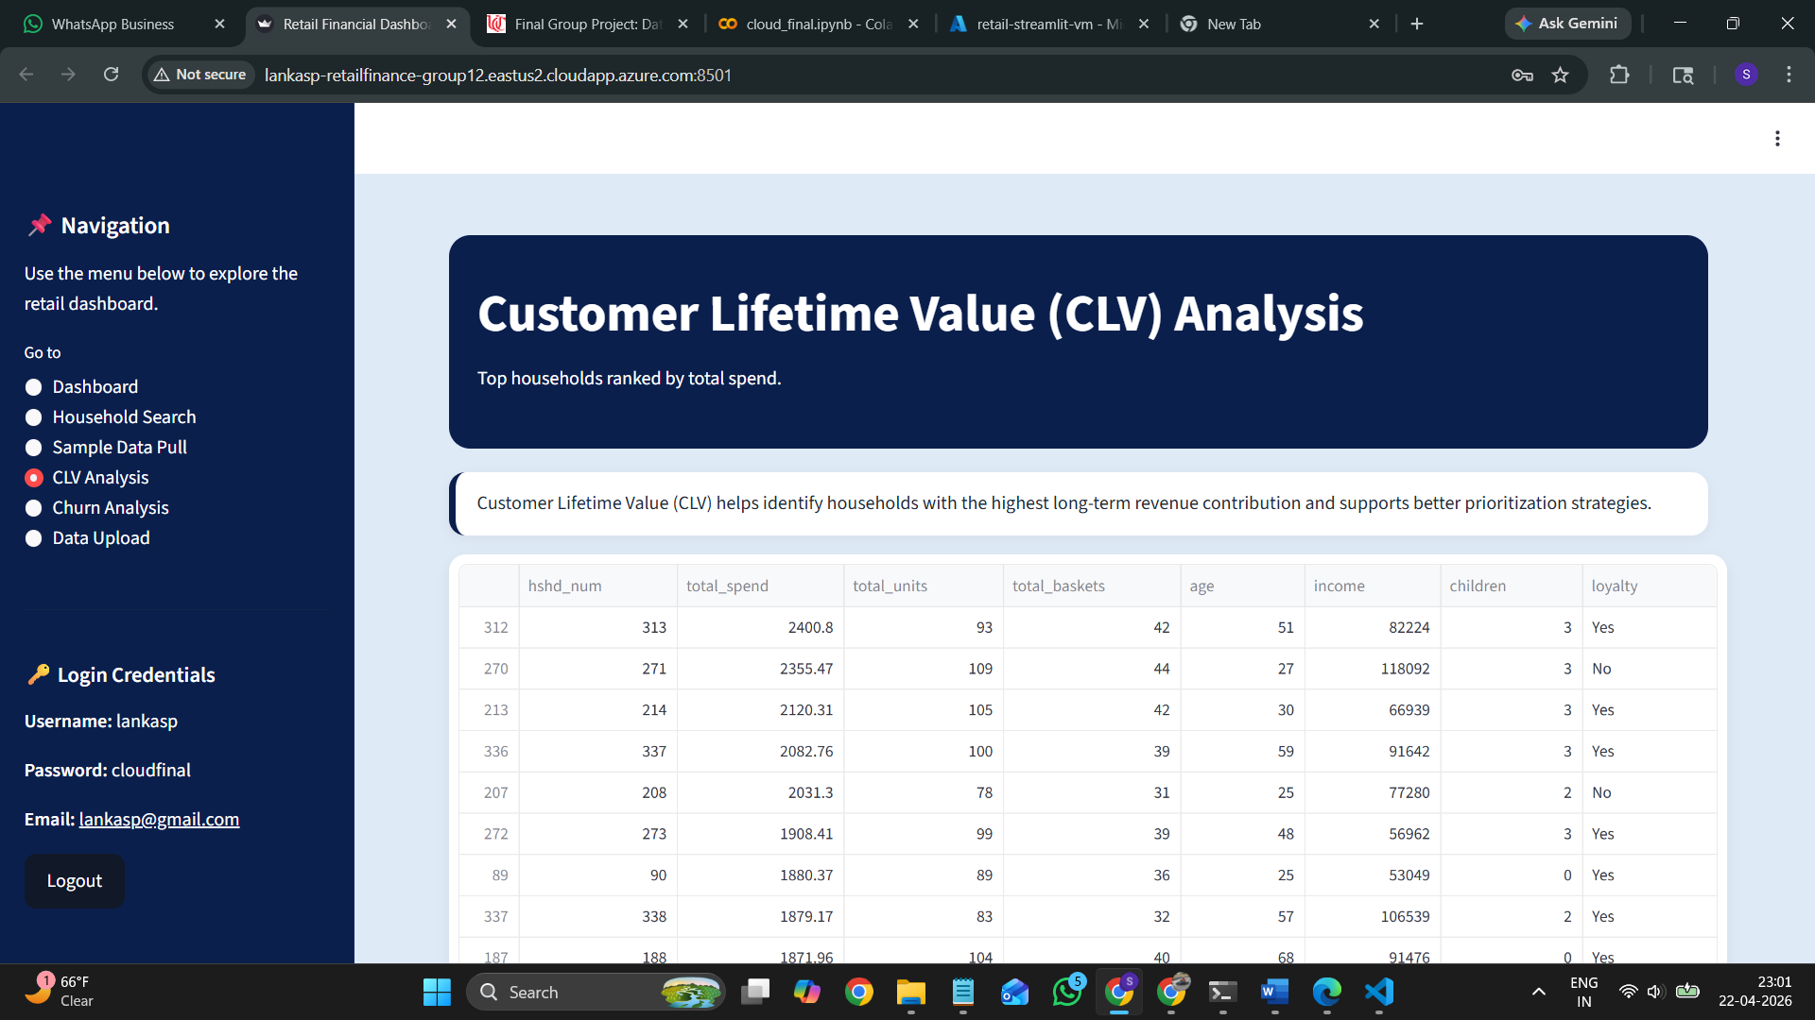
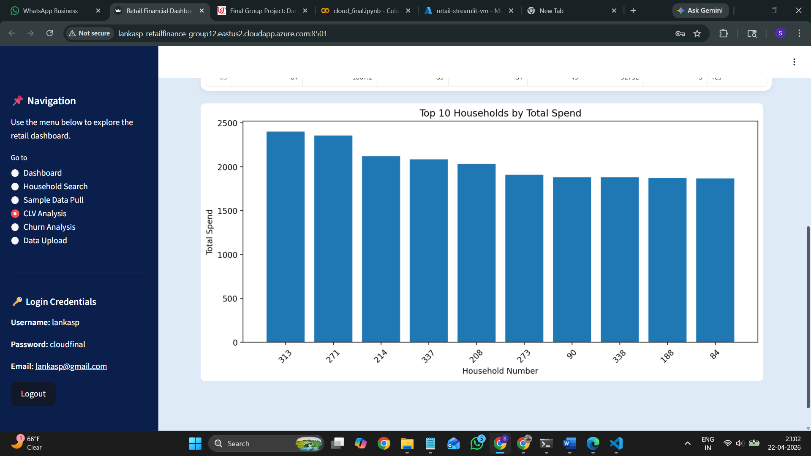
Fig 13&14: Screenshot of website showing CLV analysis

Basket Analysis and Cross-Selling Opportunities
Basket Analysis was conducted to find product combinations most commonly bought in customers transaction baskets. Transaction data was segmented by basket number, and the combination of commodities bought together in the same basket was evaluated. Frequently appearing product pairs were counted and sorted in order of top products commonly purchased together by customers. This will provide information to the retailer about how customers shop, and which products were commonly purchased together. The data generated may help to cross sell and suggest related products to customers, create bundle product deals and promotions. For example, if two kinds of products are always bought together, it would make sense to display products side by side in the store and suggest another product to customer when their purchase includes either product. It can simplify customers shopping and increase the businesses sales volume, and raise the level of customer involvement.
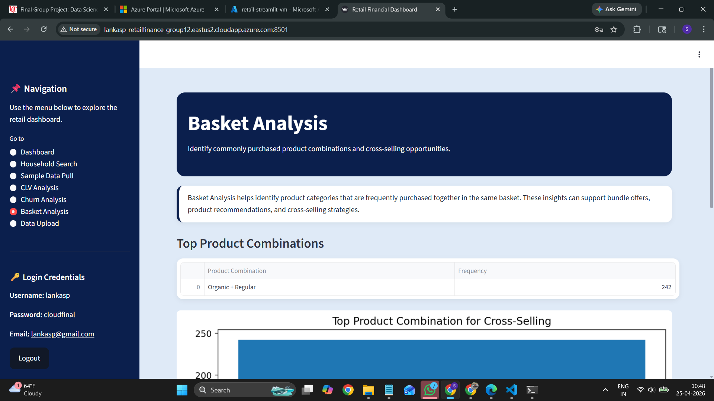
Fig 15: Screenshot of website showing Basket analysis

Churn Analysis
Churn Analysis is used to identify customers that are likely to stop or reduce engagement with the business. Within this project, we calculate churn risk based on a pre-processed data set that labels customer groups as low-risk or high-risk.
The churn risk distribution chart helps provide the number of households belonging to each classification and shows customer engagement levels overall. It also provides a detailed table displaying all of the households that are labeled as high risk, along with the relevant attributes like total spend, number of baskets, number of units purchased, age, income, and loyalty.
From the analysis, you can see a majority of customers are high-risk, which indicates the business stands to lose future income by not targeting those customers effectively.

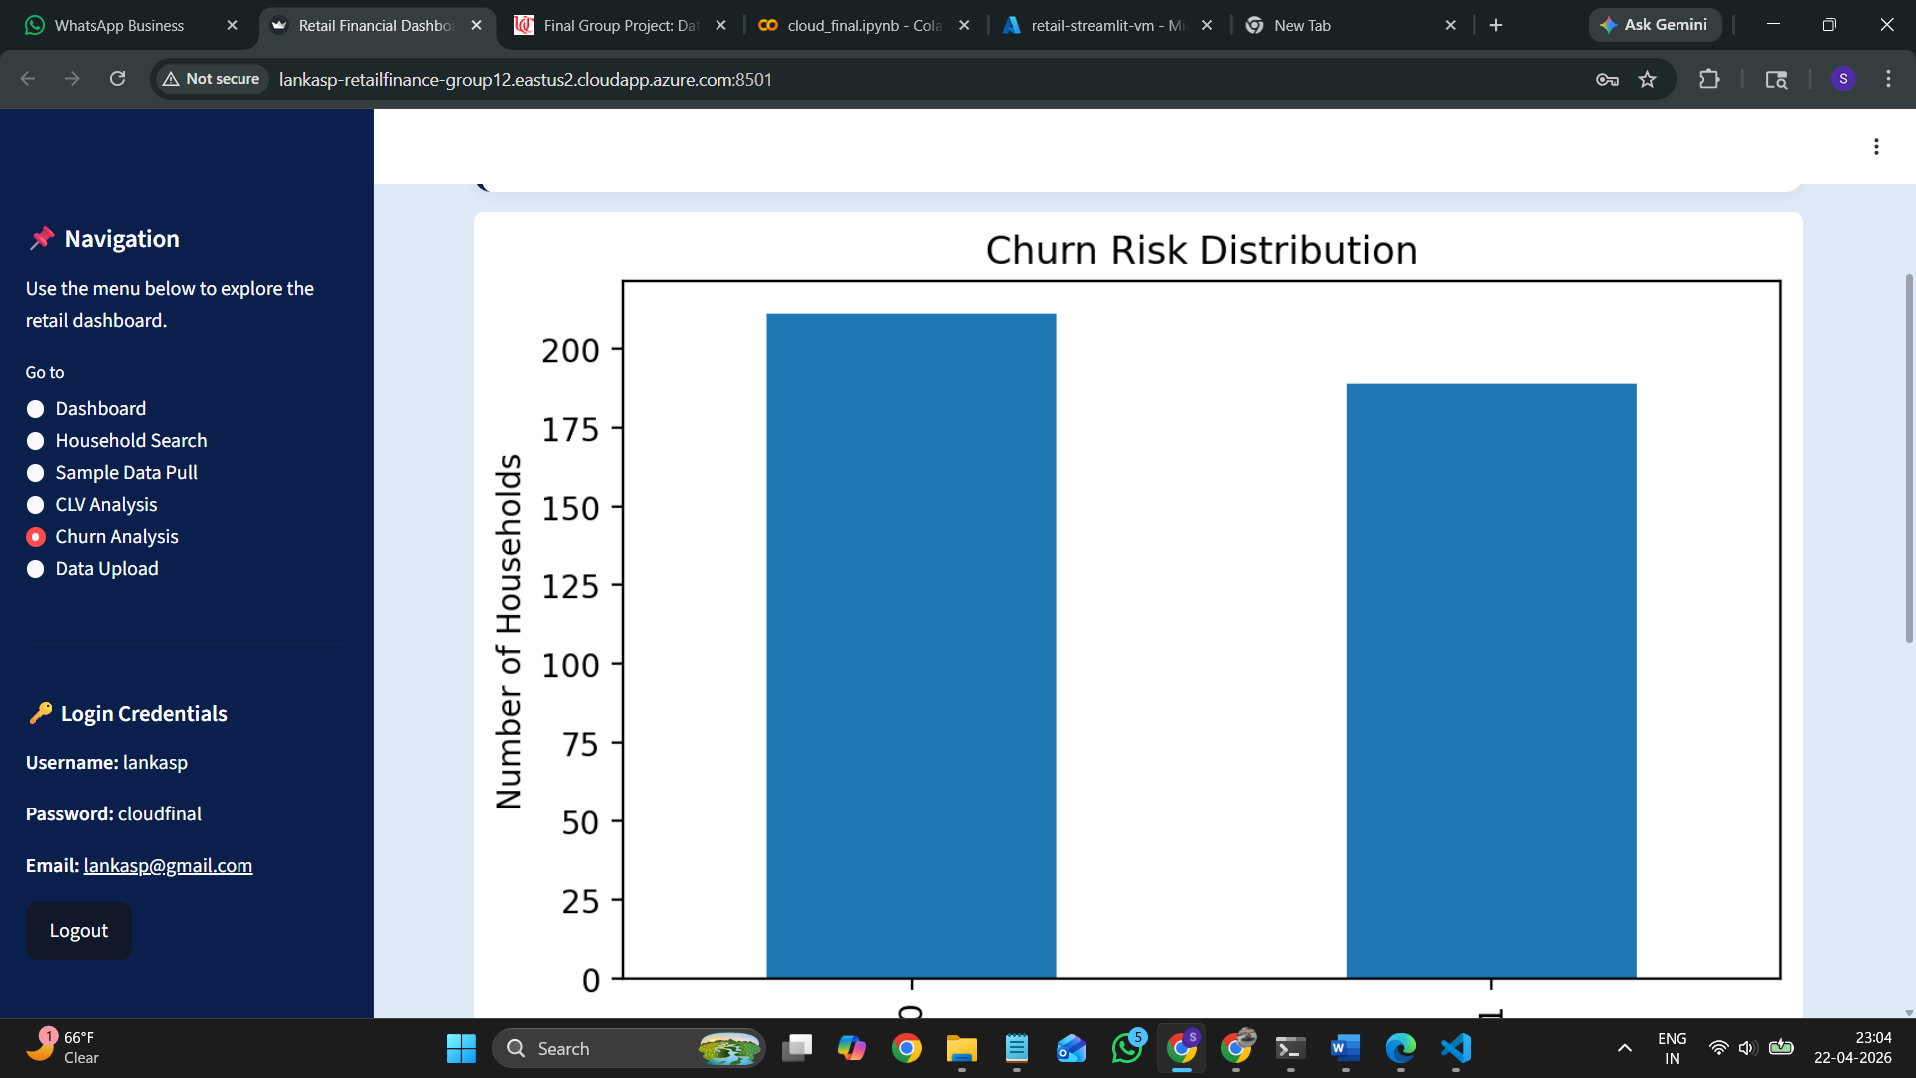
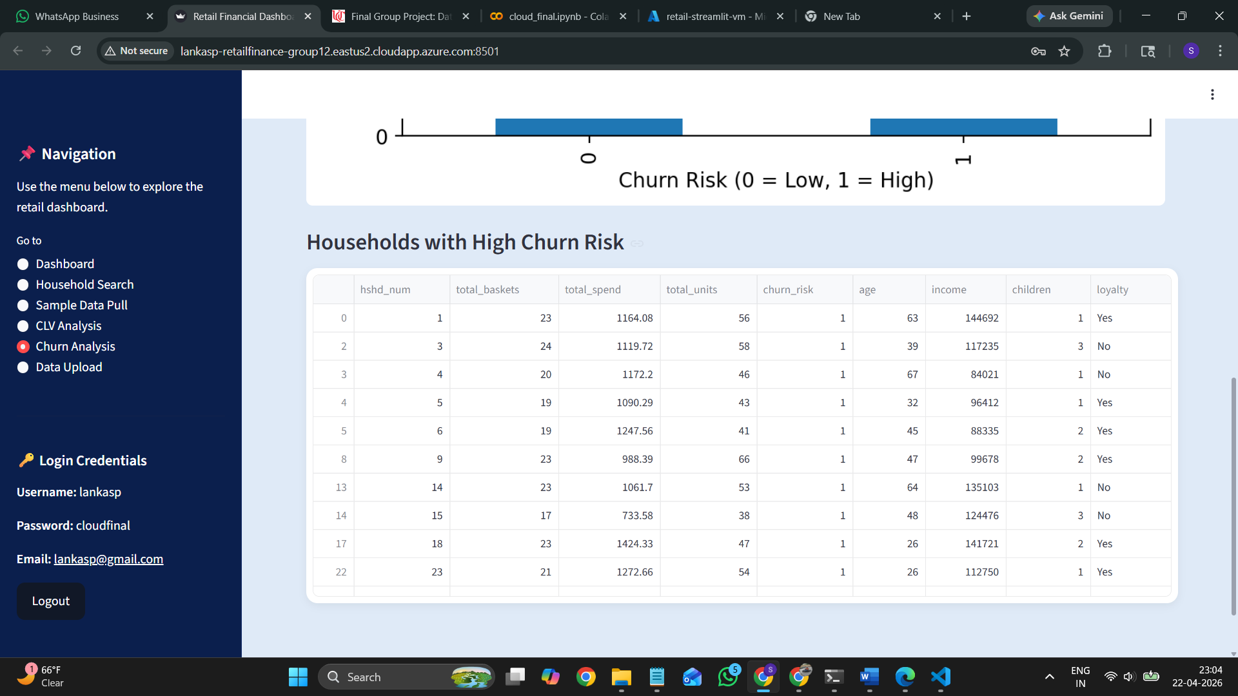
Fig 16&17: Screenshot of website showing Churn analysis

Conclusion
In this project, we have developed a cloud-based Retail Financial Dashboard, leveraging Azure services and Streamlit to visualize insights by combining transaction, household and product data. The dashboard is highly interactive, allows you to conduct analyses such as sale analysis, Customer Lifetime Value (CLV) analysis, churn analysis, and household-level data viewing. By implementing features to load dynamic data and visualize it, the system effectively aids analysis and facilitates better decisions.

Deployment URL
http://lankasp-retailfinance-group12.eastus2.cloudapp.azure.com:8501

GitHub Link: https://github.com/lankasaigopal/Cloudfinal-Retail_Finance

