Decoding Sunrisers Hyderabad's IPL 2026 Campaign
A Ball-by-Ball Performance Analysis

Author: Lanka Saimanikanta Sharma
AICTE | IBM SkillsBuild Data Analytics with AI Internship 2026
IPL 2026 (March 28 – May 9, 2026)

Table of Contents
1. Executive Summary
2. Dataset Overview
3. Data Quality Notes
4. Batting Analysis
5. Bowling Analysis
6. Fielding Analysis
7. Phase Analysis (Powerplay / Middle / Death Overs)
8. Wicket Pattern Analysis
9. Venue Analysis
10. League Stage vs. Playoffs Analysis
11. Player Performance Analysis
12. Cross-Dataset Integration
13. Key Findings
14. Limitations and Scope
15. Conclusion
16. References and Dataset Attribution
Page numbers are not shown in this Table of Contents as they cannot be determined reliably during programmatic document generation. Use the document headings to navigate.

1. Executive Summary
This report presents a data analytics study of Sunrisers Hyderabad's (SRH) performance during the Indian Premier League (IPL) 2026 season (March 28 – May 9, 2026). Five CSV datasets are analysed: a ball-by-ball deliveries file (17,477 rows across 74 matches and all 10 IPL teams), batting and bowling aggregate summaries (top-15 players each), fielding catch statistics (top-15 catch leaders), and stadium metadata. SRH participated in 15 matches spanning the League stage, Playoffs, and Final.
SRH's batting sub-dataset contains 1,737 legal deliveries and their bowling sub-dataset contains 1,727 legal deliveries. Batting run rate is computed as (runs off bat + all extras received) / (legal deliveries / 6). Bowling economy is computed as (runs off the bat, wides, and no-ball runs (byes and leg-byes excluded, as they are charged to the fielding side)) / (legal deliveries (wides and no-balls excluded) divided by 6). This definition matches standard cricket scoring convention.
Key analytical areas covered: batting, bowling, fielding, phase breakdown (Powerplay / Middle / Death), wicket pattern analysis, venue analysis, stage comparison (League vs Playoffs/Final), player profiles, and cross-dataset integration. 12 player(s) have delivery records in both the SRH batting and SRH bowling subsets (Abhishek Sharma, David Payne, Eshan Malinga, Harsh Dubey, Harshal Patel, Jaydev Unadkat, Nitish Reddy, Pat Cummins, Praful Hinge, Sakib Hussain, Shivang Kumar, Travis Head). No role field exists in any dataset; this is a data-presence observation only.
No win/loss modelling, outcome predictions, or multi-season claims are made. The corrupted Best Figures column from bowling.csv is excluded from all analysis.

2. Dataset Overview
File | Rows | Cols | Description | SRH Relevance
deliveries (1).csv | 17,477 | 19 | Ball-by-ball delivery records | Primary — all SRH match data
batting_stats.csv | 15 | 17 | Top-15 IPL 2026 batting aggregates | 3 SRH players included
bowling.csv | 15 | 10 | Top-15 IPL 2026 bowling aggregates | 2 SRH players; Best Figures excluded
fielding_stats.csv | 15 | 6 | Top-15 IPL 2026 catch leaders | 2 SRH players included
venues.csv | 12 | 5 | IPL 2026 stadium metadata | 1 SRH home ground

Dataset Source: [Requires user verification before submission — the original dataset source URL was not found in any file within this workspace. Please confirm the source and add the verified URL here before submission.]

3. Data Quality Notes
Issue | File | Resolution
Best Figures corruption | bowling.csv | Values like '4/32' read as dates (e.g. 'Apr-32'). Column exc
Team name mismatch | bowling.csv | Full names vs abbreviations in other files. Resolved via TEA
Venue name mismatch | deliveries vs venues.csv | Long strings vs canonical names. 12/13 venues mapped; Raipur
Extras repeat ball label | deliveries | Wide/no-ball rows share the over.N label of interrupted deli
Dismissal columns sparse | deliveries | ~16,600 empty values in wicket_type/player_dismissed/fielder
hitwicket spelling | deliveries | Two spellings normalised to 'hit wicket'.
Dataset source URL | All files | No source URL found in workspace. Placeholder retained — use

Bowling economy convention: runs off the bat + wides + no-ball runs (byes and leg-byes excluded); denominator = legal deliveries / 6.

4. Batting Analysis
SRH accumulated 3,020 total runs across 15 matches (2,903 runs off the bat, 117 extras received). The batting run rate — computed as total runs divided by legal deliveries / 6 — was 10.43 (N = 1,737 legal deliveries). SRH struck 255 fours and 171 sixes. The dot ball percentage was 32.8% of legal deliveries faced (tournament-wide average: 34.1%).
Abhishek Sharma recorded a strike rate of 212.3 (league top-15 average SR: 183.4, batting_stats.csv). SRH top-3 batsmen average impact score: 345.30 (league top-15 average: 308.68; n = 3 SRH / n = 15 total, batting_stats.csv).
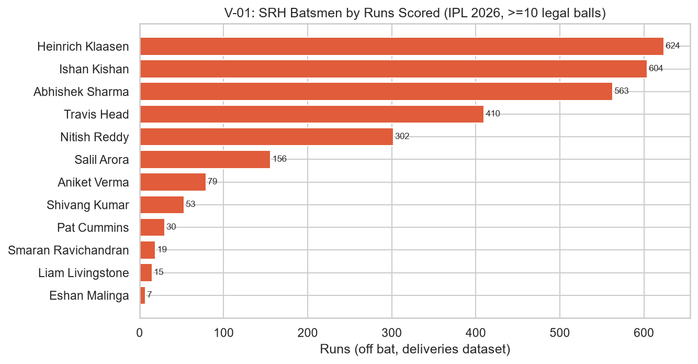
V-01: SRH Batsmen by Runs Scored (IPL 2026, ≥10 legal balls)
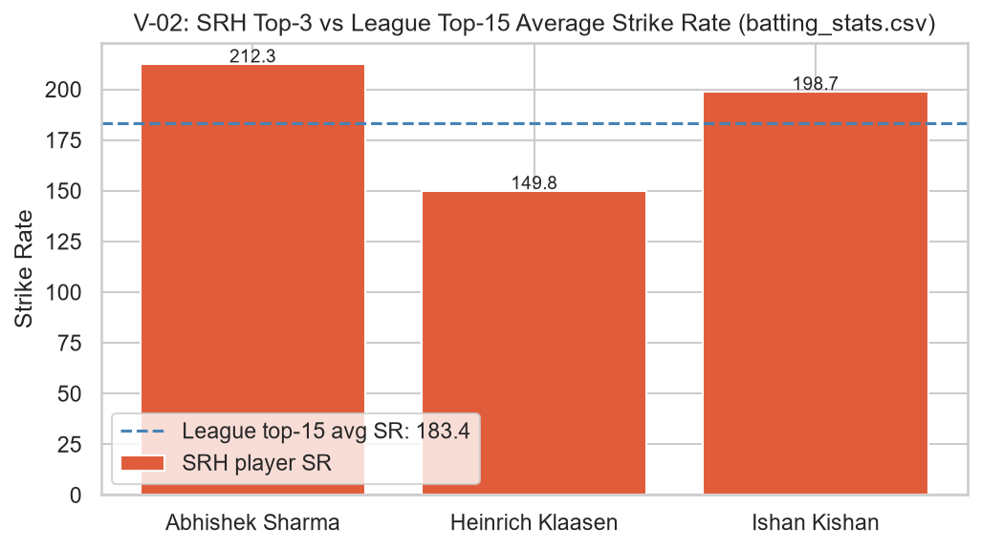
V-02: SRH Top-3 vs League Top-15 Average Strike Rate (batting_stats.csv)
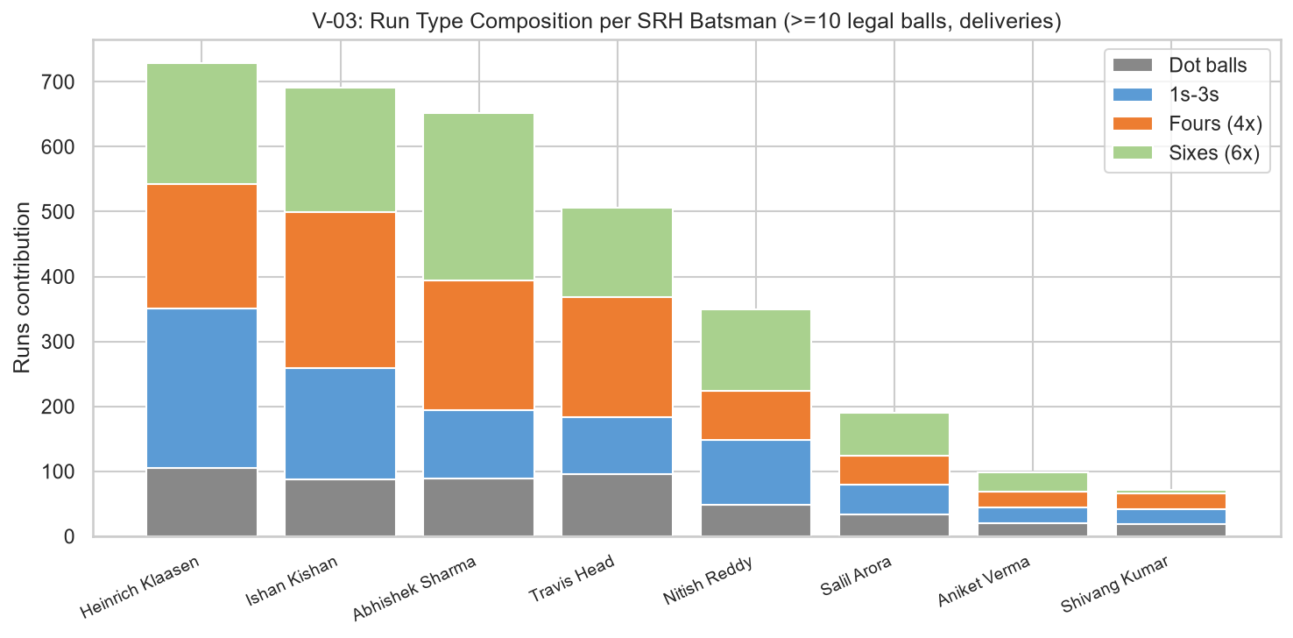
V-03: Run Type Composition per SRH Batsman (≥10 legal balls, deliveries)

5. Bowling Analysis
Bowling runs conceded are defined as runs off the bat, wides, and no-ball runs (byes and leg-byes excluded, as they are charged to the fielding side). The economy rate denominator is legal deliveries (wides and no-balls excluded) divided by 6. This follows standard cricket scoring convention.
SRH conceded 2,872 bowling runs across 15 matches. The bowling economy rate was 9.98 (N = 1,727 legal deliveries). SRH took 96 wickets while bowling.
The Best Figures column from bowling.csv is completely excluded from all calculations, tables, and visualisations due to a documented date-parse corruption (source values like '4/32' were interpreted as dates). The bowling.csv file lists 2 SRH bowlers among the top-15 IPL 2026 bowling aggregates; their economy rates are compared against the league top-15 average in the chart below.
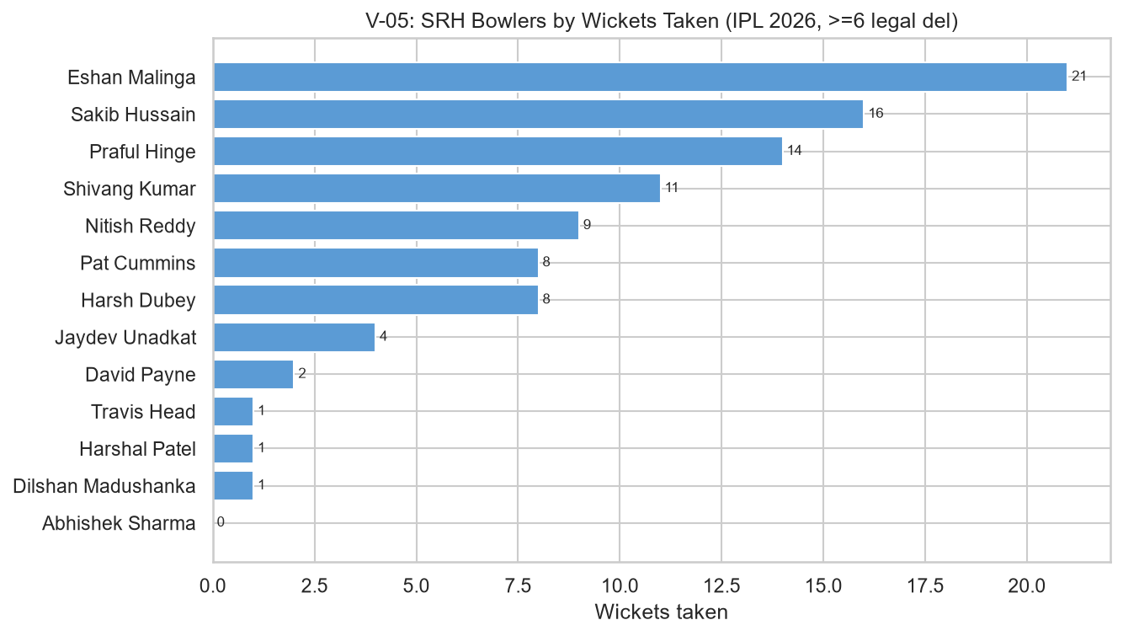
V-05: SRH Bowlers by Wickets Taken (IPL 2026, ≥6 legal deliveries)
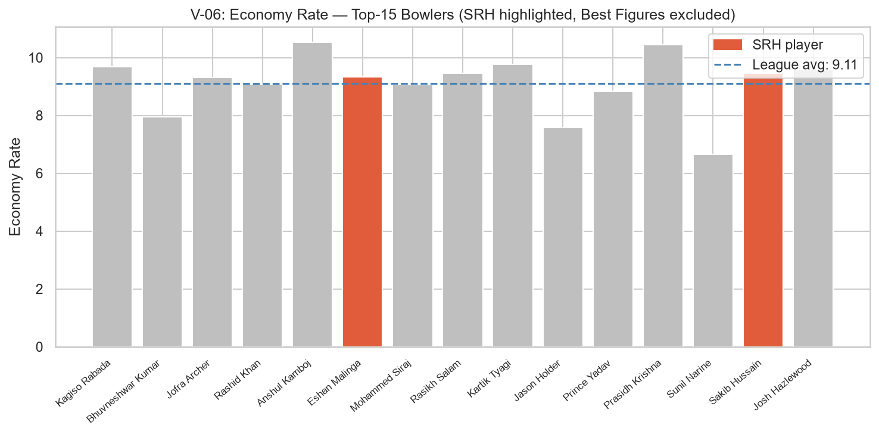
V-06: Economy Rate — Top-15 Bowlers (SRH highlighted; Best Figures excluded)
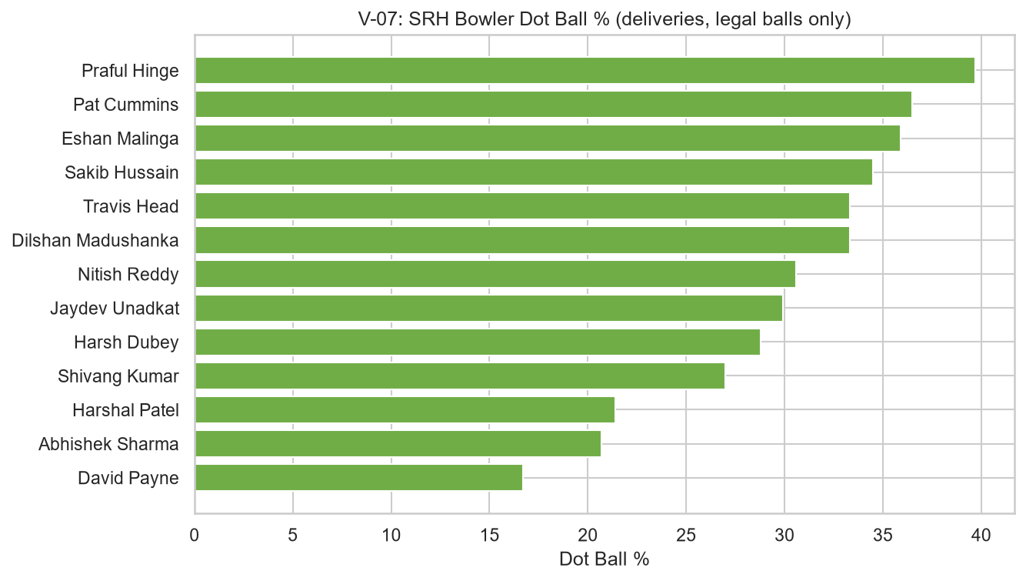
V-07: SRH Bowler Dot Ball Percentage (deliveries, legal balls only)

6. Fielding Analysis
The fielding_stats.csv file records catches for the top-15 catch leaders in IPL 2026. SRH has 2 players in this list: Heinrich Klaasen (cpm 0.875), Nitish Kumar Reddy (cpm 0.875). The league top-15 average catches-per-match (cpm) is 0.956; the average cpm for the 2 SRH players listed is 0.875. This comparison is bounded to the top-15 catch leaders only.
DATA LIMITATION: fielding_stats.csv records catches only. Stumpings, run-outs, and direct hits are not captured. The fielder column in deliveries is populated only for certain dismissal types (caught, stumped, and some run-outs). Fielding analysis is therefore limited to catch statistics and fielder-involvement counts from wicket deliveries.
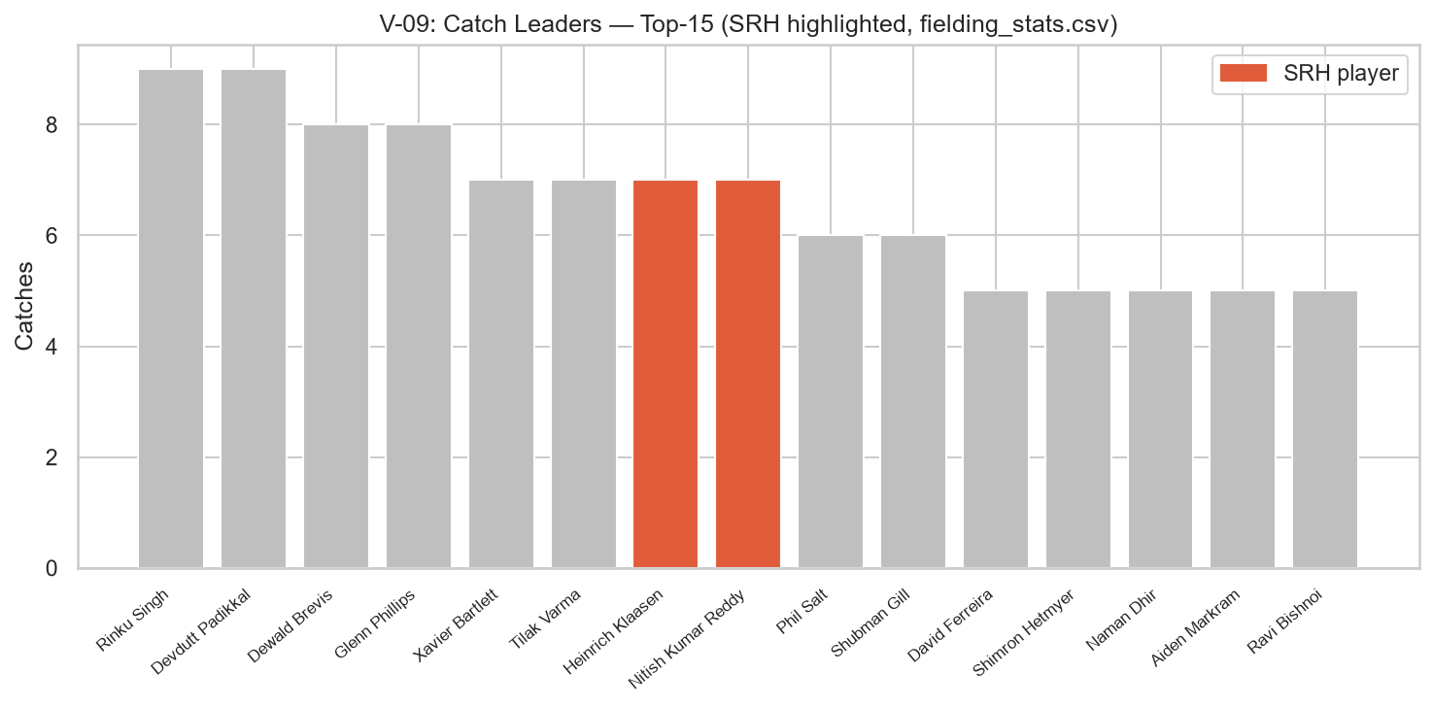
V-09: Catch Leaders — Top-15 (SRH highlighted, fielding_stats.csv)
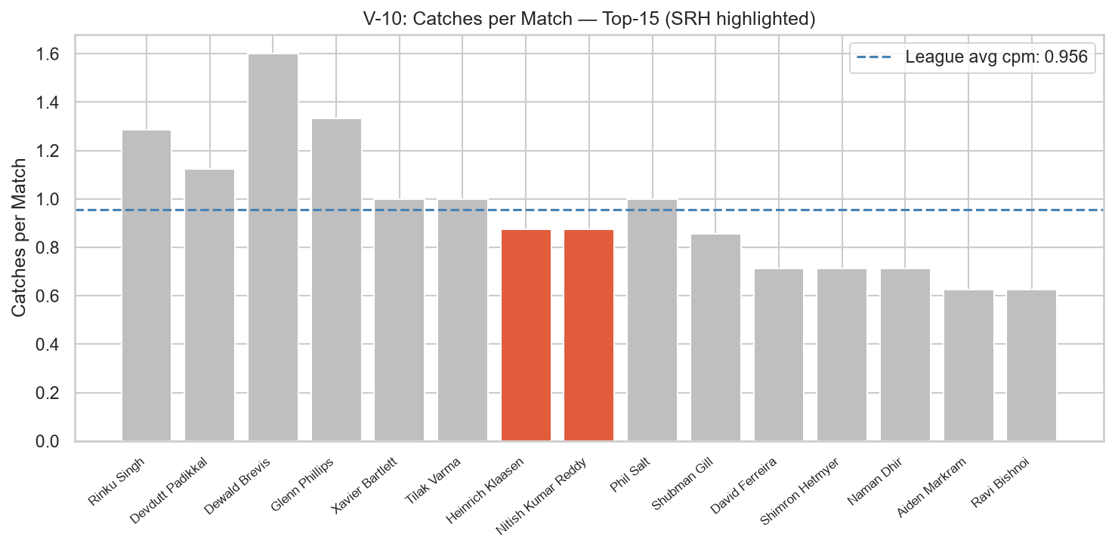
V-10: Catches per Match — Top-15 (SRH highlighted)

7. Phase Analysis (Powerplay / Middle / Death Overs)
Each delivery is classified into one of three phases based on over number: Powerplay (overs 0–5), Middle (overs 6–15), Death (overs 16–19). All economy rates use runs off the bat, wides, and no-ball runs (byes and leg-byes excluded, as they are charged to the fielding side) as the numerator and legal deliveries (wides and no-balls excluded) divided by 6 as the denominator. Sample sizes (N = legal deliveries) are stated for every metric.
SRH batting run rates by phase: Powerplay 10.48 (N = 540), Middle 9.60 (N = 894), Death 10.48 (N = 303). The phase with the highest observed SRH batting run rate was the Powerplay phase (10.48, N = 540 legal deliveries).
SRH bowling economy rates by phase: Powerplay 10.88 (N = 540), Middle 9.66 (N = 898), Death 9.28 (N = 289). The phase with the lowest observed SRH bowling economy was the Death phase (9.28, N = 289 legal deliveries). All phase comparisons are benchmarked against tournament-wide averages computed from the full deliveries dataset.
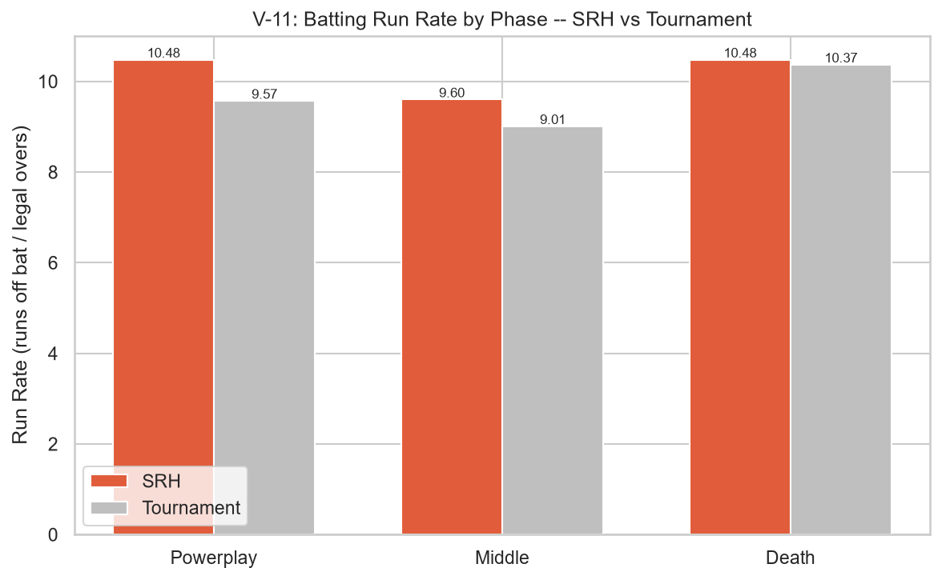
V-11: Batting Run Rate by Phase — SRH vs. Tournament Average
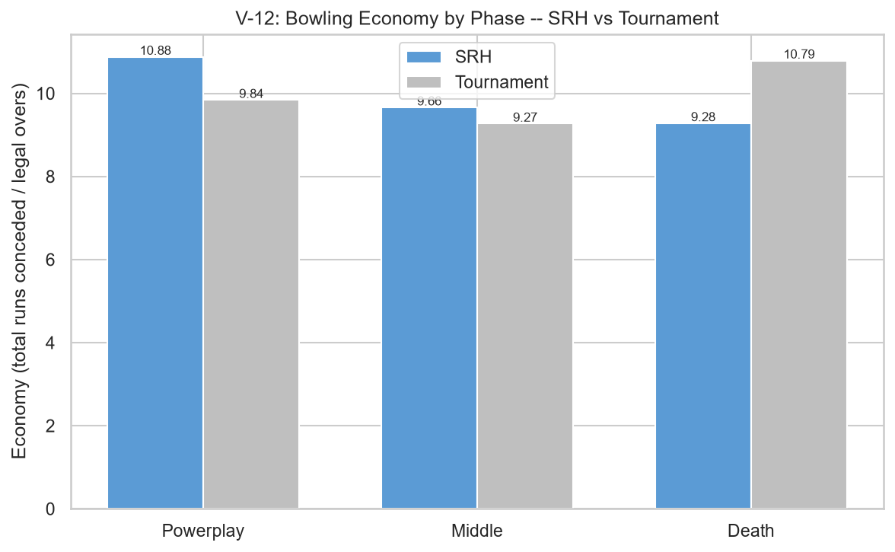
V-12: Bowling Economy by Phase — SRH vs. Tournament Average
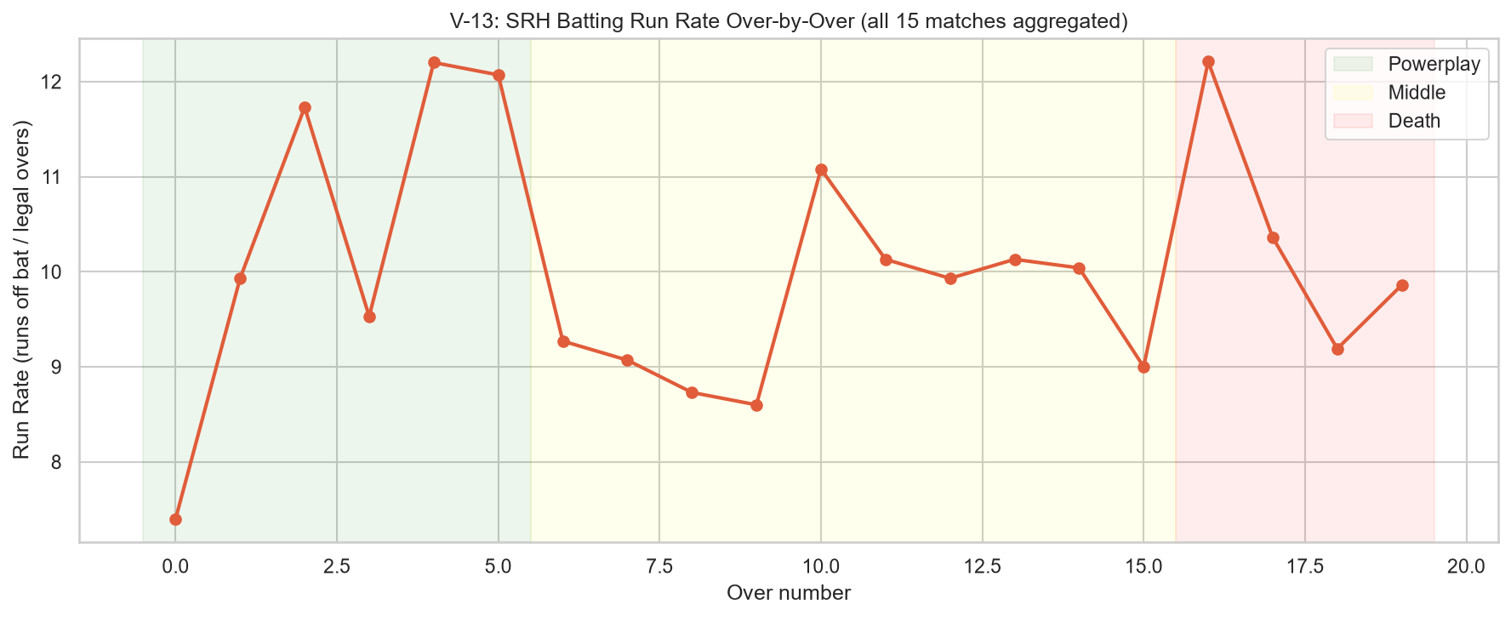
V-13: SRH Batting Run Rate Over-by-Over (all 15 matches aggregated)

8. Wicket Pattern Analysis
SRH took 96 wickets while bowling. Of these, 79 were caught dismissals (82.3% of total wickets taken, deliveries dataset). Full dismissal-type distributions, per-bowler wicket crosstabs, and phase-wise wicket counts are shown in the charts below.
SRH lost 102 wickets while batting. Of these, 81 were caught dismissals (79.4% of total wickets lost, deliveries dataset). Per-batsman dismissal records are presented in the notebook.
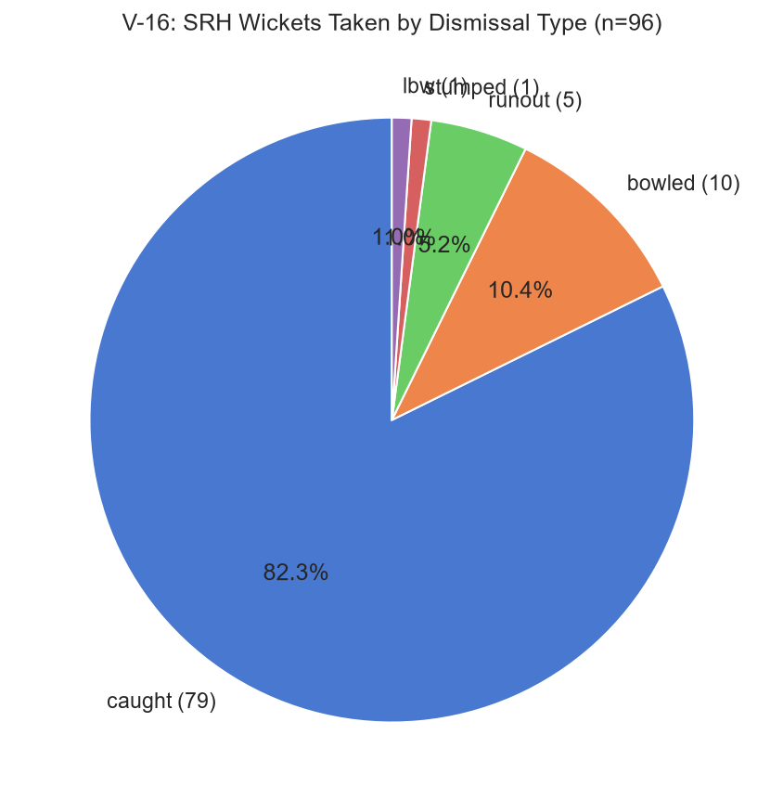
V-16: SRH Wickets Taken by Dismissal Type
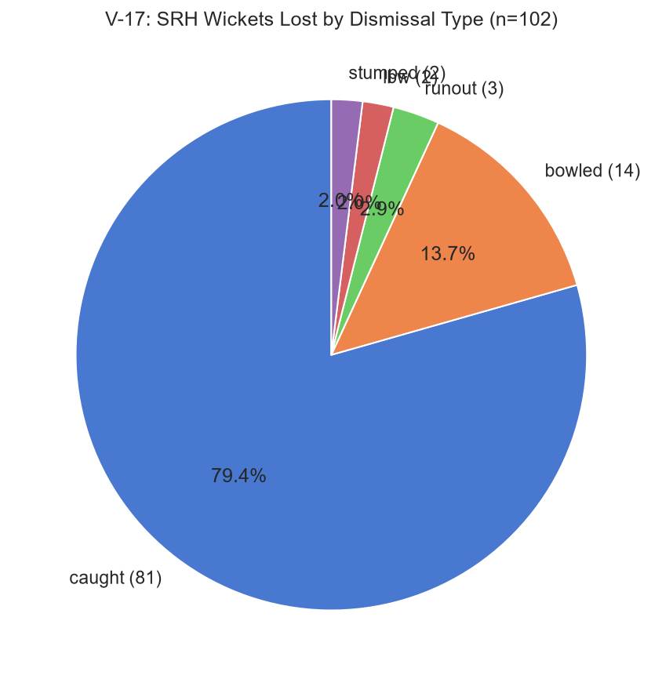
V-17: SRH Wickets Lost by Dismissal Type
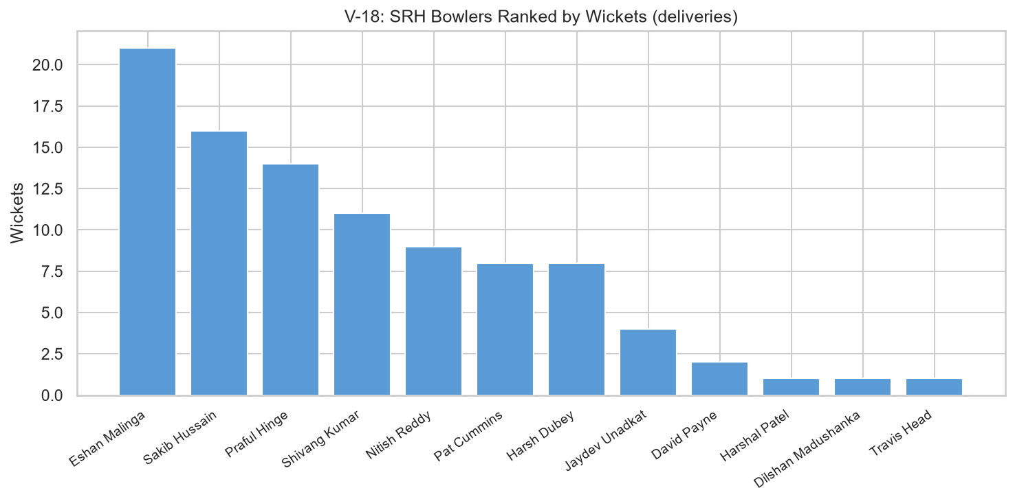
V-18: SRH Bowlers Ranked by Wickets Taken (deliveries)

9. Venue Analysis
SRH played across multiple venues during IPL 2026. The venue with the highest observed SRH batting run rate was Wankhede Stadium (12.70, N = 112 legal deliveries, 1 match(es)). The venue with the lowest observed SRH bowling economy (using runs off the bat, wides, and no-ball runs (byes and leg-byes excluded, as they are charged to the fielding side)) was Narendra Modi Stadium (8.20, N = 120 legal deliveries).
Home venue (Rajiv Gandhi International Stadium, Hyderabad): SRH batting run rate 10.07 (N = 834 legal deliveries). Away venues: SRH batting run rate 9.99 (N = 903 legal deliveries). Shaheed Veer Narayan Singh International Stadium (Raipur) is absent from venues.csv and is labelled 'Unmapped'. Venue capacity is included as descriptive context only — it is not an analytical variable.
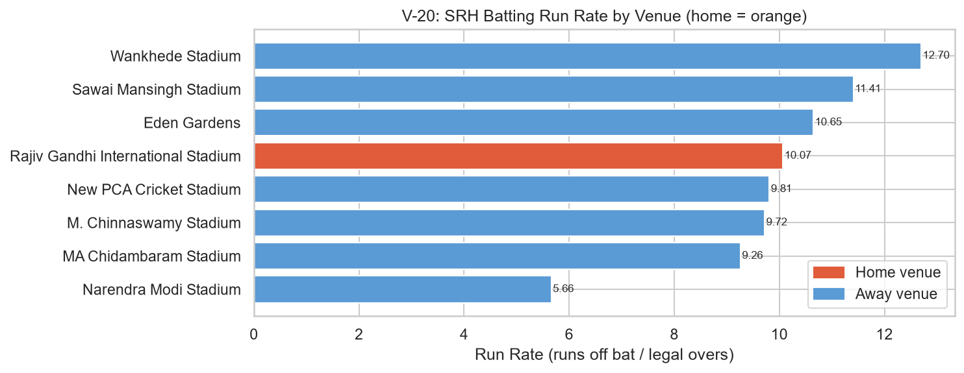
V-20: SRH Batting Run Rate by Venue (home venue = orange)

10. League Stage vs. Playoffs Analysis
CAVEAT: The League stage dataset contains substantially more deliveries than Playoffs and Final combined. All stage comparisons are directional observations based on the available data and are not statistically conclusive findings. Delivery counts are stated alongside every stage metric.
Bowling economy in this section uses runs off the bat, wides, and no-ball runs (byes and leg-byes excluded, as they are charged to the fielding side) as the numerator and legal deliveries (wides and no-balls excluded) divided by 6 as the denominator. Stage metrics include: match count, delivery count, batting run rate, bowling economy, boundary percentage, dot ball percentage, and wickets. A Phase × Stage pivot table showing legal delivery counts per cell is presented in the notebook.
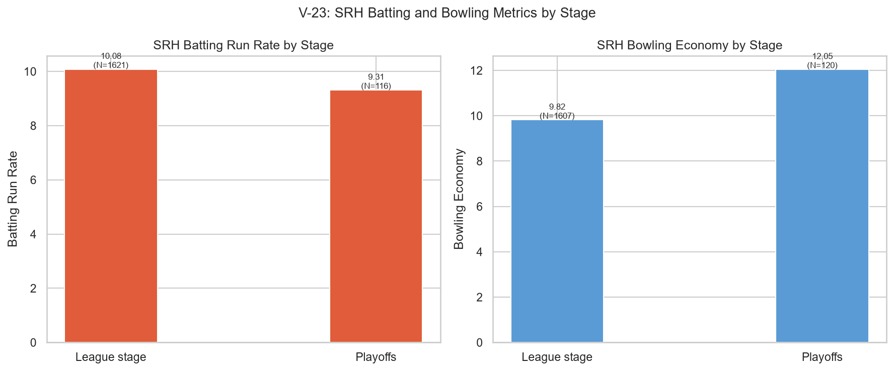
V-23: SRH Batting and Bowling Metrics by Stage

11. Player Performance Analysis
12 player(s) have delivery records in both the SRH batting and SRH bowling subsets of the deliveries dataset: Abhishek Sharma, David Payne, Eshan Malinga, Harsh Dubey, Harshal Patel, Jaydev Unadkat, Nitish Reddy, Pat Cummins, Praful Hinge, Sakib Hussain, Shivang Kumar, Travis Head. No role field exists in any of the five datasets; this is a data-presence observation only. These players are referred to as contributing in both batting and bowling, not as 'all-rounders'.
Batting profiles cover SRH batsmen with ≥20 legal balls faced. Bowling profiles cover bowlers with ≥12 legal deliveries. Player bowling economy values use runs off the bat, wides, and no-ball runs (byes and leg-byes excluded, as they are charged to the fielding side) as the numerator and legal deliveries (wides and no-balls excluded) divided by 6 as the denominator. For 3 SRH batsmen in batting_stats.csv and 2 SRH bowlers in bowling.csv, delivery-derived metrics are shown alongside summary-file metrics. The Best Figures column is excluded from all bowler displays.
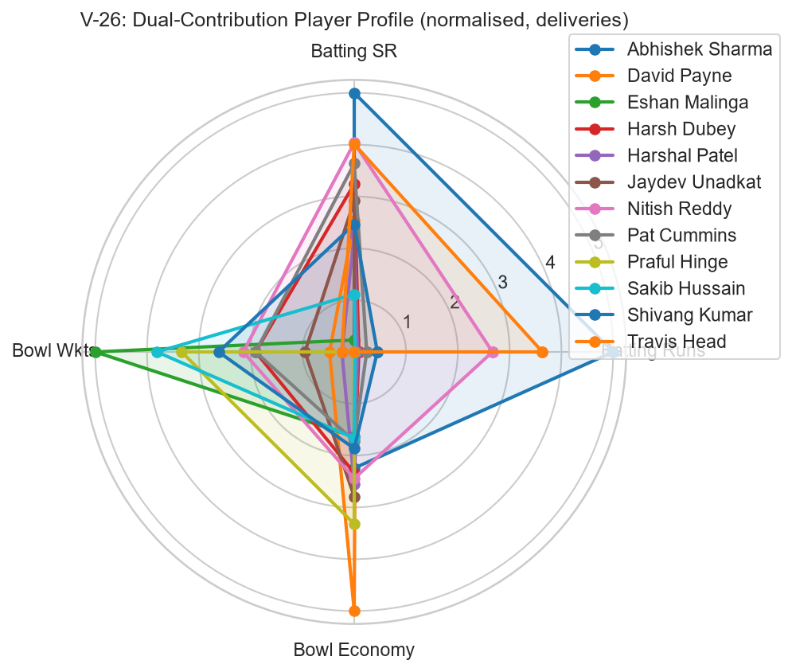
V-26: Dual-Contribution Player Profile (normalised metrics, deliveries)
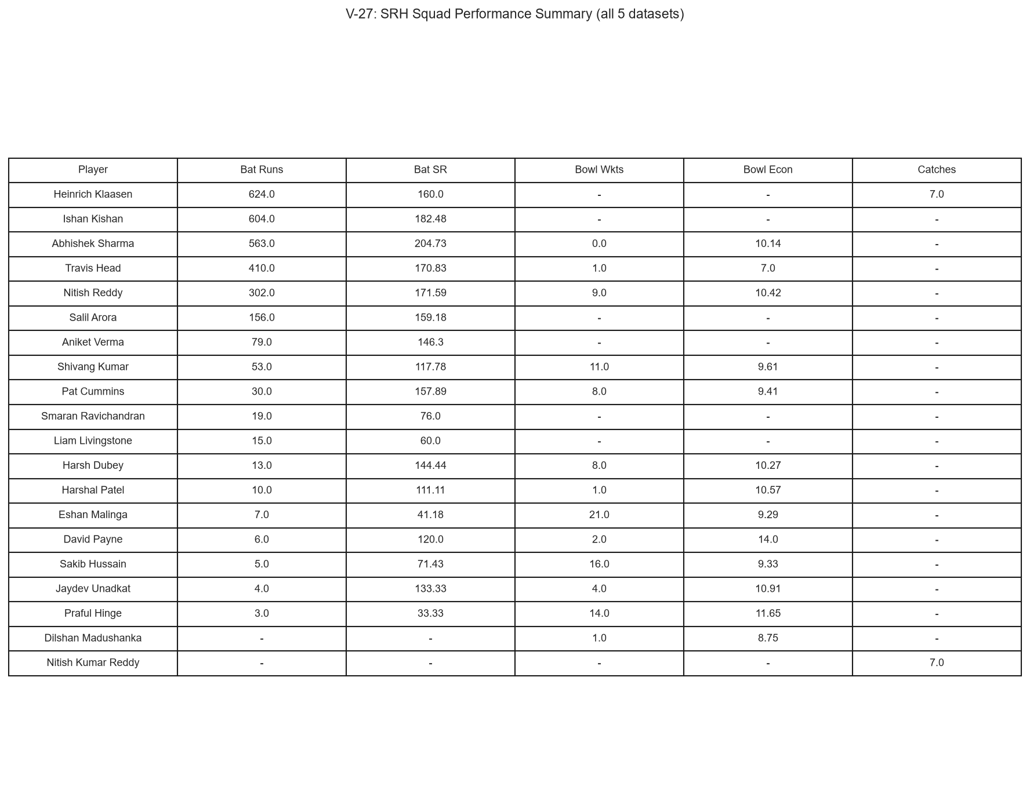
V-27: SRH Squad Performance Summary (all 5 datasets)

12. Cross-Dataset Integration
Four explicit cross-dataset joins demonstrate what each integration enables beyond what any single dataset could provide alone:
Integration 1 — deliveries.striker == batting_stats.batsman: delivery-level granularity alongside season-aggregate validation for 3 SRH batsmen.
Integration 2 — deliveries.venue_clean == venues.venue_stadium: city, state, and capacity alongside SRH delivery metrics per venue.
Integration 3 — deliveries.bowler == bowling.Player (after TEAM_MAP): delivery-derived economy (runs off bat + wides + no-ball runs, byes/leg-byes excluded) cross-validated against summary economy; Best Figures excluded.
Integration 4 — fielding_stats.player == deliveries.fielder: catch count (fielding_stats) and dismissal-involvement count (deliveries) in a single table.
Integration | Join Key | Enables
Integration 1 | deliveries.striker == batting_stats.batsman | Delivery stats + season aggregates for 3 SRH batsmen
Integration 2 | deliveries.venue_clean == venues.venue_stadium | City, state, capacity with delivery metrics
Integration 3 | deliveries.bowler == bowling.Player (after TEAM_MAP) | Delivery economy vs summary economy (Best Figures excluded)
Integration 4 | fielding_stats.player == deliveries.fielder | Catch count + dismissal involvement in one table

13. Key Findings
The following 12 metric findings are derived from the executed notebook. Every value cites its source dataset and sample size. Bowling economy throughout uses runs off the bat, wides, and no-ball runs (byes and leg-byes excluded, as they are charged to the fielding side) as the numerator and legal deliveries (wides and no-balls excluded) divided by 6 as the denominator. All findings are based on IPL 2026 data only (March–May 2026).
F1. SRH overall batting run rate: 10.43 (N = 1,737 legal deliveries, deliveries dataset).
F2. SRH overall bowling economy: 9.98 (N = 1,727 legal deliveries, deliveries dataset).
F3. Highest observed SRH batting run rate by phase: Powerplay (10.48, N = 540 legal deliveries).
F4. Lowest observed SRH bowling economy by phase: Death (9.28, N = 289 legal deliveries).
F5. Abhishek Sharma strike rate: 212.3 (league top-15 average SR: 183.4, batting_stats.csv).
F6. SRH wickets taken as catches: 79 of 96 (82.3%, deliveries).
F7. SRH wickets lost as catches: 81 of 102 (79.4%, deliveries).
F8. Venue with highest observed SRH batting run rate: Wankhede Stadium (12.70, N = 112 legal deliveries, 1 match(es), deliveries + venues).
F9. Venue with lowest observed SRH bowling economy: Narendra Modi Stadium (8.20, N = 120 legal deliveries).
F10. SRH fielders catches-per-match vs league top-15 average: SRH top-2 avg cpm = 0.875, league top-15 avg cpm = 0.956 (fielding_stats.csv).
F11. Players with delivery records in both SRH batting and bowling subsets: n = 12 (Abhishek Sharma, David Payne, Eshan Malinga, Harsh Dubey, Harshal Patel, Jaydev Unadkat, Nitish Reddy, Pat Cummins, Praful Hinge, Sakib Hussain, Shivang Kumar, Travis Head, deliveries dataset).
F12. SRH dot ball percentage while batting: 32.8% (tournament average: 34.1%, deliveries dataset).
Batting, bowling, and fielding summary files contain top-15 players only; SRH players not in those lists are represented solely through delivery-level data.

14. Limitations and Scope
• Single season (IPL 2026) only — results cannot be generalised to other seasons.
• Batting, bowling, and fielding summary files cover only the top-15 players in each category.
• No match result column exists in any dataset — win/loss analysis is not supported.
• No toss data — toss-related analysis is not supported.
• Fielding statistics are limited to catches; stumpings, run-outs, and direct hits are not captured.
• No player role field exists in any dataset — players cannot be classified by role.
• Shaheed Veer Narayan Singh International Stadium (Raipur) is absent from venues.csv — no venue metadata available for that ground.
• The Best Figures column in bowling.csv is corrupted and excluded from all calculations.

15. Conclusion
This project applied a structured data analytics workflow to five IPL 2026 datasets to characterise Sunrisers Hyderabad's campaign across 15 matches. The ball-by-ball deliveries dataset (17,477 rows) served as the primary source, enabling phase-level, over-by-over, per-player, and per-venue breakdowns. Supporting files provided aggregate context for top-15 batsmen, bowlers, and fielders.
Key observed metrics (all from IPL 2026 data): SRH batting run rate 10.43 (N = 1,737 legal deliveries); bowling economy 9.98 (N = 1,727 legal deliveries; economy = runs off the bat, wides, and no-ball runs (byes and leg-byes excluded, as they are charged to the fielding side)); 82.3% of SRH wickets taken were caught (79 of 96); 12 player(s) had delivery records in both batting and bowling subsets (Abhishek Sharma, David Payne, Eshan Malinga, Harsh Dubey, Harshal Patel, Jaydev Unadkat, Nitish Reddy, Pat Cummins, Praful Hinge, Sakib Hussain, Shivang Kumar, Travis Head).
All analyses are descriptive and bounded by available data. No win/loss outcomes, predictions, or multi-season extrapolations are made. Data quality issues — including the Best Figures corruption, venue name mismatches, and team name format differences — were documented and resolved transparently before analysis.

16. References and Dataset Attribution
Dataset Source: [Requires user verification before submission — the original dataset source URL was not found in any file within this workspace. Please confirm the source and add the verified URL here before submission.]
Programme: AICTE | IBM SkillsBuild Data Analytics with AI Internship 2026
Author: Lanka Saimanikanta Sharma
Tools: Python 3, pandas, numpy, matplotlib, seaborn, fpdf2, python-docx, jupyter, nbconvert

