**Student Name: Tarun Lanka**

**Student ID: 20003800**

B9MG119

SME: Abcodia

Cloud Technology for Business

Cloud Strategy and sample deployment

Table of Contents

1 Introduction 2

2 Enterprise background 3

3 Current IT Setup 4

4 Deployment Procedure 5

5 Recommendations 12

5.1 Cloud vs non-cloud solutions 12

5.2 Appropriate deployment types and service level 12

5.3 Justification for Recommendation 13

6 Conclusion 14

7 References 15

# Introduction

The main aim behind the development of this document file is to develop an understanding of cloud technology for the business process. For the completion of the study, Abcodia company is used which is a part of the small and medical scale category. The report contains the strategy for cloud deployment with the consideration of the enterprise background, the Current information technology setup of the company, and recommendations about the cloud and non-cloud solutions.

# Enterprise background

Abcodia is a biotechnology company that mainly focuses on cancer screening and biomarkers. The main aim behind the use of biomarkers is to detect cancer in the early stage. The headquarter of the company is located in the United Kingdom that was founded in 2010. The company is also defined as a clinical-stage organization that engages in the development of tests for the detection of cancer. The company focuses on software development so medical devices can provide the result on the basis of the change in the blood (Crunchbase 2022).

# Current IT Setup

If we talk about the recent setup of the Information technology upgradation of the company then it can be stated that Abcodia is associated with the website that contains the information cancer test which named as ROCA test. Apart from that company is associated with different pages which is helpful for the customers. The company distinguished the website into the different sections which are the patient purpose, clinical purpose, and blog sections. After inspecting the website, we get the information that there is a range of links that are disabled which leads to the weak performance of the website (ROCA Test 2023).

# Deployment Procedure

**Setup Directory structure**:

The directory structure should be set up as per according to the given image which includes the source code and all the required files along with the Docker file to create and containerize the image.

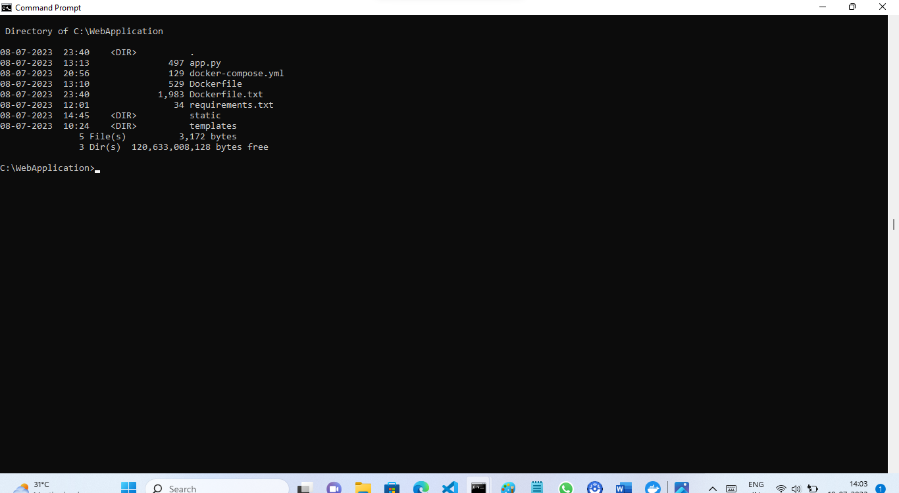

**Test the code in local:**

Run the python file in local to test the code. Copy the URL shown in the image and paste in google to check if the web application is running.

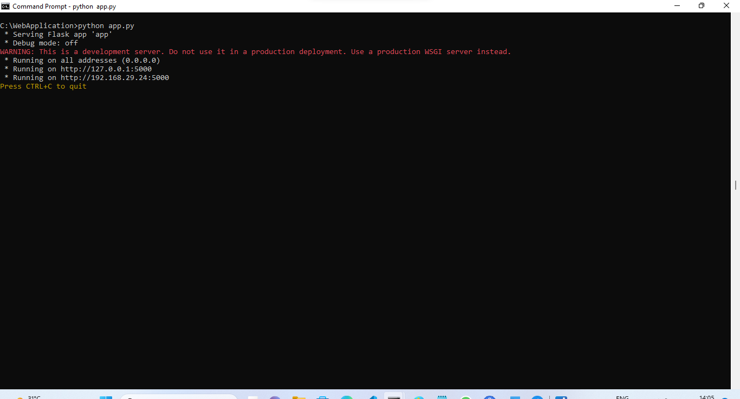

**Create a Docker image:**

In order to containerize the application, we have to create a docker image using the docker commands as shown in the image below.

Once the image is built, we can check the images present in the locally using command:

docker images: - it will display all the images present in the local.

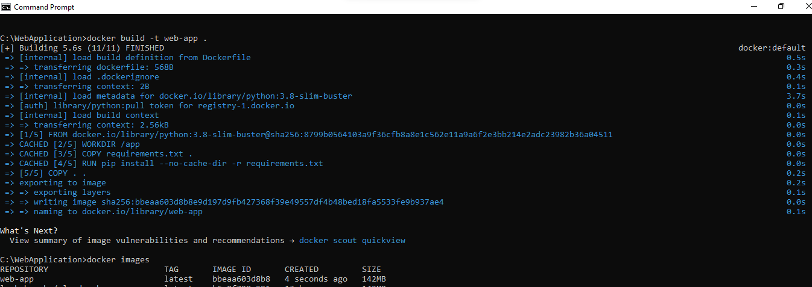

**Run the Docker image:**

Once the Docker image is created, we can run the image using the docker run command as shown in the image.

On running the image, a container is created on which the image will run. Copy the url present in the logs to check the running we application.

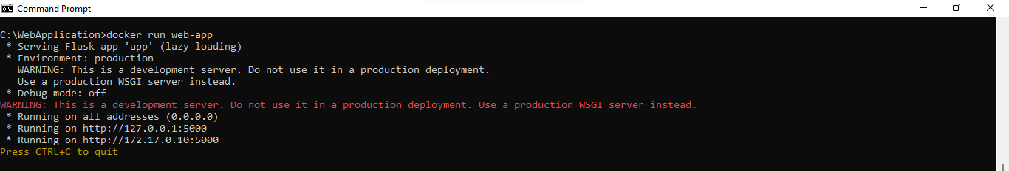

**Docker Desktop:**

We can also check the image and the container created in the docker desktop as shown in the below image.

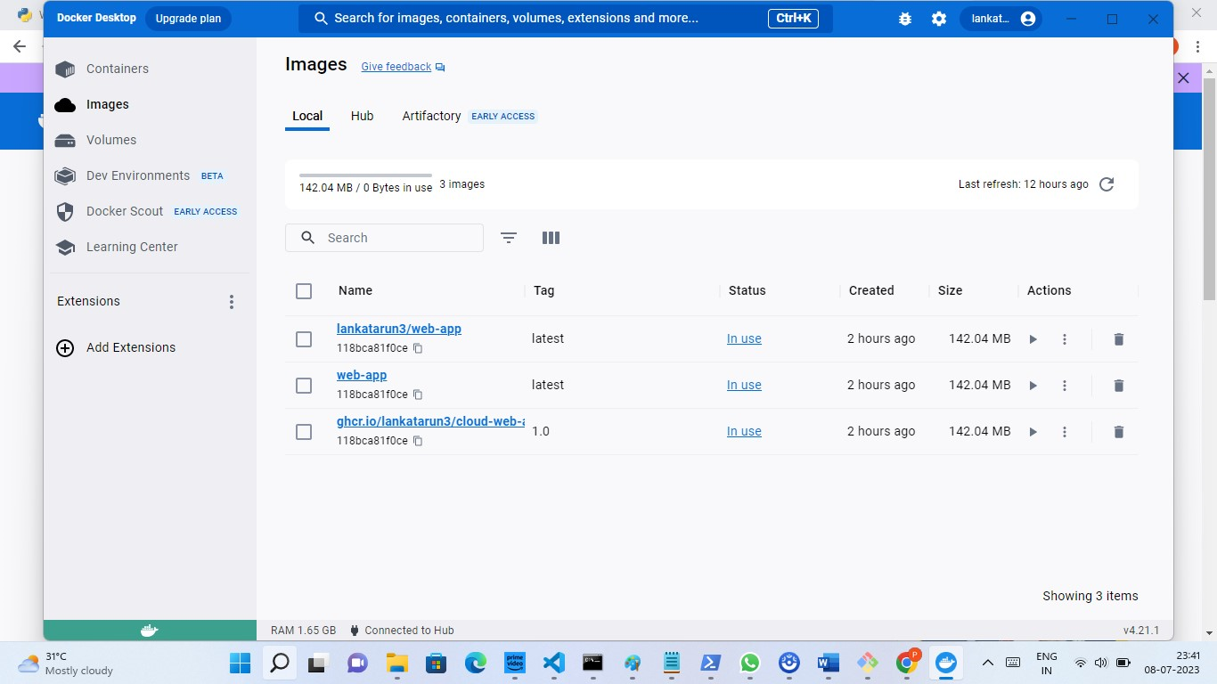

The image is also pushed to docker hub in order to run the web application through the docker desktop.

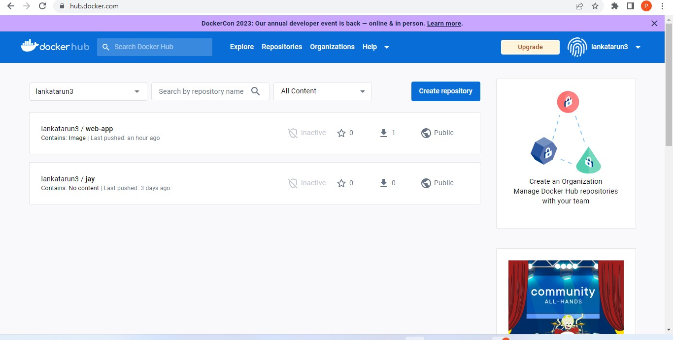

**Push the Image and source code to GitHub:**

Now the created docker image is pushed to the GitHub registry using the below steps:

* Login to the GitHub registry using PAT (Personal Access token)
* Tag the docker image to the GitHub registry
* Push the docker image to GitHub as shown in the image below.
* Verify the image pushed in GitHub using the GitHub portal.

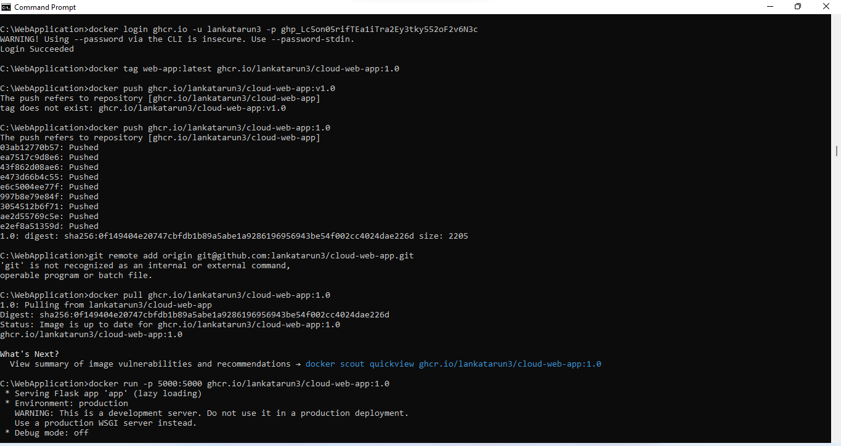

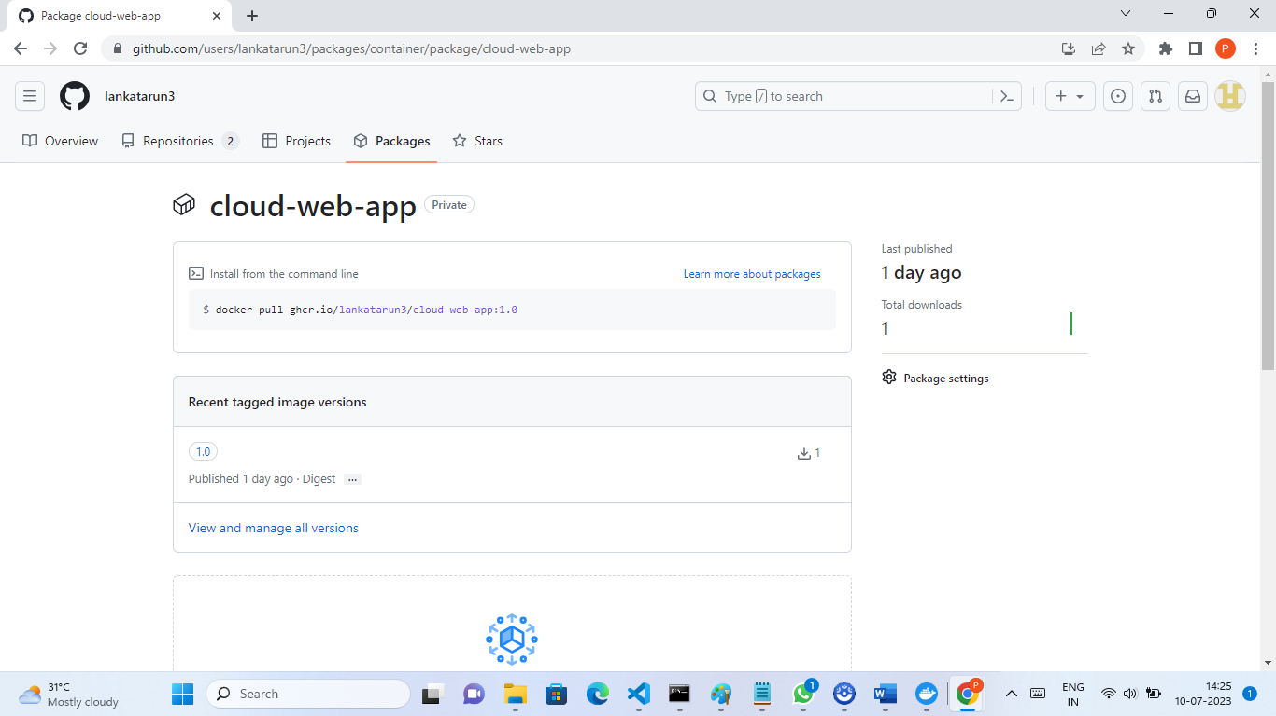

**Upload the resource to Azure as a container:**

In order to upload the container application in Azure we have to upload the image to the azure container registry by using the commands as shown:

* Login to the azure using az login
* Create the azure container registry using the resource group
* Tag the docker image to azure container registry.
* Login to azure container registry.
* Push the image to azure container registry.

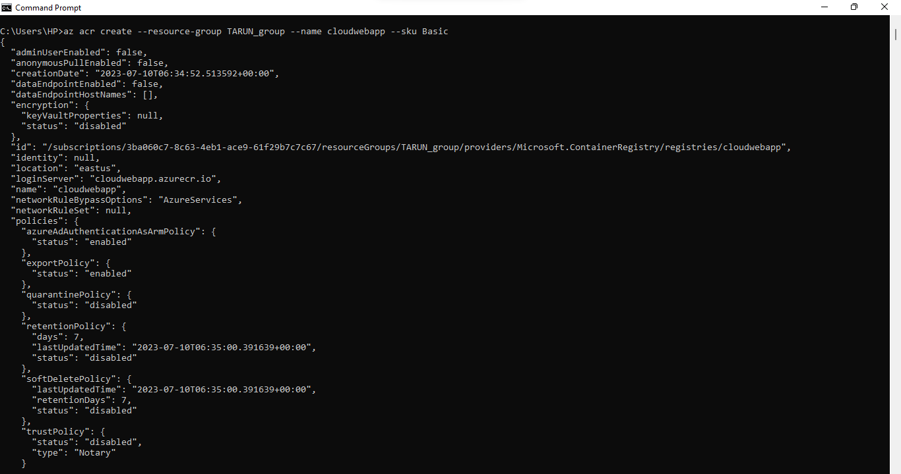

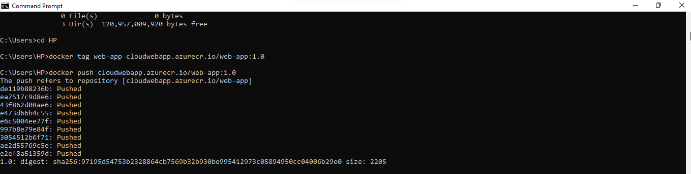

* Check the uploaded container resource on the azure container registry.

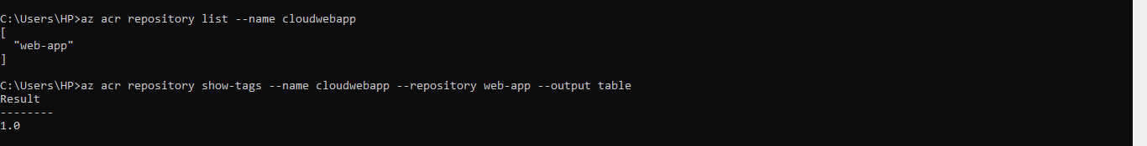

**Web application testing:**

The web application which is running on the server mentioned in the logs is as shown in the below images. It depicts the usage of the cloud application or resources by the SME company in order to move the on-premise infrastructure to cloud infrastructure using the deployment of cloud resources or services.





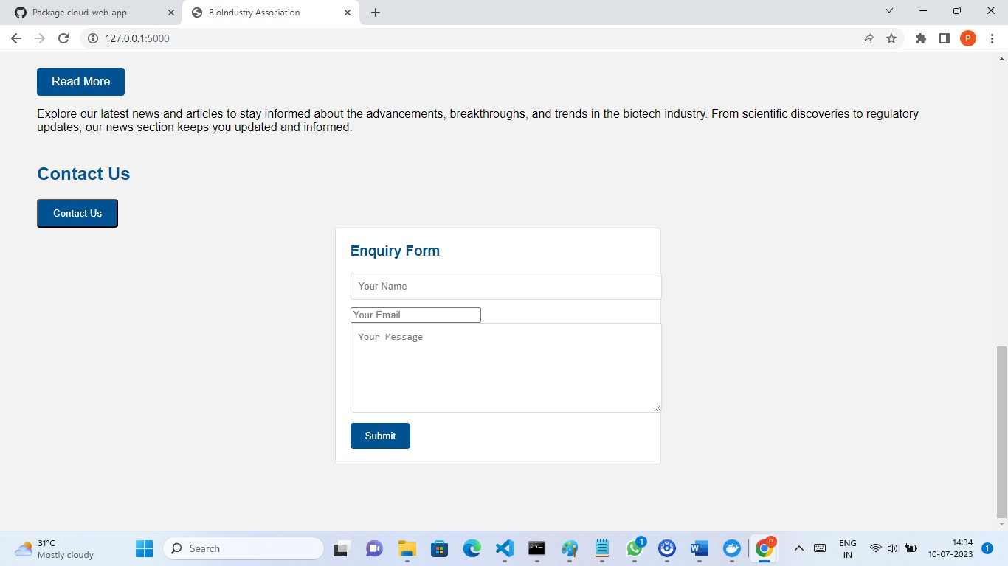

# Recommendations

## Cloud vs non-cloud solutions

**Cloud Solutions:**

* Cloud solutions involve deploying, hosting the applications on the remote server, or using the remote database to store the data.
* With the help of a cloud-based solution, The company can scale up or scale down the applications based on our requirements in order to save cost and maintain speed.
* The use of the cloud enables the services for people thus anyone can access the remote server without much more dependency on the on-premise infrastructure (IBM 2023).

**Non-Cloud Solutions:**

* Non-Cloud solutions involve deploying and hosting the applications on the On-Premise infrastructure.
* We have greater control of infrastructure in the non-cloud as we can maintain and update the infrastructure as per our needs.

## Appropriate deployment types and service level

For deploying the cloud resources or services we needed.

* Docker instance
* Docker Container
* GitHub Registry
* Containerize the application
* Updating the application.
* Multi-Container Apps

**Services/Resources used:**

* Azure Active registry
* Github Registry
* Docker Desktop
* Python/HTML/CSS/JS

The above mention technology is considered as advanced technology so it is recommended that the company should integrate with these so company is able to reduce the complexity of the different tasks. The cloud also enables data security so companies can reduce the issues of security breaches (Azure 2023).

## Justification for Recommendation

Cloud solutions facilitate with deployment, and hosting of the applications by remote server, or using the remote database to store the data. As the company is associated with a critical field thus it is necessary to secure the data so cloud services are the best option.

# Conclusion

It can be stated that this document is the perfect reflection of the entire progress of cloud deployment. In order to complete the research, we developed a web application and then push it into the docker and GitHub. After that, the application is also deployed on Azure that contains the different resources.

# References

Azure. (2023). *Data Privacy in the Trusted Cloud.* Microsoft Azure. [online] Available at: https://azure.microsoft.com/en-in/explore/trusted-cloud/privacy [Accessed 10 Jul. 2023].

Crunchbase. (2022). *Crunchbase*. [online] Available at: https://www.crunchbase.com/organization/abcodia [Accessed 10 Jul. 2023].

IBM. (2023). *What is a Cloud Server*. [online] Available at: https://www.ibm.com/topics/cloud-server [Accessed 10 Jul. 2023].

ROCA Test. (2023). *Contact Us for Assistance*. [online] Available at: https://www.therocatest.co.uk/contact-us/ [Accessed 10 Jul. 2023].

‌

‌

‌

‌

‌