Developer Integration Guide & API Specification
Transit.dll provides hardware interfacing and serial communication routines for SDR devices. It is compiled for both 32-bit (x86) and 64-bit (x64) architectures using standard C export linkage.
Function Reference
1. AutoConnectSDR
Scans available serial ports and establishes a connection to a compatible SDR unit.
int __stdcall AutoConnectSDR(char* outBuffer, int maxLength);
- Parameters:
  - outBuffer (char*, [out]): Pre-allocated buffer where the status/connection message is written.
  - maxLength (int, [in]): Total allocated size of outBuffer in bytes (recommended: 255).
- Returns:
  - > 0: Successful connection. The returned integer represents the active COM port number (e.g., 3 for COM3).
  - 0 or -1: Connection failed; no compatible device found.
2. CheckConnection
Queries the hardware state to verify if the SDR is responsive and still actively connected.
void __stdcall CheckConnection(char* outBuffer, int maxLength);
- Parameters:
  - outBuffer (char*, [out]): Pre-allocated buffer to store the connection status text.
  - maxLength (int, [in]): Size of outBuffer in bytes.
- Returns: void

3. DisconnectSDR
Safely terminates the serial connection and releases the COM port.
void __stdcall DisconnectSDR();
- Parameters: None
- Returns: void
4. CommandTokens
Processes token-based instruction sends through the device controller.
void __stdcall CommandTokens(const char* inputStr, char* outBuffer, int maxLength);
- Parameters:
  - inputStr (const char*, [in]): Input token.
  - outBuffer (char*, [out]): Pre-allocated buffer to store the processed response.
  - maxLength (int, [in]): Size of outBuffer in bytes.
- Returns: void

5. SendCommandToSDR
Transmits a raw text command directly to the connected SDR hardware.
int __stdcall SendCommandToSDR(const char* inputStr);
- Parameters:
  - inputStr (const char*, [in]): Null-terminated command string to transmit
- Returns:
  - 1 (or 0): Transmission status code (returns non-zero on successful write).

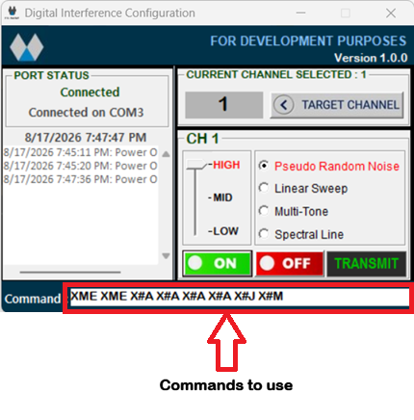
All radio adjustment setting, commands are below and you can copy and paste it into your program.

