CSE 3313 - Homework #2 - Discrete linear Shift-Invariant Systems

# LINEARITY

1. We know that putting x1 into a linear system results in the output y1; putting x2 into the system results in the output y2 and putting x3 into the system results in the output y3. What is the output of that linear system with the input below?

ay1 + by2 + cy3

2. Test the following systems for **linearity** using the test procedure given in class and determine whether they are linear or non-linear.

1. y[n] = 2x[n]+1
   1. y1[n] = 2x1[n]+1

y2[n] = 2x2[n]+1

* 1. x3[n] = ax1[n]+bx2[n]
  2. y3[n] = 2x3[n]+1

y3[n] = 2(ax1[n]+bx2[n])+1

y3[n] = 2ax1[n] + 2bx2[n] + 1

* 1. y3[n] = ay1[n]+by2[n]

y3[n] = a(2x1[n]+1)+b(2x2[n]+1)

y3[n] = 2ax1[n] + 2bx2[n] + a + b

* 1. 2ax1[n] + 2bx2[n] + a + b ≠ 2ax1[n] + 2bx2[n] + 1

NO, the system is not LINEAR

1. y[n] =
   1. y1[n] =

y2[n] =

* 1. x3[n] = ax1[n]+bx2[n]
  2. y3[n] =

y3[n] =

* 1. y3[n] = ay1[n] + by2[n]

y3[n] =

y3[n] =

y3[n] =

YES, the system is LINEAR

1. y[n] = x[2n]
   1. y1[n] = x1[2n]

y1[n] = x2[2n]

* 1. x3[n] = ax1[n]+bx2[n]
  2. y3[n] = x3[2n]

y3[n] = ax1[2n]+bx2[2n]

* 1. y3[n] = ay1[n]+by2[n]

y3[n] = ax1[2n]+bx2[2n]

* 1. ax1[2n]+bx2[2n] == ax1[2n]+bx2[2n]

YES, the system is LINEAR

# SHIFT-INVARIANCE

3. We know that putting x into a shift-invarient system results in the output y. What is the output of that shift-invariant system with the input given below?

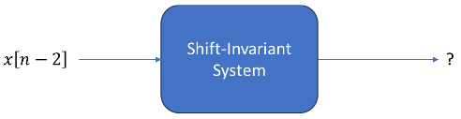

The result is y[n-2].

This is due to the shift invarience condition where if x[n]->y[n] then x[n-n0]->y[n-n0]

4. Test the above systems in problems 2z, 2b, 2c for shift-invariance using the test procedure given in class and determine whether they are shift-invarient or not shift-invarient

1. y[n] = 2x[n]+1
   1. y[n - n0] = 2x[n – n0]+1
   2. y1[n – n0] = 2x[n - n0]+1
   3. 2x[n – n0]+1 == 2x[n – n0]+1

YES, the system is SHIFT-INVARIENT

1. y[n] = $\frac{1}{2}x\left[n\right]-\frac{1}{4}x[n-1]$

$y[n – n_{0}] = \frac{1}{2}x[n – n_{0}] - \frac{1}{4}x[n-1 – n_{0}]$

$y[n – n_{0}] = \frac{1}{2}x[n – n_{0}] - \frac{1}{4}x[n- n_{0}-1]$

$y\left[n – n_{0}\right]= \frac{1}{2}x\left[n – n_{0}\right]- \frac{1}{4}x\left[n-1 – n_{0}\right] ==y[n – n_{0}] = \frac{1}{2}x[n – n_{0}] - \frac{1}{4}x[n- n_{0}-1]$

YES, the system is SHIFT-INVARIENT

1. y[n] = x[2n]
   1. y[n - n0] = x[2n - n0]
   2. y[n - n0] = x[2(n-n0)]

y[n - n0] = x[2n - 2n0]

* 1. x[2n - n0] ≠ x[2n - 2n0]

NO, the system is not SHIFT-INVARIENT

# LINEAR SHIFT-INVARIENT SYSTEMS

5. If we know that x into the sytem results in an output of y, what is the output of the linear shift-invariant (LSI) system below with the given input?

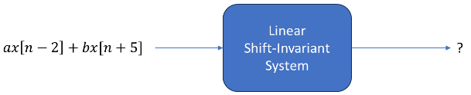

ay[n-2] + by[n+5]

6. If we know that a delta function (𝛿[𝑛]) as an input to an LSI system results in an output of h[n], what is the output of the following LSI system?

a0h[𝑛] + a1h[𝑛-1] + a2h[𝑛-2]

7. If we know that a delta function (𝛿[𝑛]) as an input to an LSI system results in an output of h[n], what is the output of the following LSI system?

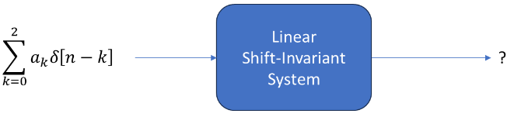

a0h[n] + a1h[n-1] + a2h[n-2]

8. If we know that a delta function (𝛿[𝑛]) as an input to an LSI system results in an output of h[n], what is the output of the following LSI system?

9. Write the decomposition of a infinitely long general sequence x[n] into a sum of weighted and shifted delta functions (𝛿[𝑛]).

$$x\left[n\right]=\sum_{k=-∞}^{∞}{x\left[k\right]δ[n-k]}$$

Where x[k] are the individual unit weights and δ[n-k] are the shifted delta functions.

10. If we know that a delta function ( 𝛿[𝑛] ) as an input to an LSI system results in an output of ℎ[𝑛],what is the output of an LSI system with your decomposed general sequence from question 9 as the input?

$$y\left[n\right]=\sum_{k=-∞}^{∞}{x\left[k\right]h[n-k]}$$

Where x[k] are the weights and h[n-k] are the outputs from δ[n-k].