A problem was identified when using subgridding in PLUMECALC V2.3.2 on a simple model that used FEHM streamline particle tracking runs with dispersion. Runs with 1x1x1, 2x2x2, and 4x4x4 subgridding over estimated concentrations by ~90% when compared to the run without subgridding. The same problem was rerun without dispersion to assist in identifying the source of the errors.
An analysis of results indicated that the error only occurred when subgridding was used with a sptr run that included dispersion and also applied diffusion (Figure 2). The error was not present in runs without dispersion [with (Figure 1) or without diffusion] and with dispersion without diffusion (Figure 3). It was also noted that the magnitude of the average over calculation was the same no matter what level of subgridding was used.
The problem of over estimating the concentration was identified as an implementation issue related to when the delay applied due to diffusion was computed. In the original implementation of mobile concentrations, the time delay was calculated before any subgridding occurred. This lead to an over calculation of concentration no matter what level of subgridding was used. This problem has been corrected by doing the time delay calculations after the subgridding (Figure 4).

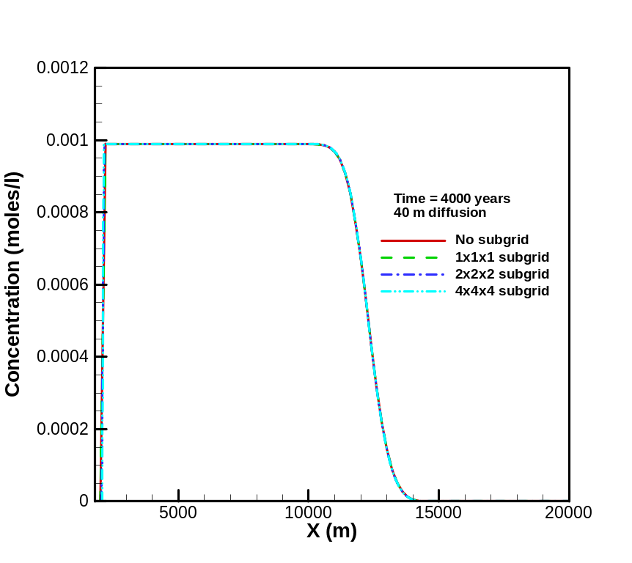
Figure 1. PLUMECALC V2.3.2 with diffusion using sptr run without dispersion.
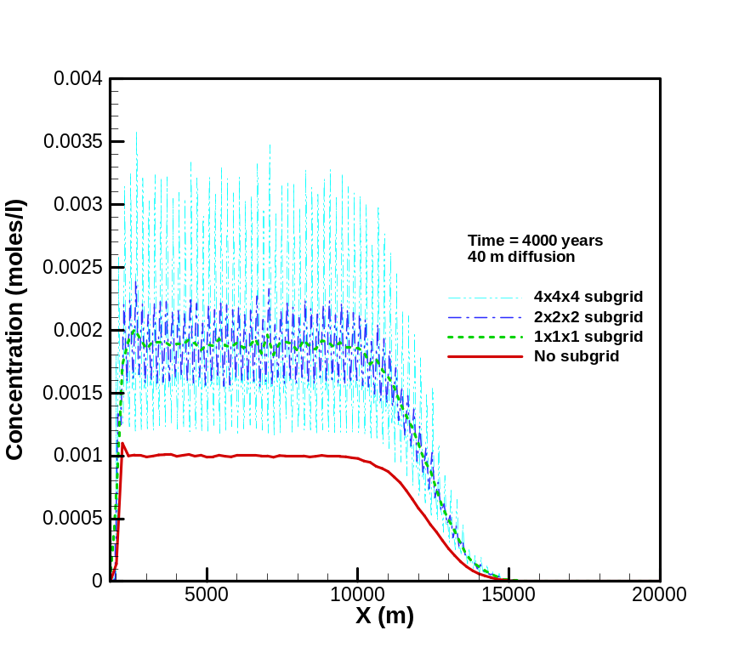
Figure 2. PLUMECALC V2.3.2 run with diffusion using sptr run with dispersion.
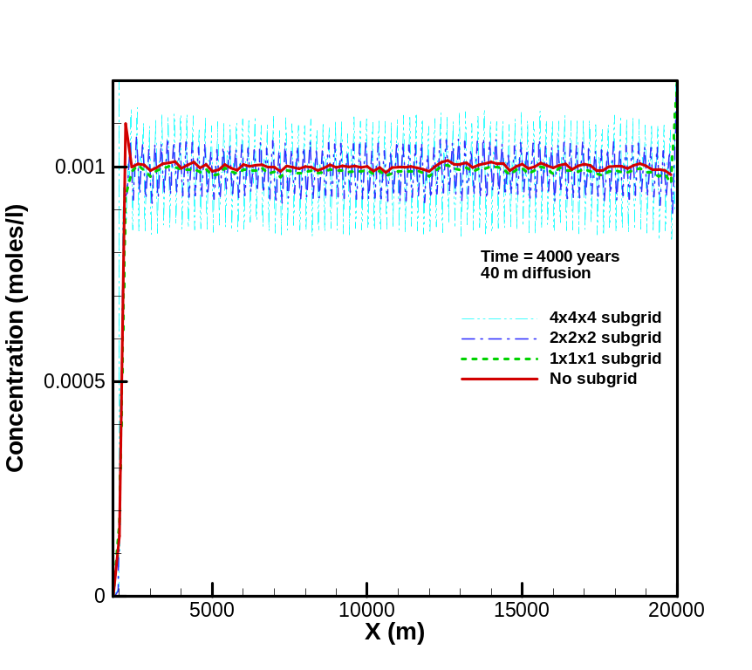
Figure 3. PLUMECALC V2.3.2 run without diffusion using sptr run with dispersion.

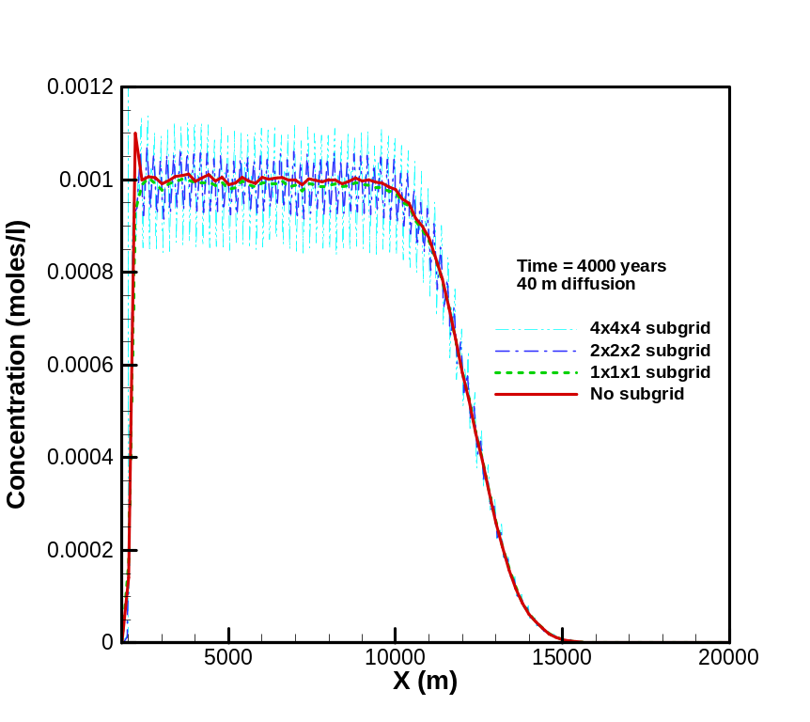
Figure 4 . PLUMECALC V2.3.3 run with diffusion using sptr run with dispersion.

A secondary issue was noted that in the presence of dispersion, the subgrid results oscillate around the average solution (as determined by running without subgridding or using the 1x1x1 subgrid equivalent). The range of oscillations for 2x2x2 subgridding were about ±6.5% of the input concentration (0.001 moles/liter) and about ±14% for 4x4x4 subgridding. Although the concentrations varied by several percent, the total mobile moles in the system varied by less than 1%.
The oscillatory nature of the results for higher levels of subgridding are most likely related to the subgrid implementation. The subgridding uses a straight line to approximate the particle path across a cell. When the particle makes a dispersive jump this approximation does not account for the instantaneous movement of the particle from one cell to the next. At this time it is not felt that it would be worth the effort to implement a better solution for the dispersive case. It is hoped that use of walkabout which works on fully unstructured grids, would eliminate the need for subgridding in dispersive models.
It is suggested that care be taken when using PLUMECALC with subgridding:
- If possible use subgridding without dispersion. If you need to subgrid, the dispersion is probably small, so insure dispersion is << than the subgrid cell size. If not, it is preferable to use walkabout with an unstructured grid and selective refinement than using sptr with dispersion to subgrid.
- If subgridding with dispersion, keep levels of subgridding to a minimum, i.e., don’t refine more than 2 – 4 times.

