**MediFor UI – User Manual**

*July 2020*

*Version 1.00*

Table of Contents

1. Introduction………………………………………………………………………………………………………………………3

* 1. Scope and Purpose………………………………………………………………………………..…………………..3
  2. Necessary Terminology………………………………………………………………………………………..…….3
  3. Features………………………………………………………………………………………………………..……………3

1. Overview………………………………………………………………………………………………………………………..…4

* 1. Gallery View…………………………………………………………………………………………..……………….....4
  2. Probe View…………………………………………………………………………………………..……………….……5
     1. Analytic Masks ………………………………………………………………..………………………………6
        1. Inspecting Masks in the Probe View………………………………………...………..…6
     2. Supplemental Data…………………………………………………………………………………………..7
        1. Supplemental Data View………………………………………………………………………7

1. Uploading Probes………………………………………………………………………………………………………………8
   1. Uploading from Filesystem…………………………………………………………………………………………8
   2. Uploading from URL……………………………………………………………………….…………………………..9
2. Gallery Filtering…………………………………………………………………………………………..…………………….10
   1. Using the Filtering Menu…………………………………………………………………………………………….10
3. Reports………………………………………………………………………………………………………………………………11
   1. Generations and Exports…………………………………………………………………………………………….11
      1. CSV Reports………………………………………………………………………………………………………11
      2. PDF Reports………………………………………………………………………………………………………12
4. Grouping…………………………………………………………………………………………………….………………………13
   1. Uploading Probes to Group…………………………………………………………………………………………14
   2. Switching Between Groups………………………………………………………………………………………….14

1 Introduction

The MediFor (MediaForensics) UI is a user interface for the DARPA MediFor program. The user interface communicates with the MediFor Analytic Service.

1.1 Scope and Purpose

This document was created as a guide for new users of the MediFor UI system. Its purpose it to give users an overview of the features that the system offers in order to prepare them to upload and analyze their own media.

1.2 Necessary Terminology

* Probe – A piece of media (image/video/audio file) uploaded to the system.
* Analytic – A single machine learning algorithm that analyzes/runs on a probe.
* Fusion Analytic – A machine learning algorithm that produces a composite/overall score for a probe based on scores from a variety of analytics run on that probe.
* Integrity Score – Score provided by an analytic/fusion analytic that indicates the probe’s ‘integrity’, meaning likelihood of authenticity, ranging from 0-100. A higher score indicates that the probe is less likely to have been manipulated.
* Mask – A heatmap produced by an analytic that highlights areas believed to be manipulated

1.3 Features

* Web-based user interface
* Built in image-view and video-playback
* Sorting (media and results)
* Pan, Zoom, Rotation
* Metadata extraction
* Report Generation
* Uploading
* Filtering
* Tagging
* Exporting

2 Overview

There are several main ‘views’ when using the Medifor Ui.

* Gallery View
* Probe View
* Upload View
* Supplemental View

2.1 Gallery View

This view lists all the uploaded probes. It is the default view when you load the application and there is no probe selected. You can view an individual probe by clicking on it.

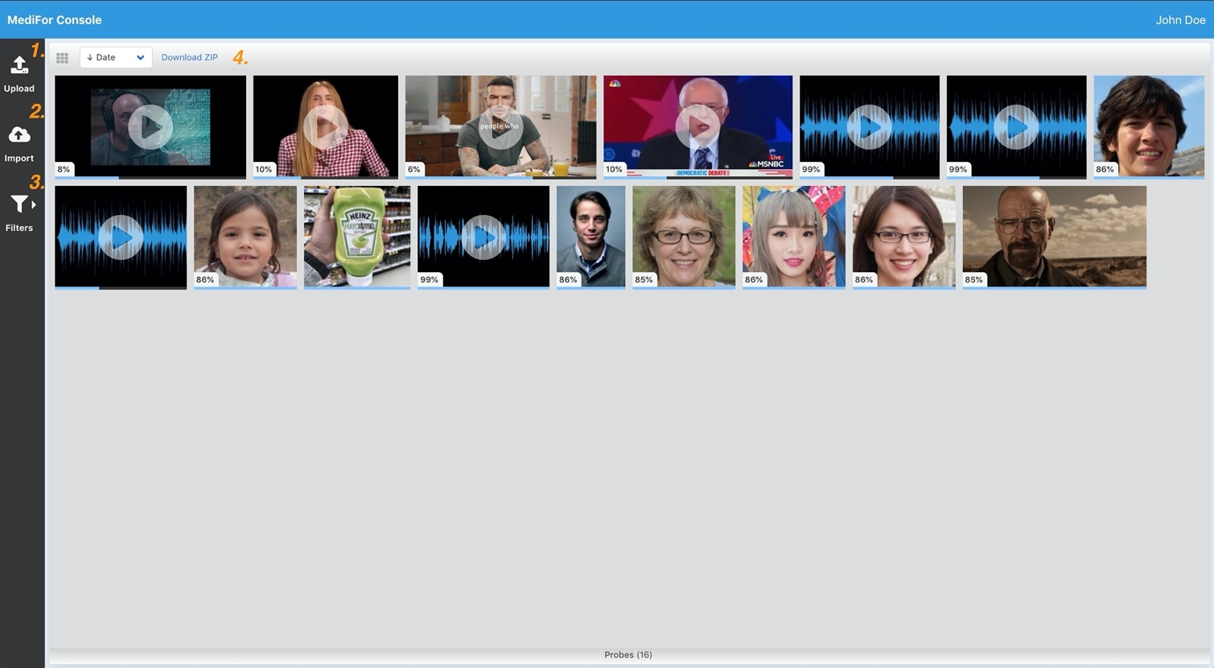  
1. Upload Button – Upload a probe from your machine.  
2. Import Button – Import a probe from a URL  
3. Filters Button – Pull up a sidebar that allows you to filter/chose probes in the gallery. **See ’Gallery Filtering’ section**  
4. Gallery Container Toolbar – Change the gallery view to a list | sort the gallery based on upload date or integrity score | download a zip file of current gallery

2.2 Probe View

This view will appear when you select a probe, by clicking one of the thumbnails in the Gallery.  
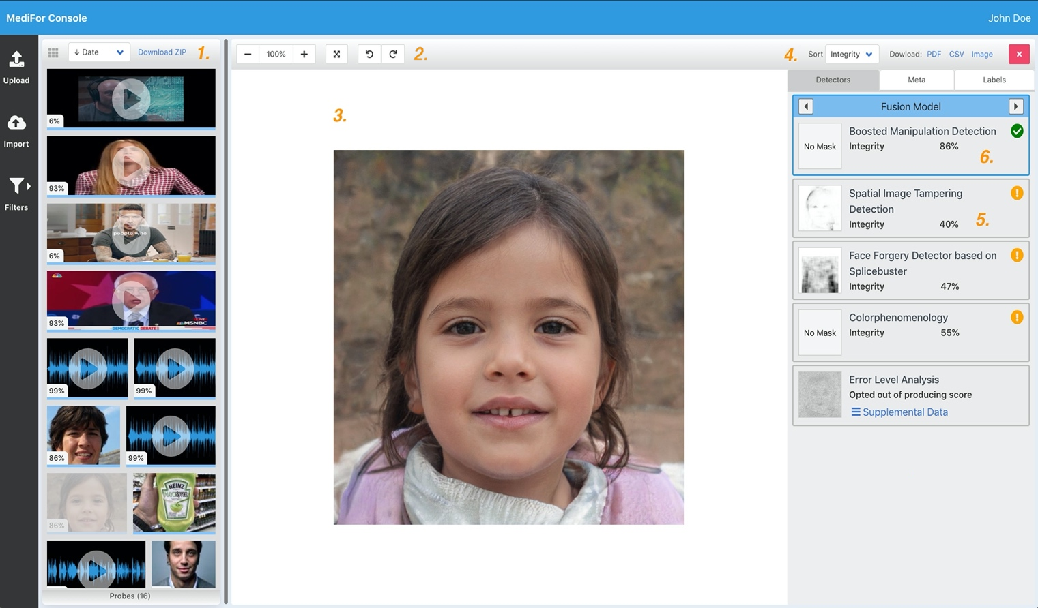  
  
1. Gallery View – A minified, resizable, version of the gallery, to quickly switch between probes  
2. Probe View Controls - Basic viewing features for this probe: zoom, full-screen, rotate.

3. Probe View – Displays the selected probe  
4. Analytic Detector List – List of all the analytics that have run on the currently-selected probe. Tabs above allow you to view metadata for the probe and any labels/tags the probe may have.

Use the toolbar at the top to sort the list alphabetically, by score, or by mask presence. You can also download the probe itself, or a CSV/PDF report for it. **See ‘Reports’ Section**  
5. Analytic List Card – Information about the analytic including the analytic‘s integrity score for the selected probe. To see more information simply select the card  
6. Fusion Analytic Card – Provides the ’Fused Score’ for the probe which is a composite score of the below ran analytics. This can be thought of as an ’overall score’. This card can be toggled between various fusion models if your system administrator has chosen multiple fusion models. **Note that when flipping through fusion models it will provide the different scores for the selected probe. This score can differ from what you see displayed in the gallery (the gallery can only provide one fusion score at a time).**

2.2.1 Analytic Masks

Some analytics will produce a mask which you can view alongside the probe in the Probe View. To view a specific mask simply click an analytic card which has a mask present.

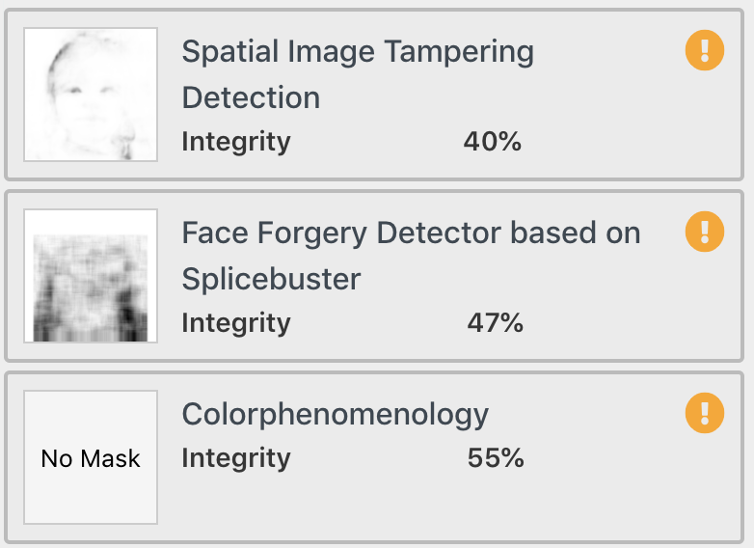

As an example, we will choose the mask produced by the ‘Spatial Image Tampering Detection’ analytic.

2.2.1.1 Inspecting Masks in the Probe View

When a mask is selected it will be overlaid onto the currently-selected probe. Zoom, pan, and rotate the probe to further inspect both the probe and the mask.

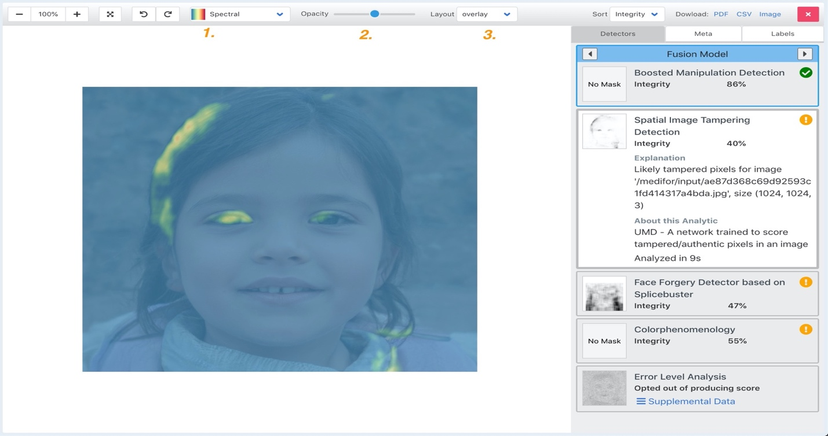

1. Mask Color Gradient Selector – Dropdown menu that allows you to change the color gradient of the mask  
2. Opacity Slider – Slider which allows you to change to opacity of the mask  
3. Layout Drop Down – Choose how you want the mask oriented in relation to the probe: overlaid, side-by-side, top-bottom

2.2.2 Supplemental Data

Some of the analytics will produce supplemental data that provides more information than just the mask or integrity score. This data can come in several forms: text file, image, video. To view this data simply click the ‘Supplemental Data’ link in the analytic card and you will be taken to the Supplemental Data view.

For this example, we will use the ‘Error Level Analysis’ Analytic.

2.2.2.1 Supplemental data view  
  
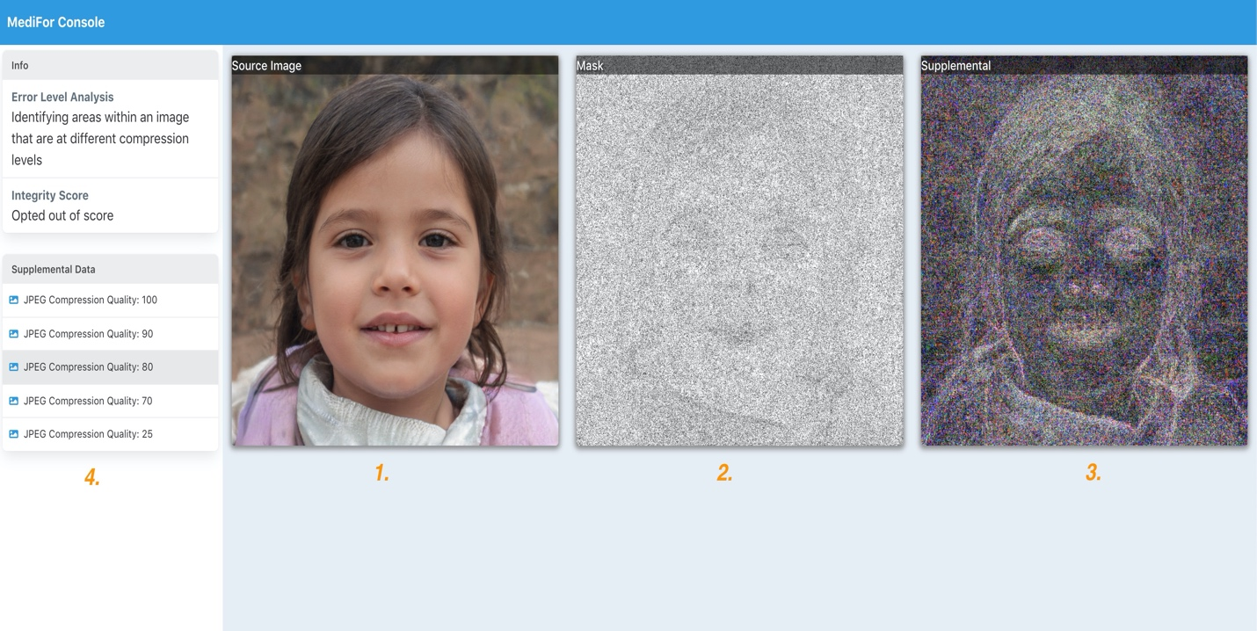

1. The original source image  
2. The mask produced by the analytic  
3. The supplemental data which in this case is a compressed version of the image  
4. The supplemental data list - in this case the supplemental data includes multiple compression levels, which you can select from this list

3 Uploading Probes

3.1 Uploading from filesystem

To upload probes from your local filesystem, select the ‘Upload’ button from the menu on the left side and you will be brought to this view.   
  
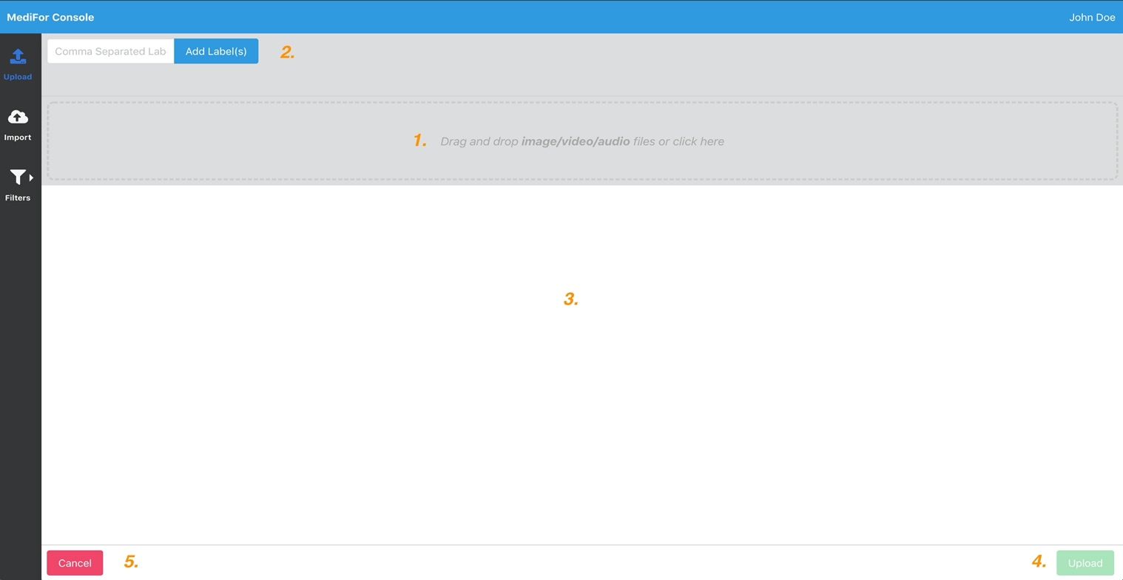

1. Drag/Drop section – Drag and drop files from your local machine into this area, or just click it  
2. Tagging/Labels - Add comma-separated labels to your uploads so you can later filter them in the gallery. **See ‘Gallery Filtering’ section**  
3. Uploads List – The files that you have staged for uploading to the system  
4. Upload Button – Upload the selected files to the system  
5. Cancel Button – To cancel your upload and go back to previous page click here

Say we wanted to upload a series of photos that were taken in Europe in the Fall of 2020 and we wanted to tag them accordingly so we could later locate them in the system, then our upload may look like the following:

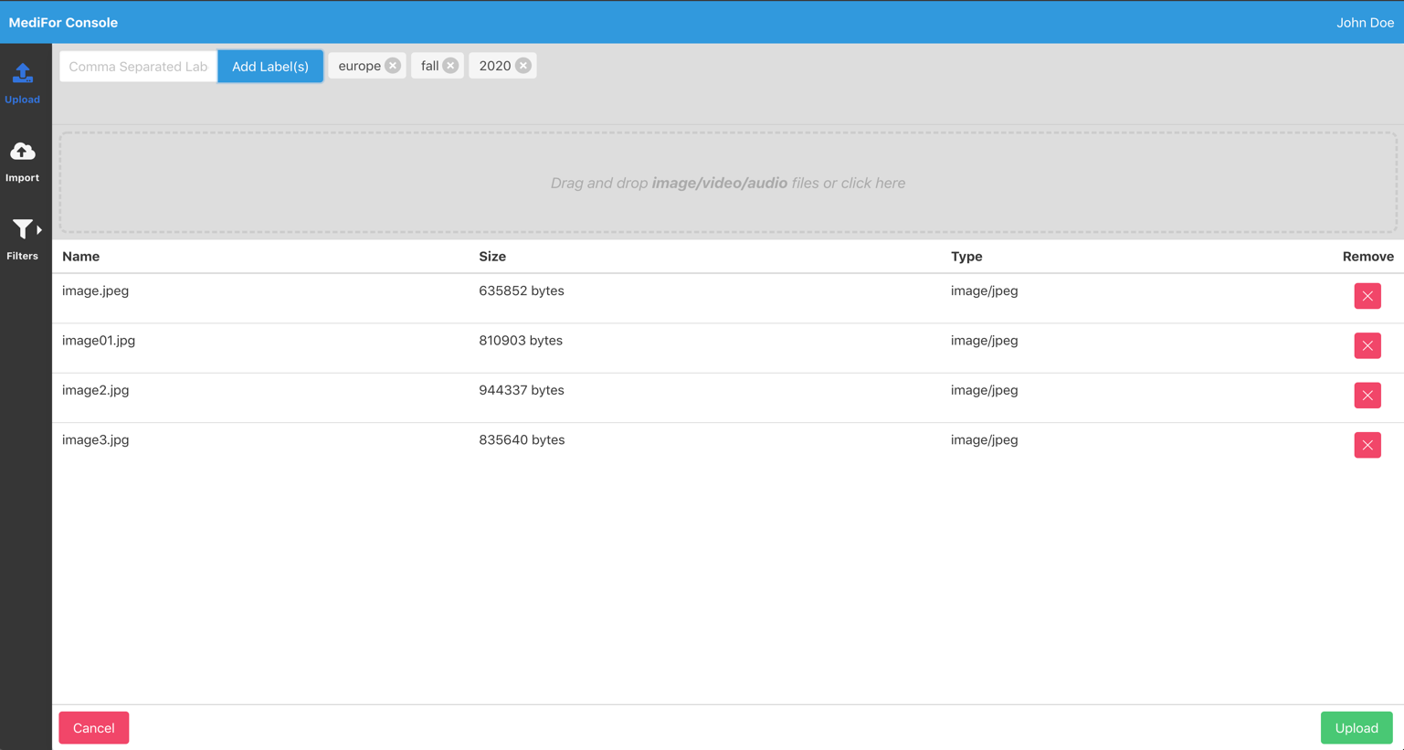

To remove any tags or any files simply click the ‘x’ next to each.

3.2 Uploading from URL

To upload probes from a URL, select the ‘Import’ button from the menu on the left side. In the bubble that pops up, you can paste your URL for upload and add any tags if needed. Make sure the URL goes to the image directly.  
Note that this feature will not work if the desired image/video is behind a paywall.



4 Gallery Filtering

Narrow down the probes displayed in the galley using filters. To access the filtering menu simply click the ‘Filters’ icon on the left side menu.  
  
4.1 Using the filtering menu

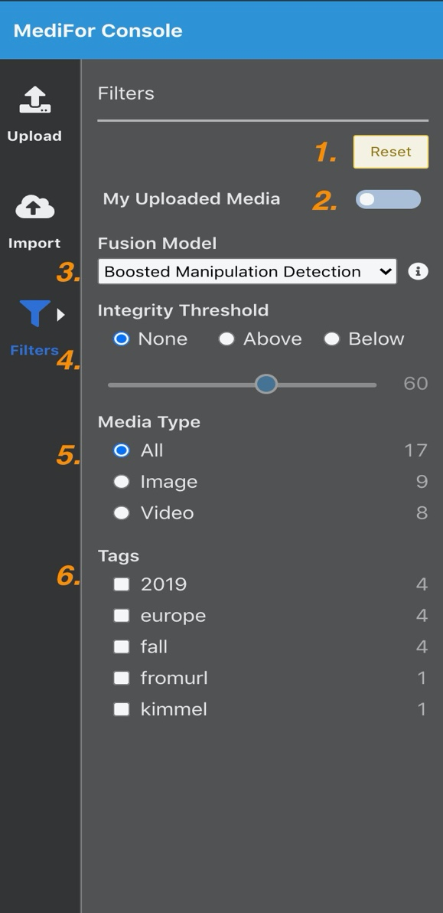

1. Reset Button – This will reset all the filtering parameters to their default values. See your system administrator for more information  
     
   2. My Uploaded Media Toggle – Toggle this switch to only display the probes that you have uploaded  
     
   3. Fusion Model Selector – Show only the probes that have been run against the selected model. This selection also determines the score displayed on the probes in the gallery, which they are sorted on. For example, if you selected ’Boosted Manipulation Detection’ then only probes with that analytic will display in the gallery, and they will each be marked with their ’Boosted Manipulation Detection’ score.  
     
   4. Score Sorting Tool – This component allows you to sort the gallery based on their scores from the chosen fusion model. You can choose a score threshold, as well as whether you want probes that are above or below that threshold  
     
   5. Media Type Tags – Only display a particular media type  
     
   6. User-Added Tags – Only display probes containing ALL the selected tags  
     
   * Note that when selecting tags, the system will return an ’inclusive’ query meaning that if you select ’europe’ and ’fall’ it will return only probes thatare tagged with both ’europe’ AND ’fall’

5 Reports

5.1 Generation and Exports

The MediFor UI system allows for several type of reports and exports to be generated: CSV, PDF and source file (the probe’s source file).  
  
  
1. Download Zip Button - This will download a zipped CSV file of all the probes in the gallery  
2. Probe Download Choices - This will only be available if a probe is selected. You can choose to download a PDF report, CSV report or the source file for the current selected probe  
  
  
5.1.1 CSV reports

All CSV reports will have the following format:

"probeFileName","stage","status","probeId","analyticID","friendlyName","description","integrityScore","tags","facets","explanation","time","maskPath"

Note that when downloading a csv, it will also provide the probe’s source file and any masks produced by the probe’s analytics.

5.1.2 PDF reports

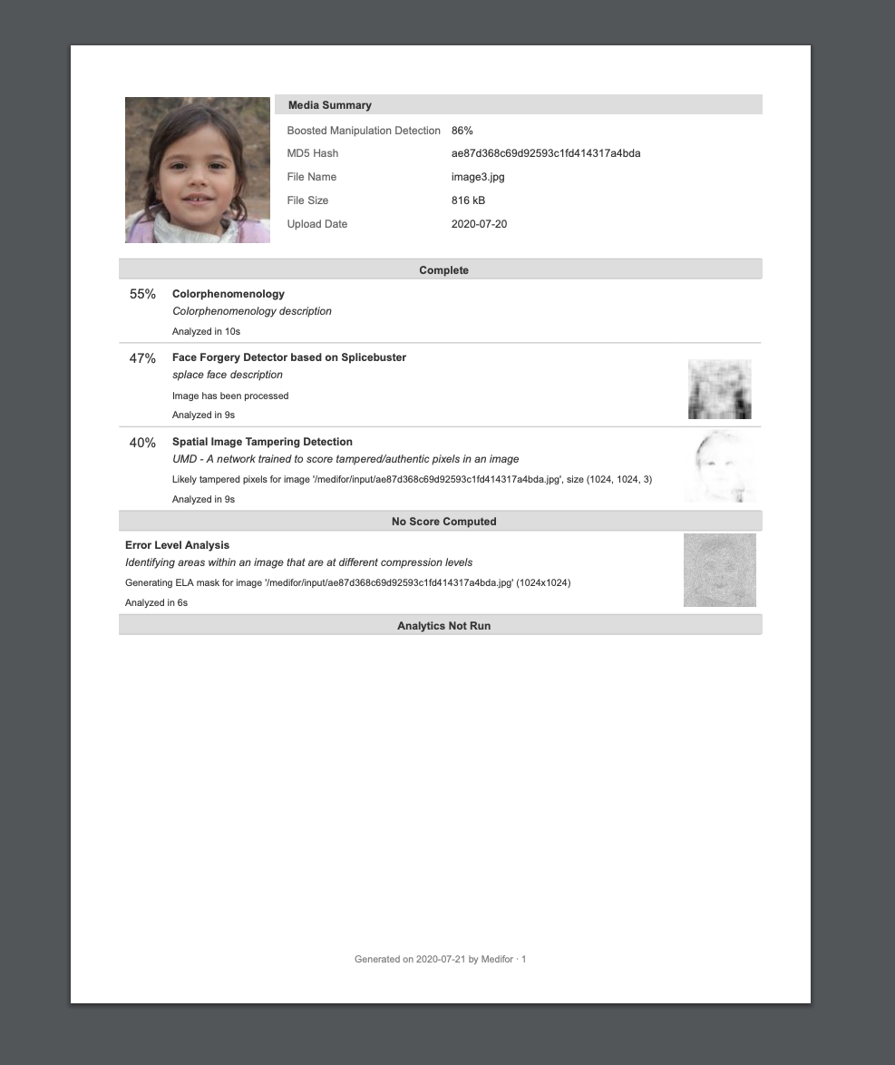  
*\* Note that the fusion model on the PDF report will be driven by the fusion model selected in the filter menu*

6 Grouping

Grouping is an optional feature that can be implemented by your system administrator. When this feature is enabled all users of the system will have access to a collection of groups. These groups are intended to divide access to certain probes between users with different permission levels.   
  
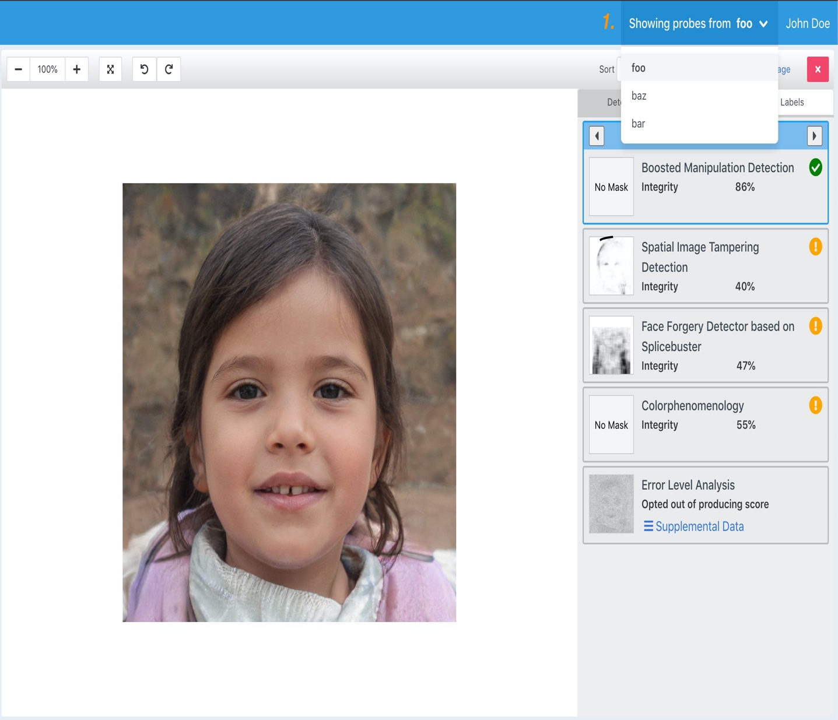

1. Group Selection Dropdown – A drop down menu of all the groups to which you have access  
  
  
  
  
  
  
6.1Uploading probes to groups

To upload a probe to a specific group, ensure that you have the desired group selected in the dropdown menu and follow the regular steps for an upload.

To upload a probe into multiple groups, follow the upload process for the probe in each group.  
  
Any tags that you add to your uploaded probe will not be visible outside of the chosen group.  
  
6.2 Switching between groups  
  
To view probes uploaded to specific groups simply select the desired group from the drop-down menu. Every time a group is selected, the gallery will refresh to display the new collection of probes.