“智能控制”第三次作业
Homework 3 (Intelligent Control): Intelligent Optimization Method
In this homework, you may use any programming language but Python is preferable. Although teamwork is allowed, you must independently complete your own homework report. It is prohibited to use any e-copy of homework report written by anyone else. You could use English to do this homework.
1、试利用遗传算法和PSO算法求解如下函数：
的最小值，其中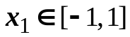，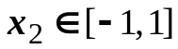，并画出种群平均适配值和最优个体适配值随代数增加的学习曲线。
分析：由于求函数的最小值，故常用一个较大值（本题为10）减去函数值f(x,y)来作为适配值进行优化

