1. **build the plugin**

build the plugin with idea

1. Create New project

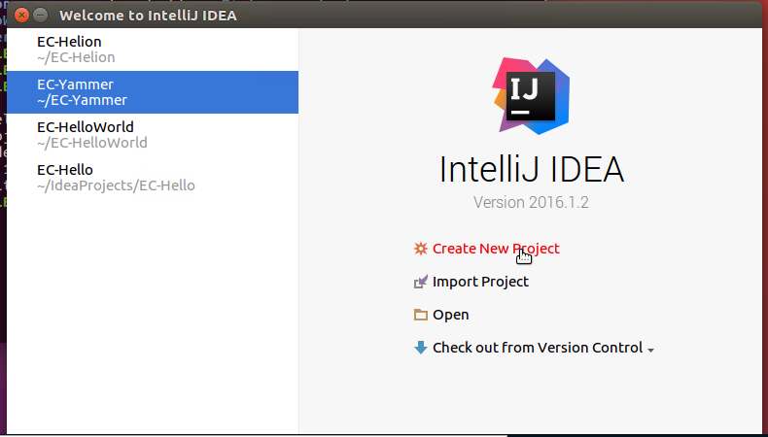

1. Use gradle to create a new project

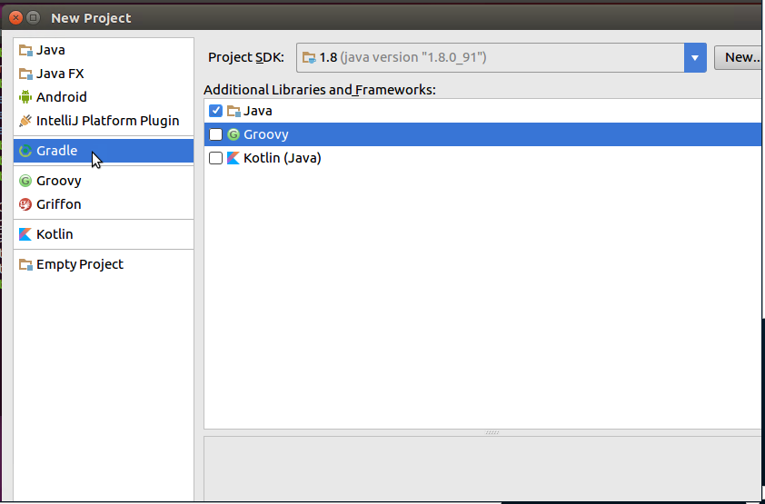

1. Set the project property

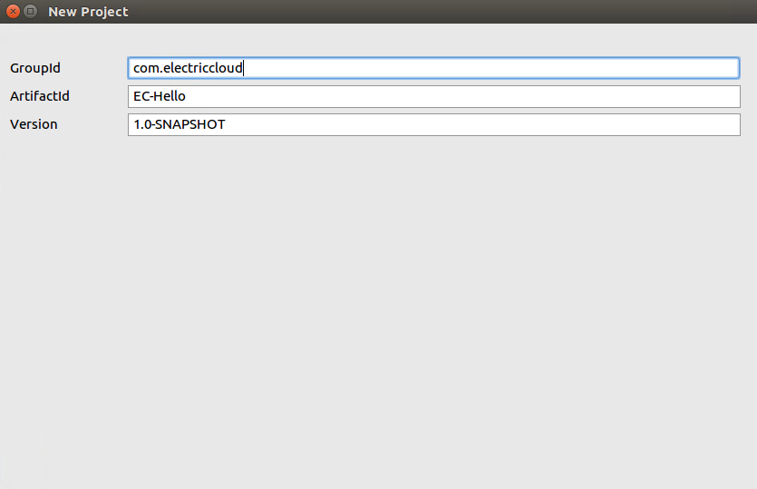

You may set the groupid with com.electriccloud , so it sync something with server , set the ArtifactId is the plugin name

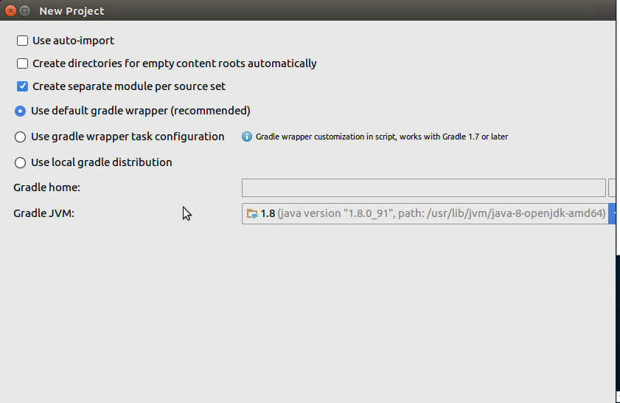

1. Set the project location

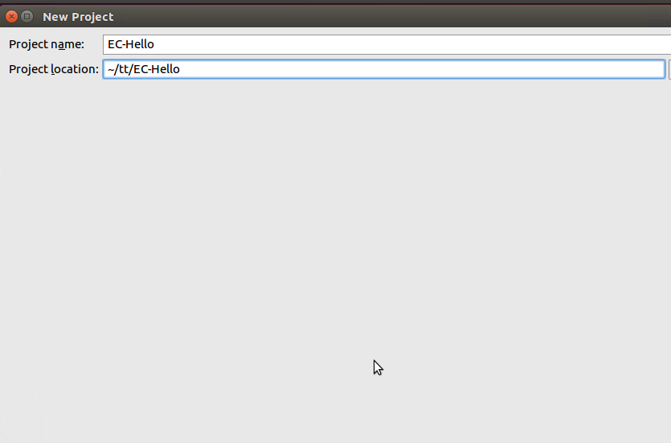

Set the location you like

1. Rewrite the build.gradle

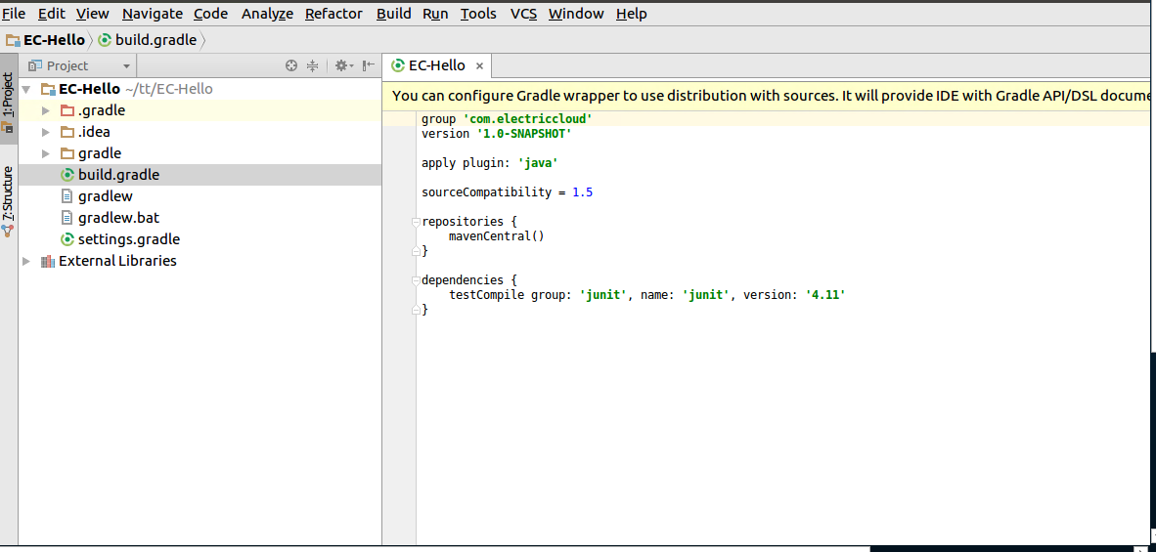

Copy <https://github.com/electric-cloud/EC-HelloWorld/blob/master/build.gradle>

Of course , You need to rewrite the description

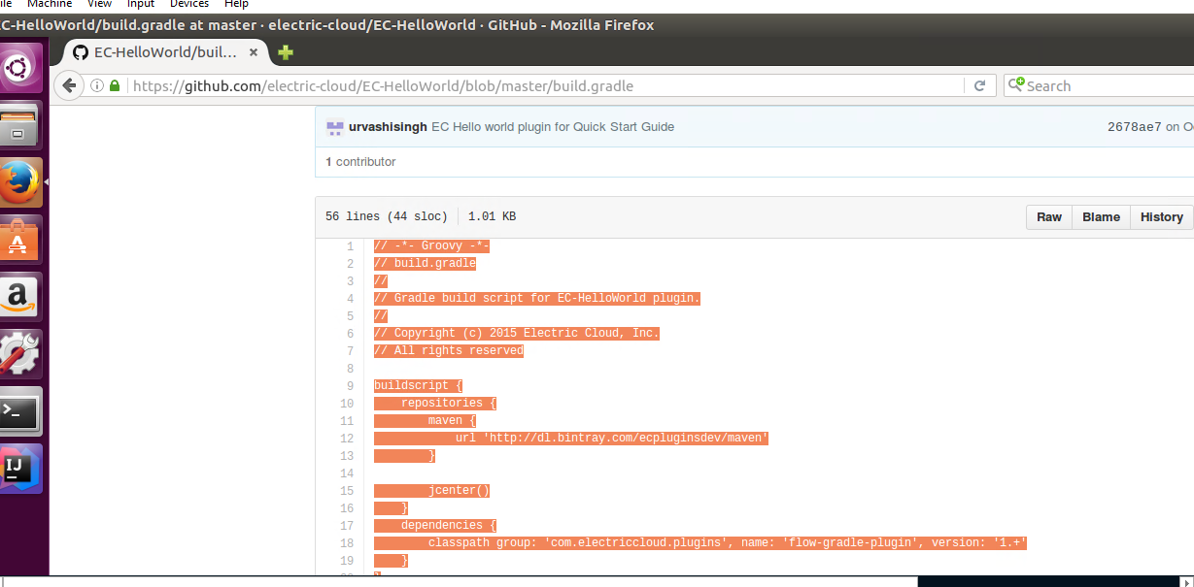

1. Run build the task to get the code

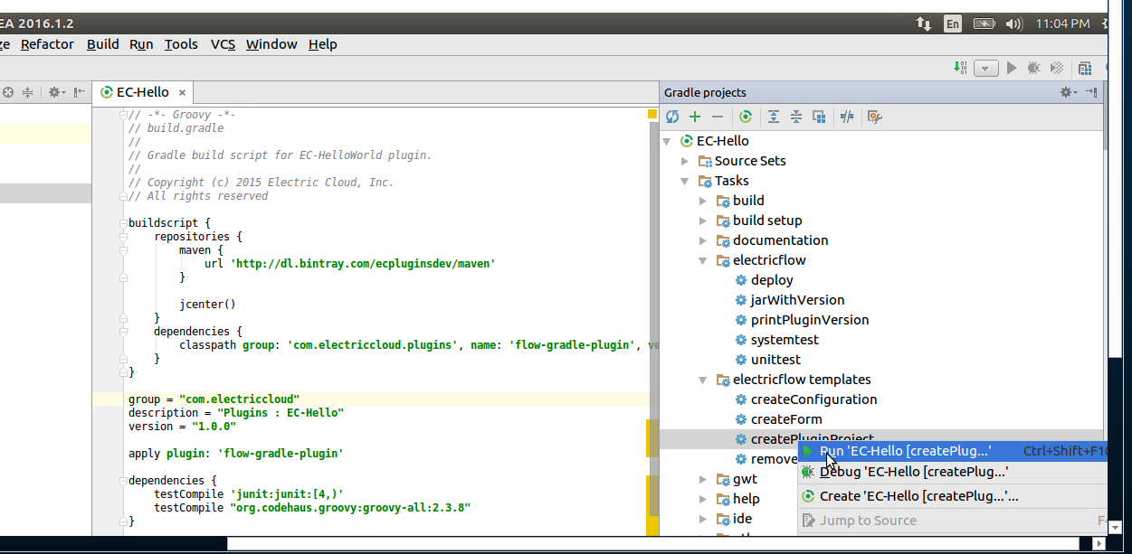

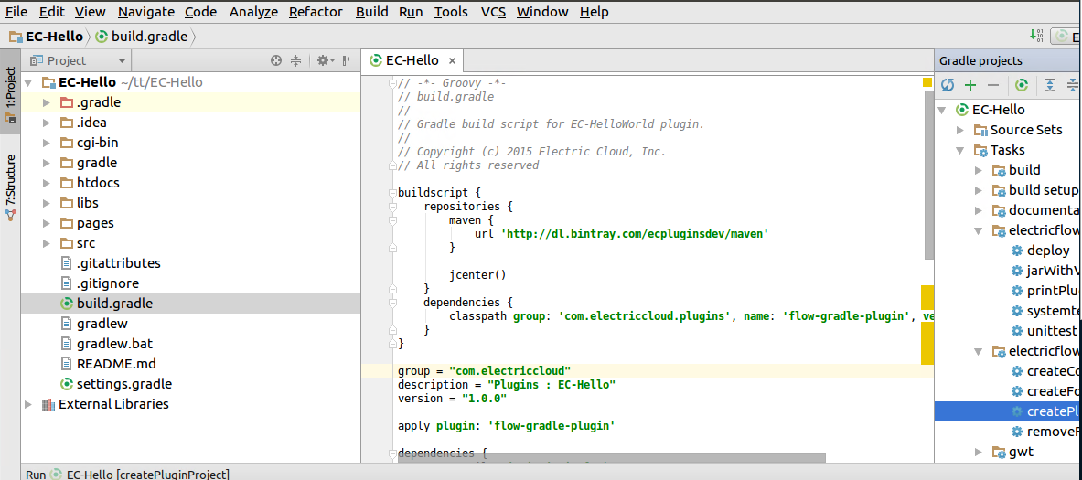

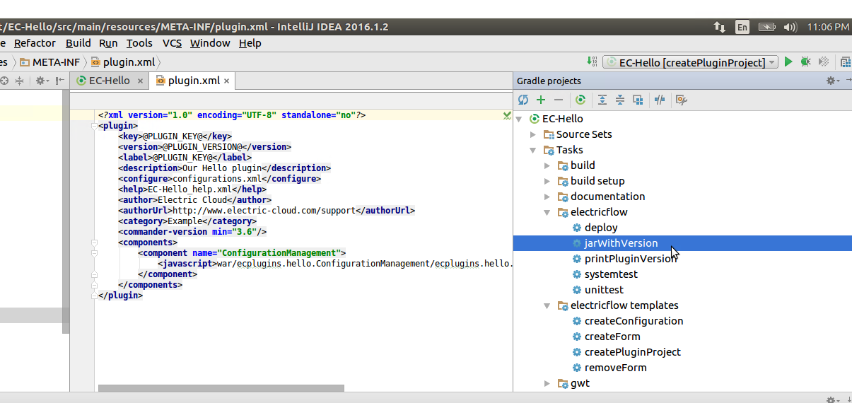

1. Get the jar file in the build

This plugin of the path is ~/tt/EC-Hello/build/EC-Hello/EC-Hello-1.0.0.0.jar

Unzip the file and sftp the file to the service

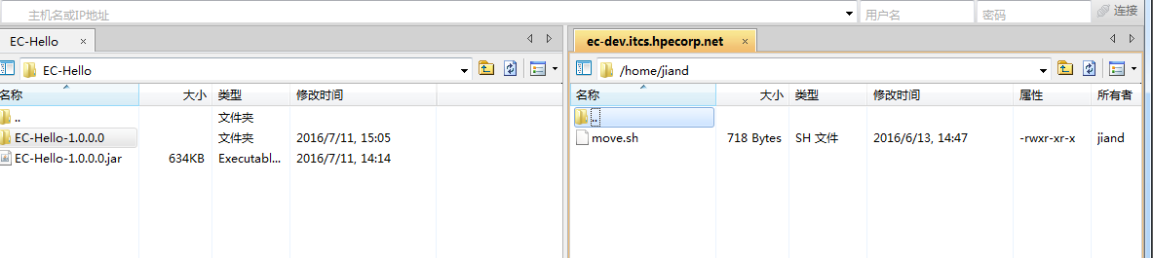



And then execute the move.sh

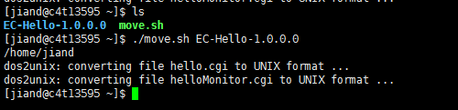

1. Upload the package of jar on the page

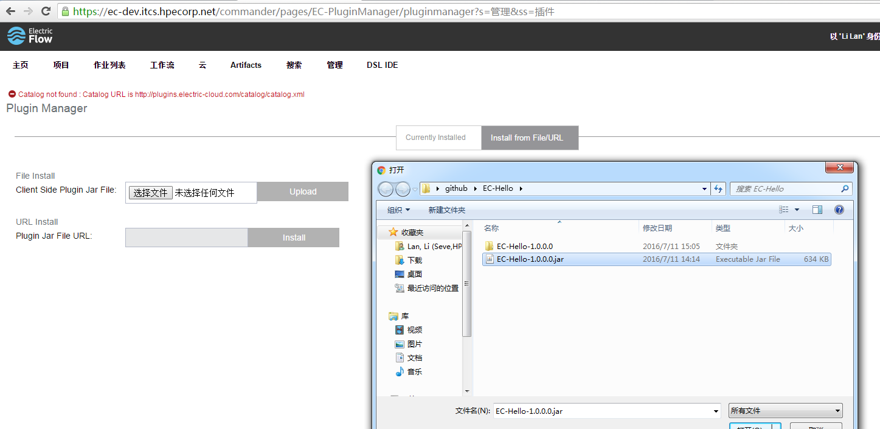

Click upload

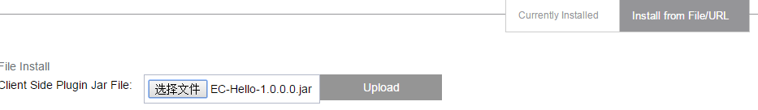

1. **File resolve**
2. **ec_setup.pl:**

**code:**

my %postMessage = (

label => "Yammer - Post Message",

procedure => "PostMessage",

description => "Post message to the Yammer group",

category => "Notification"

);

$batch->deleteProperty("/server/ec_customEditors/pickerStep/Yammer - Post Message");

@::createStepPickerSteps = (\%postMessage);

**UI:**

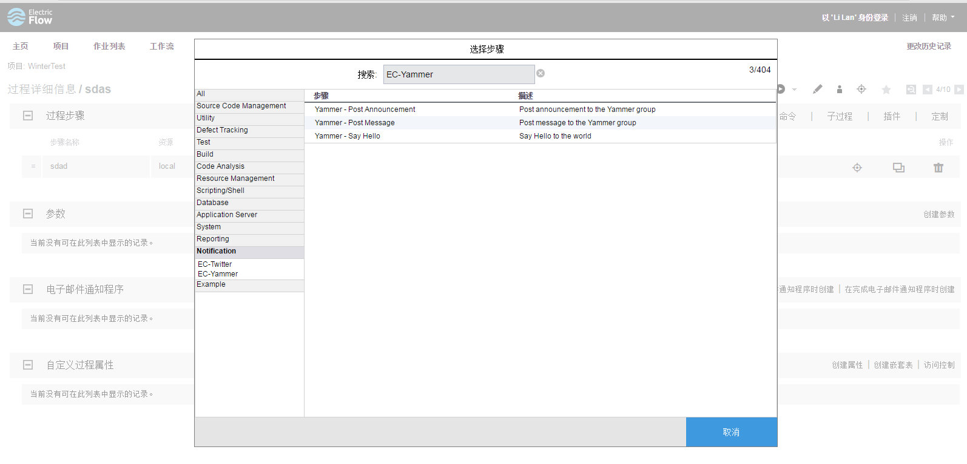

1. createAndAttachCredential.pl

Code:

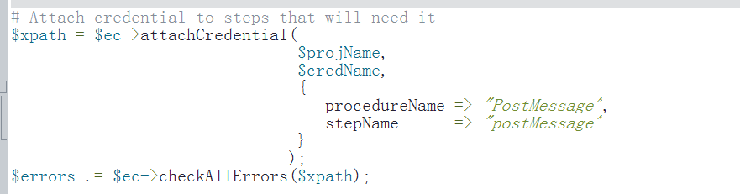

If your configure UI has this content

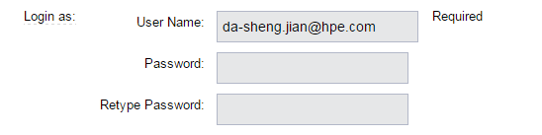

Then if want to add a procedure , you should add your procedure to the pl

Like this

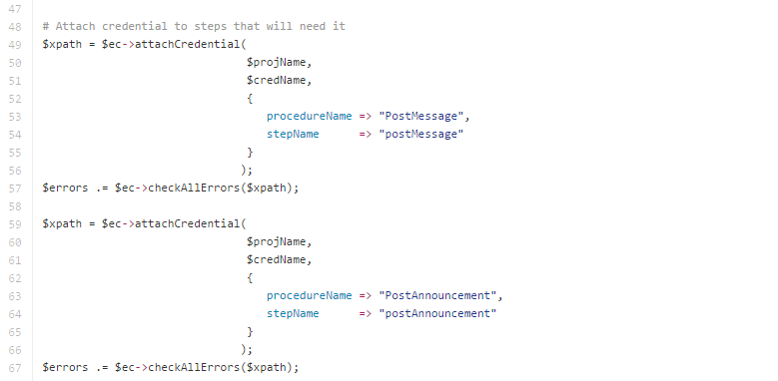

1. manifest.xml

code:

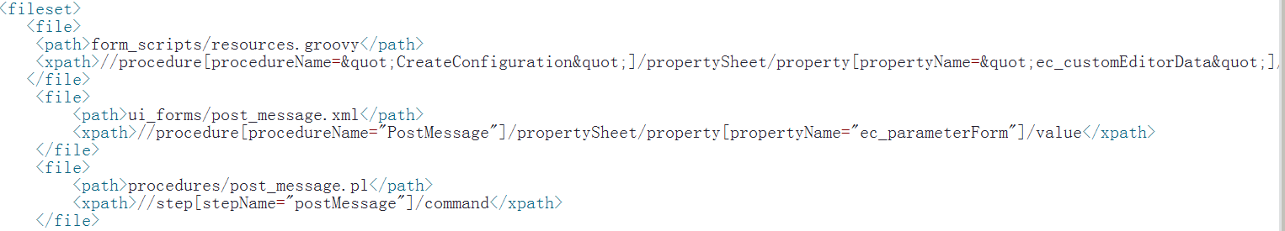

File contains path and xpath

Path: it’s the path of source file which will load into the project.xml after build.

Xpath: find the label where load the source file

Example:

//procedure[procedureName=&quot;CreateConfiguration&quot;]/propertySheet/property[propertyName=&quot;ec_customEditorData&quot;]/propertySheet/property[propertyName=&quot;parameters&quot;]/propertySheet/property[propertyName=&quot;resource&quot;]/value

It mean :

First : find a procedure which has a label “procedureName” equal “CreateConfiguration”

Second: in the procedure get the list of ec_customEditorData

And so on , at last get the “value” label of the propertyName “resource”

The path of project.xml



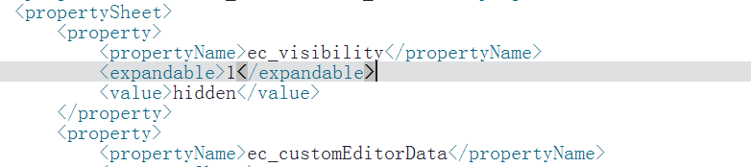

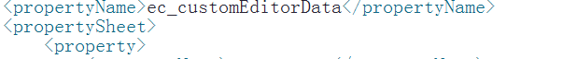





1. **project.xml**

define all the procedure

1. how to add a target of a produce

ex: we want to add block_device_mappings to the procedure

That’s all that we need to add

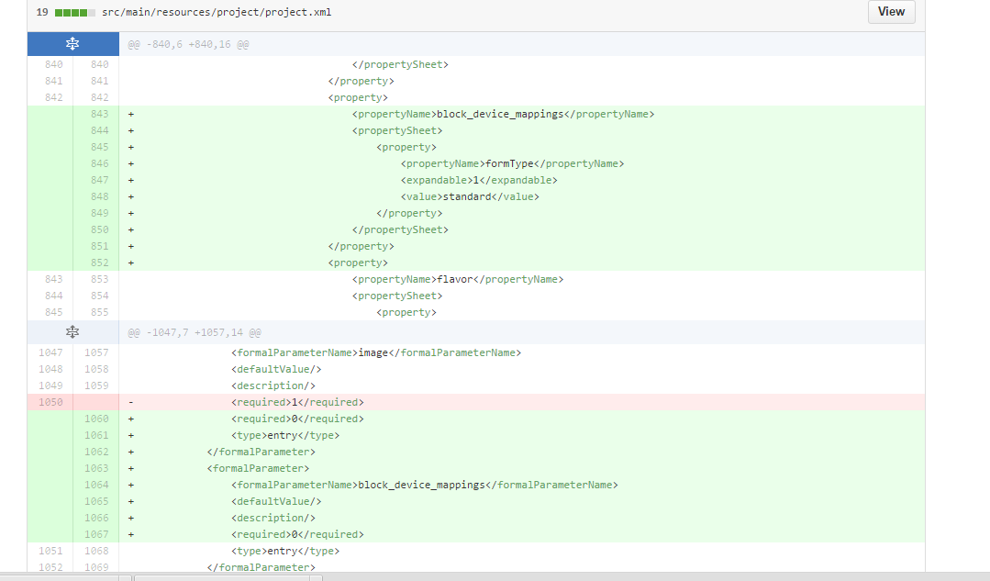

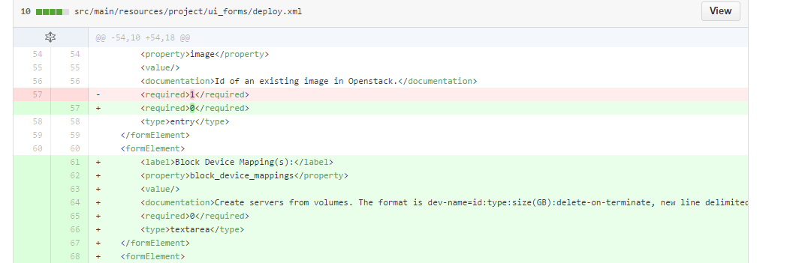

Of course , you need to add some code in your pl.

1. how to add a procedure in your project

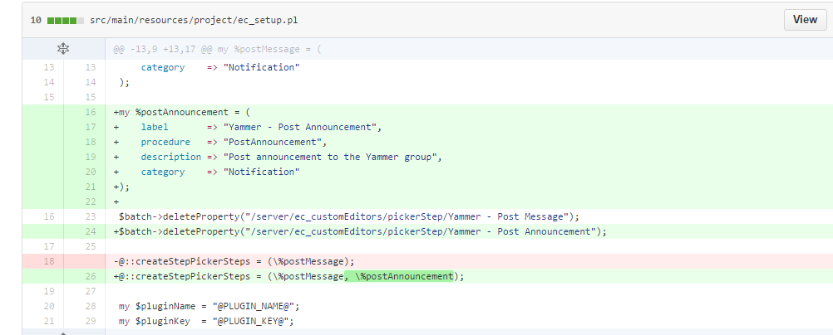

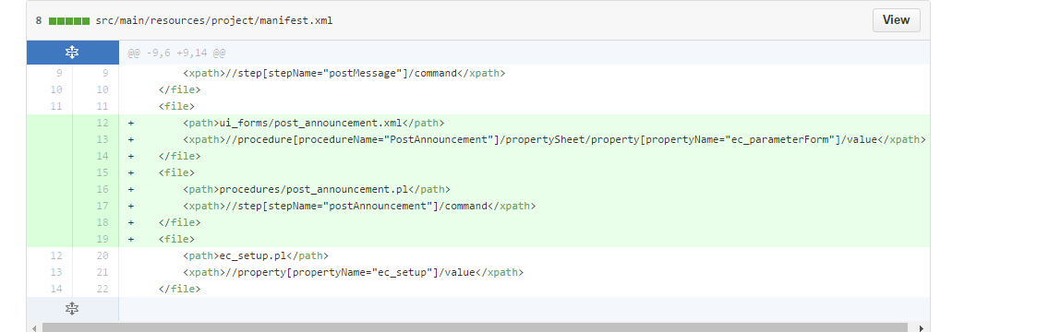



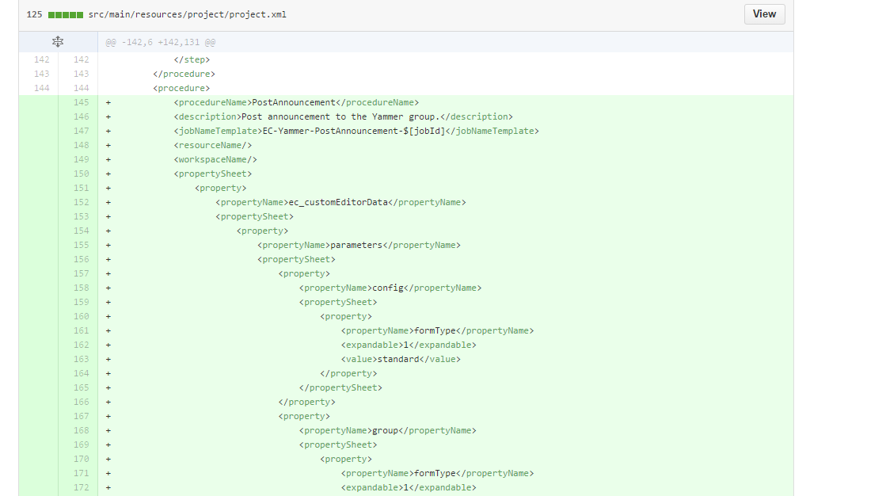

You need copy the settings of another procedure and rewrite the arguments.

And you need add the xml of the procedure



1. **move.sh**

#!/bin/bash

sourcedir=$1

pluginpath="/opt/electriccloud/electriccommander/plugins/"

direxist=`ls -ltr | awk '{print $9}' | grep $sourcedir`

if [ "$direxist" = "" ]

then

echo "can't find the directory!!"

exit 1

fi

if [ ! -d $pluginpath ]

then

echo "can't find the plugin directory,please check it"

exit 1

fi

cgidir=`echo "./$sourcedir/cgi-bin"`

if [ ! -d $cgidir ]

then

echo "can't find the path $cgibin !!!"

exit 1

fi

pluginexit=`ls $pluginpath | grep -w $sourcedir`

if [ "$pluginexit" != "" ]

then

cd $pluginpath

sudo rm -rf $sourcedir

cd -

fi

sudo mv $sourcedir $pluginpath

cd $pluginpath

sudo chown -R ecsync:ecsyncgrp $sourcedir

cd $sourcedir

cd ./cgi-bin

sudo chmod 0755 *

sudo dos2unix *