STM32F429 DISCOVERY board uCOSii transplantation Guide

1. Download STM3240G-EVAL_OS2.zip from Micrium or from my github <https://github.com/lanniaoershi/STM32F429_Discovery_UCOSII_Transplantation/tree/master/Micrium_STM3240G-EVAL_OS2>

Download stm32f4_dsp_stdperiph_lib.zip from ST or from my github

<https://github.com/lanniaoershi/STM32F429_Discovery_UCOSII_Transplantation/tree/master/STM32F4xx_DSP_StdPeriph_Lib_V1.5.1>

1. Create a folder for transplantation, my folder named “STM32F429_Discovery_uCOSii”

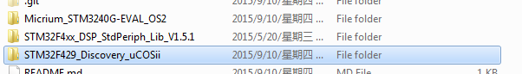

Create two folders in “STM32F429_Discovery_uCOSii”

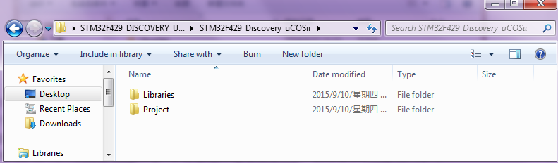

Create folder “CMSIS” in Libraries folder,

Create folders “ARM-MDK” and “User” in Project folder.

1. Add file in to folder, put STM32F4xx_DSP_StdPeriph_Lib_V1.5.1\Libraries\STM32F4xx_StdPeriph_Driver whole folder in to Libraries folder create before.

Put STM32F4xx_DSP_StdPeriph_Lib_V1.5.1\Libraries\CMSIS\Device\ST\STM32F4xx\Source\Templates\arm\startup_stm32f429_439xx.s in to STM32F429_Discovery_uCOSii\Libraries\CMSIS

Put

STM32F4xx_DSP_StdPeriph_Lib_V1.5.1\Libraries\CMSIS\Device\ST\STM32F4xx\Include stm32f4xx.h and system_stm32f4xx.h into STM32F429_Discovery_uCOSii\Libraries\CMSIS

Put STM32F4xx_DSP_StdPeriph_Lib_V1.5.1\Libraries\CMSIS\Include\core_cm4.h and core_cmFunc.h and core_cmInstr.h and core_cmSimd.h in to STM32F429_Discovery_uCOSii\Libraries\CMSIS

Put STM32F4xx_DSP_StdPeriph_Lib_V1.5.1\Libraries\CMSIS\RTOS\Template\cmsis_os.h in to STM32F429_Discovery_uCOSii\Libraries\CMSIS

And CMSIS folder will look like

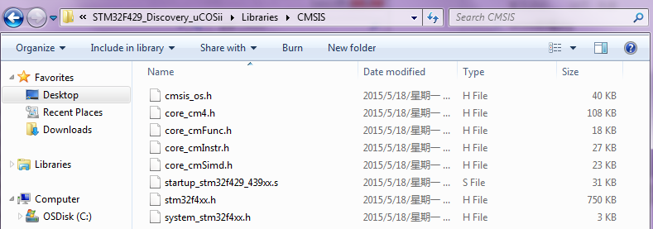

Put STM32F4xx_DSP_StdPeriph_Lib_V1.5.1\Project\STM32F4xx_StdPeriph_Templates

main.c main.h stm32f4xx_conf.h stm32f4xx_it.c stm32f4xx_it.h system_stm32f4xx.c in to STM32F429_Discovery_uCOSii\Project/User

1. Create new Keil project, and chose 429ZITx

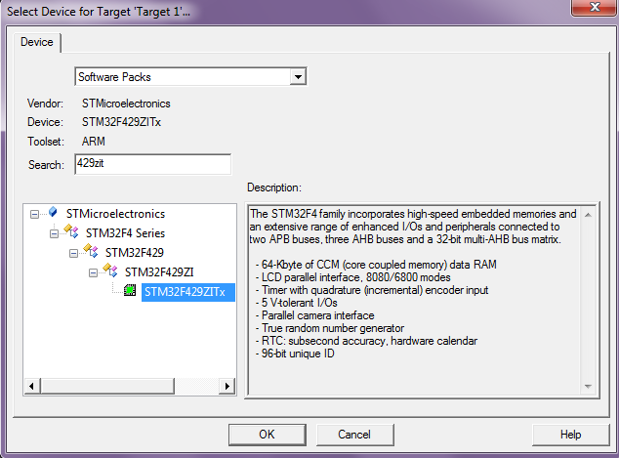

Then “OK”, if asking put startup file in to project, chose no, and now have a clean 429ZITx project.

Project-> manage-> Project Items… create group and add files

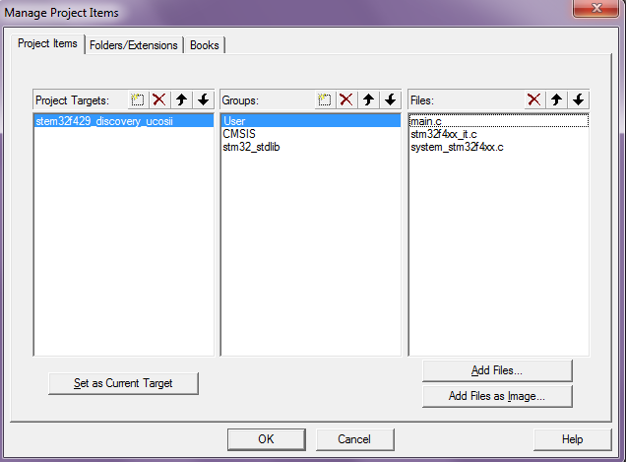

Finally project structure look like

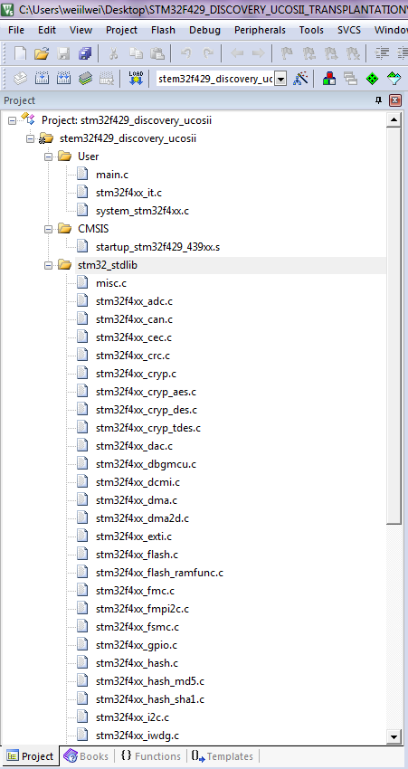

Add build include path

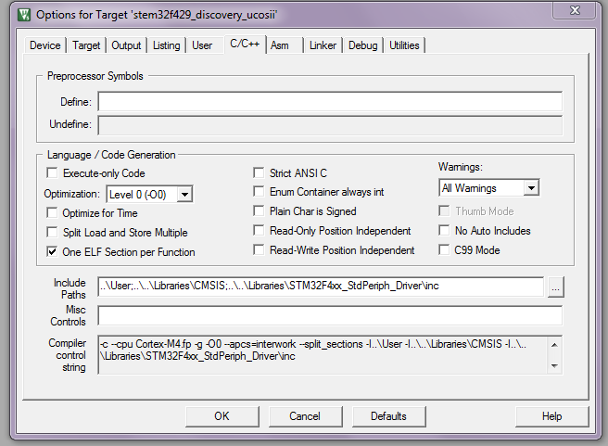

Then build, it should be have some error, here listed all error I have met

1. Not specific product



Solution: open stm32f4xx.h in STM32F429_Discovery_uCOSii\Libraries\CMSIS uncomment “#define STM32F429_439xx”

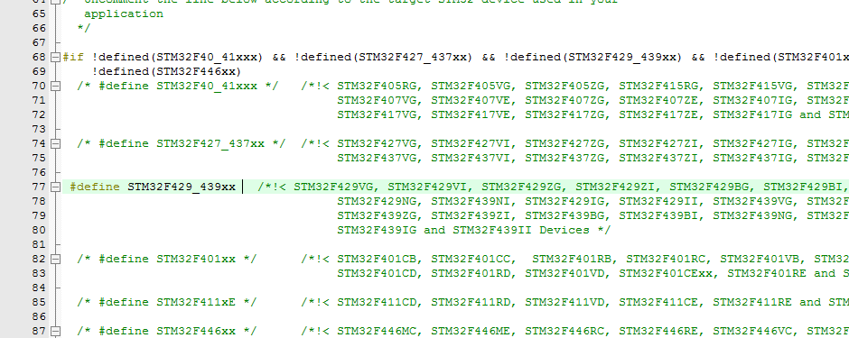

1. identifier "RCC_ClocksTypeDef" is undefined

Cause by stm32f4xx_rcc.h not include, and because in stm32f4xx.h “USE_STDPERIPH_DRIVER” is commented, uncomment it.

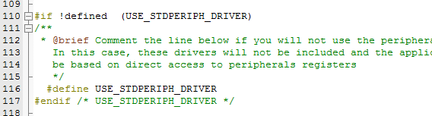

1. identifier "FSMC_XXXXXXXXX" is undefined

In file stm32f4xx.h FSMC_XXXX was define for F40_41xx

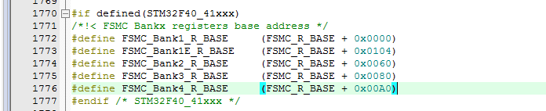

Delete stm32f4xx_fsmc.c from Libraries or un-include from build

After solved error, build should be done.

1. Option for debugger, stm32f429 discovery use on board st-link download with SWD

Set it up, and download in to discovery board.

In order to test, in main.c, code for blink led3 and led4.

Tag v0.1 release this test code.

1. Add UCOSii file to project

Copy Micrium_STM3240G-EVAL_OS2/software/ uC-CPU uC-LIB uCOS-II to STM32F429_Discovery_uCOSii\Project

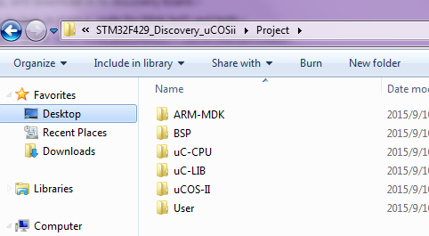

Copy Micrium_STM3240G-EVAL_OS2\Software\EvalBoards\ST\STM3240G-EVAL\uCOS-II\KeilMDK app_cfg.h, lib_cfg.h in to STM32F429_Discovery_uCOSii\Project\User

Copy Micrium_STM3240G-EVAL_OS2\Software\EvalBoards\ST\STM3240G-EVAL\uCOS-II\ cpu_cfg.h, os_cfg.h in to STM32F429_Discovery_uCOSii\Project\User

Add file to project like

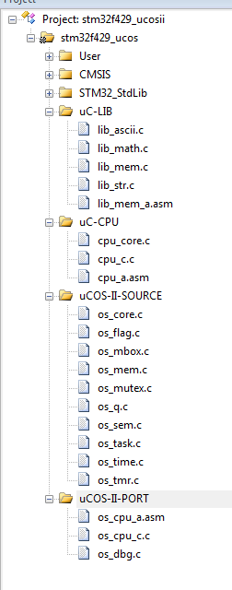

Then remember add include path

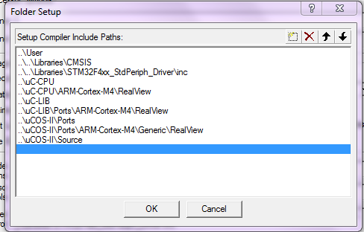

Then build, here may have some error

I met follow error

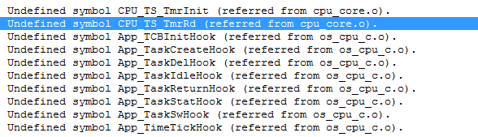

Solution: Change file User/cpu_cfg.h line 99 “#define CPU_CFG_TS_32_EN DEF_ENABLED” to “#define CPU_CFG_TS_32_EN DEF_DISABLED”

Change file User/os_cfg.h line 30 “#define OS_APP_HOOKS_EN 1u” to “#define OS_APP_HOOKS_EN 0u”

1. Using ucos create task, here will meet some exceptions, follow to see how.

Create simple task by:

led_init();

OSInit();

OSTaskCreate(led_blink_task, 0, &led_blink_task_stk[LED_BLINK_STK_SIZE-1],10);

OSStart();

Refer to project to check detail.

Exceptions:

1. After OSStart() led not blink, tracking to “OSStartHang” in os_cpu_a.asm, means system hanging infinitely.

Solution:

Change all “PendSV_Handler”(line: 83, 232, 233) in file startup_stm32f429_439xx.s to “OS_CPU_PendSVHandler” in order to match with os_cpu_a.asm and os_cpu.h, this is only one simple solution. But it can work.

1. In (1), we are still using Delay(); to delay time, ucos has provide OSTimeDly() and OSTimeDlyHMSM(); if direct use this function replace with Delay(); led will not blink;

Solution: