HTML5

Lesson 4: **Using HTML5 Markup**

Windows, Bing, PowerPoint, Internet Explorer, Visual Studio, WebMatrix, DreamSpark, and Silverlight are either registered trademarks or trademarks of Microsoft Corporation in the United States and/or other countries. Other product and company names mentioned herein may be the trademarks of their respective owners.

The example companies, organizations, products, domain names, e-mail addresses, logos, people, places, and events depicted herein are fictitious. No association with any real company, organization, product, domain name, e-mail address, logo, person, place, or event is intended or should be inferred.

The information contained in this tutorial is provided without any express, statutory, or implied warranties. Neither the authors, Microsoft Corporation, nor its resellers or distributors will be held liable for any damages caused or alleged to be caused either directly or indirectly by this tutorial.

Created for Microsoft by Avlade: [www.Avlade.com](http://www.Avlade.com)

Copyright 2011 by Microsoft Corporation.

Certain portions excerpted from the *HTML5 Digital Classroom* are copyright 2011 by AGI Training, and are used by permission. For more information about the *HTML5 Digital Classroom* book visit <http://www.digitalclassroombooks.com/Web-Design/HTML5-Digital-Classroom-Book.html>

Lesson 4  
Using HTML5 Markup

## Learning objective:

In this lesson, you will learn how to update existing HTML pages using the new HTML5 sectioning elements and other new elements.

## Starting up

You will work with several files from the HTML5_04lessons folder in this lesson. Make sure you have loaded the HTML5lessons folder onto your hard drive. See “Loading lesson files” in the Starting Up section of this book.

To accurately preview the HTML5 content that you will create in this lesson, you should be using a web browser that supports the relevant HTML5 tags such as Internet Explorer 9. Within this lesson you will learn that many older browsers do not support HTML5 markup. One of the goals of this chapter is for you to understand these issues and how to address them.

## A review of semantic markup

In this lesson, you will learn some of the new HTML5 elements that have been added to the language. To successfully complete the lesson, you should know the fundamentals of HTML and CSS and have experience building web pages with these languages.

This lesson begins with a brief overview of semantic markup, which is a formal way of saying “always choose the best tag for the job.” A more technical explanation of semantic markup is syntax that makes sense to humans as well as programs, such as a web browser. Semantic markup tries to explicitly attach meaning to content, most often through the use of tags.

At first glance, choosing the right tag seems fairly straightforward. For example, consider headings in HTML, of which there are 6 levels: <h1>, <h2>, <h3>, <h4>, <h5>, and <h6>. Rendered in the browser, the <h1> element is the largest and the <h6> element is the smallest.

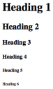

The 6 heading elements, rendered in default styles, from top to bottom.

The content within an <h1> element should have greater importance than the content in an <h3> element. Likewise, if a font style is set for the headings, the font size of an <h1> element should be set larger than the <h3> element. There is no technical reason that prevents you from creating a style making the <h3> element larger than the <h1>. From the web browser’s perspective it would make no difference, but to a human looking at the code for the first time it would be semantically confusing: an <h3> element is not supposed to be larger than an <h1>.

One of the goals of semantic markup is to make the code on a page logical and consistent. Logically chosen and consistent code is easier to update and modify for the designer, and it makes the web page more flexible and adaptable for different uses, such as websites for mobile devices. Semantic markup ensures that even pages with no style still display elements that are comprehensible and usable.

## HTML5 fundamentals

Before creating an HTML5 page, you will review the different categories of content within an HTML document. Although the changes made to HTML5 are numerous, the fundamentals of HTML (and XHTML) have not changed dramatically. One interesting development is that the syntax in HTML5 is very forgiving, especially if you compare it to XHTML 1.0 syntax. For example, all of the following is currently true in HTML5:

* HTML5 is case insensitive, meaning that you can use uppercase tags, lowercase tags or even a mixture of the two and the page will still validate. For example, the following code is technically valid:

<H1> Breaking news from Boston </h1>

* The closing tags for elements are not required. For example, adding multiple paragraphs in the following way is technically valid:

<p> There is an accident on Interstate 95 between Woburn and Burlington.

<p> Travelers should seek alternative routes.

<p> The speed limit is 55 mph.

* Attribute quotes are optional. For example, the following code is technically valid:

<img src=trafficjam.jpg alt=traffic jam>

At first glance, these rules seem to encourage inconsistent coding practices. If this is the case, why does HTML5 allow these practices? The answer is best summarized by the architects of HTML5 as an attempt to “pave the cowpaths.” In the real world, this means a farmer would wait to see what paths his animals choose to walk and then pave that path (instead of the other way around). In the realm of web development, this means that when a practice is already widespread by designers and developers “consider adopting it rather than forbidding it or inventing something new.”

In HTML5, there is an emphasis on backwards compatibility, and many of the practices mentioned above (such as using uppercase tags or not adding a closing tag) were used by document creators in the early days of the web. The W3C decided to fold this variety of coding practices into the specification to ensure that future browsers would continue to render as many pages on the web as possible.

For a more detailed explanation of the W3C’s philosophy for HTML Design Principles, visit http://www.w3.org/TR/html-design-principles/.

Just because HTML5 allows this syntax, it does not mean you should adopt these loose practices! Throughout this book we have you code as if you were writing XHTML 1.0, closing your elements using lower-case tags and adding quotation marks for attributes, remains a very good idea. By having a standardized way of writing code, you will tend to reduce the number of errors you make, and have a way to isolate problems when they do occur.

## The HTML5 DOCTYPE declaration

A significant change in the HTML5 specification can be seen on the very first line of an HTML5 document. A web browser renders a page from the top of the document to the bottom. The opening line of most HTML files is called a doctype, which indicates to the browser the type of document to expect. For example, when a designer uses the transitional version of HTML (4.0.1), the doctype is:

<!DOCTYPE HTML PUBLIC "-//W3C//DTD HTML 4.01 Transitional//EN" "http://www.w3.org/TR/html4/loose.dtd">

When a designer uses the strict version of XHTML 1.0, the doctype is:

<!DOCTYPE html PUBLIC "-//W3C//DTD XHTML 1.0 Strict//EN" "http://www.w3.org/TR/xhtml1/DTD/xhtml1-strict.dtd">

In HTML5, a doctype is much simpler:

<!DOCTYPE html>

DOCTYPE is used to validate documents. Current and future browsers can check the syntax of documents that declare themselves as HTML. Any incorrect syntax (for example, a misspelled tag or missing attribute) returns an error. Validation is an optional process, but it is often used by designers and developers to find incomplete or missing code.

If necessary, you may review the details of page validation in Lesson 2 “Fundamentals of HTML, XHTML, and CSS”

In this exercise, you will convert an older HTML page to HTML5. The document you’ll convert is an HTML 4.01 document, so you will need to update the DOCTYPE to use the simpler HTML5 DOCTYPE.

1. In your text editor, choose File > Open and navigate to the HTML5_04lessons folder. Choose the 04_index.html file, and then click Open. Save the document with a new name to ensure you have a backup copy:

Choose File > Save As, name this file 04_index_work.html, and save it within the HTML5_04lessons folder.

1. Preview this page in your browser to see the current layout. This is essentially the layout created at the end of Lesson 3 and is classified as a two-column fixed-width column layout. If you have not worked with this layout recently you should review the structure: there is a div element with the ID attribute #wrap containing the other div elements that compose the layout of the page. The CSS style for this div sets the width as 960 pixels and sets the left and right margins with the auto value to ensure the container is centered within the browser window.



The div element with the wrap ID attribute is set to 960 pixels wide and contains all the other layout sections.

One change between this lesson file and the one you created in Lesson 3 is that we have moved all of the internal styles in the 03_layout_work.html document into the external style sheet base.css.

1. Close the browser and return to your text editor. Select the entire <!DOCTYPE> section on the top two lines and delete it. Then type the following:

<!DOCTYPE html>

1. Save your file and preview in the browser. You should notice no change, but the browser recognizes this file as HTML5, not HTML 4.01.
2. Close your browser. You will replace some of the div elements with the new HTML5 elements, but first you’ll review how to categorize the different types of content in HTML5.

## The different categories used for HTML5 content

You can divide the content of a web page into categories that, for the most part, are not new to HTML5 but can help you think about how content is organized.

* Metadata content
* Flow content
* Sectioning content
* Heading content
* Phrasing content
* Embedded content
* Interactive content

These categories are helpful for grouping the elements on a page. For example, the Flow content category describes all the elements available for use in the body of a page, but you can sub-divide Flow content into smaller categories, such as Phrasing and Heading content.

### Metadata content

Content that sets up the presentation or behavior of the rest of the content on the page is called metadata content. You can also use it to set up the relationship of the document with other documents. One obvious example of metadata content is the <meta> element, which often contains keywords or a description about the page, and is used by search engines to help categorize the page. Elements, such as <style> and <script>, are also considered metadata content since they contribute to the appearance and behavior of the primary content. Metadata content is located in the <head> section of a document.

<head>

  <title> Worldwide Apparel Intranet </title>

  <meta charset=utf-8>

  <link rel="stylesheet" href="styles.css" media="all">

  <script src= "jquery-1.4.2.min.js"></script>

</head>

### Flow content

Flow content represents the elements that are considered the content of a web page. In other words, all the tags used to mark up content are placed in this category; for example, <p>, <h1>, <ol>, <table>, and so on. Flow content is traditionally text or an embedded file, such as an image or video. In HTML5, there are several new elements in this category; for example, <article>, <aside>, <audio>, <canvas>, <hgroup>, and many more.

<h3> This is flow content </h3>

<p> Lorem ipsum dolor sit amet, consectetur adipisicing elit, sed do eiusmod tempor incididunt ut labore et dolore magna aliqua. Ut enim ad minim veniam, quis nostrud exercitation ullamco laboris nisi ut aliquip ex ea commodo consequat. </p>

### Sectioning content

This category is new to HTML5 and currently includes four elements: <article>, <aside>, <nav>, and <section>. The W3C explains sectioning content as “defin[ing] the scope of headings and footers.” Sectioning content is a subset of flow content; you will learn more about sectioning later in the lesson.

You can find the definitions of sectioning content and the other categories at:   
http://developers.whatwg.org/content-models.html#kinds-of-content.

<aside>

  <h1> Volunteer Opportunities </h1>

  <p> Sort and inspect home goods and supplies for kids.</p>

</aside>

### Heading content

Heading content contains all the standard heading elements currently used in HTML 4.0: <h1>, <h2>, and so on. In addition, HTML5 includes the <hgroup> element, designed to group two or more headings. Heading content is a subset of flow content.

<hgroup>

  <h2>Top Rated Smoothies</h2>

  <h3>The Funky Orange</h3>

</hgroup>

### Phrasing content

Phrasing content is the text of the document, which includes elements that mark up the text within a paragraph. Phrasing content is a subset of flow content.

<p> The advantage of having <strong> good </strong> hiking boots becomes <em>extremely</em> clear after your third day of walking.</p>

### Embedded content

Embedded content is content that imports another resource into your document page, such as an image or video.

<audio src="high_seas_rip.mp3" controls preload="auto" autobuffer>  
</audio>

### Interactive content

One of the most basic elements, the <a> tag (used for hyperlinks), is considered an interactive element. Other elements specifically intended for user interaction are also included in this category; for example, the <textarea> (used in forms) and the <button> elements.

<input type="button" value="Am I interactive?"   
onClick='alert("Yep I am interactive")'>

Clicking a button with a JavaScript alert attached.

In the next exercise, you will learn how to use some of the new HTML5 elements by converting an existing div-based layout to one that uses new sectioning elements and other new tags.

## Using the new header element in HTML5

The HTML5 specification expands the current set of elements used today to give the designer and developer more precise semantic markup options. An example is the HTML <div> element used to divide a page into sections. The opening <div> tag is often paired with a class or ID attribute, which is then styled in CSS with various properties, such as width, height, and background-color. On its own, the <div> element is meaningless. Designers and developers give it meaning by adding ID and class names, but these names are arbitrary and not meaningful to a web browser. One of the goals of HTML5 is to add new elements that have inherent meaning within the structure of the document.

In this exercise, you will examine this structure by opening an existing layout that uses the current HTML framework, and then convert it to an HTML5 page.

1. In your text editor, choose File > Open, navigate to the HTML5_04lessons folder, select the base.css file, and choose Open.
2. Located approximately in the first 1/3 of the stylesheet is the following ID rule for the original header:

#masthead{

  background-color: #FFF;

}

This is a simple rule that defines the style of the ID called masthead. This style is set to the hexadecimal color #FFF or white. Keep the name of this style in mind as you walk through the next few steps.

1. Locate the rule for #wrap and notice this background color is set to orange. However, when you previewed the page in the last exercise there was no orange visible. This is because the white background color of the masthead is over-riding this color.
2. Continue to scroll downwards through the style sheet and note that all of these following style rules have a white background color as well: #sidebar, #main, #innerwrap and #footer. The end result is that the orange background color of the wrap div is nowhere to be seen. We are doing this for educational purposes and the reasons will become clear in a few steps as you start adding HTML5 elements.
3. Switch over to your 04_index_work.html file.
4. The first step is to replace the existing <div> tag used for the header with one of the new HTML5 elements. Within your HTML, locate the following section of code:

<div id="masthead">

  <img src="images/wa_logo.jpg" width="200"   
height="123" alt="Worldwide Apparel logo" />

</div>

The only content nested inside this div element is an image for the site logo.

1. Delete the opening and closing div tags and replace them with the following:

<header id="masthead">

  <h1> The web's #1 resource for smoothie recipes </h1>

  <img src="images/smoothieworld_logo.jpg" width="200"  
height="150" alt="smoothieworld_logo" />

</header>

This is a new HTML5 element called <header>.The W3C specification explains that, “the header element represents a group of introductory or navigational aids.” The specification also indicates that, “A header element is intended to usually contain the section’s heading (an h1–h6 element or an hgroup element), but this is not required. The header element can also be used to wrap a section’s table of contents, a search form, or any relevant logos.”

In HTML5, you can use the <header> element multiple times on a page. Later in this lesson, you will learn more about when and where you could add additional headings.

Since this is the first HTML5 element on your page, you need to consider its compatibility with web browsers not familiar with HTML5 tags. An explanation of this issue and how to resolve it is given in the next paragraphs.

1. Choose File > Save and preview your page in your current browser. If your browser supports the HTML5 <header> element, you will see no difference between this page and the page you previewed at the beginning of this lesson. If you use a browser that does not support the <header> element, the background color of the header will be orange.



The page as seen in a browser that supports the HTML5 <header> element.



Browsers that do not support the HTML5 <header> element will not recognize the style associated with it.

The difference in background colors occurs because a browser that does not support HTML5 will not render the style of the <header> element properly; the orange color seen is due to the background color of the surrounding div. Take note of the site logo, even though it is nested within the <header> element, it remains visible because it uses <img> element which all browsers recognize.

This simple example demonstrates the dilemma concerning the new HTML5 elements: How can you use these tags if their styles are not recognized by older browsers? The next section shows two solutions for this problem.

| The WHATWG defines the official use for HTML5 elements |
| --- |
| A group called the WHATWG was formed to define and document the HTML5 specification. HTML5 is still under development, so we recommend using this group’s website as your central resource for learning more about the new HTML5 elements and how to use them. You can find the WHATWG website at http://developers.whatwg.org/. |

## Adding support for HTML5 elements in browsers

To recap, when a web browser encounters any unknown element, and this element has associated CSS styles, this creates a problem. To be more specific, many older browsers treat the unknown <header> element as an inline (or text-level) element, not as a block element. Inline elements are generally found within a block of text; for example, the <strong> element and the <em> element are inline. Block elements use blocks of space on the page and create new lines when added; for example, the <p> element and all the heading elements are block-level. When a browser treats a block element as inline, the result can often be problematic. To resolve this issue, you can add a line of CSS code to force the new HTML5 elements to display as block, not as inline.

1. In your text editor, open the reset.css style sheet located in the HTML5_04lessons folder.. At the top of the page (after the first two lines of comment code), add the following block of code:

header, section, aside, nav, footer, figure, figcaption {

  display:block;

}

You listed all the selectors you’ll use in this lesson. If needed, you can return to this section and add more new HTML5 selectors. The reason you put these rules within the reset.css document instead of the base.css document is so you can reuse this reset.css file for all of your future HTML5 pages.

1. This step is only relevant if you happen to have been using an older browser and were seeing the orange background. Save your CSS file and close it. Preview your page in your browser. If you happen to be using a browser that originally displayed orange in the header area, the background should be white again, demonstrating that the <header> style is being rendered properly.
2. If your browser is still displaying the orange background as seen in Step 8 of the last exercise, then chances are you are using Internet Explorer 6,7 or 8. These browsers require a bit more work to help them display HTML5 elements. The reason for this is because when these browsers encounter an unfamiliar element they ignore it completely, therefore the solution in step 1 does not work.

One solution for adding support of HTML5 tags to Internet Explorer 6, 7 & 8 comes in the form of the Modernizr JavaScript library. The Modernizr library adds support for displaying HTML5 elements in older browsers. The JavaScript within the library is designed to detect features within any browser, and then allows you to target styles as needed. You’ll now add a link to the Modernizr library.

1. Switch over to your 04_index_work.html file. In the head section of your HTML, locate the links to your two external stylesheets, and then add the following line:

<link href="reset.css" rel="stylesheet" type="text/css" />

<link href="base.css" rel="stylesheet" type="text/css" />

**<script src="modernizr-2.0.js" type="text/javascript"></script>**

This file is currently located in your HTML5_04lessons folder. Because Modernizr is an evolving JavaScript library, so you should visit http://www.modernizr.com and make certain you have the latest version.

1. Save your file and if you are testing with Internet Explorer 6, 7, or 8 preview the page. The header section now has its original background color, as intended.



An older browser, such as Internet Explorer 6, will display the HTML5 <header> element when using the Modernizr JavaScript library.

This addition means you can continue using the new HTML5 elements now that support for virtually all popular browsers has been added. There are a few issues to consider, though. The Modernizr library is not infallible, because it relies on the user to have JavaScript enabled there may be rare occasions when a user’s web browser does not support JavaScript, or has JavaScript turned off; in such cases, none of the fixes will be visible and the page will be broken. The overwhelming majority of browsers do support JavaScript, however and it is rarely turned off by design.

## Adding the HTML5 **<nav>** elements

You’ll now add the new HTML5 sectioning elements to divide your page into logical sections; the new sectioning elements are <section>, <article>, <aside>, and <nav>. You’ll start by adding the <nav> element, since it’s the most intuitive one.

1. Locate the following block of code in your HTML:

<div id="mainnav">

  <ul>

    <li><a href="index.html">Home  
</a></li>

<li><a href="ourcompany.html">Our Company</a></li>

<li><a href="policies.html">Policies and Procedures  
</a></li>

<li><a href="doc_repository.html">Document Repository</a></li>

<li><a href="forum.html">News & Events</a></li>

  </ul>

</div>

This code uses a common list-based CSS navigation technique. The list in this code is unordered and nested within the div called mainnav. The new HTML5 <nav> element can replace the original div and ID.

1. Replace the <div> tags with the following code:

<nav>

  <ul>

   <li><a href="index.html">Home  
</a></li>

<li><a href="ourcompany.html">Our Company</a></li>

<li><a href="policies.html">Policies and Procedures  
</a></li>

<li><a href="doc_repository.html">Document Repository</a></li>

<li><a href="forum.html">News & Events</a></li>

</nav>

1. You must now update the CSS selector used in your stylesheet. In your text editor, open your base.css stylesheet and locate the following code:

#mainnav {

  background-color:#666;

  height:40px;

}

Remove the ID selector #mainnav and replace it with the nav selector, as instructed below.

1. Make the following change to your code:

nav {

background-color:#666;

  height:40px;

}

The styles are now connected to the nav element, not to the #mainnav ID. Choose File > Save to save your stylesheet. Switch to your HTML page and save that as well. Preview your page in the browser. Notice that the navigation is still not working properly.



Your navigation appears broken because you need to update all styles associated with the #nav ID.

The navigation appears broken because there are other styles using the ID name #mainnav; you need to update them all.

Close your browser and return to your text editor.

1. In your base.css stylesheet, locate the rules below the nav rule. You need to update three different selectors: #mainnav li, #mainnav ul li a and #mainnav ul li a:hover. These selectors are called contextual selectors in CSS, and they target specific tags within the context of the parent style (in this case, the ID #nav.) For example, #mainnav li defines a style for list elements (li) inside the #nav div element.

Make the changes highlighted in red:

nav li {

  float:left;

width:170px;

  height:40px;

  background-color:#CCC;

  text-align:center;

  border-left:1px black solid;

  border-right:1px black solid;

  line-height:40px;

  }

nav ul li a {

  color:#ffffff;

  text-decoration:none;

  display:block;

}

nav ul li a:hover {

  background-color:#666666;

  color:#D2CD2F;

}

1. Choose File > Save. Preview your page in the browser; your navigation should appear as it did originally.

If your navigation still appears broken, try refreshing your page in the browser. Some browsers hold onto the cache of the old page and need to be reloaded.



Your navigation now uses the HTML5 <nav> element.

### Adding the other HTML5 sectioning elements

The other elements in the sectioning category are <section>, <article>, and <aside>. You’ll add the <section> element first. The official definition of the section element is that it “represents a generic section of a document or application. A section, in this context, is a thematic grouping of content, typically with a heading.” The definition also indicates that “The section element is not a generic container element. When an element is needed for styling purposes or as a convenience for scripting, authors are encouraged to use the div element instead. A general rule is that the section element is appropriate only if the element’s contents would be listed explicitly in the document’s outline.”

You can find this definition at http://developers.whatwg.org/sections.html#sections.

This means that you can use <section> when you need to divide important and related content, such as text and images, into logical areas. For example, the page you have been working on is a home page with content that is divided visually: the column on the left is wider and a different color than the second column on the right. This second column is the sidebar and the content is unrelated to the main content, and you will return to it later in the lesson.

1. 1 In the 04_index_work.html file, locate the opening <div> tag for the main section:

<div id="main">

Locate the closing <div> tag further down the page; you will change this tag shortly. The commenting code will help you identify it.

  <p>The information on this site is provided to help you be a happier, more productive employee. If you have any questions about anything on the site or have other employee related questions, you can also call Jen Smith at extension 535! </p>

</div>

<!-- End of Main Div -->:

1. Scroll back to the opening <div> tag and replace it with the section tag as follows:

<section id="main">

1. Now scroll to the closing </div> tag you located in step 1 and replace it with closing section tag:

    <p>The information on this site is provided to help you be a happier, more productive employee. If you have any questions about anything on the site or have other employee related questions, you can also call Jen Smith at extension 535! </p>

</section>

<!-- End of Main Div -->:

The parent element of this new section is called <div id="innerwrap"> and it is used for presentation purposes only, not for content. The style associated with this div gives it a background color (white) and since this div is for presentation only, you can leave it as is.

You can still use div elements in HTML5, but the best practice is to use them when there is no better choice within the new HTML5 elements.

1. Save your file and preview your page in the browser. Before continuing with the exercise, you need to understand the document outline model that HTML5 uses.

## HTML5 document outlines

A weakness of the current HTML and XHTML specifications is the lack of a good document outline model. Consider the traditional outline you might create before writing a report or paper. Outlines illustrate the level of importance for your content as well as the relationships between this content. The HTML5 sectioning elements are designed to naturally create an outline structure from your web pages. Imagine if every web page had a “table of contents” that was automatically created from the structure of the tags being used. This is the intent of the HTML5 document outline.

The benefits of document outlines are not immediately apparent with current web browsers and mobile devices, but they can be useful for assistive devices, such as screen readers. For example, an HTML5-enabled screen reader might encounter a page with the <nav> element and choose to skip the nav, give the user the option to skip it, or read each item within the nav.

HTML and XHTML pages currently have document outlines based on the heading tags only, so they are very limited. The new HTML5 document outline model provides more detailed and meaningful outlines. For example, consider the following:

<body>

  <header>

    <h1>Welcome to our site</h1>

      <p>The best website in the world!</p>

  </header>

  <nav>

    <h1>Site Navigation</h1>

  </nav>

  <section>

    <h1>Breaking News</h1>

      <h2>Car overturns on highway</h2>

  </section>

</body>

This HTML has the following document outline:

  1. Welcome to our site

    1. Site Navigation

    2. Breaking News

      1. Car Overturns on Highway

In this example, the <nav> and <section> elements create new sections within the outline, but their name comes from the nested heading. This makes headings a much more significant part of the document outline for HTML5 sites. The HTML5 model lets you add a new h1 element per section, so different sections of the page can have their own hierarchy, as shown in the example above.

A potential complication is that currently, the HTML5 specification states that sectioning elements must contain headings, or they appear listed as Untitled in the outline. For example, in the HTML example above, deleting the heading 1 element from the <nav> element makes the outline appear as follows:

  1. Welcome to our site

    1. Untitled NAV

    2. Breaking News

      1. Car Overturns on Highway

In the screen reader example used earlier, this document outline is not ideal since the navigation is unlabeled. However, putting headings inside navigations is not currently a common practice for designers and so it is important to note that this is an area of the HTML5 specification still being refined at the time of this writing. The rules dictating HTML5 outlines might change, but you should keep in mind that document outlines can help organize your HTML5 content and teach you more about sectioning. Creating a good document outline today will help ensure your site benefits when future browsers begin to use them. Designers and developers who prioritize the accessibility of their sites should pay particular attention to the role of the document outline.

Viewing an HTML5 document outline is not necessarily easy at the moment since there are few tools available for this purpose. You can see an interactive example of a document outline however, at the following url: http://ie.microsoft.com/testdrive/HTML5/SemanticNotepad

| Deeper accessibility with WAI-ARIA roles |
| --- |
| The Accessible Rich Internet Applications Suite (WAI-ARIA), whose goal is to organize and improve accessibility across the web, is being developed alongside the HTML5 specification. A portion of the specification, called landmark roles, is specifically designed to be used with HTML and XHTML elements. A landmark role is a way of categorizing and identifying different parts of a web page. For example, a role called banner identifies the region that contains the primary heading of the page. You can add this role as an attribute for the HTML5 <header> element, for example:  <header role="banner">  Some of the landmark roles have direct equivalents to HTML elements. For example, the role="form" attribute is used for form elements and the role="navigation" is used for the HTML5 <nav> element. You can use landmark roles today, but you might need to review your code in the future to ensure that it is aligned with the specification when it is finalized.  You can learn more about WAI-ARIA and landmark roles at http://www.w3.org/WAI/PF/aria/usage#usage_intro  You can find the W3C specification for WAI-ARIA 1.0 at http://www.w3.org/WAI/PF/aria-practices/  The aria-practices page above also includes sample code and best practices for adding landmark roles into your web pages. |

## Adding the footer element

Keep in mind that the <header> element you added earlier is not a sectioning element and will not define a new section in a document outline. Similarly, the <footer> element is not categorized as a sectioning element; you can have more than one footer element per page. For example, you could have a site footer as well as a footer within a <section> element. In this exercise, you will simply replace the original div named footer with the new HTML5 footer element.

1. In your HTML page, locate the div element with the ID attribute footer and make the following change:

<footer id="siteinfo">

  <p>Copyright Worldwide Apparel 2011 </p> <p>All content on this site is confidential and should not be shared with anyone outside of Worldwide Apparel./a></p>

</footer>

1. Open your base.css external stylesheet, locate the #footer ID, and change the selector as follows:

#siteinfo {

  clear:both;

background-color:#FFF;

  background-image:url(images/footer_background.jpg);

  background-repeat:no-repeat;

  width:960px;

  height:128px;

  padding-top:10px;

}

1. Below this rule, there is a contextual selector for paragraphs inside the footer that you need to update. Replace the #footer p selector as follows:

#siteinfo p {

  margin:10px 0 0 20px;

  width:280px;

  font-family:Verdana, Geneva, sans-serif;

  font-size:0.689em;

}

1. Save your HTML and CSS files, and then preview your page in the browser. Scroll to ensure the footer is displaying as expected. (If the image is not visible, try refreshing your browser page before checking your code for errors.) In a browser that supports the HTML5 tags, your page appears as it did when you previewed it earlier in this lesson.

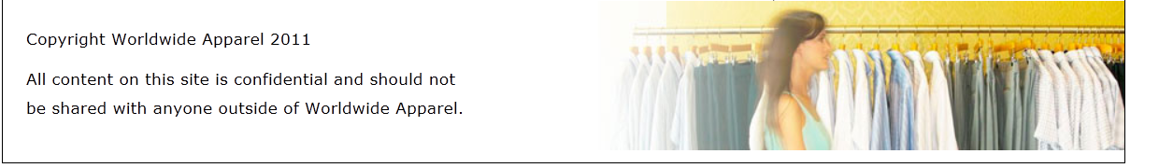

Your design now uses the HTML5 <footer> element.

In the next few exercises, you will group content using a combination of the tags you have learned, along with some new ones.

## Adding the article and aside elements

In this section, you will learn about the <article> and <aside> elements, beginning with the article element. The W3C definition states that <article> is “a self-contained composition in a document, page, application, or site and that is, in principle, independently distributable or reusable, e.g. in syndication. This could be a forum post, a magazine or newspaper article, a blog entry, a user-submitted comment, an interactive widget or gadget, or any other independent item of content.”

The key concept in the above definition is that it is *self-contained*. The <article> element was designed for content that can be extracted from its containing page; for example, in the following exercise you will copy the html from a pre-existing page and paste it into your home page.

1. In your text editor choose File > Open and navigate to your Lesson 4 folder and open the 04_article page. Preview the page in your browser. This page contains information on what a “quiet period” is when a company files for an IPO. While you do not need to read every line thoroughly, you should skim enough of it to understand that this is a self-enclosed article and does not rely on any other material.

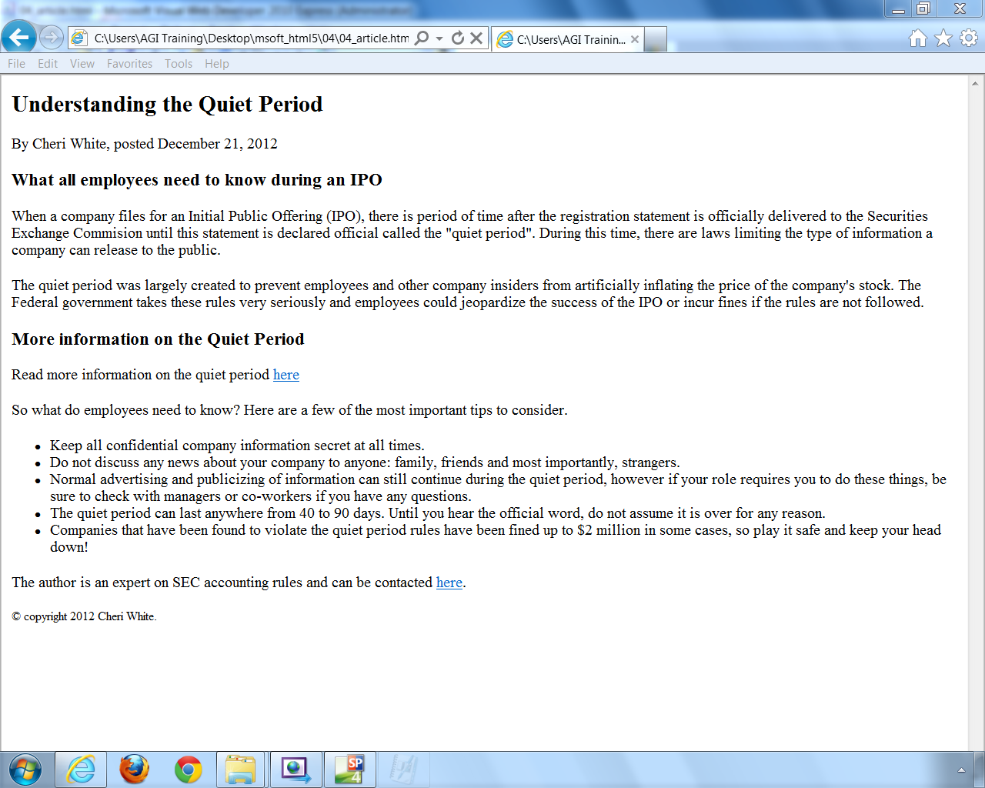

The standalone article content you will be pasting into your page.

1. Return to your text editor and select all of the code by choosing Ctrl+A, and then copy the code by choosing Ctrl+C.
2. You may close this document and switch over (or open) your 04_index_work.html document. You want this content to be nested inside of the section you created in the last exercise so locate the following paragraph and place your cursor after the closing </p> tag but before the closing </section> tag. Create an empty <article> element as seen here:

    <p>The information on this site is provided to help you be a happier, more productive employee. If you have any questions about anything on the site or have other employee related questions, you can also call Jen Smith at extension 535! </p>

<article>

</article>

</section>

1. Make sure your cursor is between the two article tags and choose Ctrl + V or Edit > Paste and paste the code you copied in step 2. All of your content is now nested inside the article element.

| How will the article element be used? |
| --- |
| The article element in HTML5 is optimal for content that might end up being published in different contexts or even on separate devices. For example, if you publish a weblog entry, visitors typically visit your website to read it. Nowadays, content can be redistributed in various ways and syndicated in formats, such as RSS feeds for newsreader applications, email, mobile applications, and more. In other words, the structure of published content needs to be flexible enough so reformatting is not required for different devices. The article element also contributes to accessibility by providing another level of logical structure within a document. |

1. As noted earlier in HTML5 you can have more than one header, so you will add one now to the content you just pasted. Locate your opening <article> tag and immediately after, add a new header element within the article:

<header>

  <h2>Understanding the Quiet Period</h2>

  <p>By Cheri White, posted December 21, 2012 <p>

  <h3>What all employees need to know during an IPO </h3>

</header>

In addition to having multiple headers on a page, you can add a <footer> element within the article to help structure it.

Locate the author contact and copyright section and add the following code:

    <footer>

<p><p> The author is an expert on SEC accounting rules and can be contacted <a href="mailto:cheri@smoothieworld.com">here</a>.</p>

<p><small>&copy; copyright 2012 Cheri White</small></p>

    </footer>

  </article>

</section>

Save your file and then preview in the browser to see the results.

The rest of this exercise illustrates the use of the aside element. You can use the aside element in two ways. One is based on the traditional use of a sidebar for a website; the second is for an area of related content within a <section> element. You will start with the sidebar of the site.

1. In your HTML, locate the opening <div> tag with the ID name sidebar:

<div id="sidebar">

  <h2>Volunteer Opportunities</h2>

. . . .

You will replace the <div> tag with the <aside> tag and change the ID name to make it more logical.

In the above code fragment we have not included all of the code in the sidebar in order to save space.

1. Change the opening <div> tag as follows:

<aside id="secondary-content">

  <h2> Volunteer Opportunities </h2>

. . .

This ID more accurately represents the role of this content. Make sure you close the <aside> tag.

1. Locate the original closing <div> tag and change it to a closing <aside> tag:

<p> Prepare meals for senior citizens and individuals recovering from surgery. Learn More </p>

</aside>

1. Open your base.css file and locate the original #sidebar selector; you need to change this to your new ID #secondary-content. Change the code as follows:

#secondary-content {

  float:right;

  width:300px;

  background-image:url(images/sidebar_bg.png);

  background-repeat:repeat-x;

background-repeat: thin solid gray;

  background-color:#FFF;

}

Why are you making this change? Technically you do not have to; however one of the goals of flexible web design is being careful of names that might signify page layout. The ID name “sidebar” is often interpreted as a visual column on the page. But what if at some point you were to place this content below your main section? The ID sidebar would no longer be relevant and #secondary-content is more flexible.

1. There are related styles that used the original #sidebar selector, and you need to change all of them. Change the selectors in the following three sets of style rules from #sidebar to #secondary-content:

#secondary-content p, #secondary-content h2, #secondary-content h3, #main p, #main h1, #main h2, #main h3,

and further below these rules:

#secondary-content h2

The aside element is not just used for layout sections on the page, you’ll now look at another use for the <aside> element.

1. In the 04_index_work.html file, locate the following code within the <section> element:

  <h3>More information on the Quiet Period<h3>

    <p> Read more information on the quiet period <a href=”#”>here</a><p>

This section of the page points to some additional information for people who might be interested in learning more about the concepts covered, but it will eventually point to content outside of the article.

A common technique used to separate the continuous flow of text and lead the reader’s eye towards other content is to add a small box to the page. In some cases, this content might be a quote from the article itself (known as a pull quote), or simply put: an aside.

1. Replace the <div class=”articleaside”> tag with the aside element, as shown.

<aside class=”moreinfo”>

<h3>More information on the Quiet Period<h3>

    <p> Read more information on the Quiet period <a href=”#”>here</a><p>

</aside>

When you use the <aside> element nested within a <section> element, as you did here, it represents content that is somewhat related to the section. When you use it as you did in the initial example, the <aside> element is a sidebar considered secondary content unrelated to the main content of the page. The class name “moreinfo” is added here so you can add a style to this content.

1. Switch to your base.css style sheet and add the following code to the bottom of your style sheet:

.moreinfo

{

float: right;

width: 200px;

background: #ddf;

padding: 10px;

margin: 6px;

}

This code will create a 200 pixel wide box with a grey background color. Additionally, it is floated right so the surrounding content will flow around it.

1. Save your HTML and CSS files and preview your page in the browser.

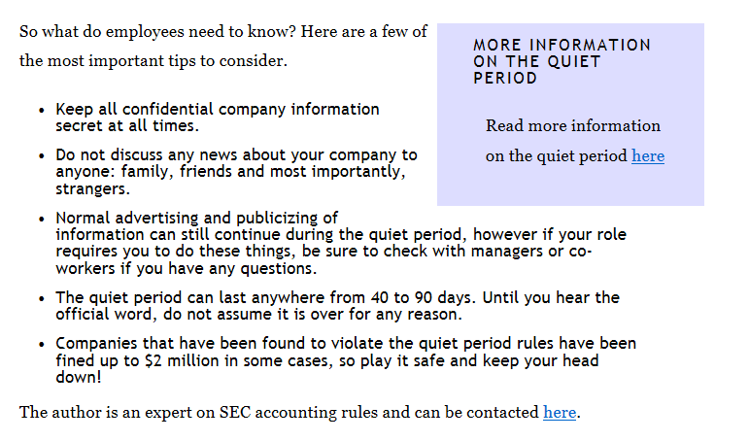

The HTML5 aside element can be used within a section to indicate related content

## Additional HTML5 elements

There are several new elements you can use to make the content of your pages more meaningful. For example, the <figure> and <figurecaption> elements help identify images and associated captions within your content.

1. Locate the closing </header> tag within your article and add an image as follows:

<h3> What all employees need to know during an IPO </h3>

</header>

<img src="images/shhh.jpg" alt="Woman saying be quiet" />

This simply embeds the image onto your page, you’ll now wrap the <figure> element around this image.

1. Add the figure element as follows:

<figure>

<img src="images/shhh.jpg" alt="Woman saying be quiet" />

</figure>

This element is designed to markup areas of your page such as images, charts, and graphs. You can also pair the figure with a caption using the <figcaption> element.

1. Add the caption by adding the following code:

<figure>

<img src="images/shhh.jpg" alt="Woman saying be quiet" />

  <figcaption> Quiet needed during an IPO.  
</figcaption>

</figure>

You can style the new elements as you would other elements. You’ll now format the figure and the caption within the article.

1. Open your base.css file and add the following rule for the figure:

figure {

  float:right;

  padding:4px;

  margin:6px;

}

Save your HTML and CSS file and then preview your page in the browser. This style floats the image over to the right and applies padding, and margin to set it off from the rest of the page.

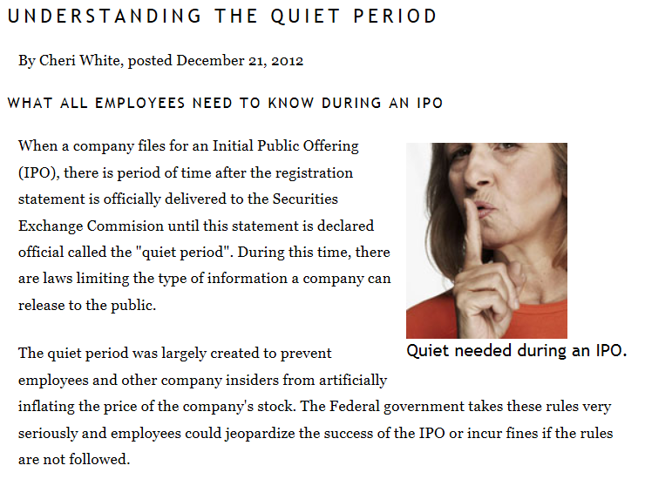

The <figure> element floated to the right of your article.

The caption does not look very good at this size, so you will now style it as well. Return to your text editor.

1. Add the following style rule below your figure rule:

figcaption {

  text-align:center;

  font:italic 0.7em Georgia, "Times New Roman", Times, serif;

}

Save your HTML and CSS files and preview your page in the browser. This centers the caption and styles the text.

## Additional HTML5 elements

Although we have covered the most important HTML5 elements in this lesson, there are additional elements as well. The following table highlights the newest HTML5 elements and their usage. Additionally, we have highlighted the HTML elements that have undergone slight revision from HTML4 to HTML5.

| List of current HTML5 elements: (cont.) | | |
| --- | --- | --- |
| **Element** | **Description** | **Attributes** |
| a | Hyperlink | globals; href; target; rel; media; hreflang; type |
| abbr | Abbreviation | globals |
| address | Contact information for a page or section | globals |
| area | Hyperlink or dead area on an image map | globals; alt; coords; shape; href; target; rel; media; hreflang; type |
| article | Self-contained syndicatable or reusable composition | globals |
| aside | Sidebar for tangentially related content | globals |
| audio | Audio player | globals; src; preload; autoplay; mediagroup; loop; controls |
| b | Represents a span of text to which attention is being drawn for utilitarian purposes without conveying any extra importance and with no implication of an alternate voice or mood. | globals |
| base | Base URL and default target browsing context for hyperlinks and forms | globals; href; target |
| blockquote | A section quoted from another source | globals; cite |
| body | Document body | globals; onafterprint; onbeforeprint; onbeforeunload; onblur; onerror; onfocus; onhashchange; onload; onmessage; onoffline; ononline; onpagehide; onpageshow; onpopstate; onredo; onresize; onscroll; onstorage; onundo; onunload |
| br | Line break, e.g. in poem or postal address | globals |
| button | Button control | globals; autofocus; disabled; form; formaction; formenctype; formmethod; formnovalidate; formtarget; name; type; value |
| canvas | Scriptable bitmap canvas | globals; width; height |
| caption | Table caption | globals |
| cite | Title of a work | globals |
| code | Computer code | globals |
| col | Table column | globals; span |
| colgroup | Group of columns in a table | globals; span |
| command | Menu command | globals; type; label; icon; disabled; checked; radiogroup |
| datalist | Container for options for combo box control | globals |
| dd | Content for corresponding dt element(s) | globals |
| del | A removal from the document | globals; cite; datetime |
| div | Generic flow container | globals |
| dl | Association list consisting of zero or more name-value groups | globals |
| dt | Legend for corresponding dd element(s) | globals |
| em | Stress emphasis | globals |
| embed | Plugin | globals; src; type; width; height; any* |
| fieldset | Group of form controls | globals; disabled; form; name |
| figcaption | Caption for figure | globals |
| figure | Figure with optional caption | globals |
| footer | Footer for a page or section | globals |
| form | User-submittable form | globals; accept-charset; action; autocomplete; enctype; method; name; novalidate; target |
| h1, h2, h3, h4, h5, h6 | Section heading | globals |
| head | Container for document metadata | globals |
| header | Introductory or navigational aids for a page or section | globals |
| hgroup | heading group | globals |
| hr | Thematic break | globals |
| html | Root element | globals; manifest |
| i | Alternate voice | globals |
| iframe | Nested browsing context | globals; src; srcdoc; name; sandbox; seamless; width; height |
| img | Image | globals; alt; src; usemap; ismap; width; height |
| input | Form control | globals; accept; alt; autocomplete; autofocus; checked; dirname; disabled; form; formaction; formenctype; formmethod; formnovalidate; formtarget; height; list; max; maxlength; min; multiple; name; pattern; placeholder; readonly; required; size; src; step; type; value; width |
| ins | An addition to the document | globals; cite; datetime |
| label | Caption for a form control | globals; form; for |
| legend | Caption for fieldset | globals |
| li | List item | globals; value* |
| link | Link metadata | globals; href; rel; media; hreflang; type; sizes |
| map | Image map | globals; name |
| mark | Highlight | globals |
| menu | Menu of commands | globals; type; label |
| meta | Text metadata | globals; name; http-equiv; content; charset |
| meter | Gauge | globals; value; min; max; low; high; optimum; form |
| nav | Section with navigational links | globals |
| noscript | Fallback content for script | globals |
| object | Image, nested browsing context, or plugin | globals; data; type; name; usemap; form; width; height |
| ol | Ordered list | globals; reversed; start |
| optgroup | Group of options in a list box | globals; disabled; label |
| option | Option in a list box or combo box control | globals; disabled; label; selected; value |
| output | Calculated output value | globals; for; form; name |
| p | Paragraph | globals |
| param | Parameter for object | globals; name; value |
| pre | Block of preformatted text | globals |
| progress | Progress bar | globals; value; max; form |
| q | Quotation | globals; cite |
| script | Embedded script | globals; src; async; defer; type; charset |
| section | Generic document or application section | globals |
| select | List box control | globals; autofocus; disabled; form; multiple; name; required; size |
| small | Side comment | globals |
| source | Media source for video or audio | globals; src; type; media |
| span | Generic phrasing container | globals |
| strong | Importance | globals |
| style | Embedded styling information | globals; media; type; scoped |
| sub | Subscript | globals |
| summary | Caption for details | globals |
| sup | Superscript | globals |
| table | Table | globals; border |
| tbody | Group of rows in a table | globals |
| td | Table cell | globals; colspan; rowspan; headers |
| textarea | Multiline text field | globals; autofocus; cols; disabled; form; maxlength; name; placeholder; readonly; required; rows; wrap |
| tfoot | Group of footer rows in a table | globals |
| th | Table header cell | globals; colspan; rowspan; headers; scope |
| thead | Group of heading rows in a table | globals |
| time | Date and/or time | globals; datetime; pubdate |
| title | Document title | globals |
| tr | Table row | globals |
| track | Timed text track | globals; default; kind; label; src; srclang |
| u | Keywords | globals |
| ul | List | globals |
| var | Variable | globals |
| video | Video player | globals; src; poster; preload; autoplay; mediagroup; loop; controls; width; height |
| wbr | Line breaking opportunity | globals |

## Self study

1. There are additional HTML5 elements not covered in this lesson. Recall that the HTML5 specification will be finalized in the year 2014. For up-to-date resources, see www.thehtmldoctor.com. For updates to the specification, see the primary sources for the HTML5 specification at http://developers.whatwg.org/.
2. You can also download the HTML5 outliner at http://code.google.com/p/h5o/ and install one of the bookmarklets if it is supported by your primary browser. Save a copy of the page and add new sections, articles, and different levels of headings to see how the outline changes.

## Review

### Questions

1. True or false; HTML5 allows the use of only one <header> and one <footer> element per page.
2. What is sectioning content in HTML5? Name the four elements grouped within this category.
3. Define the <aside> element and give examples of the two main ways it can be used.

### Answers

1. False. The <header> and <footer> elements can be used multiple times on a page. For example, you can have a site-wide header or footer and a section header or footer.
2. Sectioning elements in HTML5 define the scope of headers and footers, and are used to logically divide the areas of an HTML document. Sectioning elements also start new sections within a HTML5 document outline. The four sectioning elements are <section>, <nav>, <aside>, and <article>.
3. The <aside> element represents content, often called the sidebar, when it is separated from the content around it and used in the main context of a page. When used within a <section> element, the <aside> element presents content vaguely related to the surrounding content, such as a pull quote.