First Program
The purpose of this program will be to demonstrate your knowledge of the basic programming fundamentals and show that you can do so in JAVA. I will repeat that your final submission should be a .java file of your own individual solution (not a .class file – I am unable to grade .class files).

Your program will generate a multiple of primes table between 2 selected values. Your java program will need a class and a main to run:

//with any necessary imports
public class MyClass {
public static void main(String args[]) {

}
}

But I will not be grading your main. Instead your job is to write a your solution in a separate method (called a function in c++, java calls them methods, if your wondering why it is a fascinating google search or ask me during live sessions) name that method primeTable. Obviously, your main method (yep, we have to get used to method instead of function) will call this primeTable method to run and will be required to pass in a start and end parameters. (By the way, this is chapter 6 in fundamentals 1…)

You do not have to read any inputs from a file or a user, you may hard code the start and end values in main as long as you pass them to the function (the primeTable function must take these values in and cannot hard code them).

The only difference between methods done in JAVA and your c++ functions are that you will need to include the word ‘static’ in your method header. The example given here prints out a simple message but make certain it is in the scope block of your class where the main function is located (it can be above or below main without issue):

static void thisIsAFunction()
{
System.out.println("Hey I'm a function");
}

The actual goal of this method/function is to take in 2 inputs (as int’s) a start, and an end. Between these 2 values your function will output a table of all the prime numbers between start and end with all the multiples of them.

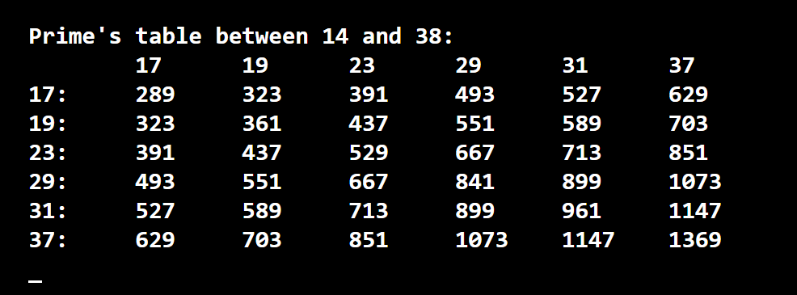

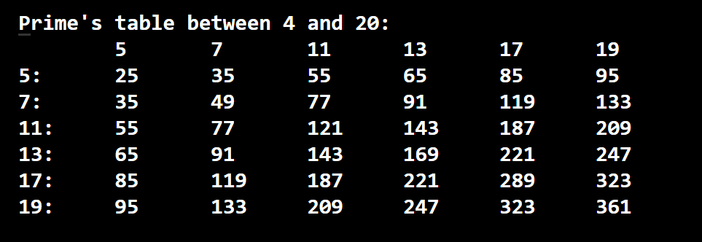

You will probably need to use 2 loops nested within each other to accomplish this goal (though it can be done with 1 loop). You may use any loop you wish but please format your table so that it is easy to read like the example above. To do so you may use the following function (or any other method such as decimal format):

