Shipping Network
In this lab we will be constructing a network of entities that will be working together to solve the problem. Groups of entities and teams are very common all kinds of fields and other examples of this type of programming problem appear quite frequently.
So the example we will be working with here in this lab is that of a shipping network. Cargo gets introduced to the system at any one of the nodes or sites in the system and from there it will need to be carried from its source to destination by a vehicle of some kind. This will require vehicles to be dispatched to collect the cargo and take it to its destination. Cargo whose destination is a site that is beyond the current vehicle’s range (boats can’t go onto land for instance) will have to drop off the cargo and have another vehicle take it to the destination.
Each vehicle can only hold so much cargo. We will be ignoring the difference in volume and weight and just represent them both as weight (or wt) for this program (a more accurate measure of sizes of vehicles and carrying compacity could be added later). You will have to be careful not to overload any one of the vehicles.
The following map and accompanying tables show the shipping routes for a sample company we will be working for. The colors illustrate the different transportation modes/vehicles.
Black = truck/small transport
Trucks and or small vehicles. Though there are many types of trucks our company limits the amount they can carry up to 5 wt.
Blue = ship or water craft
There are of course many different types of water vehicles but ours are limited to only carrying 15 wt.
Green = train
Trains for this program practically have an unlimited capacity, but to put a number on it we’ll say 100 wt
Red = Aircraft
Though aircrafts can carry up to 25 wt it comes at a premium of cost.
Note that if the cargo is too much to carry we’ll assume that it can be divided into separate shipments. For instance if a truck comes to a site to take cargo that is 8wt. It can only take 5wt, so the other 3wt will have to wait for a different vehicle to take it.

Here is a visual representation of the sample shipping network:
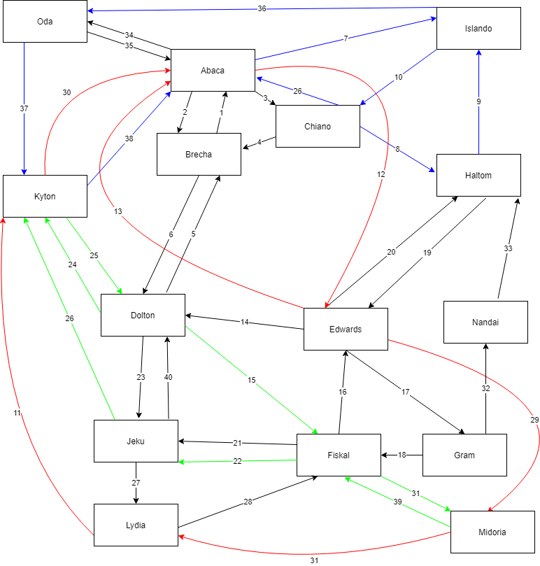

Route ID | Starting location | Destination | Cost | Time (~hours)
1 | Brecha | Abaca | 2 | 2
2 | Abaca | Brecha | 2 | 2
3 | Abaca | Chiano | 1 | 2
4 | Chiano | Brecha | 1 | 2
5 | Dolton | Brecha | 5 | 8
6 | Brecha | Dolton | 5 | 8
7 | Abaca | Islando | 8 | 10
8 | Chiano | Haltom | 6 | 9
9 | Haltom | Islando | 6 | 9
10 | Islando | Chiano | 5 | 7
11 | Lydia | Kyton | 23 | 3
12 | Abaca | Edwards | 20 | 3
13 | Edwards | Abaca | 20 | 3
14 | Edwards | Dolton | 5 | 8
15 | Dolton | Fiskal | 2 | 2
16 | Fiskal | Edwards | 4 | 5
17 | Edwards | Gram | 6 | 7
18 | Gram | Fiskal | 2 | 3
19 | Haltom | Edwards | 8 | 10
20 | Edwards | Haltom | 8 | 10
21 | Fiskal | Jeku | 5 | 8
22 | Fiskal | Jeku | 1 | 1
23 | Dolton | Jeku | 4 | 6
24 | Dolton | Kyton | 2 | 2
25 | Kyton | Dolton | 1 | 1
26 | Jeku | Kyton | 3 | 2
27 | Jeku | Lydia | 2 | 4
28 | Lydia | Fiskal | 6 | 10
29 | Edwards | Midoria | 16 | 2
30 | Kyton | Abaca | 14 | 2
31 | Midoria | Lydia | 18 | 2
32 | Gram | Nandai | 4 | 6
33 | Nandai | Haltom | 4 | 5
34 | Abaca | Oda | 4 | 3
35 | Oda | Abaca | 4 | 3
36 | Islando | Oda | 8 | 12
37 | Oda | Kyton | 4 | 8
38 | Kyton | Abaca | 3 | 6
39 | Midoria | Fiskal | 3 | 2

Text files are also provided for you but here it is color coded to try and make things easier to understand. These are the routes that we (shipping company) have established.
- Note that boats can’t go on land
- planes can’t land anywhere, they need a city with an airport
- trucks have to follow dedicated routes and many times the routes are one way – the truck then having to take another route to get back to their starting point (there are a number of reasons for this in the real world including service stations, toll routes, and typical traffic conditions).
Now that I’ve shown the sample network – I say this again SAMPLE network – you need to realize that your program must work with any kind of network given, so long as the input file(s) match the standard then your program needs to support it. I would suggest starting with a simplified network so that it is easier to output and test things.

Traveling the routes
Each vehicle only works for 1 of the travel methods. We have no hovercrafts and our airplanes cannot drop cargo out in midair for instance. So if a package needs to get from say “Kyton” to “Nandai”, you may need to use several different travel types to get there:
Maybe a train from Kyton->Dolton->Fiskal then truck to Edwards->Gram->Nandai for a total travel time of 21 hours and a cost of 17. There may be other routes from the source to destination and your program may try (emphasis on try) to find the quickest or the most cost effective routes (this will be one of the extra objectives).
Vehicles move 1 step (unit or hour) each loop of the program. So a vehicle moving from Edwards to Gram will take 7 loops. A vehicle may change their path or destination but not while move between 2 points. We would have to wait the full 7 loops and reach Gram (set our location to Gram) before we could then decide to move somewhere else.

Output
Now as we ferry cargo from location to location, we will be recording their cost, so that we can bill the company that wants the cargo sent, and the time it takes. Our program will keep track of the time and the movement of all the cargo and vehicles in the system. Each step (loop) of the program will be 1 unit/hour of time and an output of all the vehicles (including their location and current job) as well as all the active cargo will be given each step.
Vehicles:
Boat - boat1 – traveling from Abaca to Islando – no cargo
Boat – boat2 – arrived at Oda – Cargo1, Cargo2, Cargo3
Truck – truck1 – traveling from Chiano to Brecha – Cargo4
Truck – truck2 – idle (checking for cargo)
…
Cargo (awaiting pickup):
Cargo, Cargo5, Company: Bob’s Stuff, 12 wt
The exact output is left up to you but it should show all the relevant information concerning what each vehicle and cargo are doing in the simlulation.
The program will end once all the cargo in the sample file has gone through our system, the program should end and show a final tally of information including (though you may add to this)
Total number of cargo delivered
Amount of time simulated
Money made for the delivery company
Cost to cargo owners
Bob’s Stuff – $2,102
Al’s Paperclips - $743
….
A breakdown of each transportation method:
Air: Amount of cargo delivered
Amount of money earned,
time idle (not doing anything)
Truck: Amount of cargo delivered
amount of money earned,
time idle (add up all the vehicles or give an average, or percentage)
Ships: …
Trains: …
Obviously, the output will be very useful for debugging our program so take some effort to make it detailed but the exact formatting/wording I will leave up to you. Again, the program should run until there is no more cargo in the system.

Hints:
Some suggested classes include class Site or location, Vehicle, Route, Cargo. Do not go overboard, there doesn’t need to be a truck class and an airplane class, they do the same thing, just make a vehicle that has a type and make the type an enum.
Do not tackle everything at once. Try to make a simple setup with cargo coming in at one site and have 2 or 3 sites that it will go between. Then slowly start to add more to it.
Come up with a simple UML for the classes you decide to have, include what data is being kept by each class and what each class does. Try to make sure you are using the objects to do the work and not all the logic in main. What are the relationships between the classes?
Start early and ask questions!

Submission
For this assignment I want you to submit all the files needed to run your scenario including the .java files and text or data files. Please indicate what your driver class is (what starts your program) by labeling it as shipping_driver_student_name. There are a vast number of requirements and details throughout the program. To ensure that your program is graded correctly comment and label exactly how and where you are completing the requirements. This is a challenging lab, but I am here to help you with it if you can get far enough into it to ask the questions.

Grading
When grading these are the 10 objectives pulled from the lab that I am specifically looking for. Naturally being 10 of them they are ~10% each:
- Implement the findpath algorithm in the lab scenario /
- Read the data in from a file (do not hard-code in the model classes) /
- Move a vehicle from 1 point to another with the findpath /
- Loop the program through time, updating the vehicle and cargo each step of the program (vehicles shouldn’t magically teleport to the cargo to pick it up). /
- Pickup and move cargo from 1 place to another /
- Pickup and move cargo to its destination using multiple route types and vehicles //
- Choose the closest or the best vehicle to go get a new cargo (don't just send all of them there). //
(đúng type, gần, :) chọn best cost nữa?
- If I have cargo but encounter some cargo on my way do I decide to pick it up or not?
(Nó không phải trên đường mà là gần đó, có nên đổi đường không? Chắc t kệ nó quá
- Use weight appropriately, which includes splitting the cargo into multiple loads if it doesn't all fit.

- Output information and data during the simulation (who’s moving where when for what) and after the simulation (final cost values)/

- Other/additional consideration: comments, formatting of the code, etc.

(đi tới điểm tiếp theo thôi)
(request – pickup (hỏi muốn đi đâu) – nếu đi không được thì drop. Được thì đi tiếp
(nó chỉ có next location)

Setdes (next path.get(0) (?)
- can getrouteto

Public void dropoff() (in Cargo)
{
Transport = null
Transport = findClosetVehicle(location, type);
}

Bỏ 2 cái dropoff ở trong cargo với vehicle luôn

