一、爬取的站点列表：

|  |  |  |
| --- | --- | --- |
| **URL** | **网站** | **板块数** |
| bxjg.circ.gov.cn/web/site0/tab5178/ | 保监会 | 2 |
| news.carnoc.com/ | 民航资源网 | 5 |
| http://business.sohu.com/994 | 搜狐财经 | 16 |
| https://zixun.focus.cn/shichang/ | 搜狐焦点 | 6 |
| http://auto.sohu.com/qichexinwen.shtml | 搜狐汽车 | 1 |
| finance.stockstar.com/list/1221.shtml | 证券之星财经 | 9 |
| hk.stockstar.com/ | 证券之星港股 | 4 |
| stock.stockstar.com/ipo/ | 证券之星新股 | 2 |
| stock.stockstar.com/report/ | 证券之星研报 | 4 |
| http://news.cnstock.com/news/sns_jg/index.html | 中国证券网 | 7 |

二、类别列表

|  |  |
| --- | --- |
| 类别编号 | 类别名称 |
| 1 | 宏观经济 |
| 2 | 房地产 |
| 3 | 能源 |
| 4 | 金融服务 |
| 5 | 汽车 |
| 6 | 传统制造业 |
| 7 | 基础设施 |
| 8 | 医药&健康 |
| 9 | 零售 |
| 10 | 文化&传媒 |
| 11 | 矿产 |
| 12 | 钢铁 |
| 13 | 农业 |
| 14 | 旅游 |
| 15 | 通信&IT |
| 16 | 教育&人才 |
| 17 | 贸易&服务 |
| 18 | 战略新兴产业 |
| 19 | 养老产业 |
| 20 | 民营企业 |

三、站点详情

1、列表中的元素分别为站点编号，参考类别，站点链接，网站名称

2、截图为该站点需要爬取的板块（图中用方框标记部分）

3、将每个站点的板块与类别列表中的类别对应。

|  |  |  |  |
| --- | --- | --- | --- |
| 389 | 金融服务 | bxjg.circ.gov.cn/web/site0/tab5178/ | 保监会 |



|  |  |  |  |
| --- | --- | --- | --- |
| 246 | 基础设施 | news.carnoc.com/ | 民航资源网 |

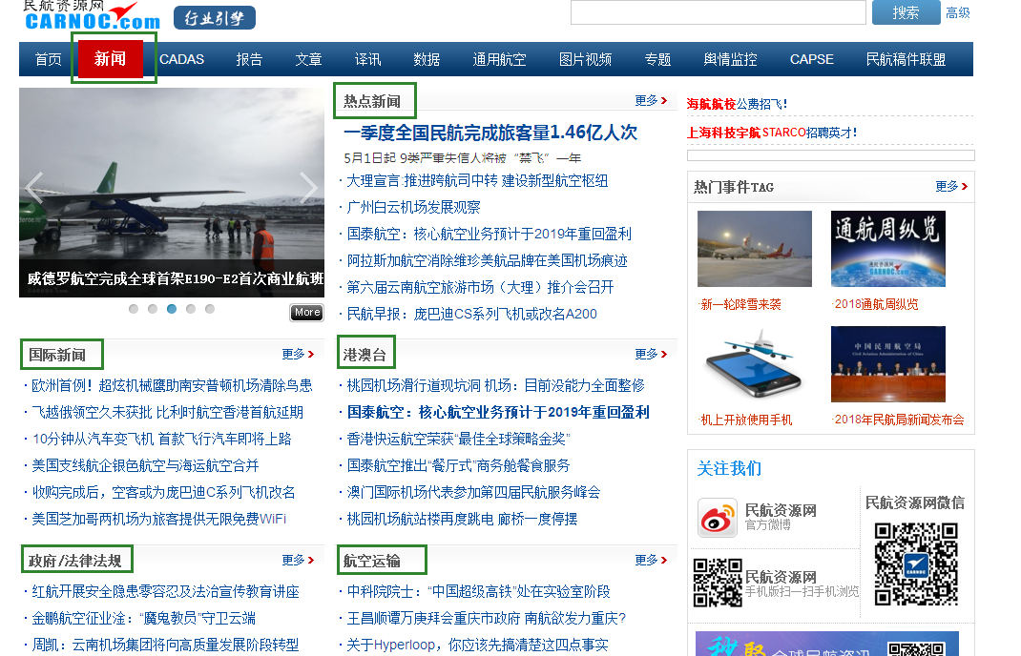

|  |  |  |  |
| --- | --- | --- | --- |
| 29 | 宏观经济 | http://business.sohu.com/994 | 搜狐财经 |
| 30 | 金融服务 | http://business.sohu.com/994 | 搜狐财经 |
| 31 | 民营企业 | http://business.sohu.com/994 | 搜狐财经 |

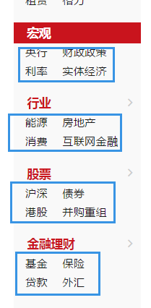

|  |  |  |  |
| --- | --- | --- | --- |
| 261 | 旅游 | https://zixun.focus.cn/shichang/ | 搜狐焦点 |

请注意：网站选择全国站，不要切换城市

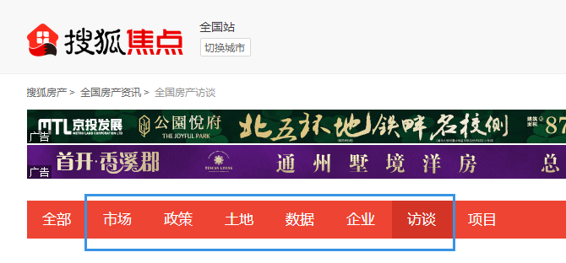

|  |  |  |  |
| --- | --- | --- | --- |
| 14 | 汽车 | http://auto.sohu.com/qichexinwen.shtml | 搜狐汽车 |



|  |  |  |  |
| --- | --- | --- | --- |
| 352 | 农业 | finance.stockstar.com/list/1221.shtml | 证券之星财经 |



|  |  |  |  |
| --- | --- | --- | --- |
| 351 | 战略新兴产业 | stock.stockstar.com/report/ | 证券之星研报 |



|  |  |  |  |
| --- | --- | --- | --- |
| 350 | 民营企业 | hk.stockstar.com/ | 证券之星港股 |



|  |  |  |  |
| --- | --- | --- | --- |
| 349 | 金融服务 | stock.stockstar.com/ipo/ | 证券之星新股 |

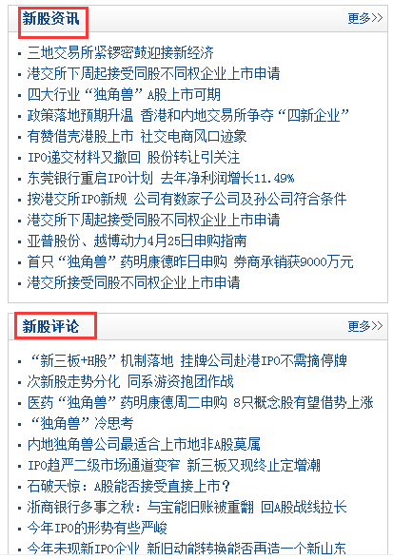

|  |  |  |  |
| --- | --- | --- | --- |
| 257 | 战略新兴产业 | http://news.cnstock.com/news/sns_jg/index.html | 中国证券网 |

