brief2net
The AI-Augmented Network Builder, explained for complete beginners

A plain-English guide to what the prototype is, why it exists, how to run it, and what it can and cannot do yet.
Prototype version 0.1.0 · 6 October 2026 · Olanrewaju Adams Agunloye

If you only read one box, read this one
Houdini is software that film and games artists use to build 3D things out of connected building blocks called nodes.
Wiring those blocks together by hand takes skill and time. brief2net lets you type a sentence such as “a tower with 30 floors that twists 3 degrees per floor”, and it writes a script that builds the node network for you inside Houdini.
It does not make a finished picture. It makes the editable machinery, with a few labelled knobs at the top, and then hands control back to the artist.

Contents
1. The big idea in one minute
2. Words you will meet
3. How it works, step by step
4. Try it yourself (no Houdini needed)
5. Using the result in Houdini
6. Reading what it gives you
7. Writing a good brief
8. What it can and cannot do today
9. How this maps to the PhD project
10. When something goes wrong
11. Where everything lives

1. The big idea in one minute
Think of a kitchen. A finished cake is the result. A recipe is the set of steps that produces the cake. If you keep the recipe, you can bake a bigger cake, a less sweet cake, or a chocolate version tomorrow without starting from scratch.
Houdini works the same way. Instead of sculpting a rock by hand, an artist builds a recipe for rocks: “start with a sphere, make it lumpy, copy it onto 500 random points on some hills.” In Houdini that recipe is a node network: boxes (nodes) joined by wires.
Building those recipes is skilled, repetitive work. brief2net drafts the recipe for you from a short written request (a brief). The artist then tastes it, adjusts the seasoning (the controls), and changes any step they like.

What brief2net is NOT
It is not an image generator. You will not get a picture out of it.
It does not replace the artist. Every decision it makes is written down so a person can check and overrule it.
It is not finished. This is an early research prototype for a PhD project (see Section 9).

2. Words you will meet
Word | Plain meaning
Houdini | 3D software by SideFX, used in film, games and visual effects. Free “Apprentice” edition exists for learning.
Procedural | Made by a set of rules rather than by hand, so you can change a rule and everything updates.
Node | One building block that does one job, e.g. “make a box” or “add noise”.
Network | Nodes joined by wires. Data flows from the top to the bottom.
SOP | Surface Operator — Houdini’s name for the nodes that make and change shapes.
Parameter (parm) | A setting on a node, like a box’s width. Has a name such as sizex.
Artist control | A parameter brief2net lifts to the top so you can change the whole network from one place.
Brief | Your one- or two-sentence description of what you want.
Recipe | A tested network pattern brief2net knows how to make (four exist today).
Spec | The drafted plan, saved as a readable text file (.spec.json) before anything is built.
Validator | The checker. It refuses to build a plan that has mistakes in it.
Build script | A Python file that, when run inside Houdini, creates the network.
Mock Houdini | A pretend Houdini used for testing on computers without Houdini installed.
Technical artist | The person who builds these tools for other artists. The intended user.

3. How it works, step by step
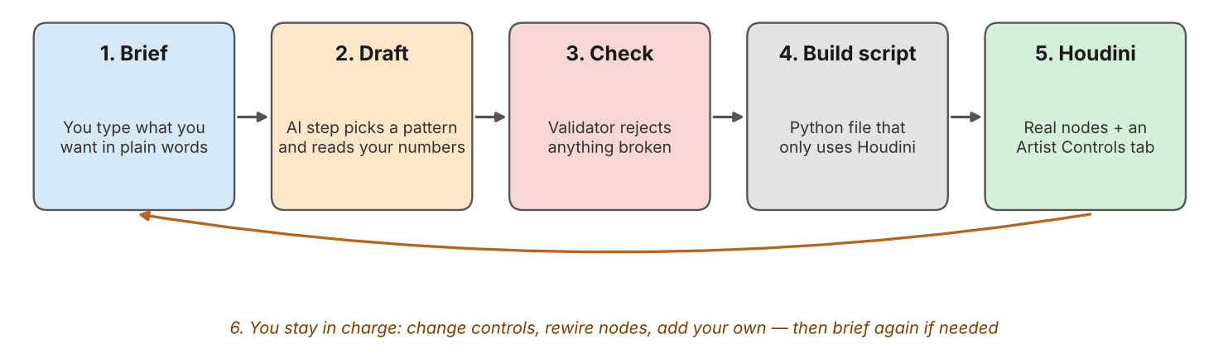
Figure 1. The five steps, and the loop back to the artist
- Brief. You type what you want, e.g. “a dense field of jagged rocks across hilly terrain, about 800 rocks”.
- Draft. The drafter decides which recipe fits (here: scatter objects on terrain), pulls numbers out of your sentence (800 rocks) and interprets describing words (“hilly” doubles hill height). Every guess is written into a list called assumptions.
- Check. The validator inspects the plan: are all node types real, do the settings exist, is anything wired twice, are there loops, does every control actually do something? Any error stops the process.
- Build script. A Python file is written that uses only Houdini’s own commands. You can open it in a text editor and read it.
- Houdini. Running the script creates normal Houdini nodes, an Artist Controls tab at the top, a comment on each node explaining its job, and a sticky note with your brief. One Ctrl+Z undoes the whole thing.

Why the “Check” step matters
AI systems can produce things that look right but are wrong. If a drafted plan names a setting that does not exist, Houdini might fail halfway, or worse, quietly ignore it. The validator makes those mistakes loud and early, before anything touches your Houdini scene.

4. Try it yourself (no Houdini needed)

4.1 What you need
- A computer with Python 3.9 or newer (free from python.org). On Windows, tick “Add Python to PATH” when installing.
- The brief2net folder from the zip file, unzipped anywhere.
- One add-on for drawing pictures. Open a terminal in the folder and type: pip install -r requirements.txt

4.2 The easiest way
- Windows: double-click start_here_windows.bat.
- Mac or Linux: open a terminal in the folder and type sh start_here_mac_linux.sh.
It lists what it can make, then asks for your brief. Press Enter with nothing typed to use an example. You will see five short sections appear:
── 2. Draft (rule-based baseline) ─────────────────────
Recipe: Scatter objects on terrain confidence: high
• Read '800 rocks' as instance_count = 800.
• 'hilly' -> terrain_height x2.0 (now 12).
── 3. Check ───────────────────────────────────────────
Validation: PASS (0 error(s), 4 warning(s))
── 4. Build script + evaluation ───────────────────────
Builds in mock Houdini yes
Controls proven live (perturbation test) 5/5

4.3 Other commands
Type this | What happens
python main.py demo | Runs four example briefs and saves everything in output/demo.
python main.py build "a fence with 20 posts" | Builds from your own brief.
python main.py recipes | Lists the four things it knows how to make, and their controls.
python main.py check FILE_build.py | Test-runs any build script in mock Houdini.
python -m unittest discover -s tests | Runs the 27 automatic tests. All should say OK.

5. Using the result in Houdini
- Open Houdini (the free Apprentice edition is fine for learning).
- From the top menu choose Windows → Python Shell.
- Type the line brief2net printed at the end, for example:
exec(open(r'C:/Users/you/brief2net/output/stacked_tower_build.py').read())
- Go to the /obj level. A new Geometry node has appeared. Double-click into it to see the network.
- Click the Geometry node itself and look at the Parameters pane. The Artist Controls tab holds the knobs. Drag “Floors” from 30 to 50 and the tower grows.
Alternatively, install houdini/brief2net_shelf_tool.py as a shelf button: you click it, a box asks for your brief, and it builds straight away.

Important — not yet tried in real Houdini
Every test so far used the pretend (mock) Houdini. The node and setting names were written from documentation, not read from a live copy of Houdini, and four of them are marked medium-confidence. Before trusting a result, run houdini/harvest_catalogue.py once inside Houdini. It checks every name against your version and tells you exactly what differs.

6. Reading what it gives you
Each run saves four files with the same starting name:
File | What it is for
name.spec.json | The plan in readable text. You can edit it by hand and rebuild from it.
name_build.py | The script you run inside Houdini. Its top lists the brief and every assumption.
name_preview.png | A diagram of the network so you can inspect it before opening Houdini.
name_report.md | The evaluation numbers and a table of the artist controls.

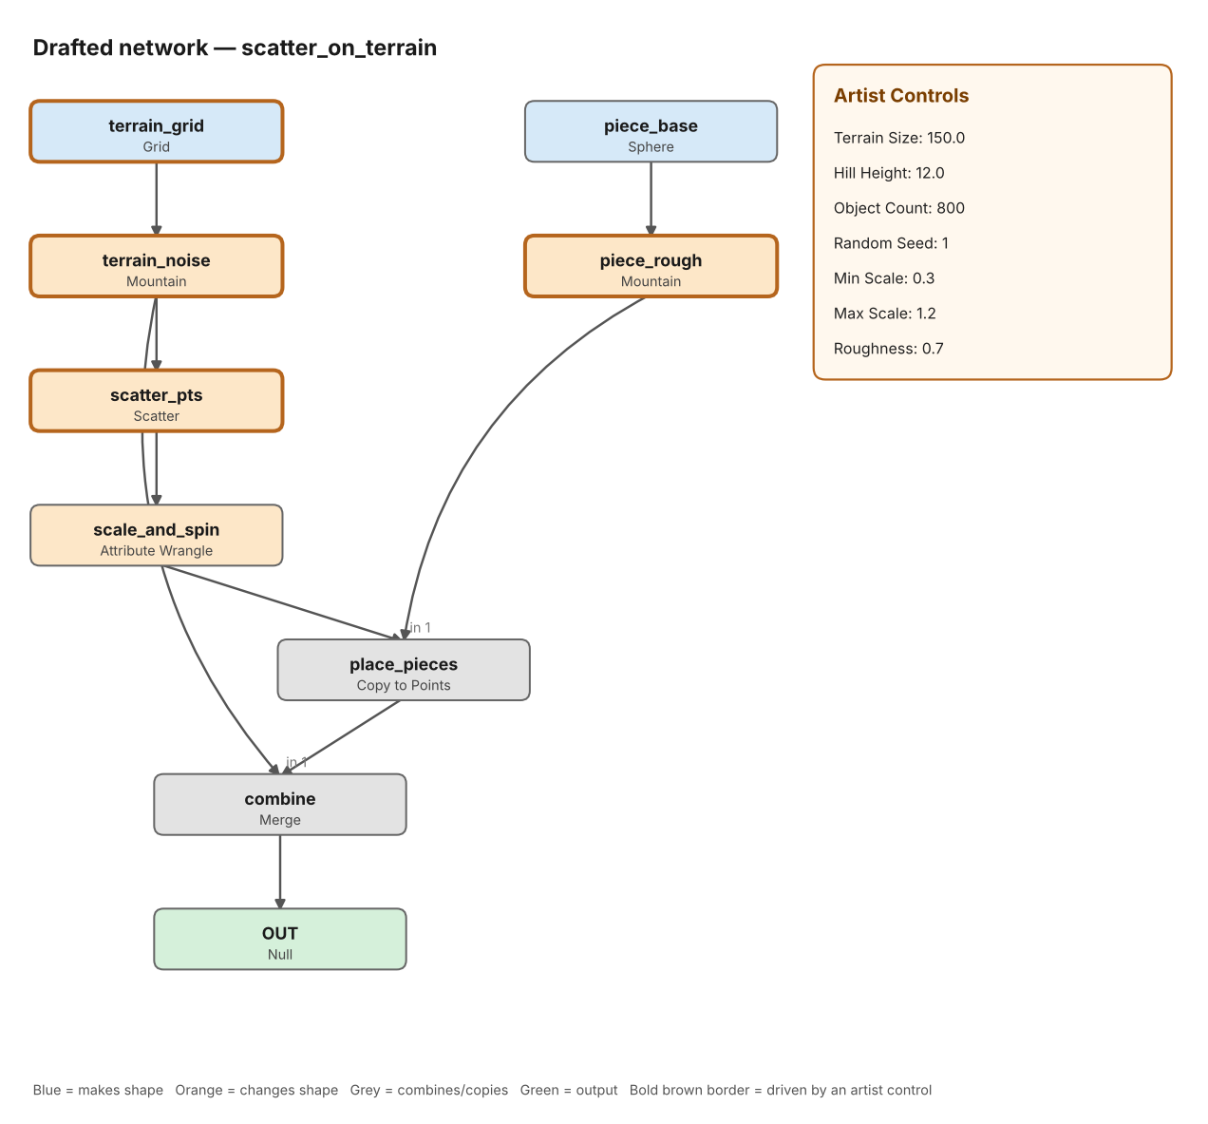
Figure 2. Preview for the rocks-on-terrain brief: two branches (ground and rock) meet at Copy to Points
How to read the preview: blue boxes create shapes, orange boxes change them, grey boxes combine or copy, and green is the final output. A thick brown border means one of the artist controls is driving that node. The panel on the right shows the controls and their starting values.
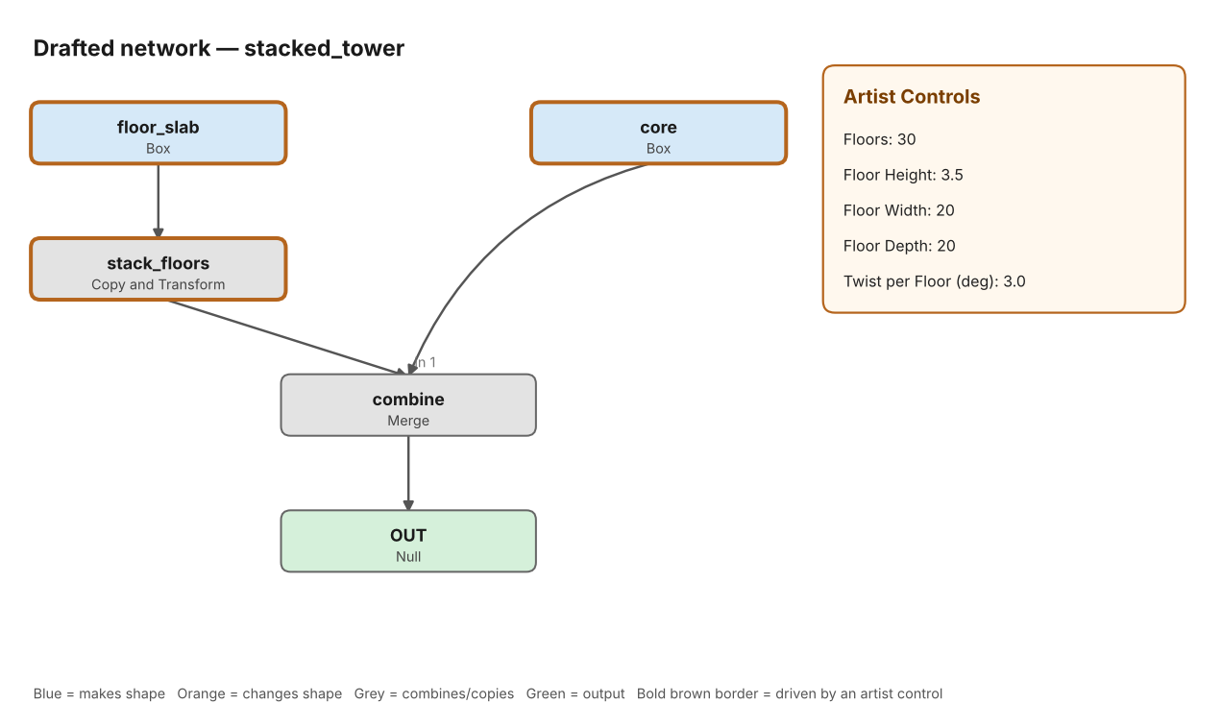
Figure 3. Preview for the tower brief: one floor plate is repeated upward and merged with a core

6.1 The evaluation numbers, explained
Line in the report | What it means
Builds in mock Houdini | The script ran from start to finish without an error.
Native operators | Share of nodes that are standard Houdini nodes. Always 100% by design, so any Houdini user can edit them.
Nodes with an explanatory comment | Share of nodes that carry a note saying why they are there.
Parameters linked to controls | How many settings follow the artist controls rather than being fixed numbers.
Controls proven live | Each control is nudged by 10% and the tool checks that something in the network changes. A control that changes nothing is a broken promise.
Controls read inside VEX | Controls used in a small code node. These can only be fully checked in real Houdini.

7. Writing a good brief
Helps | Does not help (yet)
Name the subject: rocks, tower, fence, asteroid | Moods and feelings: “melancholy”, “epic”
Give numbers with nouns: “40 floors”, “600 rocks” | Numbers without nouns: “make it 40”
Use simple describing words: dense, sparse, tall, low, jagged, smooth, craggy, large | Long stories or several objects in one brief
Mention a colour for the asteroid: rust, icy, grey | References to films or other artists’ work

If your brief matches nothing it knows, brief2net says so and stops, rather than guessing. You can force a recipe: python main.py build "my words" --recipe fence.

8. What it can and cannot do today
Can do | Cannot do yet
Draft four kinds of network: scatter on terrain, stacked tower, fence, organic blob | Invent a brand-new kind of network it has no recipe for
Read numbers and simple describing words | Understand sketches, reference images or complex language
Refuse broken plans with a clear reason | Prove the final shape looks good (mock Houdini does not compute geometry)
Write a standalone, readable Houdini script with artist controls | Run in real Houdini — not yet tested there
Call a large language model (optional, needs an API key) | Guarantee the language-model path works — it is written but untested

Is the default drafter really “AI”?
Honestly, not in the machine-learning sense. The default drafter is a transparent rule-based baseline: it scores your words against keyword lists and reads numbers with simple patterns. That is deliberate. It makes the whole pipeline testable today and gives future AI methods (language models, image models, inverse procedural modelling, Bayesian optimisation) a fair, measurable baseline to beat.

9. How this maps to the PhD project
The project asks how AI can help technical artists build procedural networks they can still inspect, edit and extend. The prototype is a first, honest step on each of its three objectives.
Objective | What exists now | What comes next
1. Investigate AI-augmented authoring | Typed plan (spec) between AI and Houdini; validator gate; LLM drafter with validator-driven repair | Compare LLM, vision-language and inverse-procedural drafters against the rule baseline on a shared brief set
2. Build a working network builder | Standalone build scripts, native nodes only, Artist Controls tab, undo group, comments, shelf tool | Verify in real Houdini; grow the recipe and operator catalogue; Bayesian optimisation to tune controls toward a reference
3. Evaluate technical and creative use | Automatic technical checks: builds, native ratio, live-control test, 27 unit tests | Studies with technical artists on editability, creative control and agency; real cook-time checks

The approach is not tied to Houdini. The plan file and validator are general; only the build-script writer is Houdini-specific, so the same idea could target other node-based tools later.

10. When something goes wrong
What you see | What to do
“python is not recognised” | Python is not installed or not on PATH. Reinstall from python.org and tick “Add Python to PATH”.
“No module named matplotlib” | Run pip install -r requirements.txt in the brief2net folder.
“does not match any recipe I know” | Name the subject more plainly, or add --recipe with one of the four names.
“Validation: FAIL” | The plan had a mistake, so nothing was built. The lines starting ERROR say what.
In Houdini: AttributeError on .set or .setExpression | A setting name differs in your Houdini version. Run houdini/harvest_catalogue.py and rebuild.
In Houdini: “Invalid node type name” | That node type is named differently in your version. The harvester will list it.
You do not like the result | That is expected. Change the controls, rewire nodes, or edit the .spec.json and rebuild.

11. Where everything lives
Path | Job
main.py | Front door. Run with no words for the guided mode.
brief2net/drafter.py | Turns your brief into a plan, recording assumptions.
brief2net/recipes.py | The four tested network patterns.
brief2net/catalogue.py | The list of allowed Houdini nodes and their settings.
brief2net/validator.py | The checker that blocks broken plans.
brief2net/codegen.py | Writes the Houdini build script.
brief2net/mock_hou.py | Pretend Houdini for testing.
brief2net/evaluate.py | Works out the evaluation numbers.
brief2net/llm_drafter.py | Optional language-model drafter (untested).
houdini/ | Shelf tool and the catalogue checker to run inside Houdini.
tests/ | 27 automatic tests.

