DAILY ONLINE ACTIVITIES SUMMARY

Date: | 10-07-2020 |  |  |  |  | Name: | LANSON PEREIRA
Sem & Sec | 4th& A |  |  |  |  | USN: | 4AL18CS040
Online Test Summary
Subject |  | Object Oriented Concepts
Max. Marks |  | N\A |  | Score |  |  | N\A
Certification Course Summary
Course | Introduction to Blockchain: Quick Guide Exploring Blockchain
Certificate Provider |  |  | BitDegree |  | Duration |  |  | 4 HOURS
Coding Challenges
Problem Statement:
1.Given the participants' score sheet for your University Sports Day, you are required to find the runner-up score. You are given scores. Store them in a list and find the score of the runner-up.
Status: executed
Uploaded the report in Github |  |  |  |  | YES
If yes Repository name |  |  |  |  | - https://github.com/lansonlp/Lockdown-Coding  - https://github.com/lansonlp/Lockdown-Certification-Course
Uploaded the report in slack |  |  |  |  | YES

Descriptive Test Details:
The test was from module 1 of OOC. There were 3 questions given to us to write within 45 minutes. We had to scan the answers that we have written in A4 sheets and make it as a pdf and submit it in Google classroom.

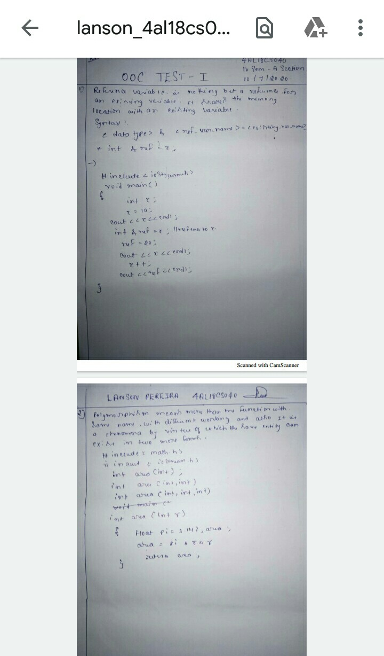

Online Certification Course Summary:
I have opted my Online Certification Course In BitDegree. The course which i have opted is Introduction to Blockchain: Quick Guide Exploring Blockchain
The following topics were coverd in this course
- Blockchain Types
- Public
- Private

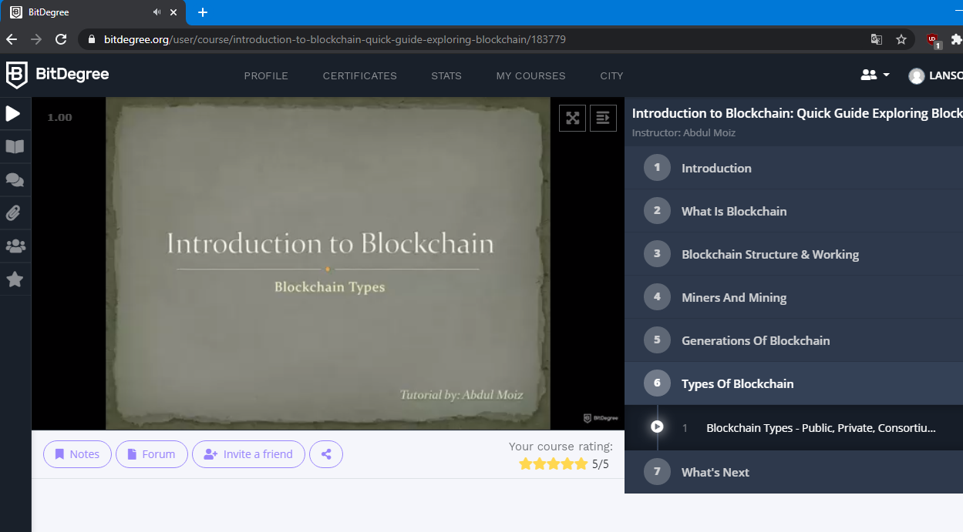

- Given the participants' score sheet for your University Sports Day, you are required to find the runner-up score. You are given scores. Store them in a list and find the score of the runner-up

