DAILY ONLINE ACTIVITIES SUMMARY
Date: | 30-06-2020 |  |  |  |  | Name: | LANSON PEREIRA
Sem & Sec | 4th& A |  |  |  |  | USN: | 4AL18CS040
Online Test Summary
Subject |  | N\A
Max. Marks |  | N\A |  | Score |  |  | N\A
Certification Course Summary
Course | Learn JavaScript Quick Course for Beginners
Certificate Provider |  |  | BitDegree |  | Duration |  |  | 4 HOURS
Coding Challenges
Problem Statement:
1. Write a C++ program to move all the zeros to the end of the array.
Status: executed
Uploaded the report in Github |  |  |  |  | YES
If yes Repository name |  |  |  |  | - https://github.com/lansonlp/Lockdown-Coding  - https://github.com/lansonlp/Lockdown-Certification-Course
Uploaded the report in slack |  |  |  |  | YES

Online Certification Course Summary:
I have opted my Online Certification Course In BitDegree. The course which i have opted is Learn JavaScript Quick Course for Beginners
The following topics were coverd in this course
- JavaScript DOM Interaction
- JavaScript Project Part 1 & Part 2

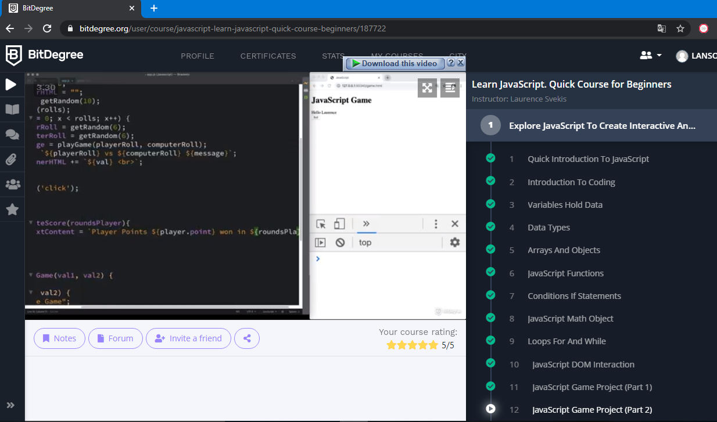

Certificate :

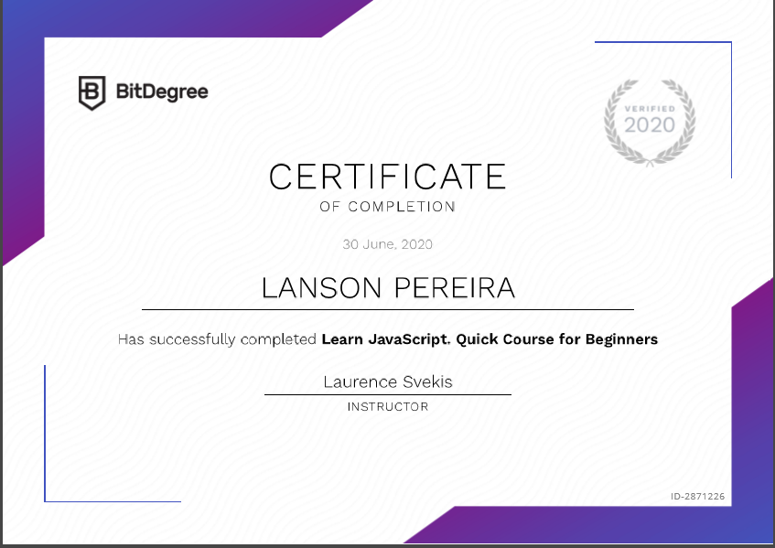

- Write a C++ program to move all the zeros to the end of the array.

