DAILY ONLINE ACTIVITIES SUMMARY
Date: | 01-06-2020 |  |  |  |  | Name: | LANSON PEREIRA
Sem & Sec | 4th& A |  |  |  |  | USN: | 4AL18CS040
Online Test Summary
Subject |  | Complex analysis, probability and statistical methods
Max. Marks |  | 30 |  | Score |  |  | 23
Certification Course Summary
Course | WordPress for Beginners - Learn How to Create a Blog
Certificate Provider |  |  | BitDegree |  | Duration |  |  | 48 HOURS
Coding Challenges
Problem Statement:
1 .Write a program to find sub arrays.
2.Write a C program to find the leaders in the array.

Status: executed
Uploaded the report in Github |  |  |  |  | YES
If yes Repository name |  |  |  |  | - https://github.com/lansonlp/Lockdown-Coding  - https://github.com/lansonlp/Lockdown-Certification-Course
Uploaded the report in slack |  |  |  |  | YES

Online Test Details :
The online test was from module 5 which was about joint probability distribution and sampling theory. There were 20 questions where 10 was for 1 mark each and the remaining 10 for 2 marks each and the duration was 45 minutes. The questions were optimal and were easy. The score that I got in the test is 23/30.

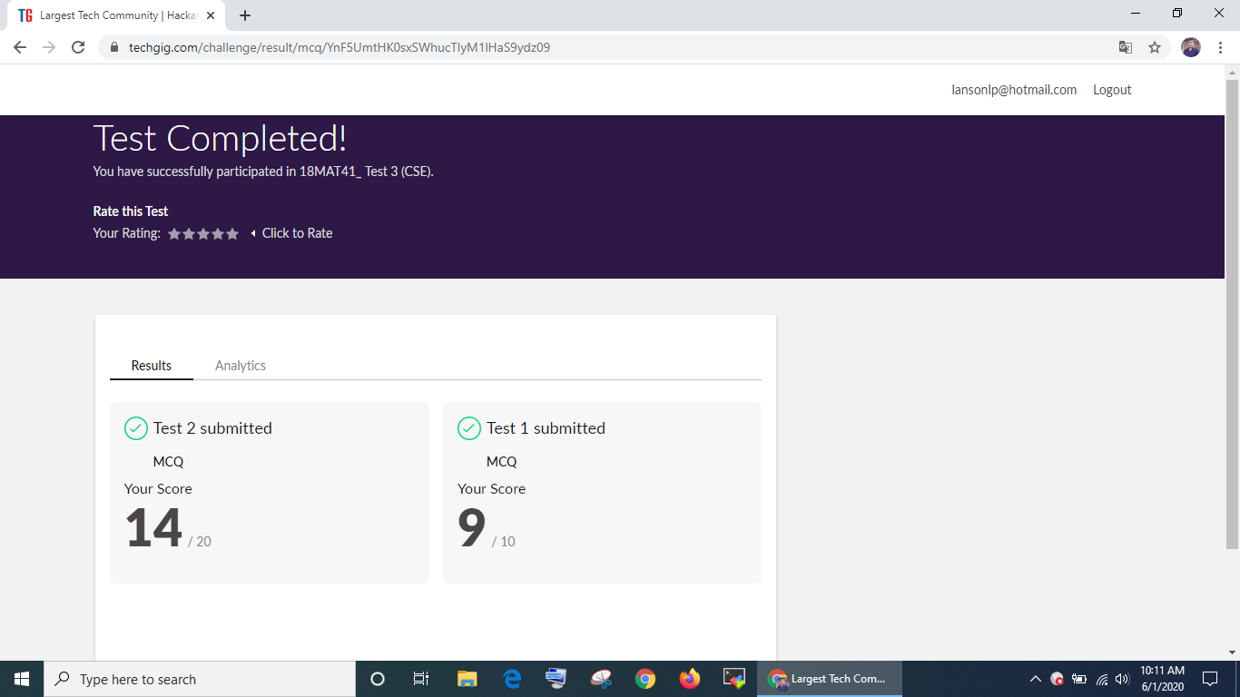

Online Certification Course Summary:

I have opted my Online Certification Course In BitDegree. The course which i have opted is WordPress for Beginners - Learn How to Create a Blog.

WordPress is a free and open-source content management system written in PHP and paired with a MySQL or MariaDB database. Features include a plugin architecture and a template system, referred to within WordPress as Themes.

Course Description

WordPress can be used to create a traditional blogging site; however, it can also be used to create a standard website for business or personal use. This course focuses on creating websites using WordPress.

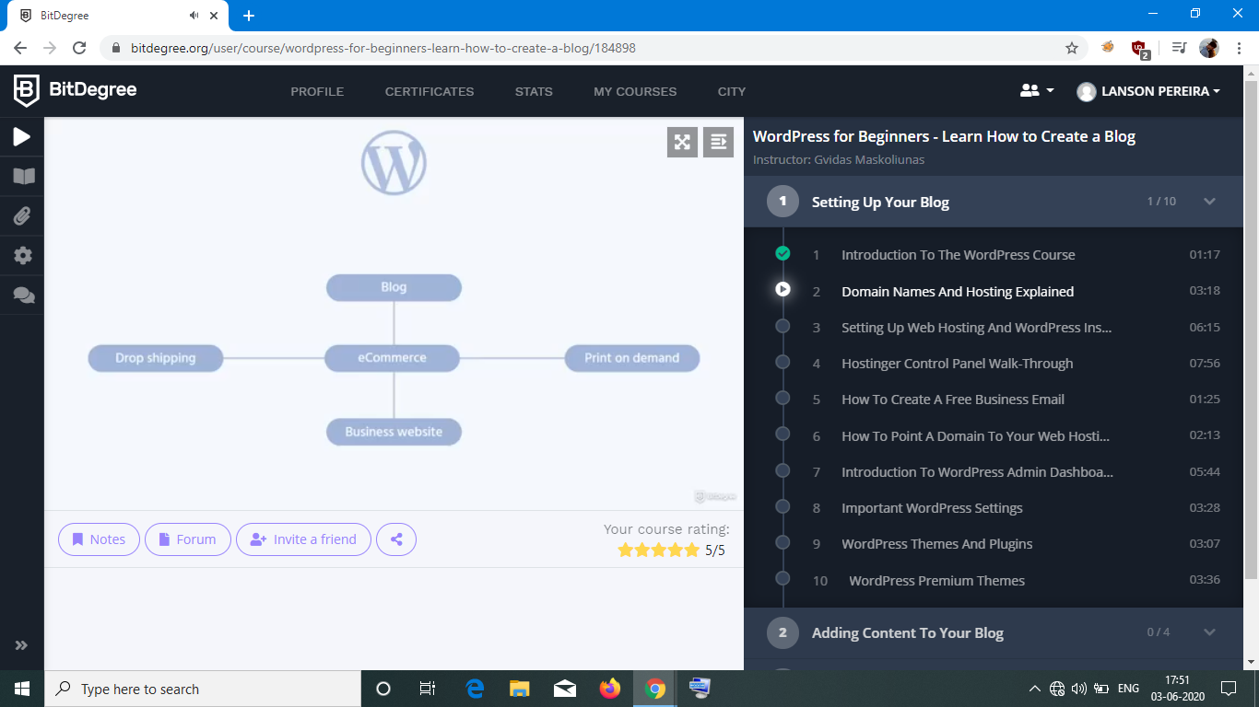
1 .Write a program to find sub arrays.

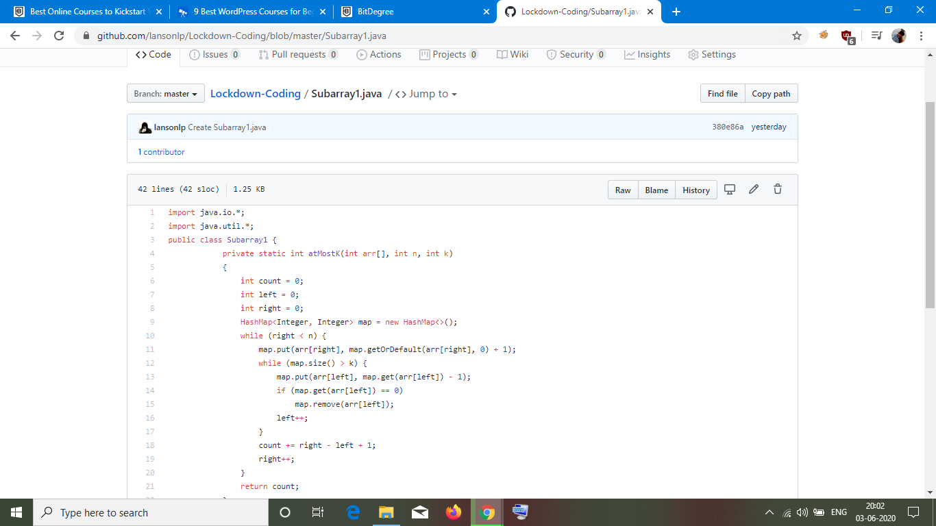

2. Write a C program to find the leaders in the array.

