DAILY ONLINE ACTIVITIES SUMMARY
Date: | 02-06-2020 |  |  |  |  | Name: | LANSON PEREIRA
Sem & Sec | 4th& A |  |  |  |  | USN: | 4AL18CS040
Online Test Summary
Subject |  | N/A
Max. Marks |  | N/A |  | Score |  |  | N/A
Certification Course Summary
Course | WordPress for Beginners - Learn How to Create a Blog
Certificate Provider |  |  | BitDegree |  | Duration |  |  | 48 HOURS
Coding Challenges
Problem Statement
1. Program to represent input mismatch exception
2. Perfect sum problem
Status: executed
Uploaded the report in Github |  |  |  |  | YES
If yes Repository name |  |  |  |  | - https://github.com/lansonlp/Lockdown-Coding  - https://github.com/lansonlp/Lockdown-Certification-Course
Uploaded the report in slack |  |  |  |  | YES

Online Certification Course Summary:

I have opted my Online Certification Course In BitDegree. The course which i have opted is WordPress for Beginners - Learn How to Create a Blog.

WordPress is a free and open-source content management system written in PHP and paired with a MySQL or MariaDB database. Features include a plugin architecture and a template system, referred to within WordPress as Themes.

Course Description

WordPress can be used to create a traditional blogging site; however, it can also be used to create a standard website for business or personal use. This course focuses on creating websites using WordPress.

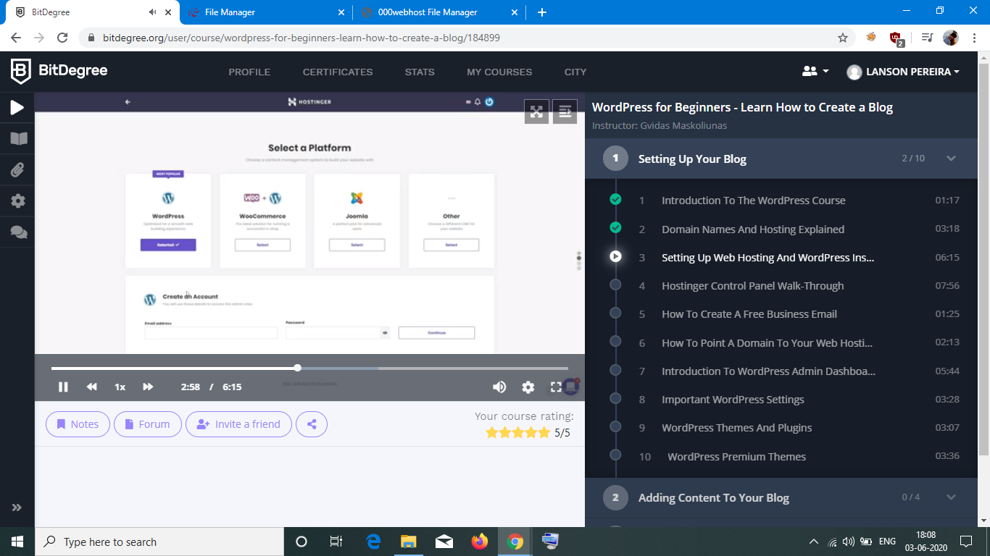

1. Program to represent input mismatch exception

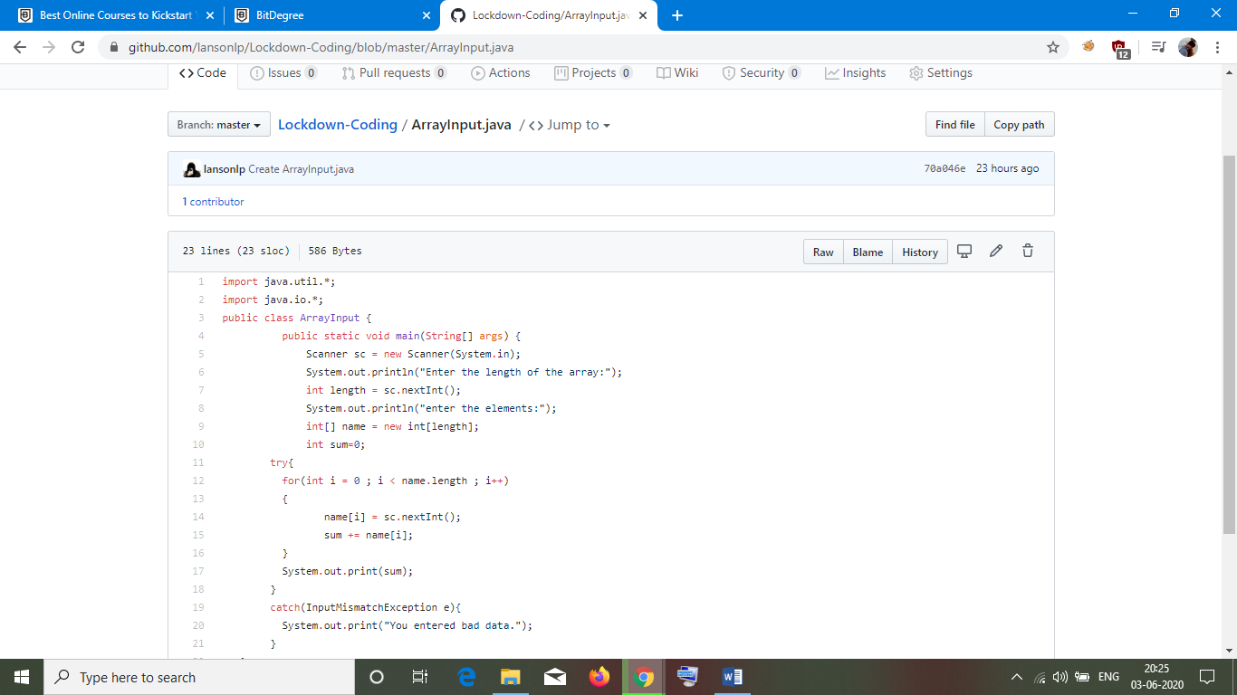
2. Perfect sum problem
