DAILY ONLINE ACTIVITIES SUMMARY
Date: | 03-06-2020 |  |  |  |  | Name: | LANSON PEREIRA
Sem & Sec | 4th& A |  |  |  |  | USN: | 4AL18CS040
Online Test Summary
Subject |  | Object Oriented Concepts
Max. Marks |  | 30 |  | Score |  |  | 22
Certification Course Summary
Course | WordPress for Beginners - Learn How to Create a Blog
Certificate Provider |  |  | BitDegree |  | Duration |  |  | 48 HOURS
Coding Challenges
Problem Statement : 1. program to find Last Digit of a^b
2. Largest of two possible digit swaps
Status: executed
Uploaded the report in Github |  |  |  |  | YES
If yes Repository name |  |  |  |  | - https://github.com/lansonlp/Lockdown-Coding  - https://github.com/lansonlp/Lockdown-Certification-Course
Uploaded the report in slack |  |  |  |  | YES

Online Test Details :
The online test was from module 2 and 3 which was about introduction to java, classes, inheritance and exception handling. There were 30 questions and the duration was 45 minutes. The questions were optimal and were easy. The score that I got in the test is 22/30.

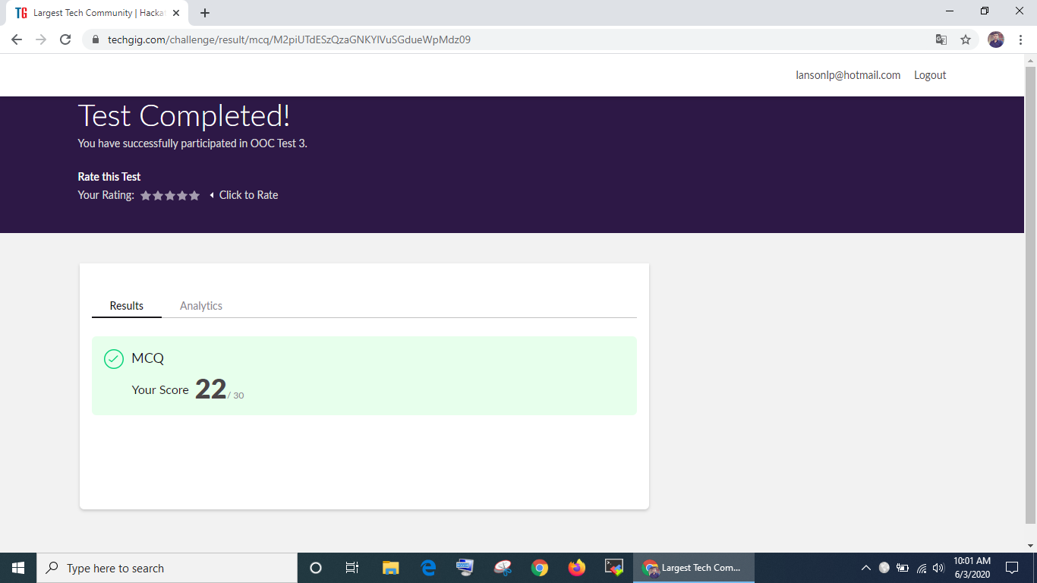

Online Certification Course Summary:

I have opted my Online Certification Course In BitDegree. The course which i have opted is WordPress for Beginners - Learn How to Create a Blog.

WordPress is a free and open-source content management system written in PHP and paired with a MySQL or MariaDB database. Features include a plugin architecture and a template system, referred to within WordPress as Themes.

Course Description

WordPress can be used to create a traditional blogging site; however, it can also be used to create a standard website for business or personal use. This course focuses on creating websites using WordPress.

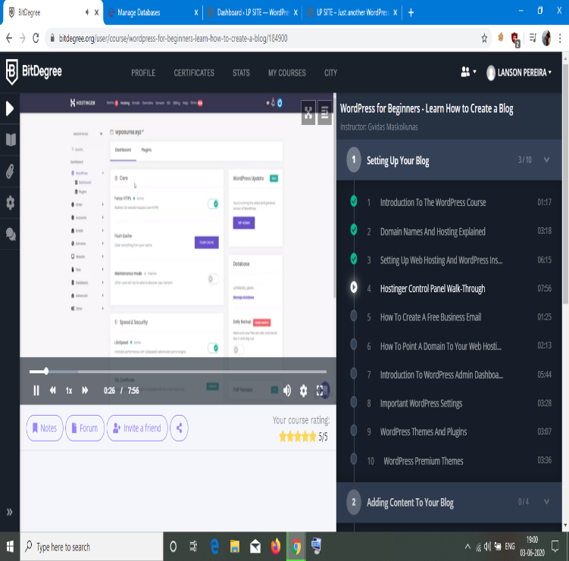
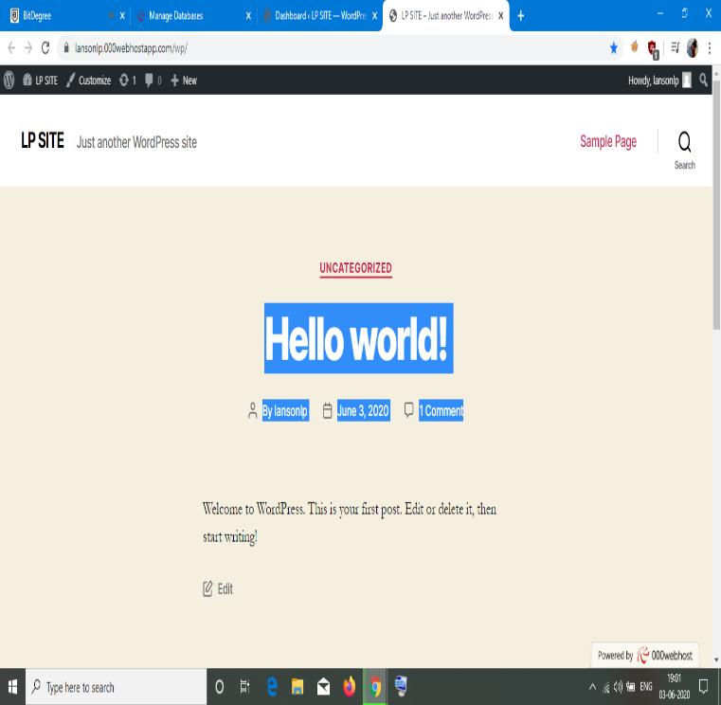

1. Program to find Last Digit of a^b

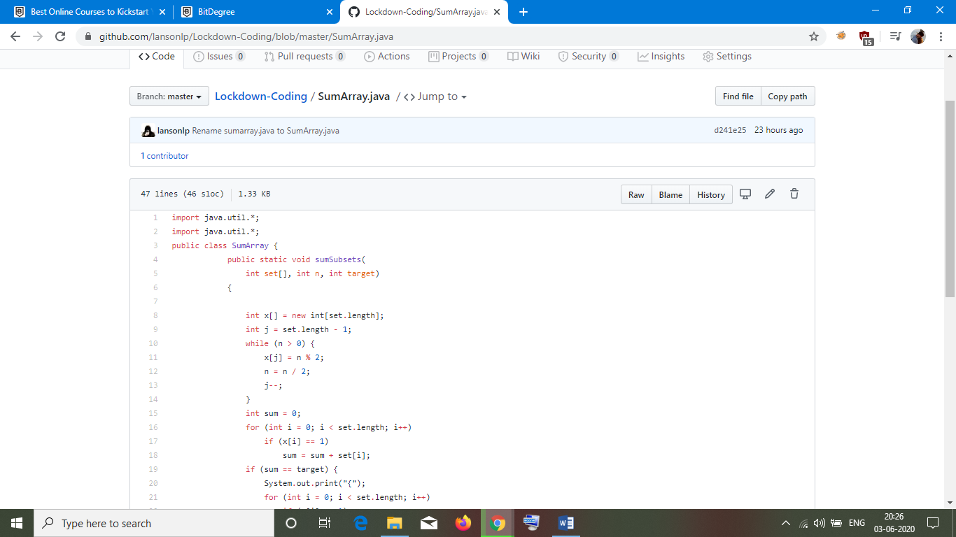

2. Largest of two possible digit swaps

