DAILY ONLINE ACTIVITIES SUMMARY
Date: | 05-06-2020 |  |  |  |  | Name: | LANSON PEREIRA
Sem & Sec | 4th& A |  |  |  |  | USN: | 4AL18CS040
Online Test Summary
Subject |  | N/A
Max. Marks |  | N/A |  | Score |  |  | N/A
Certification Course Summary
Course | WordPress for Beginners - Learn How to Create a Blog
Certificate Provider |  |  | BitDegree |  | Duration |  |  | 48 HOURS
Coding Challenges
Problem Statement:
1.Monk and Power time(from hackerearth)
2.Disk tower (from hackerearth)
Status: executed
Uploaded the report in Github |  |  |  |  | YES
If yes Repository name |  |  |  |  | - https://github.com/lansonlp/Lockdown-Coding  - https://github.com/lansonlp/Lockdown-Certification-Course
Uploaded the report in slack |  |  |  |  | YES

Online Certification Course Summary:

I have opted my Online Certification Course In BitDegree. The course which i have opted is WordPress for Beginners - Learn How to Create a Blog.

WordPress is a free and open-source content management system written in PHP and paired with a MySQL or MariaDB database. Features include a plugin architecture and a template system, referred to within WordPress as Themes.

Introduction to WordPress admin dashboard

Important WordPress settings

WordPress themes and plugins

WordPress premium themes

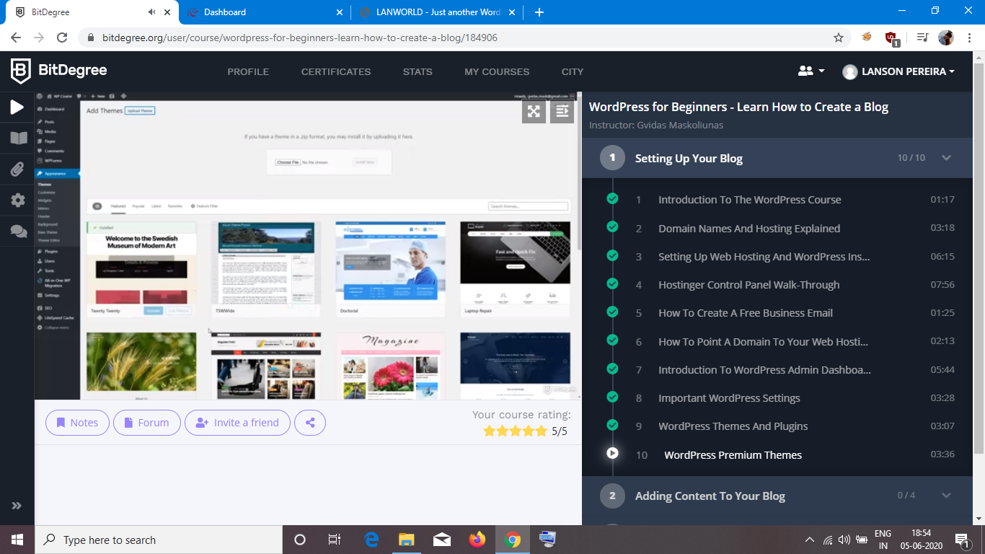

Monk and Power time(from hackerearth)
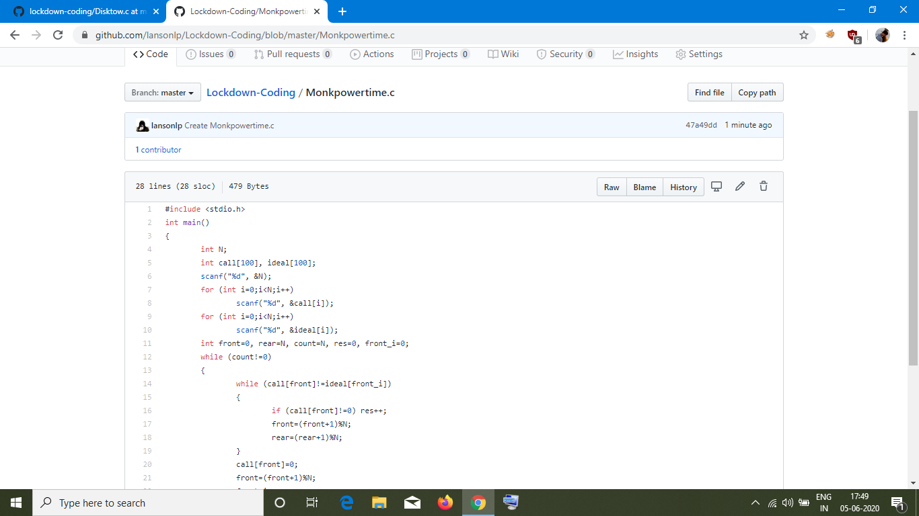
2.Disk tower (from hackerearth)
