DAILY ONLINE ACTIVITIES SUMMARY
Date: | 18-05-2020 |  |  |  |  | Name: | LANSON PEREIRA
Sem & Sec | 4th& A |  |  |  |  | USN: | 4AL18CS040
Online Test Summary
Subject |  | COMPLEX ANALYSIS,PROBABILITY AND STASTICAL METHOD
Max. Marks |  | 30 |  | Score |  |  | -
Certification Course Summary
Course | Introducing Coding for Beginners: an HTML and CSS Online Course
Certificate Provider |  |  | BitDegree |  | Duration |  |  | 60 HOURS
Coding Challenges
Challenges Problem Statement 1: Given array of distinct integers. The task is to count all the triplets such that the sum of two elements equals to the third element Problem Statement
2: Write a C program to check whether the two strings are anagram or not

Status: executed
Uploaded the report in Github |  |  |  |  | YES
If yes Repository name |  |  |  |  | - https://github.com/lansonlp/Lockdown-Coding  - https://github.com/lansonlp/Lockdown-Certification-Course
Uploaded the report in slack |  |  |  |  | YES

Online Test summary:18MAT21 test was scheduled from 9:30 am to 10 am And the syllabus IA test was 4TH module there were 30 questions and the time limit for the test is 30minutes the question were MCQ type ..

Snapshot: not taken

Online Certification Course Summary: I have opted my Online Certification Course In BitDegree the course which i have opted is Introducing Coding for Beginners: an HTML and CSS Online Course..

This course covers the following topics :
Basic web development
Creating forms, buttons, and other elements
HTML coding basics
CSS basics

Description :

A Fun Way to Get Familiar With Coding for Beginners.

Master HTML and CSS basics Step-by-Step.

Lecture 1 & 2 : HTML Document Structure , Headings and paragraphs

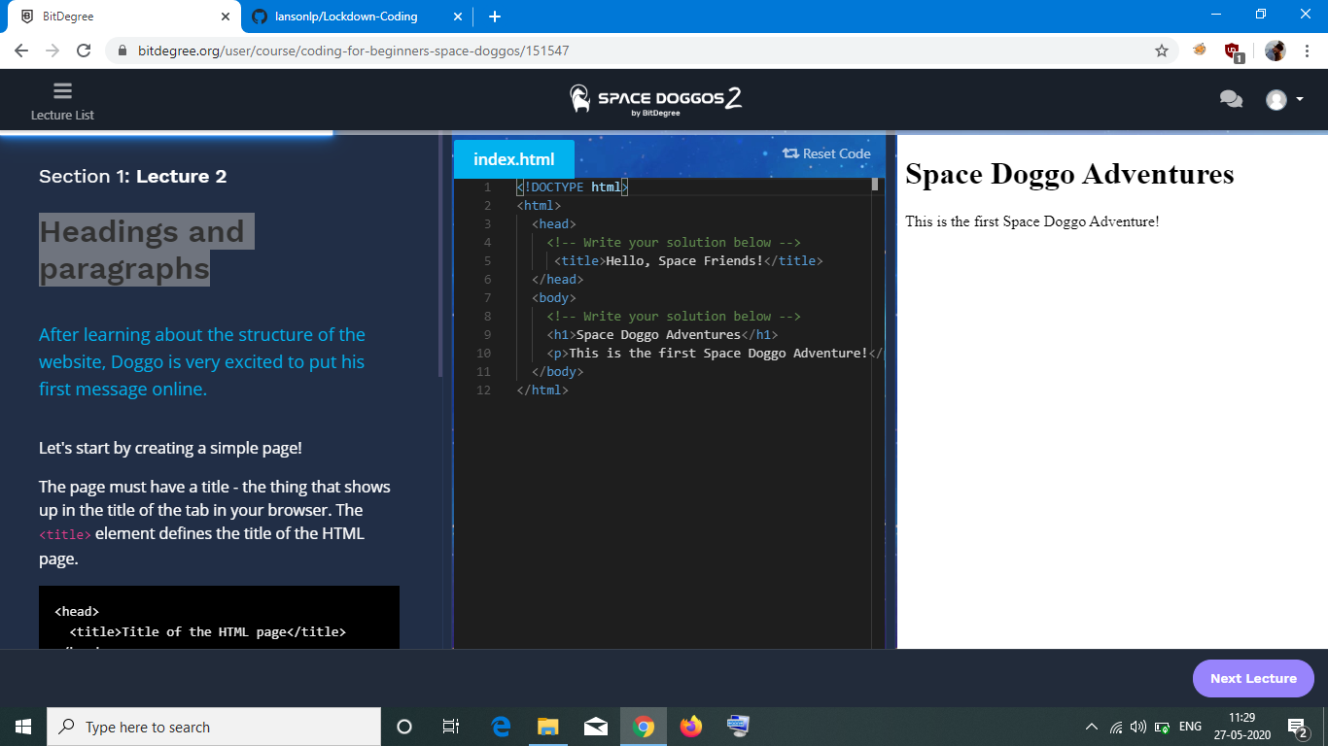

1. : Given array of distinct integers. The task is to count all the triplets such that the sum of two elements equals to the third element Problem Statement

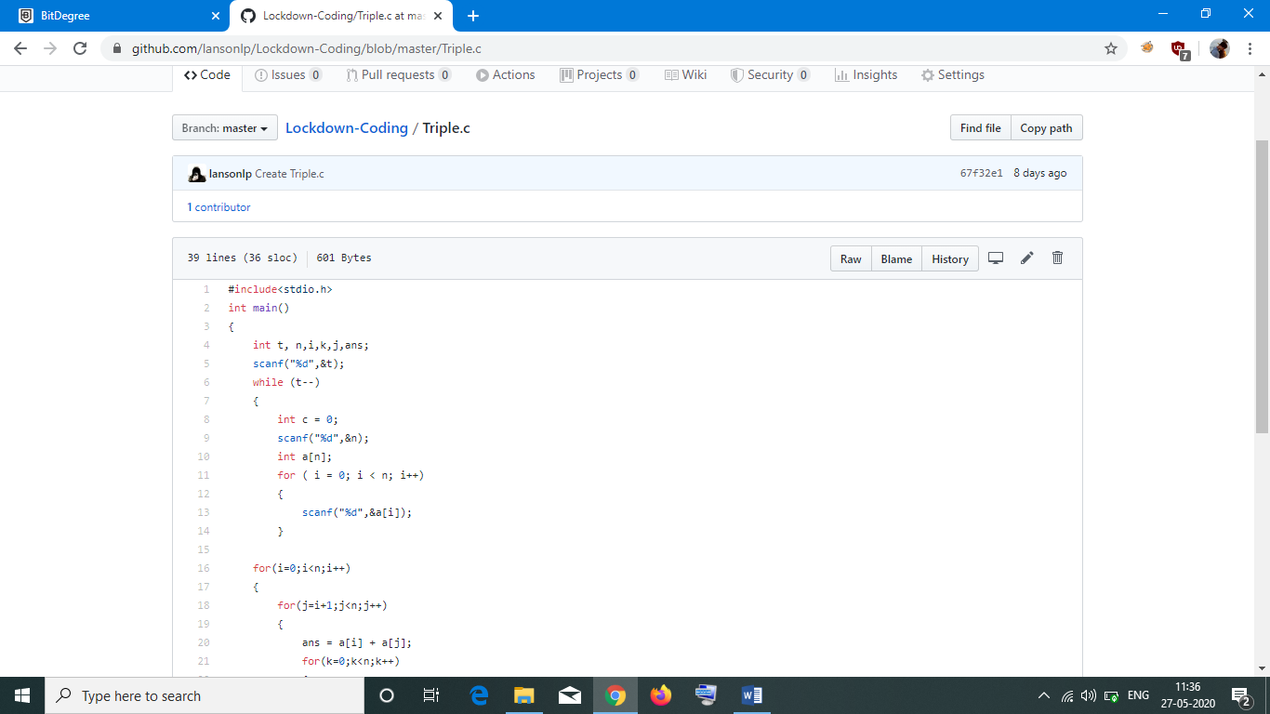

2: Write a C program to check whether the two strings are anagram or not

