DAILY ONLINE ACTIVITIES SUMMARY
Date: | 19-05-2020 |  |  |  |  | Name: | LANSON PEREIRA
Sem & Sec | 4th& A |  |  |  |  | USN: | 4AL18CS040
Online Test Summary
Subject |  | Design and Analysis of Algorithms
Max. Marks |  | 30 |  | Score |  |  | 14
Certification Course Summary
Course | Introducing Coding for Beginners: an HTML and CSS Online Course
Certificate Provider |  |  | BitDegree |  | Duration |  |  | 60 HOURS
Coding Challenges
Challenges Problem Statement 1. To check whether one string is a sub sequence of another string

2. To find the short palindrome of a string
3. To check if a inked list is a palindrome or not using stacks
Status: executed
Uploaded the report in Github |  |  |  |  | YES
If yes Repository name |  |  |  |  | - https://github.com/lansonlp/Lockdown-Coding  - https://github.com/lansonlp/Lockdown-Certification-Course
Uploaded the report in slack |  |  |  |  | YES

The online test was from module 1 which was about Introduction to the subject and asymptotic notations. There were 25 questions and the duration was 30 minutes. The questions were optimal and were easy. The score that I received was 14/30.
Snapshot: not taken

Online Certification Course Summary: I have opted my Online Certification Course In BitDegree the course which i have opted is Introducing Coding for Beginners: an HTML and CSS Online Course..

This course covers the following topics :
Basic web development
Creating forms, buttons, and other elements
HTML coding basics
CSS basics

Description :

A Fun Way to Get Familiar With Coding for Beginners.

Master HTML and CSS basics Step-by-Step.

Lecture 3 : Multimedia
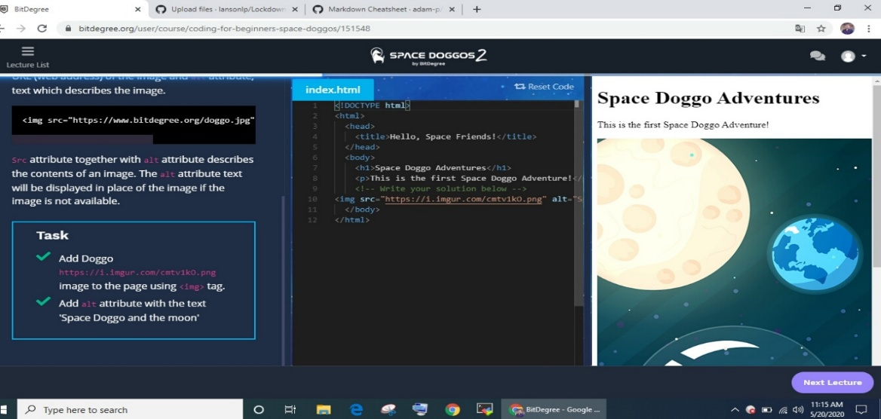

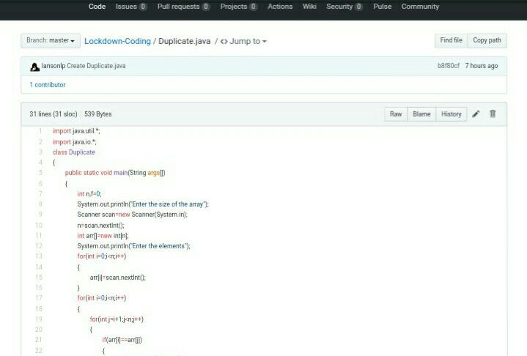
1.To print Duplicate elements of an array

2. To reverse a singly Linked list
