DAILY ONLINE ACTIVITIES SUMMARY
Date: | 26-06-2020 |  |  |  |  | Name: | LANSON PEREIRA
Sem & Sec | 4th& A |  |  |  |  | USN: | 4AL18CS040
Online Test Summary
Subject |  | N\A
Max. Marks |  | N\A |  | Score |  |  | N\A
Certification Course Summary
Course | PyQt5 - Create an AMAZING Calculator
Certificate Provider |  |  | BitDegree |  | Duration |  |  | 3 HOURS
Coding Challenges
Problem Statement:
1. Given start end of range ,Write a Python program to print all negative numbers in given range
Status: executed
Uploaded the report in Github |  |  |  |  | YES
If yes Repository name |  |  |  |  | - https://github.com/lansonlp/Lockdown-Coding  - https://github.com/lansonlp/Lockdown-Certification-Course
Uploaded the report in slack |  |  |  |  | YES

Online Certification Course Summary:
I have opted my Online Certification Course In BitDegree. The course which i have opted is PyQt5 - Create an AMAZING Calculator
The following topics were coverd in this course
- Creating Controller
- Implementing the Model

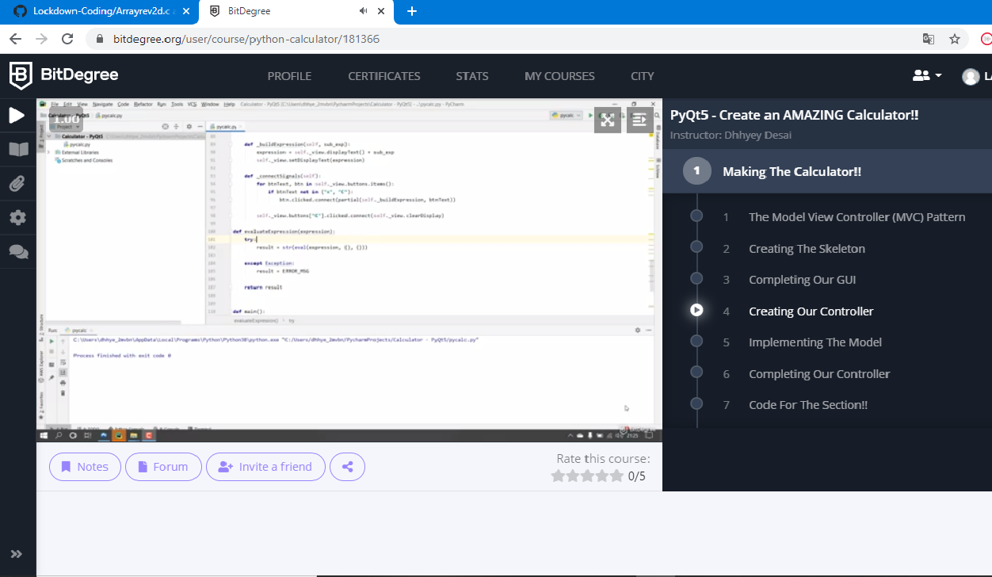

Given start end of range ,Write a Python program to print all negative numbers in given range.

