DAILY ONLINE ACTIVITIES SUMMARY

Date: | 06-07-2020 |  |  |  |  | Name: | LANSON PEREIRA
Sem & Sec | 4th& A |  |  |  |  | USN: | 4AL18CS040
Online Test Summary
Subject |  | Engineering Mathematics - 4
Max. Marks |  | N\A |  | Score |  |  | N\A
Certification Course Summary
Course | Introduction to Blockchain: Quick Guide Exploring Blockchain
Certificate Provider |  |  | BitDegree |  | Duration |  |  | 4 HOURS
Coding Challenges
Problem Statement:
1. Given an array of integer arr[] and an integer k, the task is to find the median of each window of size k starting from the left and moving towards the right by one position each time.
Status: executed
Uploaded the report in Github |  |  |  |  | YES
If yes Repository name |  |  |  |  | - https://github.com/lansonlp/Lockdown-Coding  - https://github.com/lansonlp/Lockdown-Certification-Course
Uploaded the report in slack |  |  |  |  | YES

Descriptive Test Details:
The test was from module 1 and there were 3 questions to solve. The time limit was 45 minutes. We had to write the test in A4 sheet and had to upload in Google classroom.



Online Certification Course Summary:
I have opted my Online Certification Course In BitDegree. The course which i have opted is Introduction to Blockchain: Quick Guide Exploring Blockchain
The following topics were coverd in this course
- Decentralization
- Distributed ledger
- Cryptography

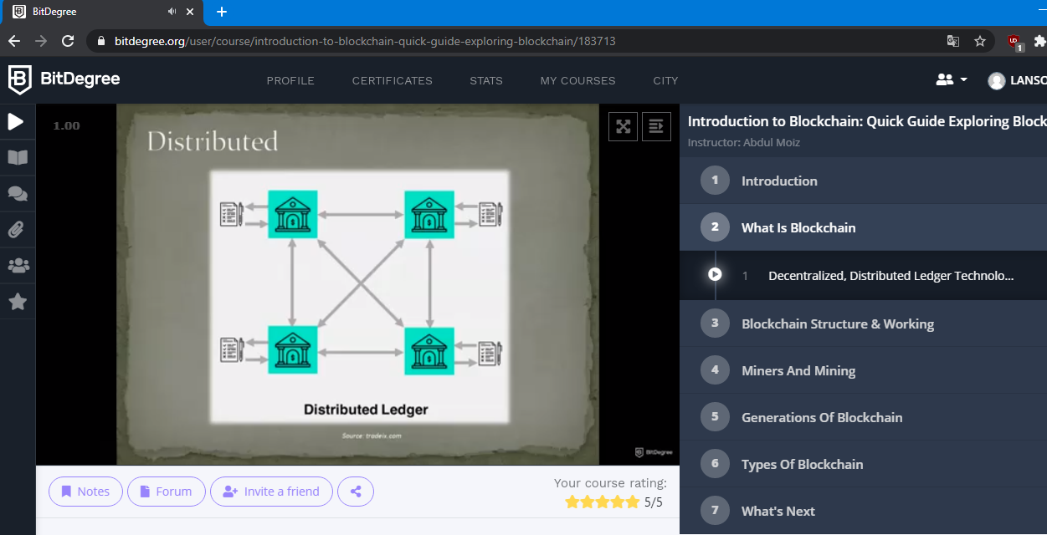

1. Given an array of integer arr[] and an integer k, the task is to find the median of each window of size k starting from the left and moving towards the right by one position each time.

