DAILY ONLINE ACTIVITIES SUMMARY
Date: | 14-06-2020 |  |  |  |  | Name: | LANSON PEREIRA
Sem & Sec | 4th& A |  |  |  |  | USN: | 4AL18CS040
Online Test Summary
Subject |  | Complex Analysis, Probability and Statistical Methods
Max. Marks |  | 30 |  | Score |  |  | 28
Certification Course Summary
Course | Bootstrap and PHP Blog Tutorial Step by Step
Certificate Provider |  |  | BitDegree |  | Duration |  |  | 2 HOURS
Coding Challenges
Problem Statement:

1. Write a python program to check whether a given a binary tree is a valid binary search tree (BST) or not .

Status: executed
Uploaded the report in Github |  |  |  |  | YES
If yes Repository name |  |  |  |  | - https://github.com/lansonlp/Lockdown-Coding  - https://github.com/lansonlp/Lockdown-Certification-Course
Uploaded the report in slack |  |  |  |  | YES

Online Test Details:
The online test was from module 1 which was about the calculus of complex function and construction of analytic function. There were 15 questions and the duration was 40 minutes. The questions were optimal and were easy. The score that I got in the test is 28/30.

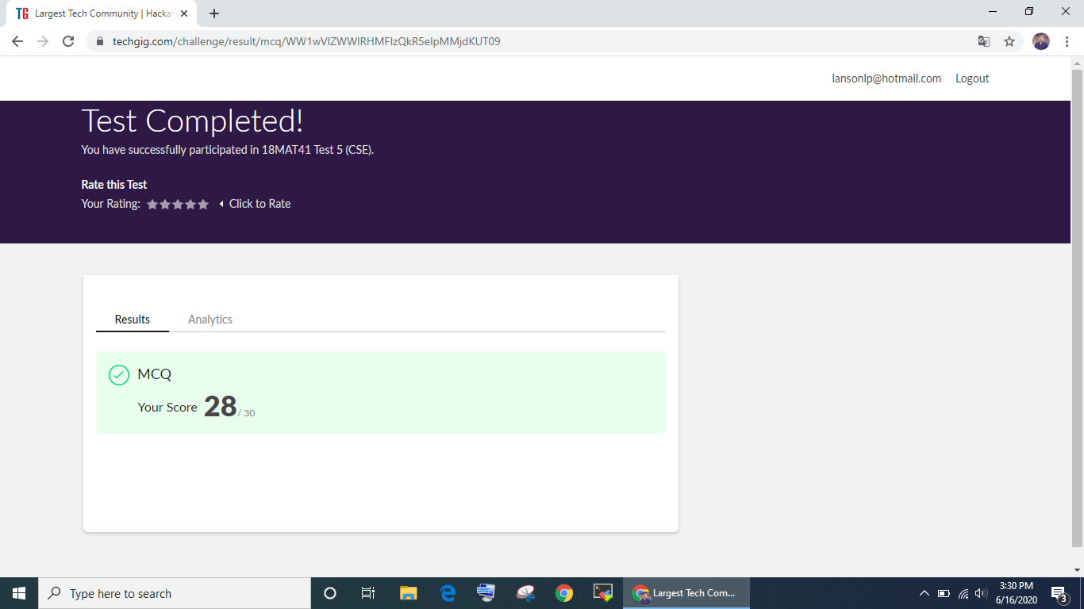

Online Certification Course Summary:

I have opted my Online Certification Course In BitDegree. The course which i have opted is Bootstrap and PHP Blog Tutorial Step by Step.

Writing Your First Posts

Rendering the Posts

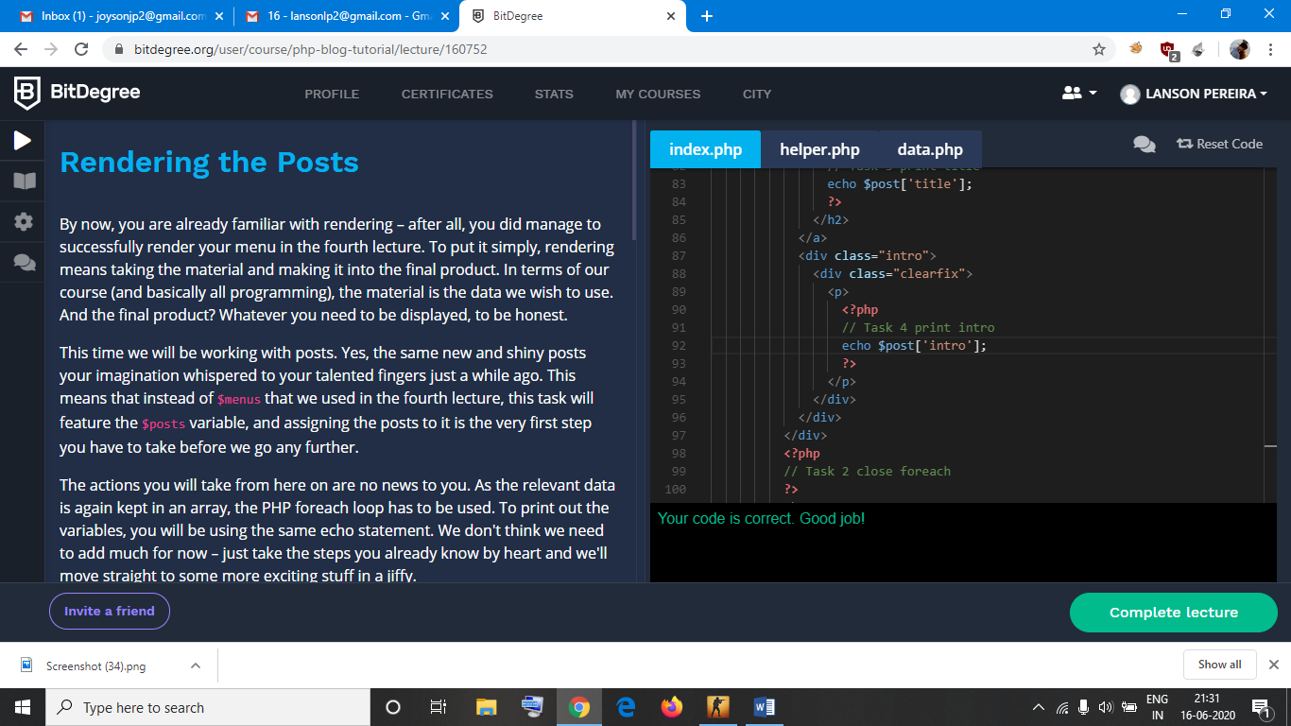

1. Write a python program to check whether a given a binary tree is a valid binary search tree (BST) or not .

