DAILY ONLINE ACTIVITIES SUMMARY
Date: | 21-05-2020 |  |  |  |  | Name: | LANSON PEREIRA
Sem & Sec | 4th& A |  |  |  |  | USN: | 4AL18CS040
Online Test Summary
Subject |  | Microcontroller and Embedded Systems
Max. Marks |  | 30 |  | Score |  |  | 23
Certification Course Summary
Course | Introducing Coding for Beginners: an HTML and CSS Online Course
Certificate Provider |  |  | BitDegree |  | Duration |  |  | 60 HOURS
Coding Challenges
Challenges Problem Statement 1. To demonstrate the process of SRTF shedulling
2. To remove duplicate elements from a SLL

Status: executed
Uploaded the report in Github |  |  |  |  | YES
If yes Repository name |  |  |  |  | - https://github.com/lansonlp/Lockdown-Coding  - https://github.com/lansonlp/Lockdown-Certification-Course
Uploaded the report in slack |  |  |  |  | YES

The online test was from module 1 which was about Introduction to the subject and the fundamentals of ARM processor. There were 30 questions and the duration was 30 minutes. The questions were optimal and were easy ,the score that I received was 23/30.
Snapshot: not taken

Online Certification Course Summary: I have opted my Online Certification Course In BitDegree the course which i have opted is Introducing Coding for Beginners: an HTML and CSS Online Course.

This course covers the following topics :
Basic web development
Creating forms, buttons, and other elements
HTML coding basics
CSS basics

Description :

A Fun Way to Get Familiar With Coding for Beginners.

Master HTML and CSS basics Step-by-Step.

Lecture 5 : HTML Tables

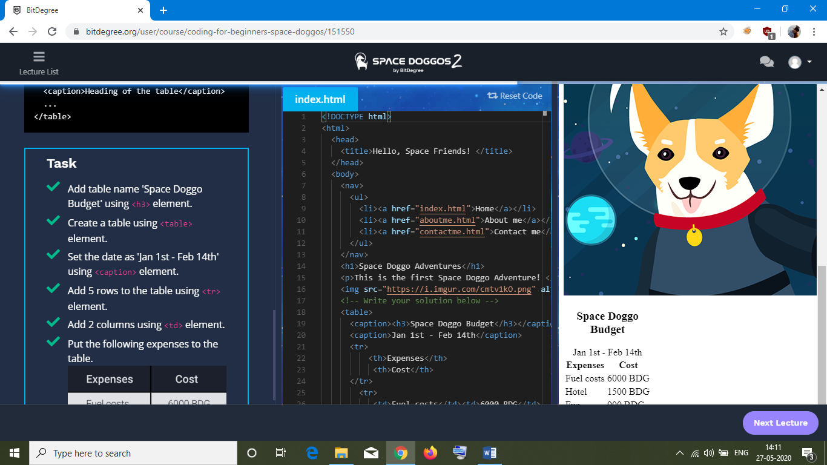

1. To demonstrate the process of SRTF sheduling

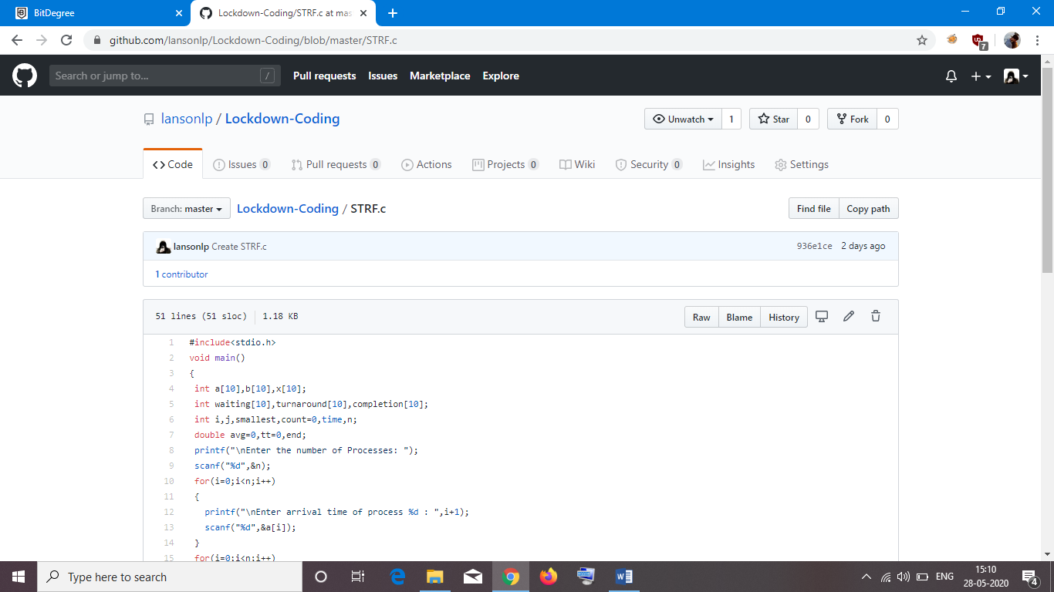

2. To remove duplicate elements from a SLL

