DAILY ONLINE ACTIVITIES SUMMARY
Date: | 19-06-2020 |  |  |  |  | Name: | LANSON PEREIRA
Sem & Sec | 4th& A |  |  |  |  | USN: | 4AL18CS040
Online Test Summary
Subject |  | Microcontrollers and embedded systems
Max. Marks |  | 20 |  | Score |  |  | 20
Certification Course Summary
Course | Absolute Guide: Linux Tutorial for Beginners
Certificate Provider |  |  | BitDegree |  | Duration |  |  | 4 HOURS
Coding Challenges
Problem Statement:

1.Write a C Program to Count total set bits in all numbers from 1 to n.

Status: executed
Uploaded the report in Github |  |  |  |  | YES
If yes Repository name |  |  |  |  | - https://github.com/lansonlp/Lockdown-Coding  - https://github.com/lansonlp/Lockdown-Certification-Course
Uploaded the report in slack |  |  |  |  | YES

Online Test Details:
The online test was on module 4 which was all of objective type. The questions are optimal and easy. There were 20 questions for 30 minutes. The score that I got was 20/20.

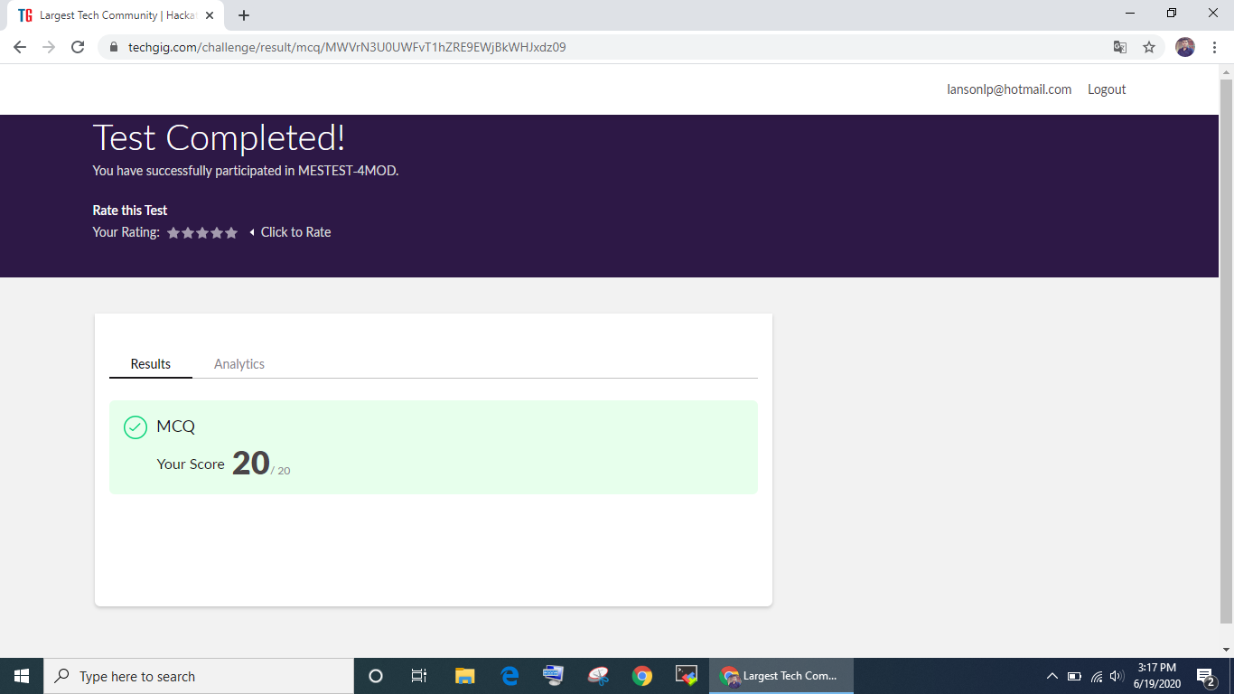

Online Certification Course Summary:

I have opted my Online Certification Course In BitDegree. The course which i have opted is Absolute Guide: Linux Tutorial for Beginners .

Introduction

Linux Tutorials and projects

Installing an SSL Certificate on CentOs Running Apache

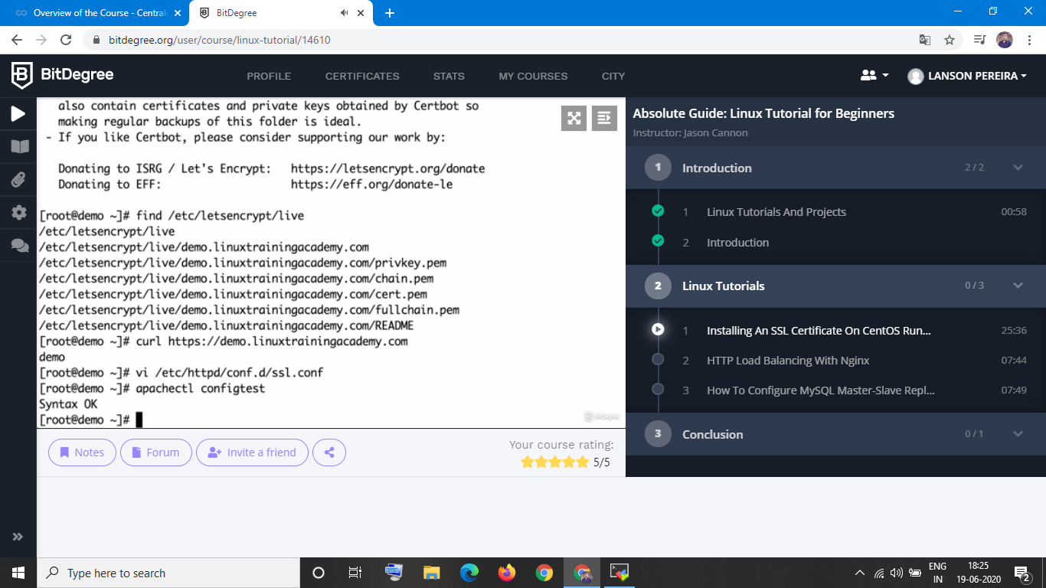

1.Write a C Program to Count total set bits in all numbers from 1 to n.

