DAILY ONLINE ACTIVITIES SUMMARY
Date: | 20-06-2020 |  |  |  |  | Name: | LANSON PEREIRA
Sem & Sec | 4th& A |  |  |  |  | USN: | 4AL18CS040
Online Test Summary
Subject |  | Data communication
Max. Marks |  | 30 |  | Score |  |  | 29
Certification Course Summary
Course | Absolute Guide: Linux Tutorial for Beginners
Certificate Provider |  |  | BitDegree |  | Duration |  |  | 4 HOURS
Coding Challenges
Problem Statement:

1. Program to rotate a square matrix by 90 degree either clockwise or anti-clockwise

Status: executed
Uploaded the report in Github |  |  |  |  | YES
If yes Repository name |  |  |  |  | - https://github.com/lansonlp/Lockdown-Coding  - https://github.com/lansonlp/Lockdown-Certification-Course
Uploaded the report in slack |  |  |  |  | YES

Online Test Details:
The online test was on modules 3 and 4 which was all of objective type. The questions are optimal and easy. There were 30 questions for 30 minutes. The score that I got was 29/30.

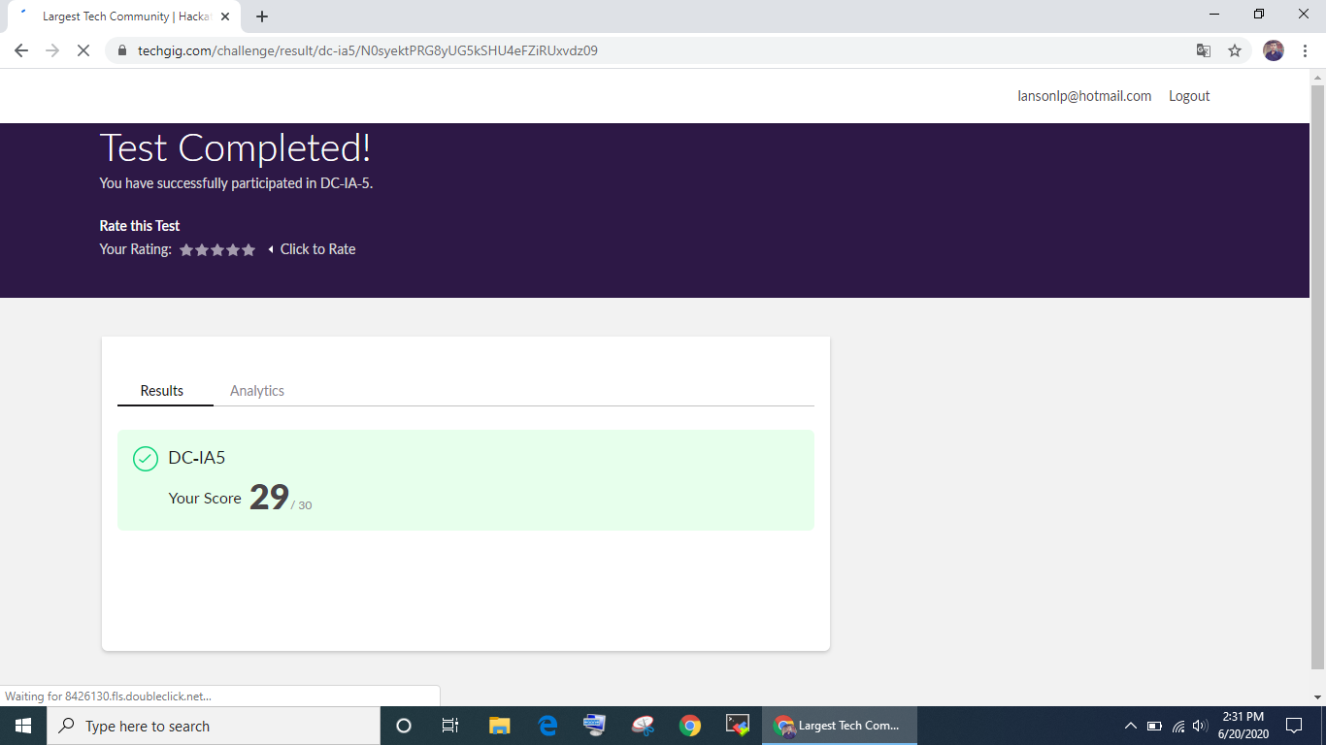

Online Certification Course Summary:

I have opted my Online Certification Course In BitDegree. The course which i have opted is Absolute Guide: Linux Tutorial for Beginners .

HTTP Load Balancing With Nginx

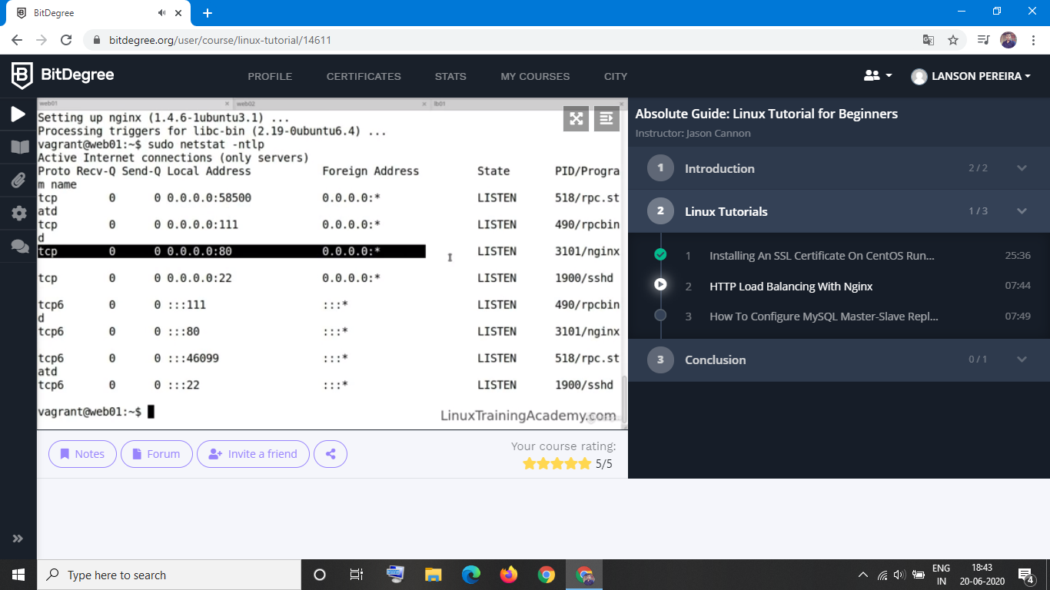

1. Program to rotate a square matrix by 90 degree either clockwise or anti-clockwise

