DAILY ONLINE ACTIVITIES SUMMARY
Date: | 14-06-2020 |  |  |  |  | Name: | LANSON PEREIRA
Sem & Sec | 4th& A |  |  |  |  | USN: | 4AL18CS040
Online Test Summary
Subject |  | N\A
Max. Marks |  | N\A |  | Score |  |  | N\A
Certification Course Summary
Course | Bootstrap and PHP Blog Tutorial Step by Step
Certificate Provider |  |  | BitDegree |  | Duration |  |  | 2 HOURS
Coding Challenges
Problem Statement:

1. Write a Java Program to find if string is K-Palindrome or not.

Status: executed
Uploaded the report in Github |  |  |  |  | YES
If yes Repository name |  |  |  |  | - https://github.com/lansonlp/Lockdown-Coding  - https://github.com/lansonlp/Lockdown-Certification-Course
Uploaded the report in slack |  |  |  |  | YES

Online Certification Course Summary:

I have opted my Online Certification Course In BitDegree. The course which i have opted is Bootstrap and PHP Blog Tutorial Step by Step.

Intro to the Bootstrap Framework

PHP Arrays

Understanding the Set of Functions

Dynamic Menu Rendering

Creating a New Data Structure for Posts

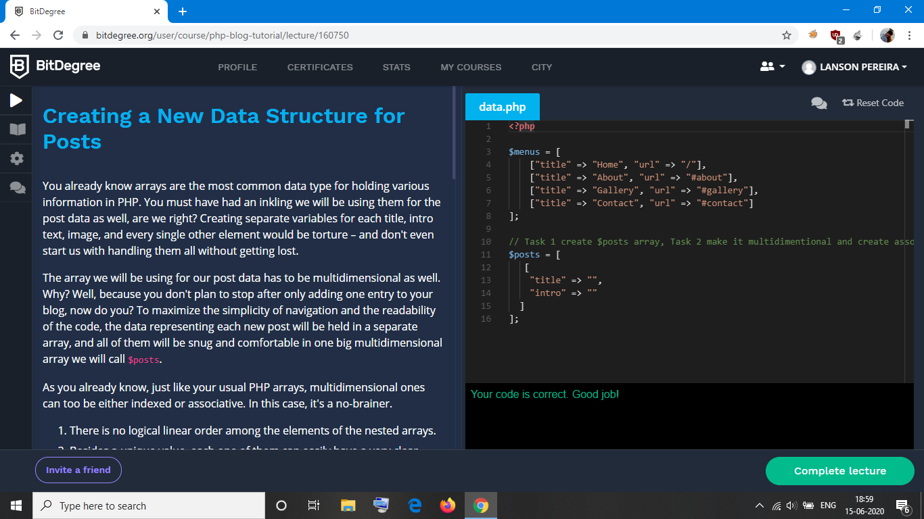

Write a Java Program to find if string is K-Palindrome or not.

