DAILY ONLINE ACTIVITIES SUMMARY
Date: | 22-05-2020 |  |  |  |  | Name: | LANSON PEREIRA
Sem & Sec | 4th& A |  |  |  |  | USN: | 4AL18CS040
Online Test Summary
Subject |  | OPERATING SYSTEM
Max. Marks |  | 30 |  | Score |  |  | 26
Certification Course Summary
Course | Introducing Coding for Beginners: an HTML and CSS Online Course
Certificate Provider |  |  | BitDegree |  | Duration |  |  | 60 HOURS
Coding Challenges
Challenges Problem Statement : 1. Stack operation using SLL
2. Round robin type of process scheduling
Status: executed
Uploaded the report in Github |  |  |  |  | YES
If yes Repository name |  |  |  |  | - https://github.com/lansonlp/Lockdown-Coding  - https://github.com/lansonlp/Lockdown-Certification-Course
Uploaded the report in slack |  |  |  |  | YES

Online Test Details:

The online test was from module 1 which was about the introduction to operating systems, system structures, different operating system services and process management. There were 30 questions and the duration was 40 minutes. The questions were optimal and were easy. The score that I got in the test is 26/30.
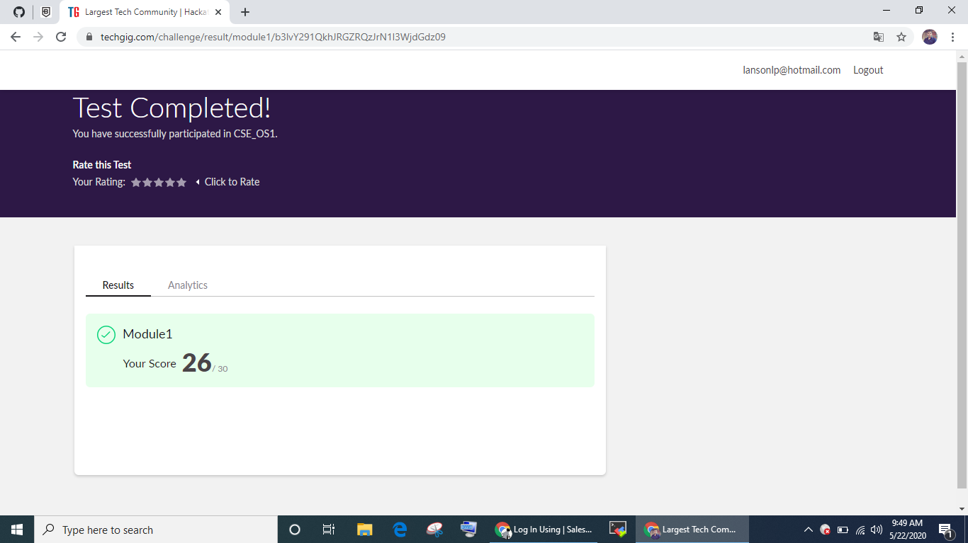

Online Certification Course Summary: I have opted my Online Certification Course In BitDegree the course which i have opted is Introducing Coding for Beginners: an HTML and CSS Online Course..

This course covers the following topics :
Basic web development
Creating forms, buttons, and other elements
HTML coding basics
CSS basics

Description :

A Fun Way to Get Familiar With Coding for Beginners.

Master HTML and CSS basics Step-by-Step.

Lecture 6 : HTML Forms
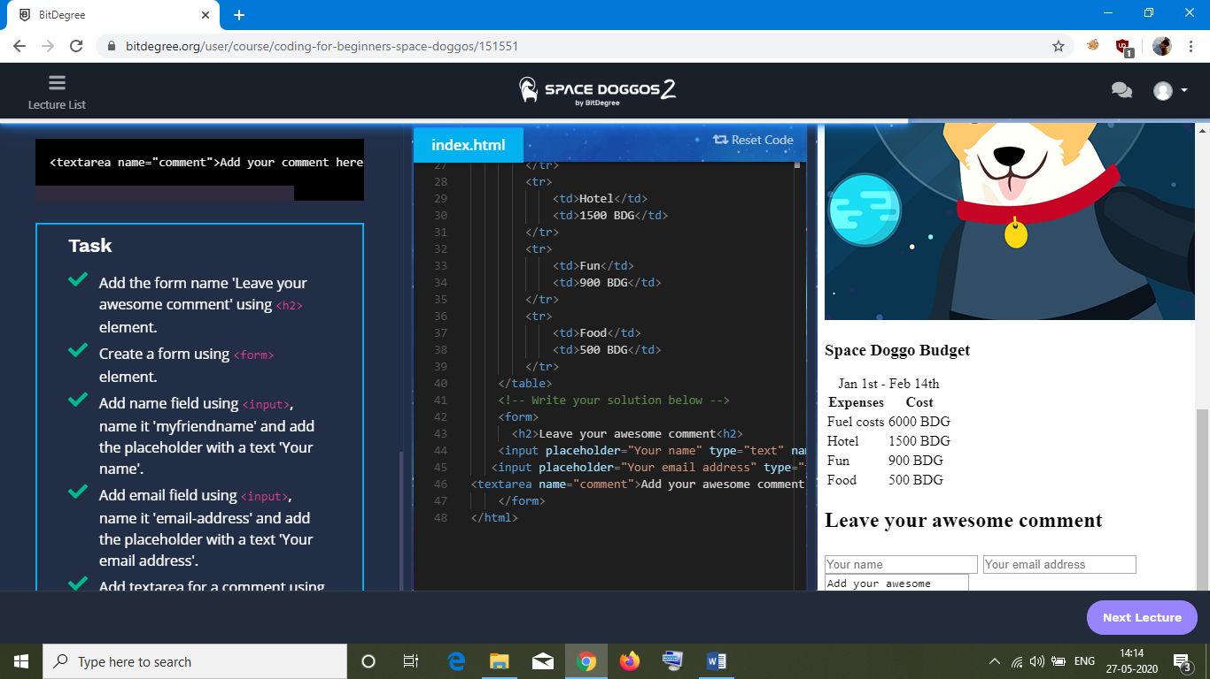

1. Stack operation using SLL

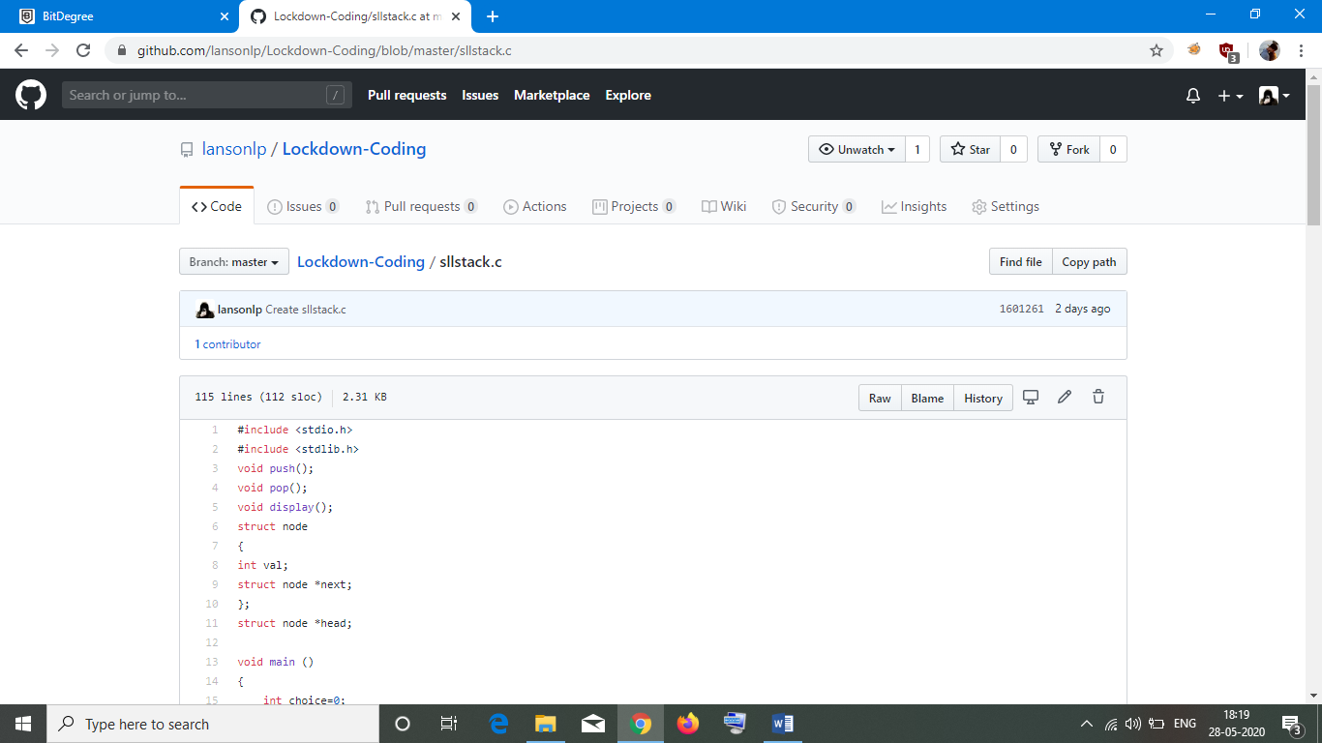
2. Round robin type of process scheduling

