DAILY ONLINE ACTIVITIES SUMMARY
Date: | 25-05-2020 |  |  |  |  | Name: | LANSON PEREIRA
Sem & Sec | 4th& A |  |  |  |  | USN: | 4AL18CS040
Online Test Summary
Subject |  | N/A
Max. Marks |  | N/A |  | Score |  |  | N/A
Certification Course Summary
Course | Introducing Coding for Beginners: an HTML and CSS Online Course
Certificate Provider |  |  | BitDegree |  | Duration |  |  | 60 HOURS
Coding Challenges
Challenges Problem Statement 1. To check whether two strings are identical
2. To check whether it’s possible to reach 1 by performing two operations
on a number

Status: executed
Uploaded the report in Github |  |  |  |  | YES
If yes Repository name |  |  |  |  | - https://github.com/lansonlp/Lockdown-Coding  - https://github.com/lansonlp/Lockdown-Certification-Course
Uploaded the report in slack |  |  |  |  | YES

Online Test Details : N/A

Online Certification Course Summary: I have opted my Online Certification Course In BitDegree the course which i have opted is Introducing Coding for Beginners: an HTML and CSS Online Course.

This course covers the following topics :
Basic web development
Creating forms, buttons, and other elements
HTML coding basics
CSS basics

Description :

A Fun Way to Get Familiar With Coding for Beginners.

Master HTML and CSS basics Step-by-Step.

Section 2: Lecture 1 : Styling a website
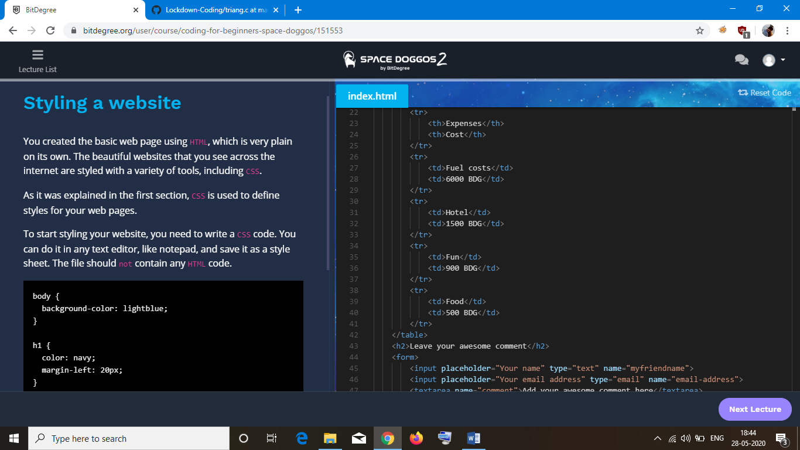

To check whether two strings are identical

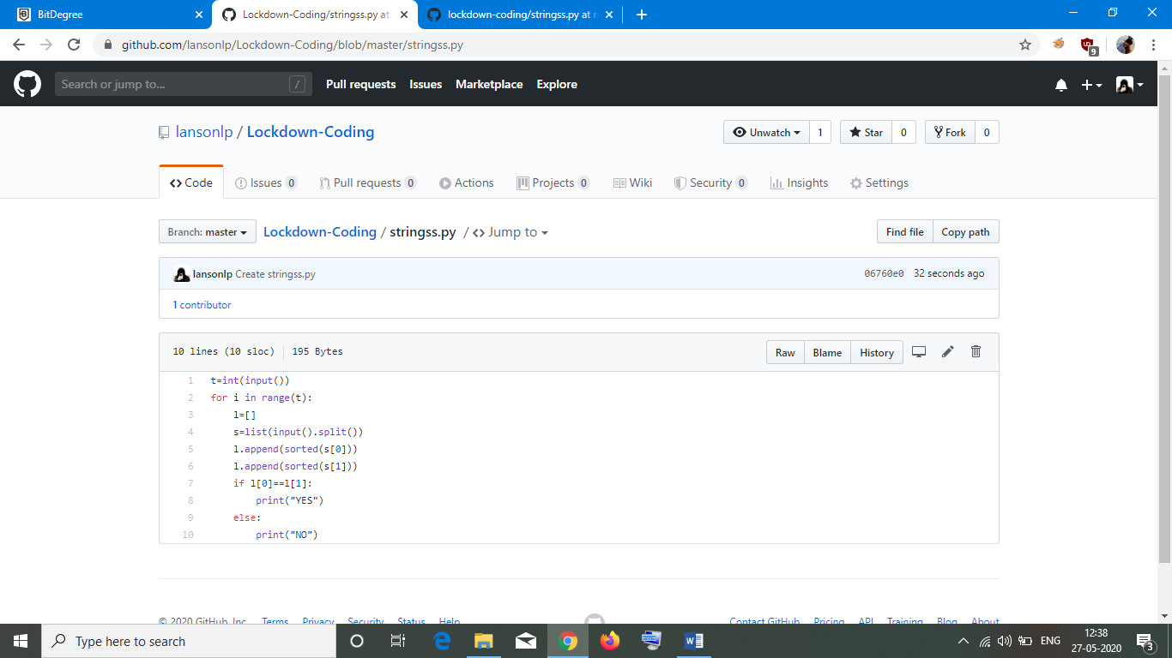

To check whether it’s possible to reach 1 by performing two operations on a number

