DAILY ONLINE ACTIVITIES SUMMARY
Date: | 27-05-2020 |  |  |  |  | Name: | LANSON PEREIRA
Sem & Sec | 4th& A |  |  |  |  | USN: | 4AL18CS040
Online Test Summary
Subject |  | Object Oriented Concepts
Max. Marks |  | 30 |  | Score |  |  | 27
Certification Course Summary
Course | Introducing Coding for Beginners: an HTML and CSS Online Course
Certificate Provider |  |  | BitDegree |  | Duration |  |  | 60 HOURS
Coding Challenges
Challenges Problem Statement : 1. Display the sorted array and Number of passes performed for sorting.
2. find the largest element on the left side of each index which is
smaller than the element present at that index

Status: executed
Uploaded the report in Github |  |  |  |  | YES
If yes Repository name |  |  |  |  | - https://github.com/lansonlp/Lockdown-Coding  - https://github.com/lansonlp/Lockdown-Certification-Course
Uploaded the report in slack |  |  |  |  | YES

Online Test Details:
The online test was from module 5 which was about the introduction to applets, swings and about different event handling topics in JAVA. There were 30 questions and the duration was 40 minutes. The questions were optimal and were easy. The score that I got in the test is 27/30.
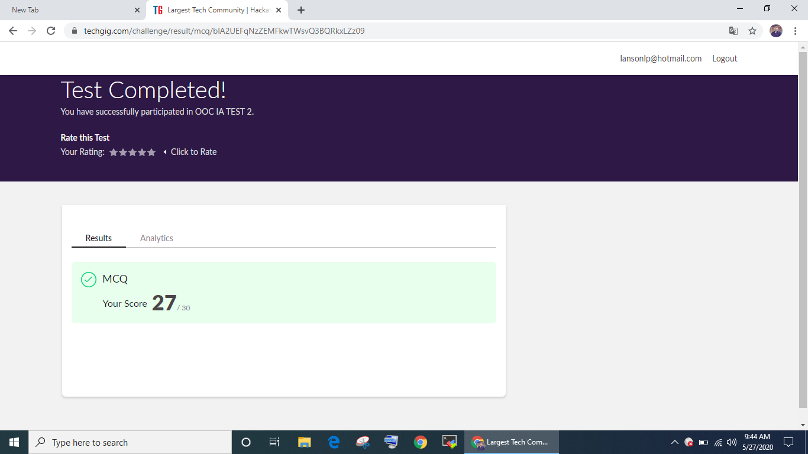

Online Certification Course Summary: I have opted my Online Certification Course In BitDegree the course which i have opted is Introducing Coding for Beginners: an HTML and CSS Online Course..

This course covers the following topics :
Basic web development
Creating forms, buttons, and other elements
HTML coding basics
CSS basics

Description :

A Fun Way to Get Familiar With Coding for Beginners.

Master HTML and CSS basics Step-by-Step.

Section 2: Lecture 3 : CSS Selectors
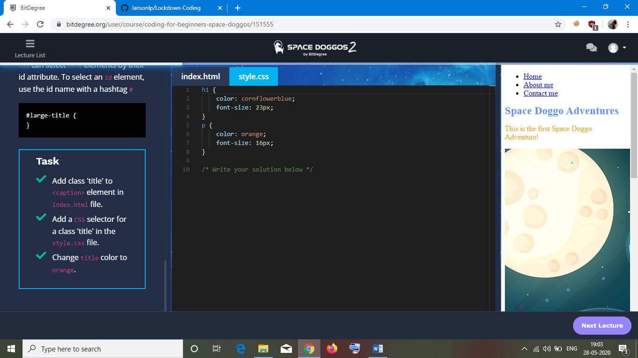
1. Display the sorted array and Number of passes performed for sorting

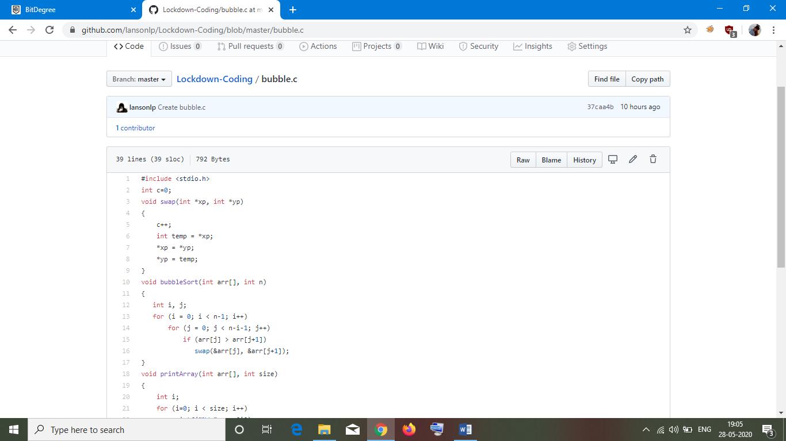
2. Find the largest element on the left side of each index which is smaller than the element present at that index

