DAILY ONLINE ACTIVITIES SUMMARY
Date: | 30-05-2020 |  |  |  |  | Name: | LANSON PEREIRA
Sem & Sec | 4th& A |  |  |  |  | USN: | 4AL18CS040
Online Test Summary
Subject |  | 1. Data Communication 2.Aadalitha Kannada
Max. Marks |  | 30  30 |  | Score |  |  | 27  27
Certification Course Summary
Course | Introducing Coding for Beginners: an HTML and CSS Online Course
Certificate Provider |  |  | BitDegree |  | Duration |  |  | 60 HOURS
Coding Challenges
Challenges Problem Statement: 1.Find out the minimum amount of time.
2 .Find whether arrays are equal or not.
Status: executed
Uploaded the report in Github |  |  |  |  | YES
If yes Repository name |  |  |  |  | - https://github.com/lansonlp/Lockdown-Coding  - https://github.com/lansonlp/Lockdown-Certification-Course
Uploaded the report in slack |  |  |  |  | YES

Online Test Details:
The online test was from module 2. There were 20 questions and the duration was 40 minutes. The questions were optimal and were easy. The score that I got in the test is 18/20.
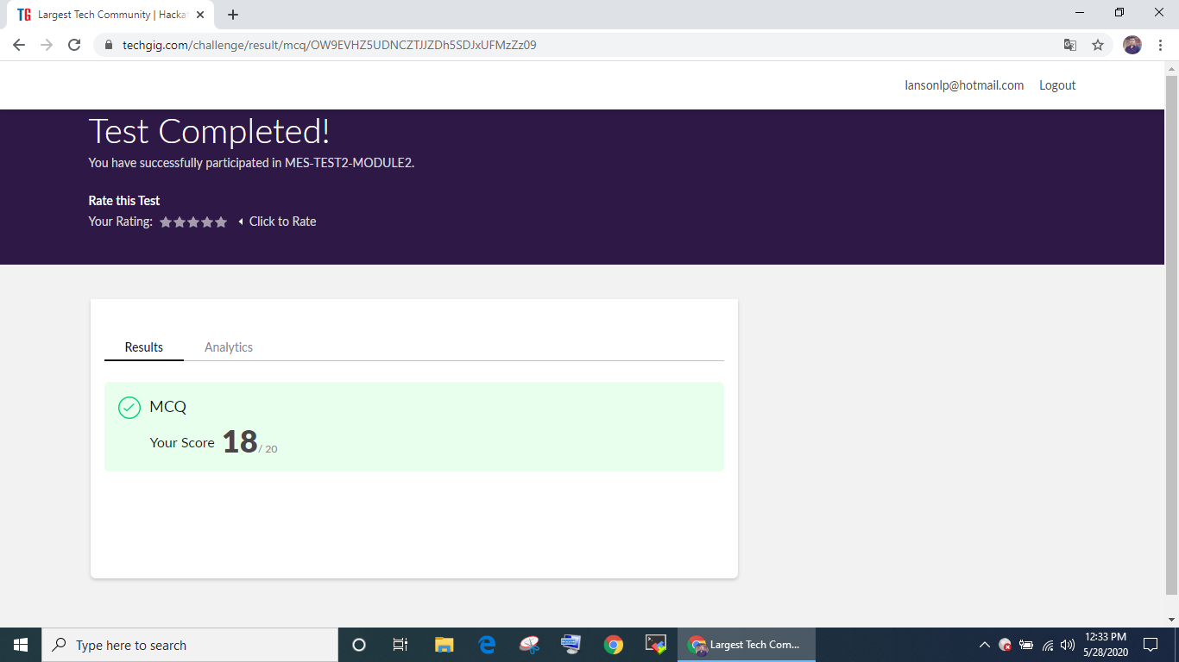

The online test was from all 10 modules. There were 50 questions and the duration was 40 minutes. The score that I got in the test is 19/50.
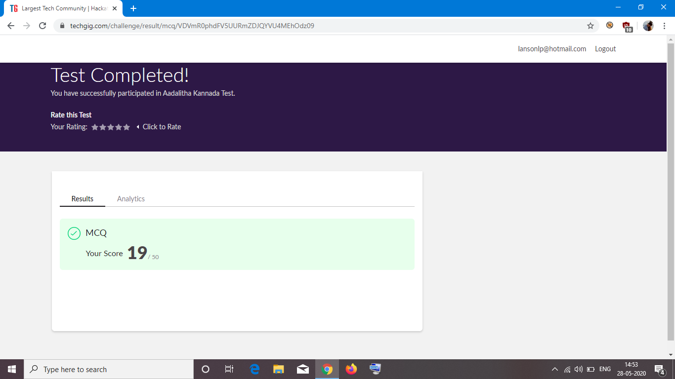

Online Certification Course Summary: I have opted my Online Certification Course In BitDegree the course which i have opted is Introducing Coding for Beginners: an HTML and CSS Online Course..

This course covers the following topics :
Basic web development
Creating forms, buttons, and other elements
HTML coding basics
CSS basics

Description :

A Fun Way to Get Familiar With Coding for Beginners.

Master HTML and CSS basics Step-by-Step.
Section 2: Lecture 4 : Text Styling & Formatting

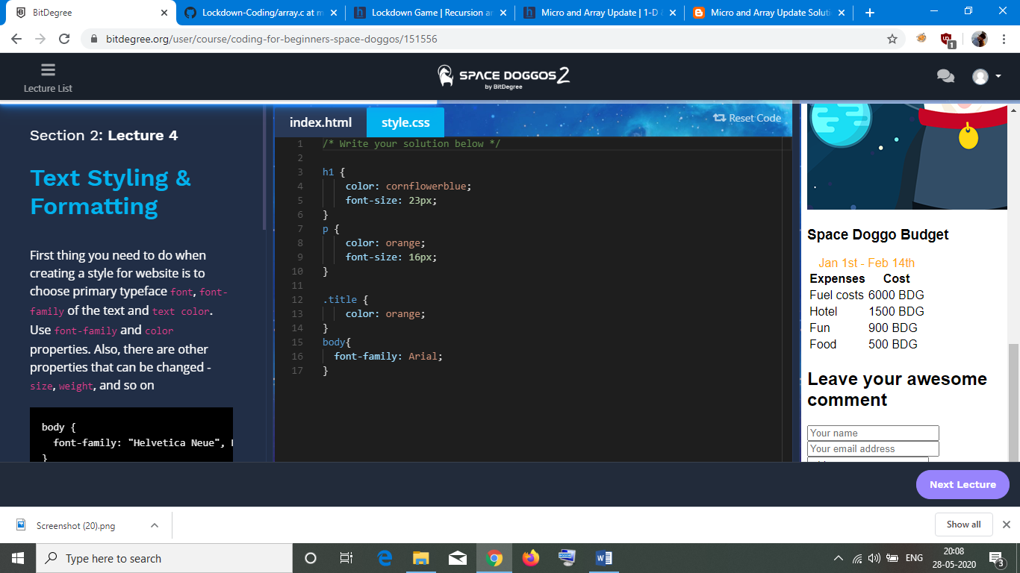
Section 2: Lecture 5 : Background styling

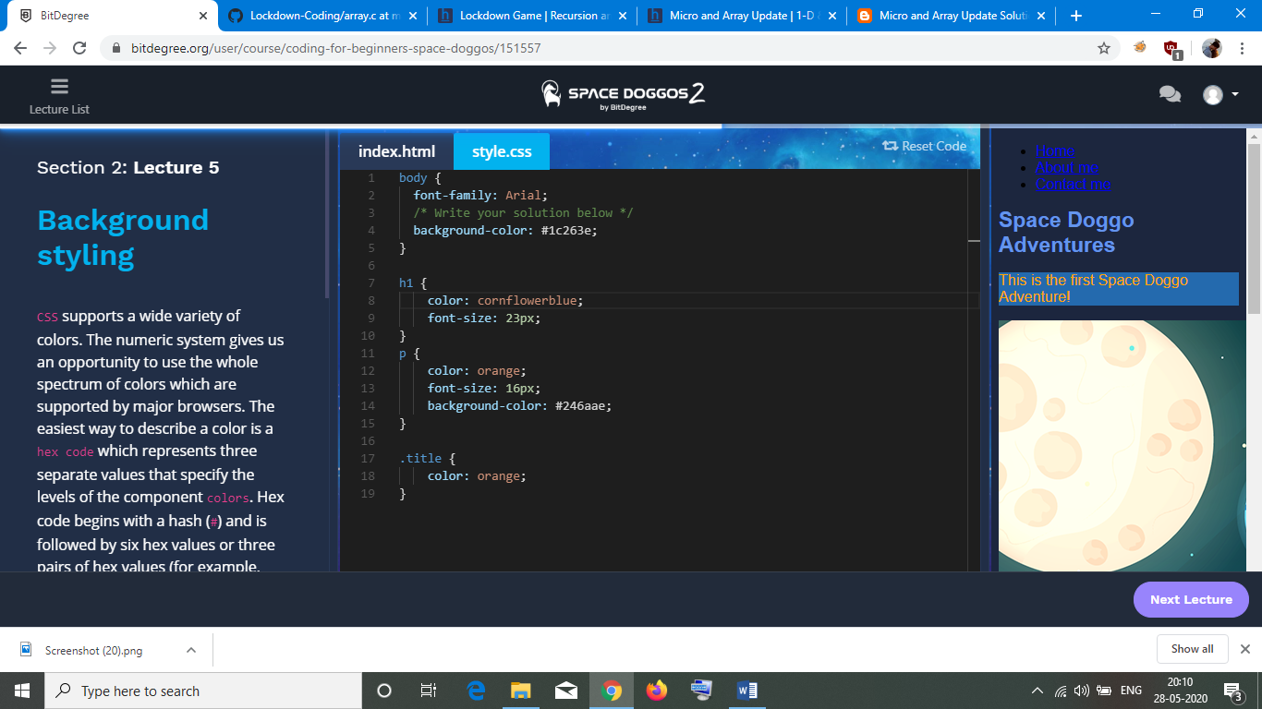
1.Find out the minimum amount of time

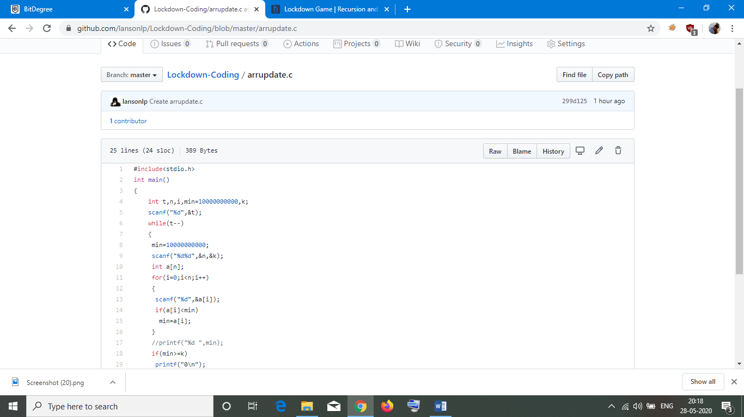
2. Find whether arrays are equal or not

