DAILY ONLINE ACTIVITIES SUMMARY
Date: | 29-05-2020 |  |  |  |  | Name: | LANSON PEREIRA
Sem & Sec | 4th& A |  |  |  |  | USN: | 4AL18CS040
Online Test Summary
Subject |  | Operating system
Max. Marks |  | 30 |  | Score |  |  | 25
Certification Course Summary
Course | Introducing Coding for Beginners: an HTML and CSS Online Course
Certificate Provider |  |  | BitDegree |  | Duration |  |  | 60 HOURS
Coding Challenges
Problem Statement
1. Write a Java program to Find size of the largest ‘+’ formed by all ones in a binary matrix.
2. Write a C Program to generate first N Armstrong Numbers
Status: executed
Uploaded the report in Github |  |  |  |  | YES
If yes Repository name |  |  |  |  | - https://github.com/lansonlp/Lockdown-Coding  - https://github.com/lansonlp/Lockdown-Certification-Course
Uploaded the report in slack |  |  |  |  | YES

Online Test Details:
OS: The online test was from module 2 which was about Multi-threaded Programming. There were 30 questions and the duration was 45 minutes. The questions were optimal and were easy. The score that I got in the test is 25/30.

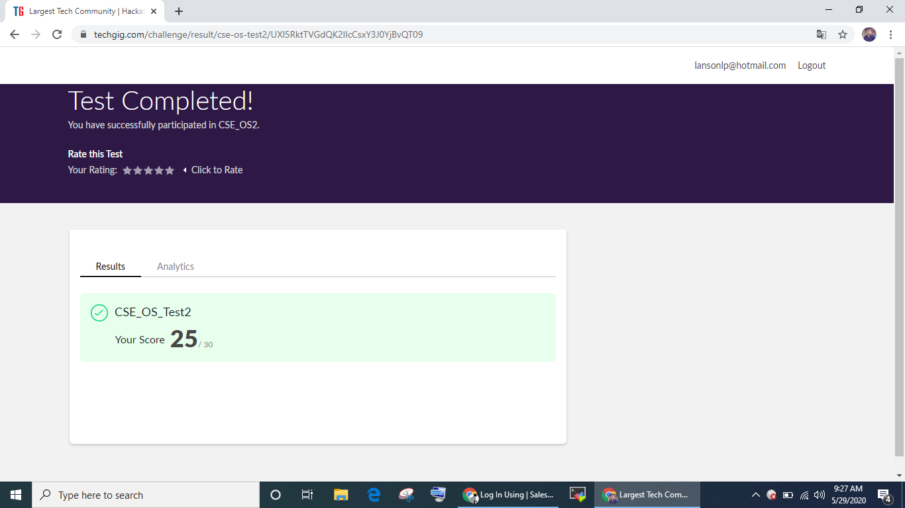

Online Certification Course Summary: I have opted my Online Certification Course In BitDegree the course which i have opted is Introducing Coding for Beginners: an HTML and CSS Online Course..

This course covers the following topics :
Basic web development
Creating forms, buttons, and other elements
HTML coding basics
CSS basics

Description :

A Fun Way to Get Familiar With Coding for Beginners.

Master HTML and CSS basics Step-by-Step.

Section 2: Lecture 6 : Styling Tables
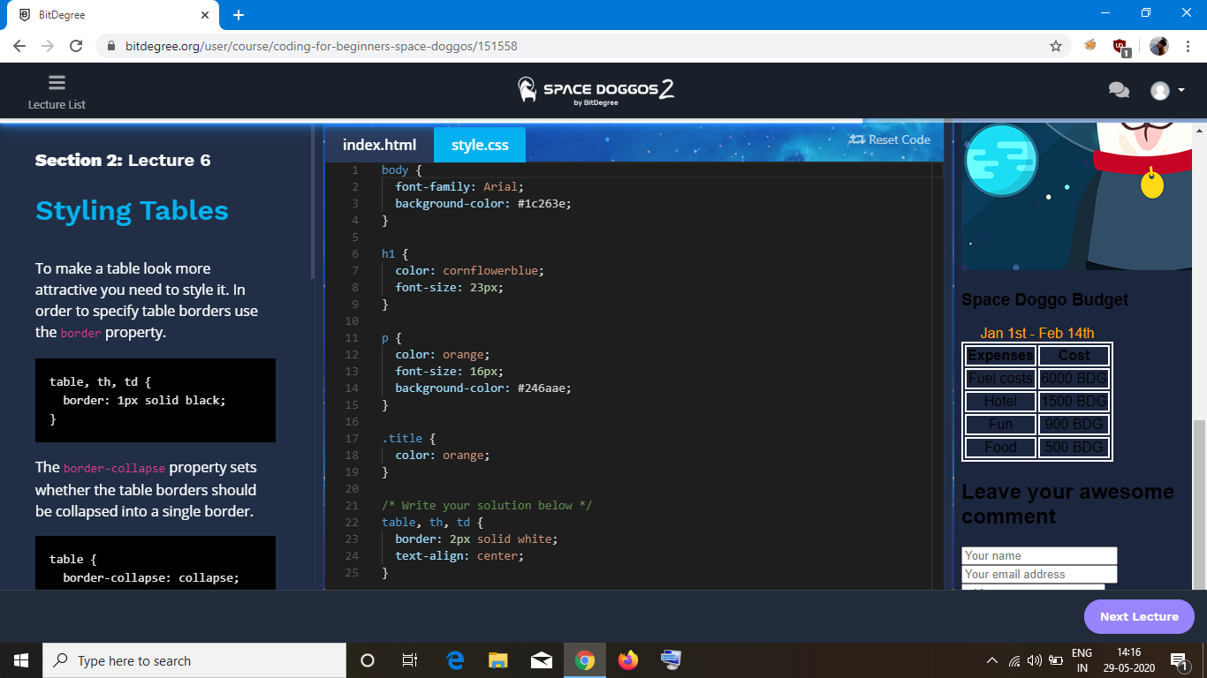

Section 2: Lecture 7: CSS Image positioning

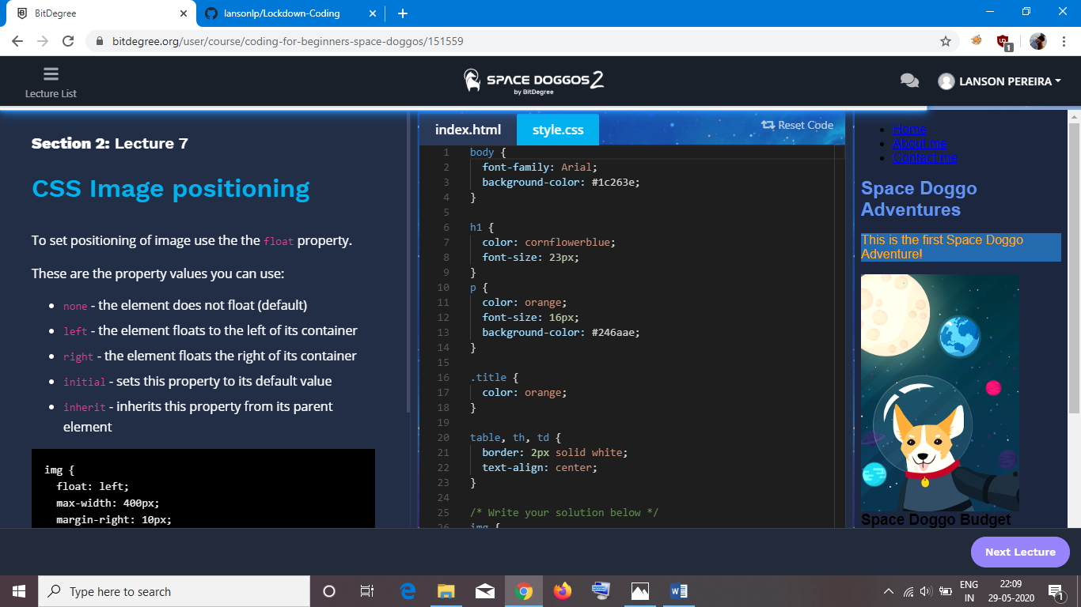

1. Write a Java program to find size of the largest ‘+’ formed by all ones in a binary matrix

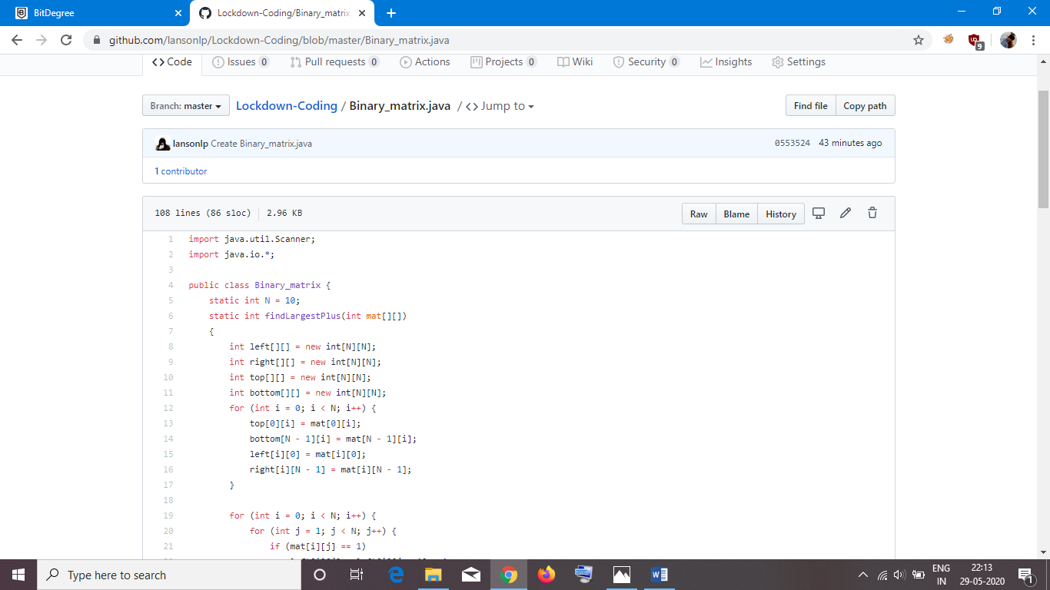
2. Write a C Program to generate first N Armstrong Numbers

