DAILY ONLINE ACTIVITIES SUMMARY
Date: | 30-05-2020 |  |  |  |  | Name: | LANSON PEREIRA
Sem & Sec | 4th& A |  |  |  |  | USN: | 4AL18CS040
Online Test Summary
Subject |  | 1. Data Communication  2. Complex analysis, probability and statistical methods
Max. Marks |  | 30  30 |  | Score |  |  | 27  27
Certification Course Summary
Course | Introducing Coding for Beginners: an HTML and CSS Online Course
Certificate Provider |  |  | BitDegree |  | Duration |  |  | 60 HOURS
Coding Challenges
Problem Statement
1.Write a C Program to count Uppercase, Lowercase, special character and numeric values for a given String
Status: executed
Uploaded the report in Github |  |  |  |  | YES
If yes Repository name |  |  |  |  | - https://github.com/lansonlp/Lockdown-Coding  - https://github.com/lansonlp/Lockdown-Certification-Course
Uploaded the report in slack |  |  |  |  | YES

Online Test Details :

- Data communication: The online test was from module 3 and 4 which was about bandwidth utilization, switching, error detection and correction, data link control, media access control. Introduction to data link layer and IPv4 & addressing sub netting. There were 30 questions and the duration was 45 minutes. The questions were optimal and were easy. The score that I got in the test is 27/30.

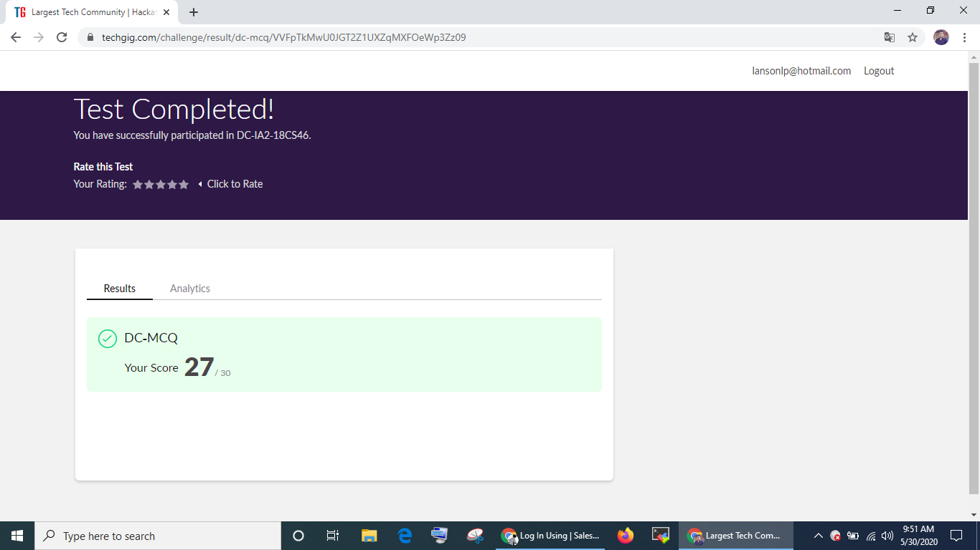
- Complex analysis, probability and statistical methods: The online test was from module 3 which was about probability distribution. There were 20 questions where 10 was for 1 mark each and the remaining 10 for 2 marks each and the duration was 45 minutes. The questions were optimal and were easy. The score that I got in the test is 27/30.

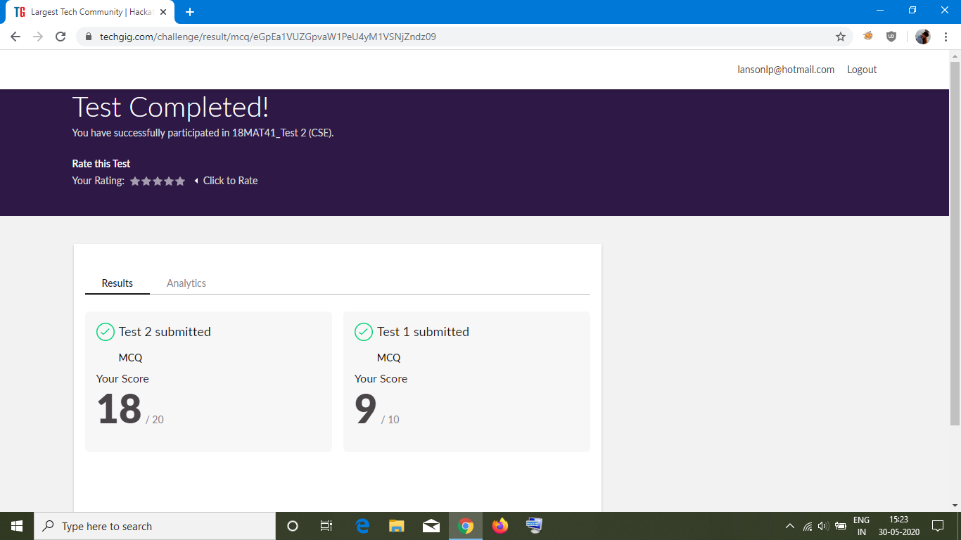

Online Certification Course Summary: I have opted my Online Certification Course In BitDegree the course which i have opted is Introducing Coding for Beginners: an HTML and CSS Online Course..

This course covers the following topics :
Basic web development
Creating forms, buttons, and other elements
HTML coding basics
CSS basics

Description :

A Fun Way to Get Familiar With Coding for Beginners.

Master HTML and CSS basics Step-by-Step.
Section 3: Lecture 1 : Fixing and Uploading the Website

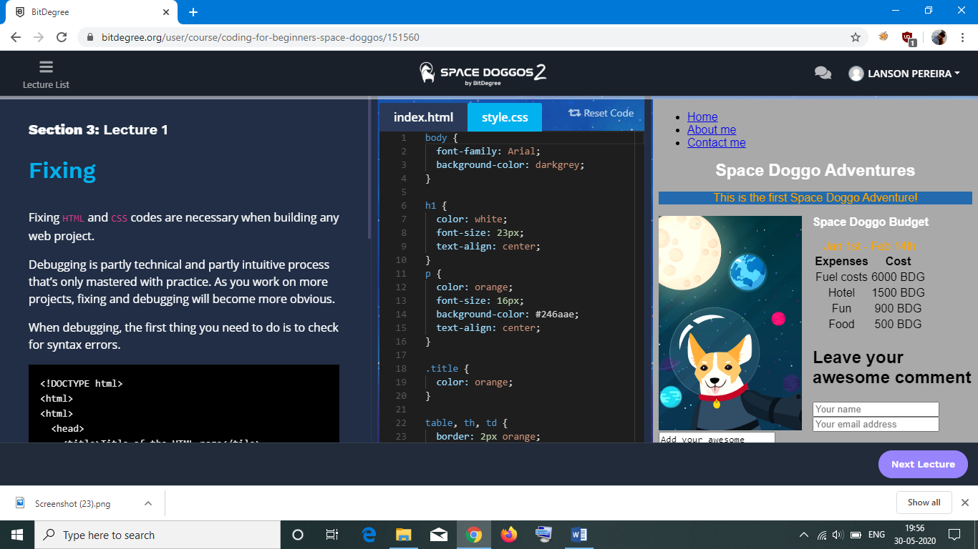
Certificate :

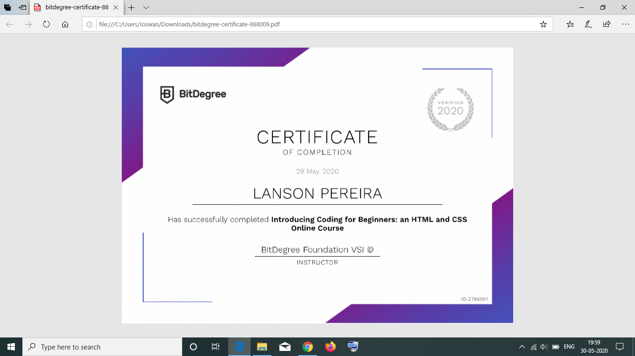
1.Write a C Program to count Uppercase, Lowercase, special character and numeric values for a given String

